Hello church family,
With the AGM just around the corner, as an Elders Board we wanted to give you a high level overview of last year’s finances. Below is a brief summary for you.
This past year for both Pacific Community Church and Cloverdale Community Kitchen has be anything but normal. As we continued to navigate the impacts and requirements of COVID, we weren’t able to meet in person for much of the year. However, we continued to be blessed in many ways. For example, for PCC we were blessed to have Pastor Jon join us and lead us well through these challenging times, and for CCK, while the needs in the community have grown, seeing how our community has come together to fill those needs through incredible giving of both time and resources has been an inspiration.
Financially, the past year has continued to be strong. While we didn’t finish the year with the same level of surplus as we did the previous year, the strong results in 2019/20 set us up well for a stable 2020/21 fiscal year. The tables below highlight the results for both PCC and CCK from last year.
The first two are income statements snapshots for PCC & CCK.
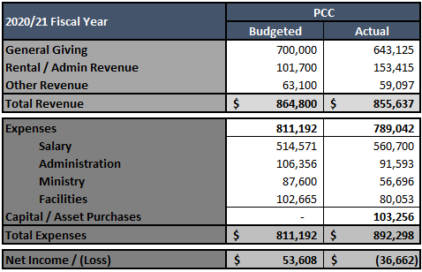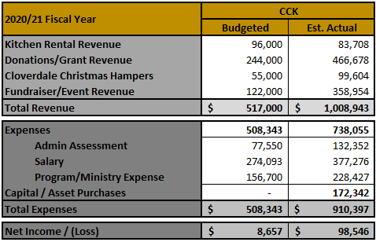
This next table is a summarized view of the balance sheet – showing our assets and liabilities.
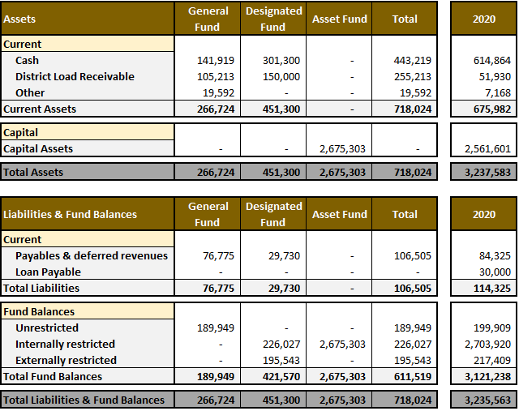
Full financial statements are available upon request. Paper copies will be available at the AGM where we will also share a few more highlights at that time; however, if you have any questions in the meantime, please don’t hesitate to reach out to Dave Stinchcombe (Board Treasurer) or Jordan Pousett (Board Chair).

