Join the Parade Fun on December 11!
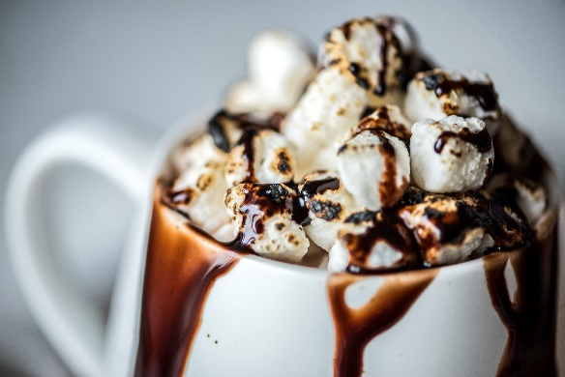
How, you ask?
Help serve hot cocoa and engage with parade attendees!
Be a Christmas Caroler! No singing expertise required!
Work behind the scenes to set up the hot cocoa bar!
Connect with parade goers at the photo op!
Set-up begins at 11:30.
Serving hot cocoa and photo op begin at 12:45.
Caroling begins at 1:00.
Clean up begins at 2:00 pm when the parade begins.
Sign up today for a 30-minute shift!

 | Set-up | Serving Hot Cocoa | Caroling | Photo Op | Cleanup
11:30 AM | Roni
 | Karen
12:00 PM
12:30 PM
12:45 PM
1:00 PM
1:30 PM |  | Karen
2:00 PM
2:15 PM |  |  |  |  | Karen

