Faith Evangelical Lutheran Church, Washington, IL
All Saints Sunday
November 7, 2021

Welcome
Confession and Forgiveness

P: In the name of the Father, and of the + Son, and of the Holy Spirit.
C: Amen.
You may make the sign of the cross as a reminder of your baptism.
P: Almighty God, to whom all hearts are open, all desires known, and from whom no secrets are hid: cleanse the thoughts of our hearts by the inspiration of your Holy Spirit, that we may perfectly love you and worthily magnify your holy name, through Jesus Christ our Lord.
C: Amen.
P: Let us confess our sin in the presence of God and of one another.
Please keep silence for reflection
P: Most merciful God,
C: we confess that we are captive to sin and cannot free ourselves. We have sinned against you in thought, word, and deed, by what we have done and by what we have left undone. We have not loved you with our whole heart; we have not loved our neighbors as ourselves. For the sake of your Son, Jesus Christ, have mercy on us. Forgive us, renew us, and lead us, so that we may delight in your will and walk in your ways, to the glory of your holy name. Amen.
P: In the mercy of almighty God, Jesus Christ was given to die for us, and for his sake God forgives us all our sins. As a called and ordained minister of the church of Christ, and by his authority, I therefore declare to you the entire forgiveness of all your sins, in the name of the Father, and of the + Son, and of the Holy Spirit.
C: Amen.
Faith Lutheran Church
2206 Washington Rd,
Washington, IL 61571
Website and online worship:
www.shareourfaith.org
Church: 309-745-9306
faithlth@shareourfaith.org
Pastor John Rothfusz
Home: 309-745-9282
pastor@shareourfaith.org

Peace: As forgiven children of God, we have peace
with God, and peace with one another.
P The peace of the Lord be with you always.
C And also with you.
P Let us share that peace with one another.

*Hymn: “For All the Saints” Red Book #422
Text: William W. How, 1823-1897
Music: SINE NOMINE, Ralph Vaughan Williams, 1872-1958
Music from The English Hymnal outsied the USA © Oxford University Press 1906. All rights reserved.

P The grace of our Lord Jesus Christ, the love of God,
and the communion of the Holy Spirit be with you all.
C And also with you.

Hymn of Praise
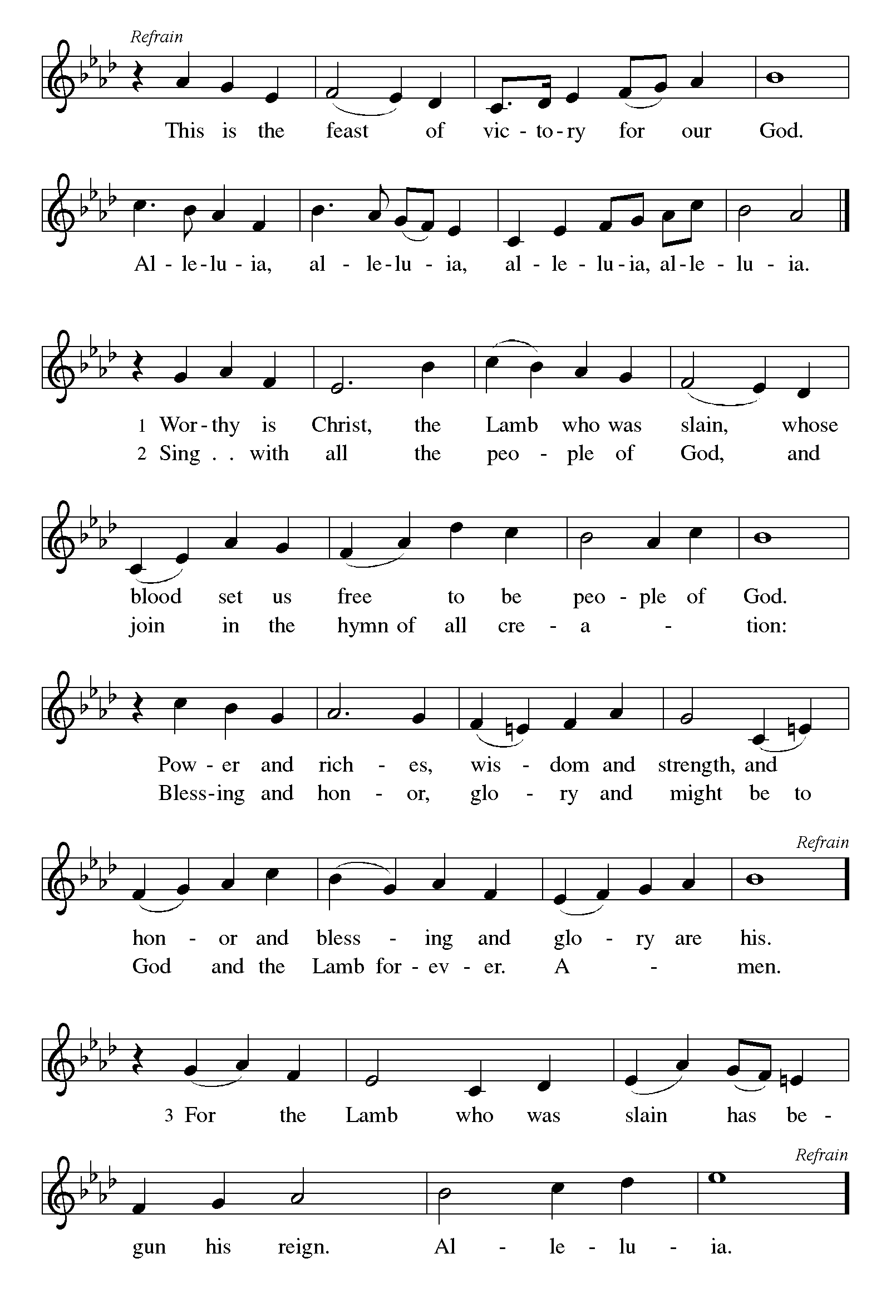

P The Lord be with you
C And also with you.
Let us pray together the Prayer of the Day

Almighty God, you have knit your people together in one communion in the mystical body of your Son, Jesus Christ our Lord. Grant us grace to follow your blessed saints in lives of faith and commitment, and to know the inexpressible joys you have prepared for those who love you, through Jesus Christ, our Savior and Lord, who lives and reigns with you and the Holy Spirit, one God, now and forever.
Amen.

Children’s Message

First Reading: Isaiah 25:6-9, Pew Bible Page #565
⁶On this mountain the Lord of hosts will make for all peoples a feast of rich food, a feast of well-aged wines, of rich food filled with marrow, of well-aged wines strained clear. ⁷And he will destroy on this mountain the shroud that is cast over all peoples, the sheet that is spread over all nations; ⁸he will swallow up death forever. Then the Lord God will wipe away the tears from all faces, and the disgrace of his people he will take away from all the earth, for the Lord has spoken. ⁹It will be said on that day, Lo, this is our God; we have waited for him, so that he might save us. This is the Lord for whom we have waited; let us be glad and rejoice in his salvation.
R The Word of the Lord
C Thanks be to God
Second Reading: Revelation 21:1-6a Pew Bible Page #1013
¹I saw a new heaven and a new earth; for the first heaven and the first earth had passed away, and the sea was no more. ²And I saw the holy city, the new Jerusalem, coming down out of heaven from God, prepared as a bride adorned for her husband. ³And I heard a loud voice from the throne saying,
“See, the home of God is among mortals. He will dwell with them; they will be his peoples, and God himself will be with them; ⁴he will wipe every tear from their eyes. Death will be no more; mourning and crying and pain will be no more,
for the first things have passed away.” ⁵And the one who was seated on the throne said, “See, I am making all things new.” Also he said, “Write this, for these words are trustworthy and true.” ^{6a}Then he said to me, “It is done! I am the Alpha and the Omega, the beginning and the end.”
R The Word of the Lord
C Thanks be to God
Gospel Reading: John 11:32-44 Pew Bible Page #870

C Glory to you, O Lord
³²When Mary came where Jesus was and saw him, she knelt at his feet and said to him, “Lord, if you had been here, my brother would not have died.” ³³When Jesus saw her weeping, and the Jews who came with her also weeping, he was greatly disturbed in spirit and deeply moved. ³⁴He said, “Where have you laid him?” They said to him, “Lord, come and see.” ³⁵Jesus began to weep. ³⁶So the Jews said, “See how he loved him!” ³⁷But some of them said, “Could not he who opened the eyes of the blind man have kept this man from dying?”
³⁸Then Jesus, again greatly disturbed, came to the tomb. It was a cave, and a stone was lying against it. ³⁹Jesus said, “Take away the stone.” Martha, the sister of the dead man, said to him, “Lord, already there is a stench because he has been dead four days.” ⁴⁰Jesus said to her, “Did I not tell you that if you believed, you would see the glory of God?” ⁴¹So they took away the stone. And Jesus looked upward and said, “Father, I thank you for having heard me. ⁴²I knew that you always hear me, but I have said this for the sake of the crowd standing here, so that they may believe that you sent me.” ⁴³When he had said this, he cried with a loud voice, “Lazarus, come out!” ⁴⁴The dead man came out, his hands and feet bound with strips of cloth, and his face wrapped in a cloth. Jesus said to them, “Unbind him, and let him go.”

The Gospel of the Lord
C Praise to you, O Christ

Sermon by Pastor John Rothfusz

Sermon Hymn: “Behold the Host Arrayed in White” Red Book #425
Text: hans A. Brorson, 1694-1764; tr.. Gracia Grindal, b. 1943-, alt
Music: DEN STORE HVIDE FLOK, Norwegian folk tune, 17th cent.; arr. Edward H. Grieg, 1843-1907
Text © 1978 Lutheran Book of Worship, admin. Augsburg Fortress

Lighting candles in memory of loved ones who have died.

Apostles’ Creed
C: I believe in God, the Father almighty,
creator of heaven and earth.
I believe in Jesus Christ, God's only Son, our Lord,
who was conceived by the Holy Spirit,
born of the virgin Mary,
suffered under Pontius Pilate,
was crucified, died, and was buried;
he descended to the dead.
On the third day he rose again;
he ascended into heaven,
he is seated at the right hand of the Father,
and he will come to judge the living and the dead.
I believe in the Holy Spirit,
the holy catholic church, the communion of saints,
the forgiveness of sins, the resurrection of the body,
and the life everlasting. Amen.

Prayers: After each portion of the prayers finishes with “Lord in your mercy,” please respond, “Hear our prayer.”

Offering: Jesus fills us with faith and sends us out as his witnesses. Let us commit ourselves to the Lord and joyfully lift our tithes and offerings to the Lord.

Please take a moment now to make an electronic offering to the church on the website, with the Tithe.ly app on your phone, or write a check and drop it in the plate at communion time.
Faith Lutheran website link www.shareourfaith.org

A Let us pray. Blessed are you, O God,
C maker of all things. Through your goodness you have blessed us with these gifts: our selves, our time, and our possessions. Use us, and what we have gathered, in feeding the world with your love, through the one who gave himself for us, Jesus Christ, our Savior and Lord. Amen.
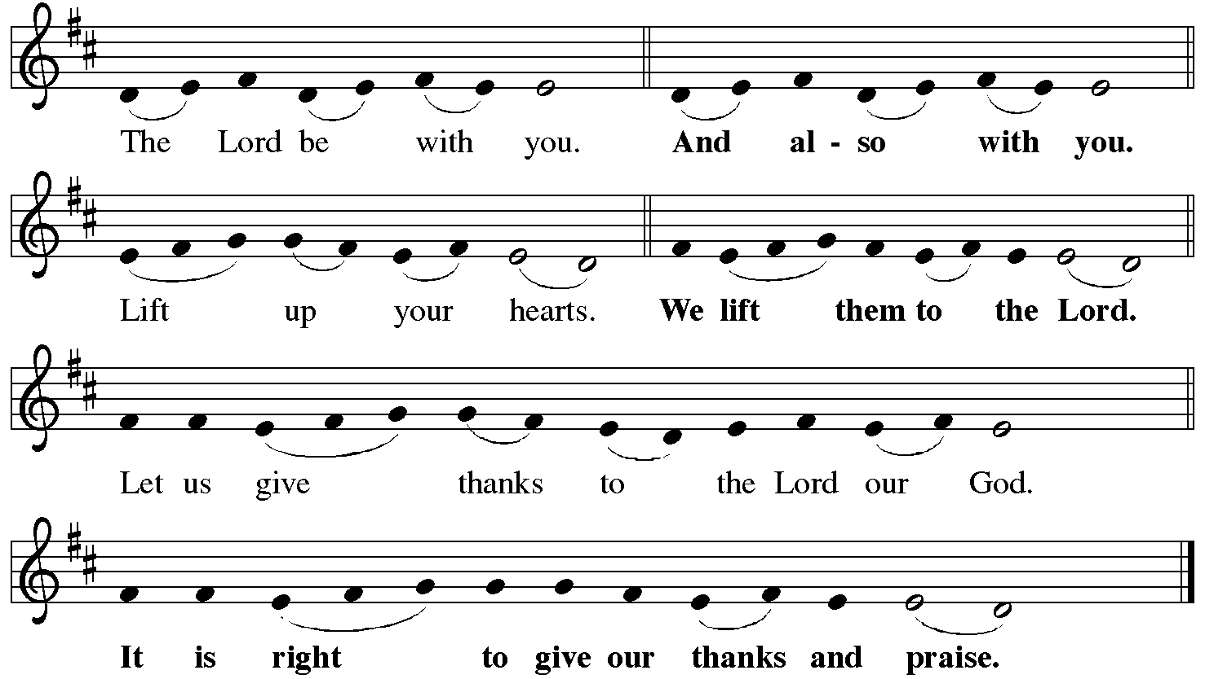
P It is indeed right, our duty and our joy… with the church on earth and the hosts of heaven, we praise your name and join their unending hymn:
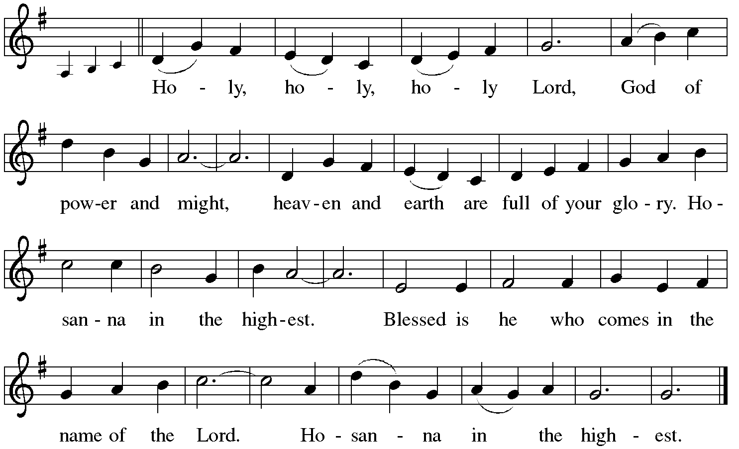

Holy Communion: Preface pp. 108-111 or other Eucharistic prayer

In the night in which he was betrayed,
our Lord Jesus took bread, and gave thanks;
broke it, and gave it to his disciples, saying:
Take and eat; this is my body, given for you.
Do this for the remembrance of me.
Again, after supper, he took the cup, gave thanks,
and gave it for all to drink, saying:
This cup is the new covenant in my blood,
shed for you and for all people for the forgiveness of sin.
Do this for the remembrance of me.
C The Lord's Prayer
Our Father, who art in heaven, hallowed be thy name,
thy kingdom come, thy will be done, on earth as it is in heaven.
Give us this day our daily bread; and forgive us our trespasses,
as we forgive those who trespass against us;
and lead us not into temptation, but deliver us from evil.
For thine is the kingdom, and the power, and the glory,
forever and ever. Amen
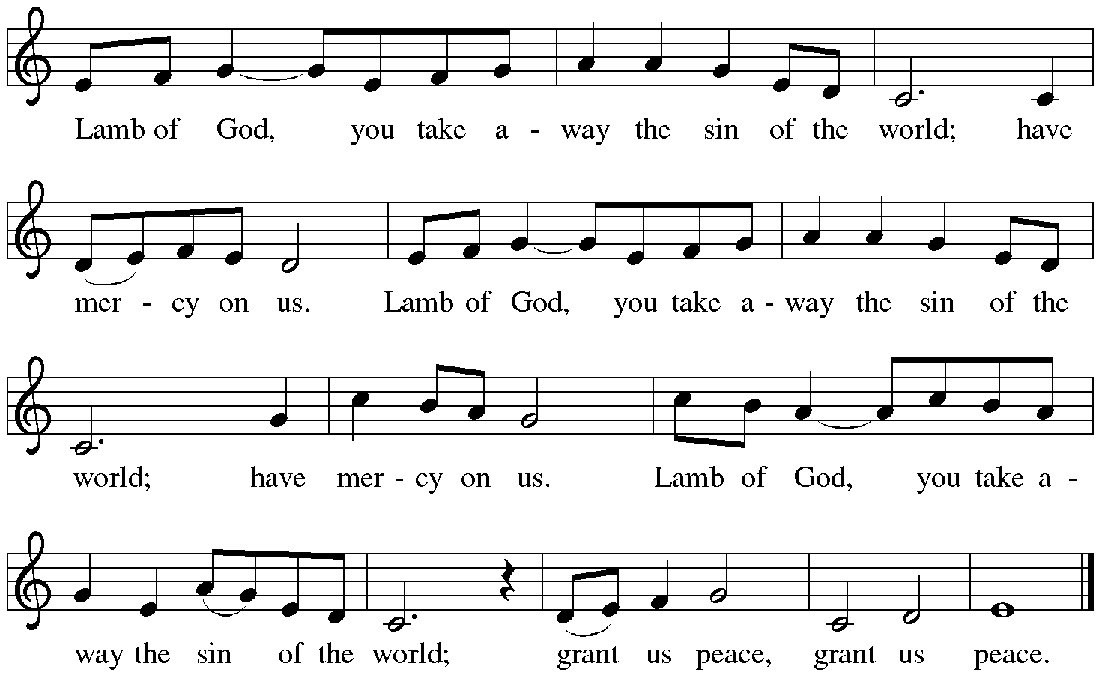

Distribution:

Communion Prayer

Announcements
Blessing
P The Lord bless you and keep you. The Lord make his face shine on you and be gracious to you. The Lord look upon you with favor and + give you peace.
In the name of the Father, and of the Son and of the Holy Spirit.
C Amen
Hymn: “Oh, When the Saints Go Marching In” Back Book p. #8
Text: African American spiritual
Music: WHEN THE SAINTS, African American spiritual

Dismissal
A Go in peace. Serve the Lord.
C Thanks be to God!
Postlude

Liturgy and texts from Sundays and Seasons.com. Copyright 2021 Augsburg Fortress. All rights reserved.
Reprinted by permission under Augsburg Fortress Liturgies Annual License #23628.

