Faith Evangelical Lutheran Church, Washington, IL
Twenty-second Sunday after Pentecost
October 24, 2021

Welcome
Confession and Forgiveness

P: In the name of the Father, and of the + Son, and of the Holy Spirit.
C: Amen.
You may make the sign of the cross as a reminder of your baptism.
P: Almighty God, to whom all hearts are open, all desires known, and from whom no secrets are hid: cleanse the thoughts of our hearts by the inspiration of your Holy Spirit, that we may perfectly love you and worthily magnify your holy name, through Jesus Christ our Lord.
C: Amen.
P: Let us confess our sin in the presence of God and of one another.
Please keep silence for reflection
P: Most merciful God,
C: we confess that we are captive to sin and cannot free ourselves. We have sinned against you in thought, word, and deed, by what we have done and by what we have left undone. We have not loved you with our whole heart; we have not loved our neighbors as ourselves. For the sake of your Son, Jesus Christ, have mercy on us. Forgive us, renew us, and lead us, so that we may delight in your will and walk in your ways, to the glory of your holy name. Amen.
P: In the mercy of almighty God, Jesus Christ was given to die for us, and for his sake God forgives us all our sins. As a called and ordained minister of the church of Christ, and by his authority, I therefore declare to you the entire forgiveness of all your sins, in the name of the Father, and of the + Son, and of the Holy Spirit.
C: Amen.
Faith Lutheran Church
2206 Washington Rd,
Washington, IL 61571
Website and online worship:
www.shareourfaith.org
Church: 309-745-9306
faithlth@shareourfaith.org
Pastor John Rothfusz
Home: 309-745-9282
pastor@shareourfaith.org

Peace: As forgiven children of God, we have peace
with God, and peace with one another.
P The peace of the Lord be with you always.
C And also with you.
P Let us share that peace with one another.

*Hymn: “Gather Us In” Red Book #532

Text: Marty Haugen, b. 1950
Music: GATHER US IN, Marty Haugen
Text and music © 1982 GIA Publications, Inc., 7404 S. Mason Ave., Chicago, IL 60638. www.giamusic.lcom. 800.442.3358. All rights reserved Used by permission. Reprinted under OneLicense.net#A-711151

P The grace of our Lord Jesus Christ, the love of God,
and the communion of the Holy Spirit be with you all.
C And also with you.

Hymn of Praise
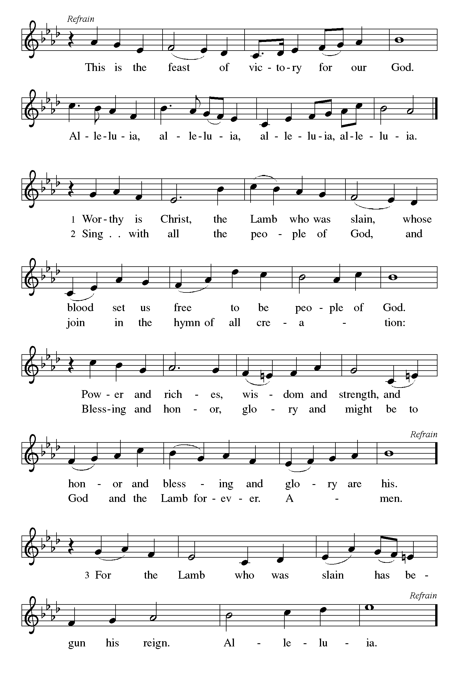

P The Lord be with you
C And also with you.
Let us pray together the Prayer of the Day
Eternal light, shine in our hearts. Eternal wisdom, scatter the darkness of our ignorance. Eternal compassion, have mercy on us. Turn us to seek your face, and enable us to reflect your goodness, through Jesus Christ, our Savior and Lord. Amen.

Children’s Message

First Reading: Jeremiah 31:7-9 Pew Bible Page #633
Thus says the Lord: Sing aloud with gladness for Jacob, and raise shouts for the chief of the nations; proclaim, give praise, and say, “Save, O Lord, your people,
the remnant of Israel.” ⁸See, I am going to bring them from the land of the north,
and gather them from the farthest parts of the earth, among them the blind and the lame, those with child and those in labor, together; a great company, they shall return here. ⁹With weeping they shall come, and with consolations I will lead them back, I will let them walk by brooks of water, in a straight path in which they shall not stumble; for I have become a father to Israel, and Ephraim is my firstborn.

R The Word of the Lord
C Thanks be to God

Psalm 126
¹When the Lord restored the fortunes of Zion,
then were we like those who dream.
²Then was our mouth filled with laughter, and our tongue with shouts of joy; Then they said among the nations, “The Lord has done great things for them.”
³The Lord has done great things for us,
and we are glad indeed.
⁴Restore our fortunes, O Lord,
like the watercourses of the Negeb.
⁵Those who sowed with tears
will reap with songs of joy.
⁶Those who go out weeping, carrying the seed,
will come again with joy, shouldering their sheaves.

Gospel Reading: Mark 10:46-52 Pew Bible Page #818

C Glory to you, O Lord

⁴⁶As [Jesus] and his disciples and a large crowd were leaving Jericho, Bartimaeus son of Timaeus, a blind beggar, was sitting by the roadside. ⁴⁷When he heard that it was Jesus of Nazareth, he began to shout out and say, “Jesus, Son of David, have mercy on me!” ⁴⁸Many sternly ordered him to be quiet, but he cried out even more loudly, “Son of David, have mercy on me!” ⁴⁹Jesus stood still and said, “Call him here.” And they called the blind man, saying to him, “Take heart; get up, he is calling you.” ⁵⁰So throwing off his cloak, he sprang up and came to Jesus. ⁵¹Then Jesus said to him, “What do you want me to do for you?” The blind man said to him, “My teacher, let me see again.” ⁵²Jesus said to him, “Go; your faith has made you well.” Immediately he regained his sight and followed him on the way.
The Gospel of the Lord
C Praise to you, O Christ

Sermon by Pastor John Rothfusz

Sermon Hymn: “You Are Mine” Red Book #581

Text: David Haas, b. 1957
Music: YOU ARE MINE, David Haas
Text and music © 1991 GIA Publications, Inc., 7404 S. Mason Ave., Chicago, IL 60638. www.giamusic.com. 800. 442.3358. All rights reserved. Used by persmission. Reprinted under OneLicense.net#A-711151

Apostles’ Creed
C: I believe in God, the Father almighty,
creator of heaven and earth.
I believe in Jesus Christ, God's only Son, our Lord,
who was conceived by the Holy Spirit,
born of the virgin Mary,
suffered under Pontius Pilate,
was crucified, died, and was buried;
he descended to the dead.
On the third day he rose again;
he ascended into heaven,
he is seated at the right hand of the Father,
and he will come to judge the living and the dead.
I believe in the Holy Spirit,
the holy catholic church, the communion of saints,
the forgiveness of sins, the resurrection of the body,
and the life everlasting. Amen.

Prayers: After each portion of the prayers finishes with “Lord in your mercy,” please respond, “Hear our prayer.”

Offering: Jesus fills us with faith and sends us out as his witnesses. Let us commit ourselves to the Lord and joyfully lift our tithes and offerings to the Lord.

Please take a moment now to make an electronic offering to the church on the website, with the Tithe.ly app on your phone, or write a check and drop it in the plate at communion time.
Faith Lutheran website link www.shareourfaith.org

A Let us pray. Blessed are you, O God,
C maker of all things. Through your goodness you have blessed us with these gifts: our selves, our time, and our possessions. Use us, and what we have gathered, in feeding the world with your love, through the one who gave himself for us, Jesus Christ, our Savior and Lord. Amen.

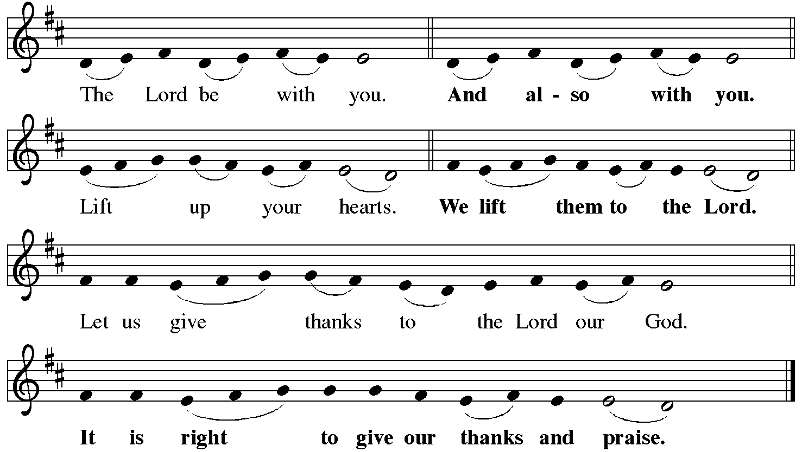
P It is indeed right, our duty and our joy… with the church on earth and the hosts of heaven, we praise your name and join their unending hymn:
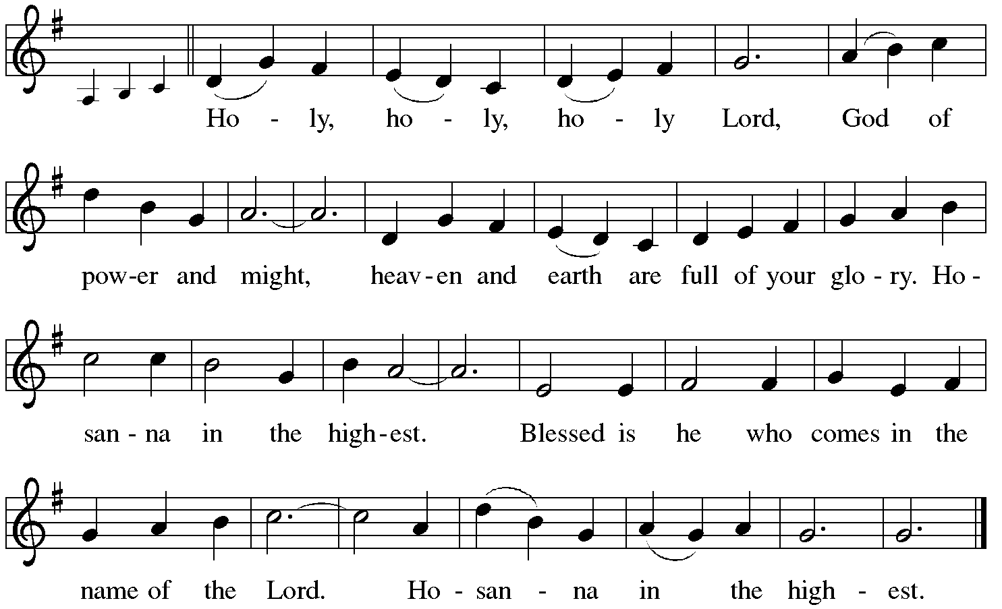

Holy Communion: Preface pp. 108-111 or other Eucharistic prayer

In the night in which he was betrayed,
our Lord Jesus took bread, and gave thanks;
broke it, and gave it to his disciples, saying:
Take and eat; this is my body, given for you.
Do this for the remembrance of me.
Again, after supper, he took the cup, gave thanks,
and gave it for all to drink, saying:
This cup is the new covenant in my blood,
shed for you and for all people for the forgiveness of sin.
Do this for the remembrance of me.
C The Lord's Prayer
Our Father, who art in heaven, hallowed be thy name,
thy kingdom come, thy will be done, on earth as it is in heaven.
Give us this day our daily bread; and forgive us our trespasses,
as we forgive those who trespass against us;
and lead us not into temptation, but deliver us from evil.
For thine is the kingdom, and the power, and the glory,
forever and ever. Amen
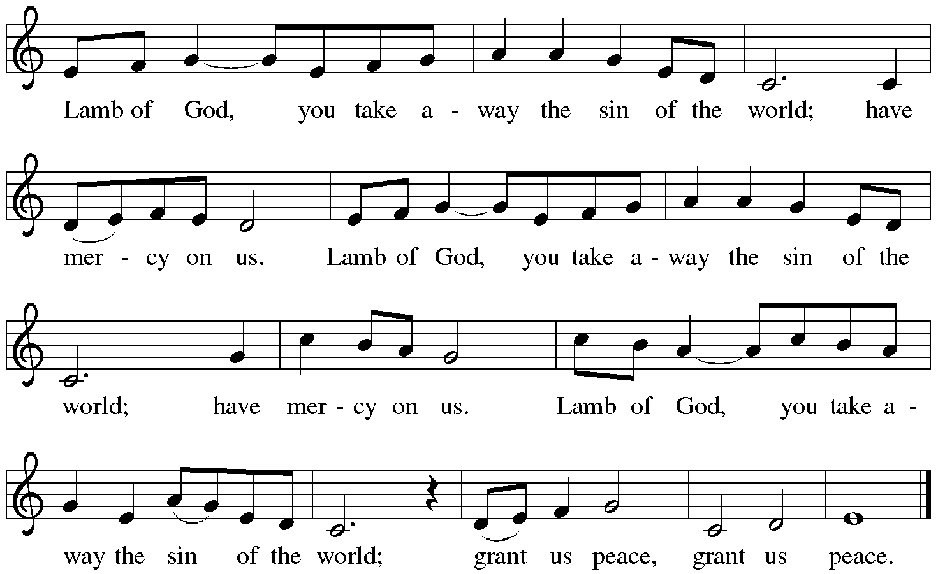

Distribution:

Communion Prayer

Announcements
Blessing
P The Lord bless you and keep you. The Lord make his face shine on you and be gracious to you. The Lord look upon you with favor and + give you peace.
In the name of the Father, and of the Son and of the Holy Spirit.
C Amen
Hymn: “Guide Me Ever, Great Redeemer” Red Book #618

Text: William Williams, 1717-1792; tr. William Williams and Peter Williams, 1722-1796, alt.
Music: CWM RHONDDA, John Hughes, 1873-1932

Dismissal
A Go in peace. Serve the Lord.
C Thanks be to God!
Postlude

Liturgy and texts from Sundays and Seasons.com. Copyright 2021 Augsburg Fortress. All rights reserved.
Reprinted by permission under Augsburg Fortress Liturgies Annual License #23628.

