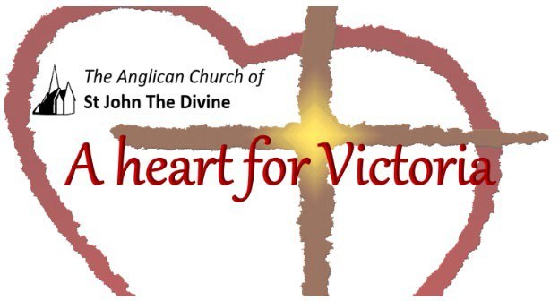

Tuesday October 19th, 2021

Lunchtime Worship

St. John’s acknowledges that the Church buildings, and all living in Victoria, are on the ancestral lands of the Lekwungen speaking people.

Gathering to worship
Let us worship together at this continuing season of harvest
All Amen

God is with you
All And also with you.

This is the day that the Divine has made
All We will rejoice and be glad in it.
Opening Prayer
All Lord, direct our thoughts, and teach us to pray.
Lift up our hearts to worship you in spirit and in truth Amen
Blessed is the Creator
All for God has heard the voice of our prayer.

The Church Family Prayer
Loving God,
All: you have called us to be your family and to celebrate our life together in worship. We pray now, for all members of our family as we gather in our church buildings, our homes, and online. Through your spirit keep us united in love. Bless each of us with your beloved friendship. Teach us, gracious God, how to be your church in these times. Help us to know that we are your people, that we are your Family, always. Amen.

The Collect of the Day
Suffering God,
when we seek glory for ourselves
cast down all our idols
and direct our hearts
to him who bears our wounds
and is our peace,
Jesus Christ, the true God and servant of all.
All: Amen. Prayers for an Inclusive Church (2009) alt.

A reading from Mark chapter 10

Jesus called them and said to them, ‘You know that among the Gentiles those whom they recognize as their rulers lord it over them, and their great ones are tyrants over them. But it is not so among you; but whoever wishes to become great among you must be your servant, and whoever wishes to be first among you must be slave of all. For the Son of Man came not to be served but to serve, and to give his life a ransom for many.’

A Harvest Prayer
O Heavenly Father: we thank Thee for food and remember the hungry. We thank Thee for health and remember the sick. We thank Thee for friends and remember the friendless. We thank Thee for freedom and remember the enslaved. May these remembrances stir us to service. That Thy gifts to us may be used for others. Amen.

A prayer for children
Loving God,
your Son told his disciples
to become like little children.
Lead us to work for the welfare
and protection of all young people.
May we respect their dignity
that they may flourish in life,
following the example of our Lord.
Amen.

A prayer of hope

God of compassion,
your love for humanity was revealed in Jesus,
whose earthly life began in the poverty of a stable
and ended in the pain and isolation of the cross:
we hold before you those who are homeless and cold.
Draw near and comfort them in spirit
and bless those who work to provide them
with shelter, food and friendship.

Affirmation

With people everywhere
All We affirm God’s goodness at the heart of humanity Planted more deeply than all that is wrong

With all creation
All We celebrate the miracle and wonder of life.
The unfolding purposes of God, forever at work In ourselves and the world
Iona Abbey Worship Book

During this time may our Church be a sign of hope, comfort and love to all.

Grant peace.

Grant comfort.

Grant healing.

Be with us, Lord. Amen.

Gracious God,
All accept these prayers
In the name of our brother, Jesus Christ.

All Amen.

Let us say together:

The Prayer to Our Father (in the original Aramaic)
Abwûn

Oh Thou, from whom the breath of life comes,
d'bwaschmâja

who fills all realms of sound, light and vibration.
Nethkâdasch schmach

May Your light be experienced in my utmost holiest.
Têtê malkuthach.

Your Heavenly Domain approaches.
Nehwê tzevjânach aikâna d'bwaschmâja af b'arha.

Let Your will come true - in the universe just as on earth.
Hawvlân lachma d'sûnkanân jaomâna.

Give us wisdom for our daily need,
Waschboklân chaubên wachtahên aikâna daf chnân schwoken l'chaijabên.

detach the fetters of faults that bind us, as we let go the guilt of others.
Wela tachlân l'nesjuna

Let us not be lost in superficial things
ela patzân min bischa.

but let us be freed from that which keeps us from our true purpose.
Metol dilachie malkutha wahaila wateschbuchta l'ahlâm almîn.

From You comes the all-working will, the lively strength to act, the song that beautifies all and renews itself from age to age.
Sealed in trust, faith and truth.
Amen

The Value of Little Things
by William Cutter
What if the little rain should say,
"So small a drop as I
Can ne'er refresh the thirsty earth,
I'll tarry in the sky!"
What if a shining beam of noon
Should in its fountain stay,
Because its feeble light alone
Is not enough for day!
Doth not each rain-drop help to form
The cool refreshing shower?
And every ray of light to warm
And beautify the flower?

Thank you for spending this time with us today.

Go in peace to love and serve.
All Thanks be to God. Amen.

Copyright acknowledgment
Order of service based on New Patterns for Worship © 2003
Some material included in this service is copyright: © The Archbishops' Council 2000
Some material included in this service is copyright: © The Archbishops' Council 2002 Sacred Space, 2020

