Faith Evangelical Lutheran Church, Washington, IL
Twenty-first Sunday after Pentecost
October 17, 2021

Welcome
Confession and Forgiveness

P: In the name of the Father, and of the + Son, and of the Holy Spirit.
C: Amen.
You may make the sign of the cross as a reminder of your baptism.
P: Almighty God, to whom all hearts are open, all desires known, and from whom no secrets are hid: cleanse the thoughts of our hearts by the inspiration of your Holy Spirit, that we may perfectly love you and worthily magnify your holy name, through Jesus Christ our Lord.
C: Amen.
P: Let us confess our sin in the presence of God and of one another.
Please keep silence for reflection
P: Most merciful God,
C: we confess that we are captive to sin and cannot free ourselves. We have sinned against you in thought, word, and deed, by what we have done and by what we have left undone. We have not loved you with our whole heart; we have not loved our neighbors as ourselves. For the sake of your Son, Jesus Christ, have mercy on us. Forgive us, renew us, and lead us, so that we may delight in your will and walk in your ways, to the glory of your holy name. Amen.
P: In the mercy of almighty God, Jesus Christ was given to die for us, and for his sake God forgives us all our sins. As a called and ordained minister of the church of Christ, and by his authority, I therefore declare to you the entire forgiveness of all your sins, in the name of the Father, and of the + Son, and of the Holy Spirit.
C: Amen.
Faith Lutheran Church
2206 Washington Rd,
Washington, IL 61571
Website and online worship:
www.shareourfaith.org
Church: 309-745-9306
faithlth@shareourfaith.org
Pastor John Rothfusz
Home: 309-745-9282
pastor@shareourfaith.org

Peace: As forgiven children of God, we have peace
with God, and peace with one another.
P The peace of the Lord be with you always.
C And also with you.
P Let us share that peace with one another.

*Hymn: “For the Beauty of the Earth” Red Book #879

P The grace of our Lord Jesus Christ, the love of God,
and the communion of the Holy Spirit be with you all.
C And also with you.

Hymn of Praise
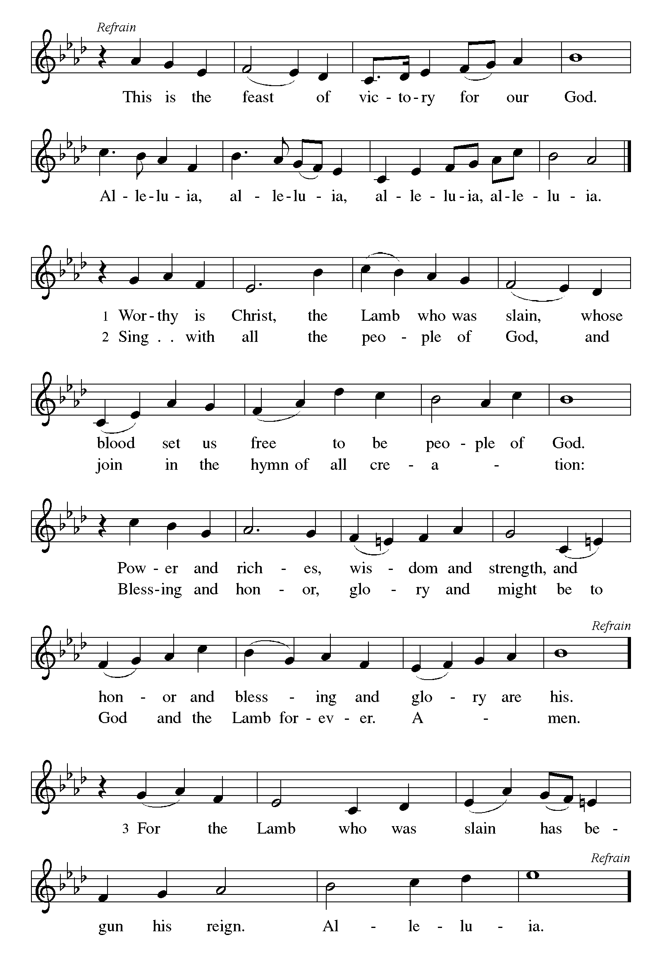

P The Lord be with you
C And also with you.
Let us pray together the Prayer of the Day
Sovereign God, you turn your greatness into goodness for all the peoples on earth. Shape us into willing servants of your kingdom, and make us desire always and only your will, through Jesus Christ, our Savior and Lord.
Amen.

Children’s Message

First Reading: 1 Corinthians 12:4-13 Pew Bible Page #930
⁴Now there are varieties of gifts, but the same Spirit; ⁵and there are varieties of services, but the same Lord; ⁶and there are varieties of activities, but it is the same God who activates all of them in everyone. ⁷To each is given the manifestation of the Spirit for the common good. ⁸To one is given through the Spirit the utterance of wisdom, and to another the utterance of knowledge according to the same Spirit, ⁹to another faith by the same Spirit, to another gifts of healing by the one Spirit, ¹⁰to another the working of miracles, to another prophecy, to another the discernment of spirits, to another various kinds of tongues, to another the interpretation of tongues. ¹¹All these are activated by one and the same Spirit, who allots to each one individually just as the Spirit chooses. ¹²For just as the body is one and has many members, and all the members of the body, though many, are one body, so it is with Christ. ¹³For in the one Spirit we were all baptized into one body — Jews or Greeks, slaves or free — and we were all made to drink of one Spirit.

R The Word of the Lord
C Thanks be to God

Gospel Reading: John 15:1-11 Pew Bible Page #874

C Glory to you, O Lord

¹I am the true vine, and my Father is the vinegrower. ²He removes every branch in me that bears no fruit. Every branch that bears fruit he prunes to make it bear more fruit. ³You have already been cleansed by the word that I have spoken to you. ⁴Abide in me as I abide in you. Just as the branch cannot bear fruit by itself unless it abides in the vine, neither can you unless you abide in me. ⁵I am the vine, you are the branches. Those who abide in me and I in them bear much fruit, because apart from me you can do nothing. ⁶Whoever does not abide in me is thrown away like a branch and withers; such branches are gathered, thrown into the fire, and burned. ⁷If you abide in me, and my words abide in you, ask for whatever you wish, and it will be done for you. ⁸My Father is glorified by this, that you bear much fruit and become my disciples. ⁹As the Father has loved me, so I have loved you; abide in my love. ¹⁰If you keep my commandments, you will abide in my love, just as I have kept my Father's commandments and abide in his love. ¹¹I have said these things to you so that my joy may be in you, and that your joy may be complete.

The Gospel of the Lord
C Praise to you, O Christ

Sermon by Pastor John Rothfusz

Sermon Hymn: “Here I Am, Lord” Red Book #574

Text: Daniel L. Schutte, b. 1946
Music: HERE I AM, LORD, Daniel L. Schutte
Text and music © 1981 OCP Publications, Inc., 5536 NE Hassalo, Portland, OR 97213. All rights reserved. Used by permission. Reprinted under OneLicense.net#A-711151

Apostles’ Creed
C: I believe in God, the Father almighty,
creator of heaven and earth.
I believe in Jesus Christ, God's only Son, our Lord,
who was conceived by the Holy Spirit,
born of the virgin Mary,
suffered under Pontius Pilate,
was crucified, died, and was buried;
he descended to the dead.
On the third day he rose again;
he ascended into heaven,
he is seated at the right hand of the Father,
and he will come to judge the living and the dead.
I believe in the Holy Spirit,
the holy catholic church, the communion of saints,
the forgiveness of sins, the resurrection of the body,
and the life everlasting. Amen.

Prayers: After each portion of the prayers finishes with “Lord in your mercy,” please respond, “Hear our prayer.”

Offering: Jesus fills us with faith and sends us out as his witnesses. Let us commit ourselves to the Lord and joyfully lift our tithes and offerings to the Lord.

Please take a moment now to make an electronic offering to the church on the website, with the Tithe.ly app on your phone, or write a check and drop it in the plate at communion time.
Faith Lutheran website link www.shareourfaith.org

A Let us pray. Blessed are you, O God,
C maker of all things. Through your goodness you have blessed us with these gifts: our selves, our time, and our possessions. Use us, and what we have gathered, in feedi ng the world with your love, through the one who gave himself for us, Jesus Christ, our Savior and Lord. Amen.

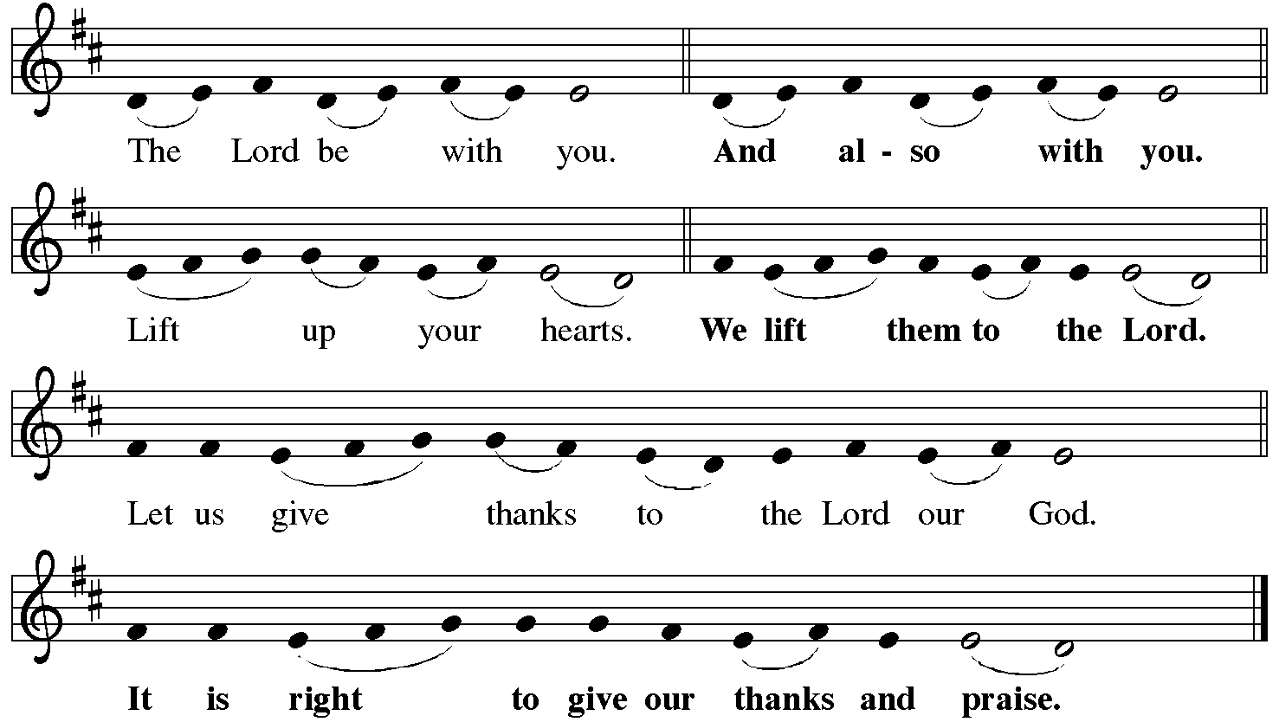
P It is indeed right, our duty and our joy… with the church on earth and the hosts of heaven, we praise your name and join their unending hymn:
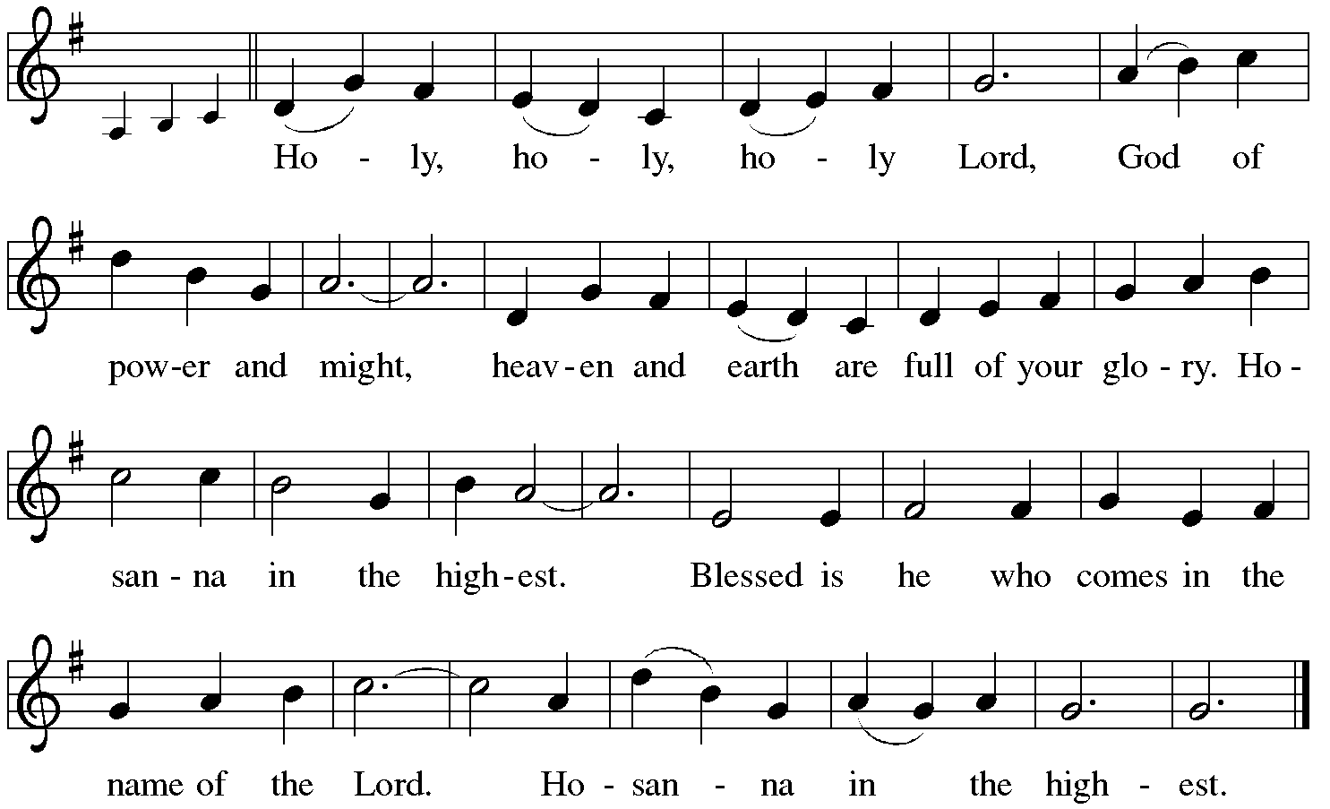

Holy Communion: Preface pp. 108-111 or other Eucharistic prayer

In the night in which he was betrayed,
our Lord Jesus took bread, and gave thanks;
broke it, and gave it to his disciples, saying:
Take and eat; this is my body, given for you.
Do this for the remembrance of me.
Again, after supper, he took the cup, gave thanks,
and gave it for all to drink, saying:
This cup is the new covenant in my blood,
shed for you and for all people for the forgiveness of sin.
Do this for the remembrance of me.
C The Lord's Prayer
Our Father, who art in heaven, hallowed be thy name,
thy kingdom come, thy will be done, on earth as it is in heaven.
Give us this day our daily bread; and forgive us our trespasses,
as we forgive those who trespass against us;
and lead us not into temptation, but deliver us from evil.
For thine is the kingdom, and the power, and the glory,
forever and ever. Amen
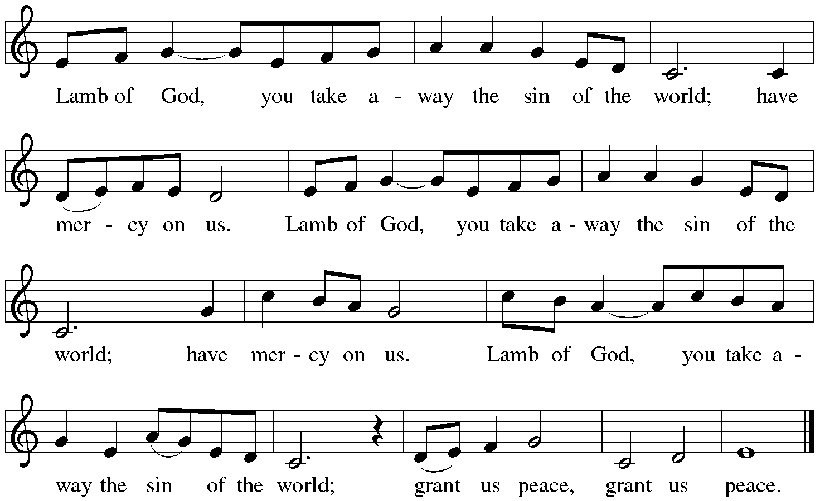

Distribution:

Communion Prayer

Announcements
Blessing
P The Lord bless you and keep you. The Lord make his face shine on you and be gracious to you. The Lord look upon you with favor and + give you peace.
In the name of the Father, and of the Son and of the Holy Spirit.
C Amen

Commitment Time

Liturgy and texts from Sundays and Seasons.com. Copyright 2021 Augsburg Fortress. All rights reserved.
Reprinted by permission under Augsburg Fortress Liturgies Annual License #23628.

