Faith Evangelical Lutheran Church, Washington, IL
Twentieth Sunday after Pentecost
October 10, 2021

Welcome
Confession and Forgiveness

P: In the name of the Father, and of the + Son, and of the Holy Spirit.
C: Amen.
You may make the sign of the cross as a reminder of your baptism.
P: Almighty God, to whom all hearts are open, all desires known, and from whom no secrets are hid: cleanse the thoughts of our hearts by the inspiration of your Holy Spirit, that we may perfectly love you and worthily magnify your holy name, through Jesus Christ our Lord.
C: Amen.
P: Let us confess our sin in the presence of God and of one another.
Please keep silence for reflection
P: Most merciful God,
C: we confess that we are captive to sin and cannot free ourselves. We have sinned against you in thought, word, and deed, by what we have done and by what we have left undone. We have not loved you with our whole heart; we have not loved our neighbors as ourselves. For the sake of your Son, Jesus Christ, have mercy on us. Forgive us, renew us, and lead us, so that we may delight in your will and walk in your ways, to the glory of your holy name. Amen.
P: In the mercy of almighty God, Jesus Christ was given to die for us, and for his sake God forgives us all our sins. As a called and ordained minister of the church of Christ, and by his authority, I therefore declare to you the entire forgiveness of all your sins, in the name of the Father, and of the + Son, and of the Holy Spirit.
C: Amen.
Faith Lutheran Church
2206 Washington Rd,
Washington, IL 61571
Website and online worship:
www.shareourfaith.org
Church: 309-745-9306
faithlth@shareourfaith.org
Pastor John Rothfusz
Home: 309-745-9282
pastor@shareourfaith.org

Peace: As forgiven children of God, we have peace
with God, and peace with one another.
P The peace of the Lord be with you always.
C And also with you.
P Let us share that peace with one another.

*Hymn: “As Saints of Old” Red Book #695

Text: Frank Von Christierson, 1900-1996, alt
Music: FOREST GREEN, English folk tune
Text © 1961, ren. 1989 The Hymn Society, admin. Hope Publishing Company, Carol Stream, IL 60188. All rights reserved. Used by permission. Reprinted under OneLicense.net#A-711151

P The grace of our Lord Jesus Christ, the love of God,
and the communion of the Holy Spirit be with you all.
C And also with you.

Hymn of Praise
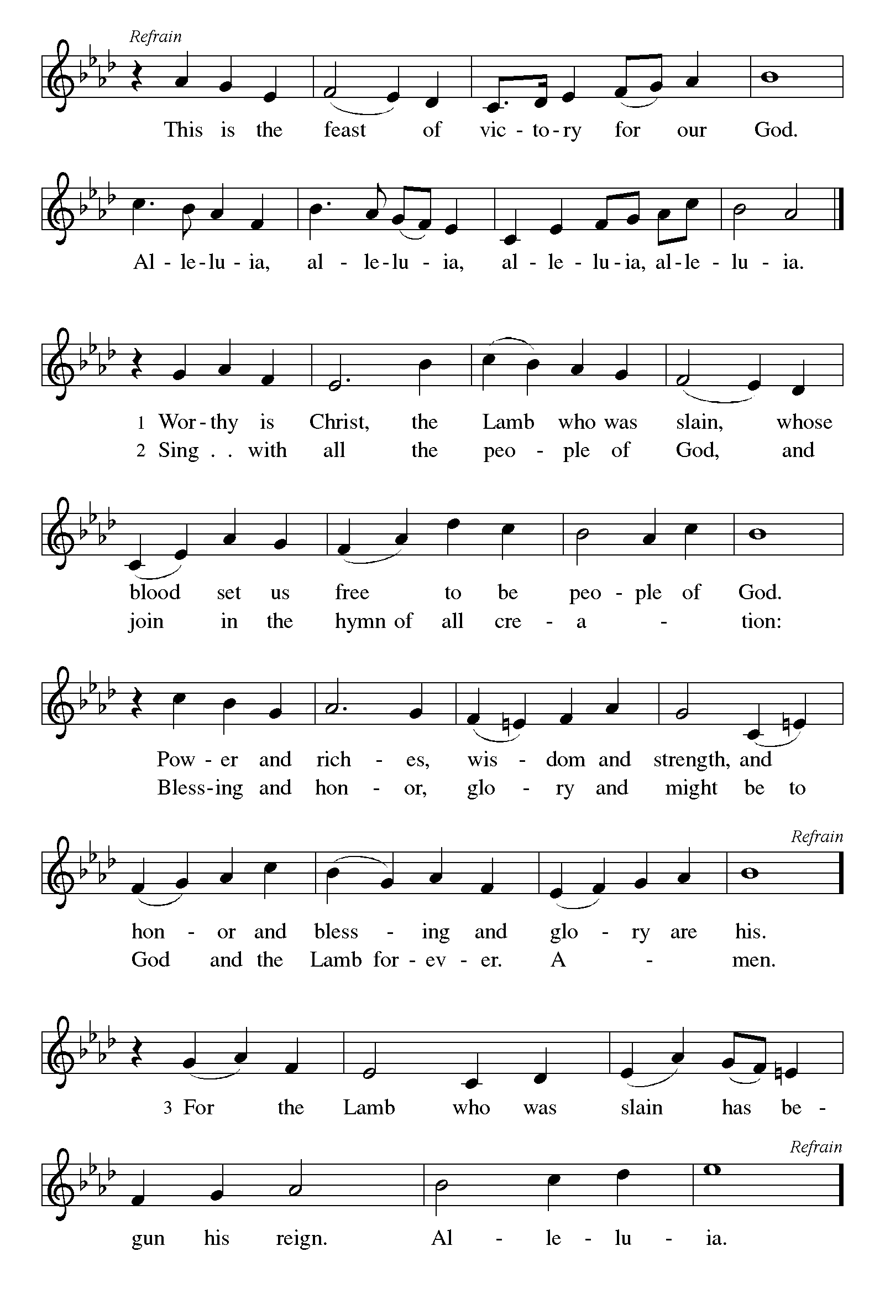

P The Lord be with you
C And also with you.
Let us pray together the Prayer of the Day
Almighty and ever-living God, increase in us your gift of faith, that, forsaking what lies behind and reaching out to what lies ahead, we may follow the way of your commandments and receive the crown of everlasting joy, through Jesus Christ, our Savior and Lord.
Amen.

Children’s Message

First Reading: Jonah 3:10-4:11 Pew Bible Page #745
¹⁰When God saw what they did, how they turned from their evil ways, God changed his mind about the calamity that he had said he would bring upon them; and he did not do it.
¹But this was very displeasing to Jonah, and he became angry. ²He prayed to the LORD and said, "O LORD! Is not this what I said while I was still in my own country? That is why I fled to Tarshish at the beginning; for I knew that you are a gracious God and merciful, slow to anger, and abounding in steadfast love, and ready to relent from punishing. ³And now, O LORD, please take my life from me, for it is better for me to die than to live." ⁴And the LORD said, "Is it right for you to be angry?" ⁵Then Jonah went out of the city and sat down east of the city, and made a booth for himself there. He sat under it in the shade, waiting to see what would become of the city. ⁶The Lord GOD appointed a bush, and made it come up over Jonah, to give shade over his head, to save him from his discomfort; so Jonah was very happy about the bush. ⁷But when dawn came up the next day, God appointed a worm that attacked the bush, so that it withered. ⁸When the sun rose, God prepared a sultry east wind, and the sun beat down on the head of Jonah so that he was faint and asked that he might die. He said, "It is better for me to die than to live." ⁹But God said to Jonah, "Is it right for you to be angry about the bush?" And he said, "Yes, angry enough to die." ¹⁰Then the LORD said, "You are concerned about the bush, for which you did not labor and which you did not grow; it came into being in a night and perished in a night. ¹¹And should I not be concerned about Nineveh, that great city, in which there are more than a hundred and twenty thousand persons who do not know their right hand from their left, and also many animals?"

R The Word of the Lord
C Thanks be to God

Gospel Reading: Matthew 20:1-15 Pew Bible Page # 795

C Glory to you, O Lord

¹For the kingdom of heaven is like a landowner who went out early in the morning to hire laborers for his vineyard. ²After agreeing with the laborers for the usual daily wage, he sent them into his vineyard. ³When he went out about nine o'clock, he saw others standing idle in the marketplace; ⁴and he said to them, 'You also go into the vineyard, and I will pay you whatever is right.' So they went. ⁵When he went out again about noon and about three o'clock, he did the same. ⁶And about five o'clock he went out and found others standing around; and he said to them, 'Why are you standing here idle all day?' ⁷They said to him, 'Because no one has hired us.' He said to them, 'You also go into the vineyard.' ⁸When evening came, the owner of the vineyard said to his manager, 'Call the laborers and give them their pay, beginning with the last and then going to the first.' ⁹When those hired about five o'clock came, each of them received the usual daily wage. ¹⁰Now when the first came, they thought they would receive more; but each of them also received the usual daily wage. ¹¹And when they received it, they grumbled against the landowner, ¹²saying, 'These last worked only one hour, and you have made them equal to us who have borne the burden of the day and the scorching heat.' ¹³But he replied to one of them, 'Friend, I am doing you no wrong; did you not agree with me for the usual daily wage? ¹⁴Take what belongs to you and go; I choose to give to this last the same as I give to you. ¹⁵Am I not allowed to do what I choose with what belongs to me? Or are you envious because I am generous?'

The Gospel of the Lord
C Praise to you, O Christ

Sermon by Pastor John Rothfusz

Sermon Hymn: “Lord of All Hopefulness” Red Book #765

Text: Jan Struther, 1901-1953
Music: SLANE, Irish traditional
Text © Oxford University Press 1931. Reprinted under OneLicense.net#A-711151

Blessing Prayer Shawls

Apostles’ Creed
C: I believe in God, the Father almighty,
creator of heaven and earth.
I believe in Jesus Christ, God's only Son, our Lord,
who was conceived by the Holy Spirit,
born of the virgin Mary,
suffered under Pontius Pilate,
was crucified, died, and was buried;
he descended to the dead.
On the third day he rose again;
he ascended into heaven,
he is seated at the right hand of the Father,
and he will come to judge the living and the dead.
I believe in the Holy Spirit,
the holy catholic church, the communion of saints,
the forgiveness of sins, the resurrection of the body,
and the life everlasting. Amen.

Prayers: After each portion of the prayers finishes with “Lord in your mercy,” please respond, “Hear our prayer.”

Offering: Jesus fills us with faith and sends us out as his witnesses. Let us commit ourselves to the Lord and joyfully lift our tithes and offerings to the Lord.

Please take a moment now to make an electronic offering to the church on the website, with the Tithe.ly app on your phone, or write a check and drop it in the plate at communion time.
Faith Lutheran website link www.shareourfaith.org

A Let us pray. Blessed are you, O God,
C maker of all things. Through your goodness you have blessed us with these gifts: our selves, our time, and our possessions. Use us, and what we have gathered, in feeding the world with your love, through the one who gave himself for us, Jesus Christ, our Savior and Lord. Amen.

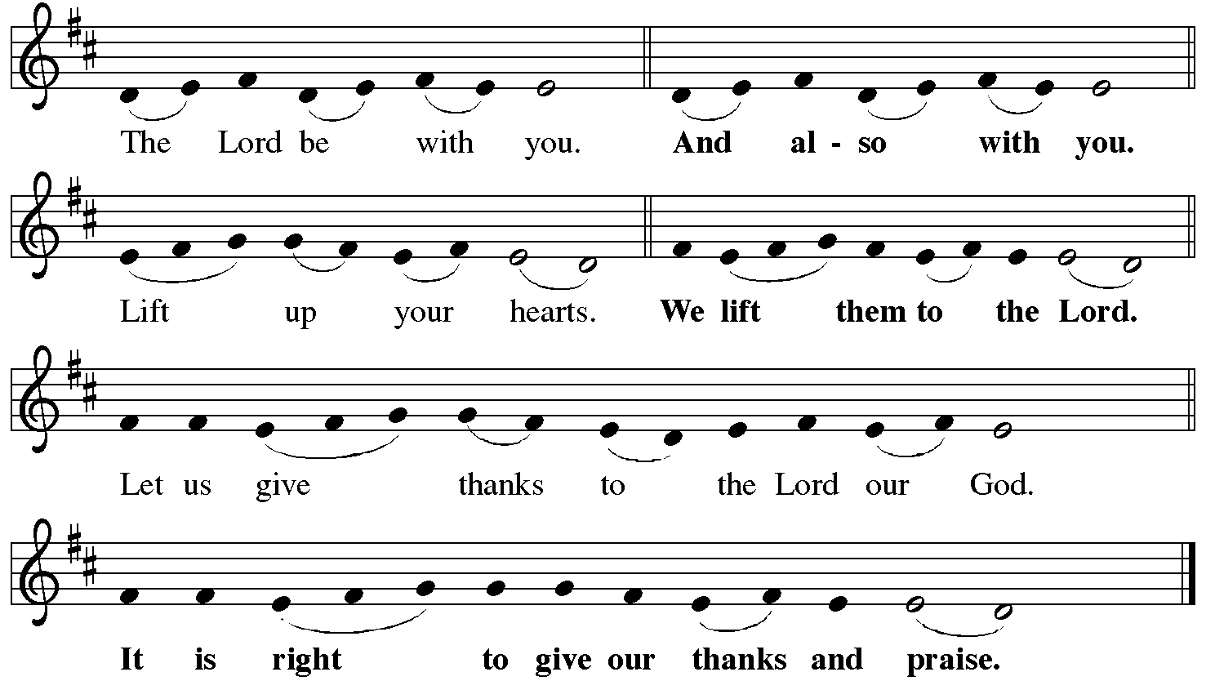
P It is indeed right, our duty and our joy… with the church on earth and the hosts of heaven, we praise your name and join their unending hymn:
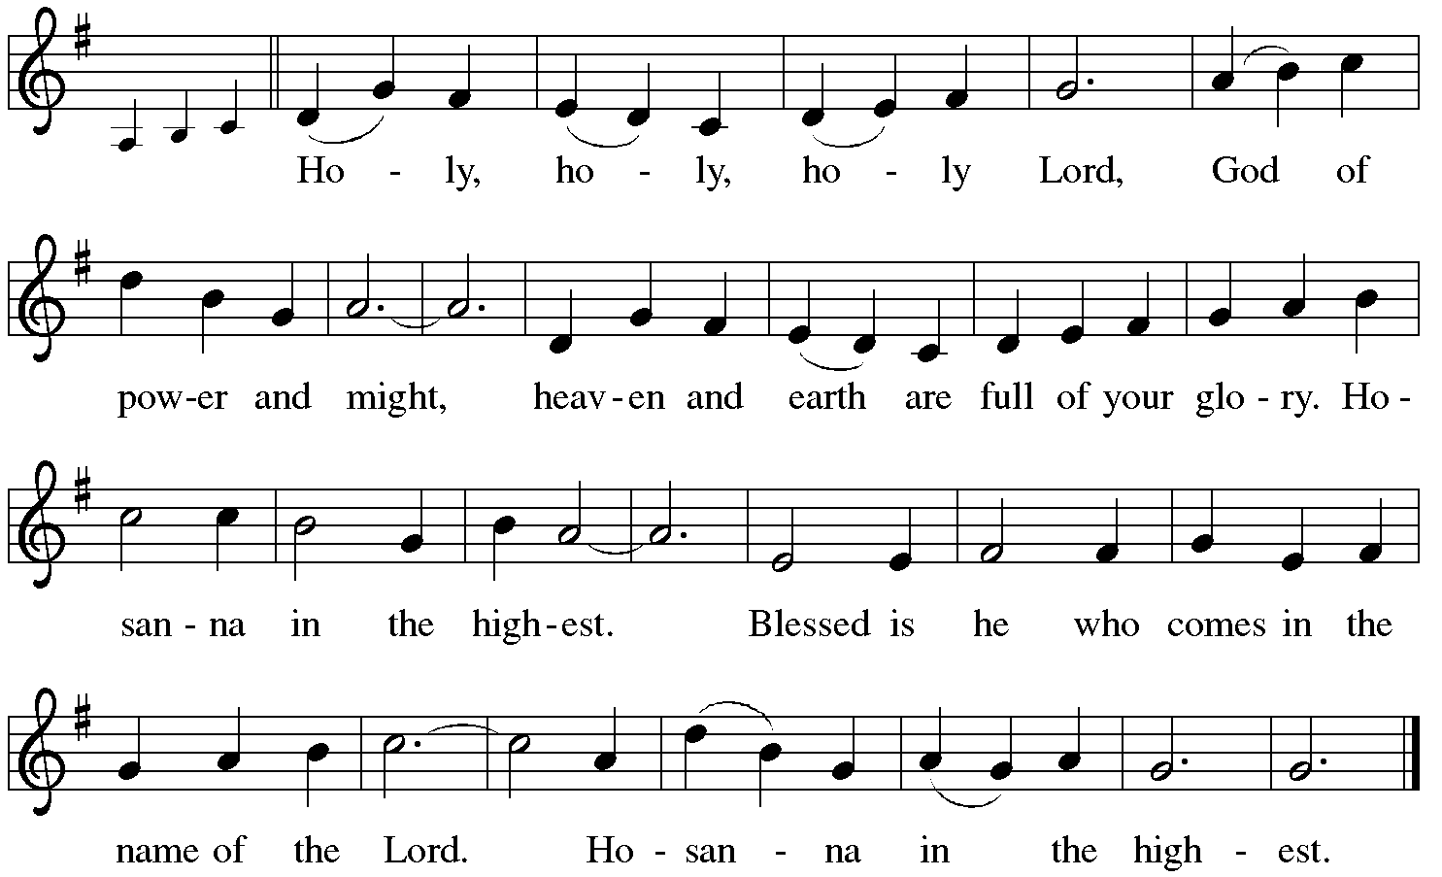

Holy Communion: Preface pp. 108-111 or other Eucharistic prayer

In the night in which he was betrayed,
our Lord Jesus took bread, and gave thanks;
broke it, and gave it to his disciples, saying:
Take and eat; this is my body, given for you.
Do this for the remembrance of me.
Again, after supper, he took the cup, gave thanks,
and gave it for all to drink, saying:
This cup is the new covenant in my blood,
shed for you and for all people for the forgiveness of sin.
Do this for the remembrance of me.
C The Lord's Prayer
Our Father, who art in heaven, hallowed be thy name,
thy kingdom come, thy will be done, on earth as it is in heaven.
Give us this day our daily bread; and forgive us our trespasses,
as we forgive those who trespass against us;
and lead us not into temptation, but deliver us from evil.
For thine is the kingdom, and the power, and the glory,
forever and ever. Amen
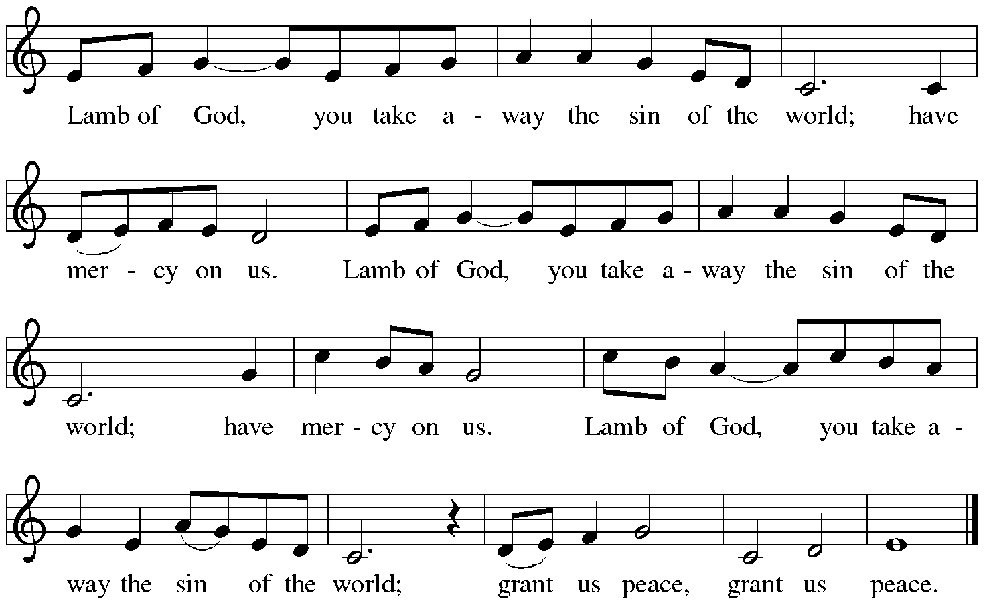

Distribution:

Communion Prayer

Announcements
Blessing
P The Lord bless you and keep you. The Lord make his face shine on you and be gracious to you. The Lord look upon you with favor and + give you peace.
In the name of the Father, and of the Son and of the Holy Spirit.
C Amen

Hymn: “Amazing Grace, How Sweet the Sound” Red Book # 779

Dismissal
A Go in peace. Serve the Lord.
C Thanks be to God!

Liturgy and texts from Sundays and Seasons.com. Copyright 2021 Augsburg Fortress. All rights reserved.
Reprinted by permission under Augsburg Fortress Liturgies Annual License #23628.

