Children’s Page

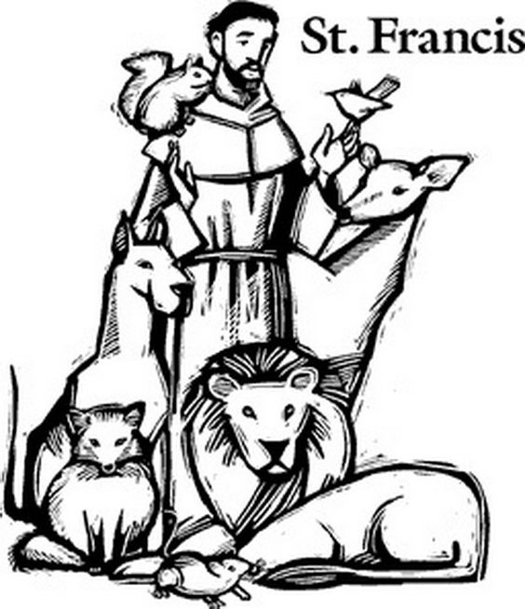
All creatures worship God most high,
lift up your voice in earth and sky,
alleluia, alleluia!
Thou burning sun with golden beam,
thou silver moon with softer gleam,
O sing ye, O sing ye, alleluia, alleluia, alleluia!
Evangelical Lutheran Worship # 835 verse 1

