Faith Evangelical Lutheran Church, Washington, IL
Nineteenth Sunday after Pentecost
October 3, 2021

Welcome
Confession and Forgiveness

P: In the name of the Father, and of the + Son, and of the Holy Spirit.
C: Amen.
You may make the sign of the cross as a reminder of your baptism.
P: Almighty God, to whom all hearts are open, all desires known, and from whom no secrets are hid: cleanse the thoughts of our hearts by the inspiration of your Holy Spirit, that we may perfectly love you and worthily magnify your holy name, through Jesus Christ our Lord.
C: Amen.
P: Let us confess our sin in the presence of God and of one another.
Please keep silence for reflection
P: Most merciful God,
C: we confess that we are captive to sin and cannot free ourselves. We have sinned against you in thought, word, and deed, by what we have done and by what we have left undone. We have not loved you with our whole heart; we have not loved our neighbors as ourselves. For the sake of your Son, Jesus Christ, have mercy on us. Forgive us, renew us, and lead us, so that we may delight in your will and walk in your ways, to the glory of your holy name. Amen.
P: In the mercy of almighty God, Jesus Christ was given to die for us, and for his sake God forgives us all our sins. As a called and ordained minister of the church of Christ, and by his authority, I therefore declare to you the entire forgiveness of all your sins, in the name of the Father, and of the + Son, and of the Holy Spirit.
C: Amen.
Faith Lutheran Church
2206 Washington Rd,
Washington, IL 61571
Website and online worship:
www.shareourfaith.org
Church: 309-745-9306
faithlth@shareourfaith.org
Pastor John Rothfusz
Home: 309-745-9282
pastor@shareourfaith.org

Peace: As forgiven children of God, we have peace
with God, and peace with one another.
P The peace of the Lord be with you always.
C And also with you.
P Let us share that peace with one another.

*Hymn: “My Life Flows On in Endless Song” Red Book #763
Public Domain

P The grace of our Lord Jesus Christ, the love of God,
and the communion of the Holy Spirit be with you all.
C And also with you.

Hymn of Praise
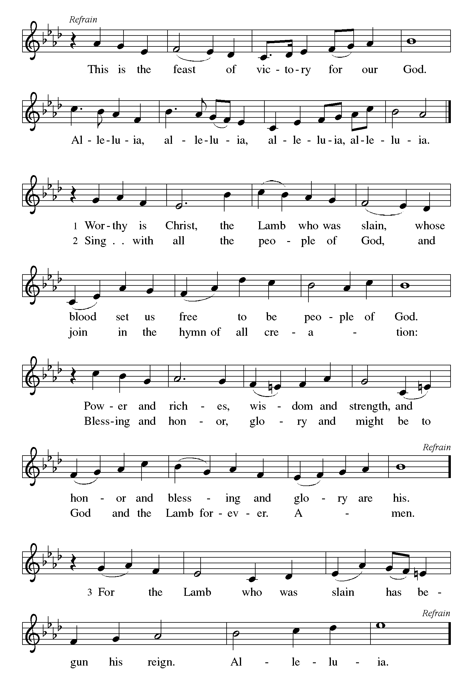

P The Lord be with you
C And also with you.
Let us pray together the Prayer of the Day
Sovereign God, you have created us to live in loving community with one another. Form us for life that is faithful and steadfast, and teach us to trust like little children, that we may reflect the image of your Son, Jesus Christ, our Savior and Lord. Amen.

Children’s Message

First Reading: Genesis 2:18-24 Pew Bible Page 2
¹⁸The Lord God said, “It is not good that the man should be alone; I will make him a helper as his partner.” ¹⁹So out of the ground the Lord God formed every animal of the field and every bird of the air, and brought them to the man to see what he would call them; and whatever the man called every living creature, that was its name. ²⁰The man gave names to all cattle, and to the birds of the air, and to every animal of the field; but for the man there was not found a helper as his partner. ²¹So the Lord God caused a deep sleep to fall upon the man, and he slept; then he took one of his ribs and closed up its place with flesh. ²²And the rib that the Lord God had taken from the man he made into a woman and brought her to the man. ²³Then the man said,
“This at last is bone of my bones
and flesh of my flesh;
this one shall be called Woman,
for out of Man this one was taken.”
²⁴Therefore a man leaves his father and his mother and clings to his wife, and they become one flesh.

R The Word of the Lord
C Thanks be to God

Gospel Reading: Mark 12:1-11 Pew Bible p. 819

C Glory to you, O Lord
¹Then he began to speak to them in parables. "A man planted a vineyard, put a fence around it, dug a pit for the wine press, and built a watchtower; then he leased it to tenants and went to another country. ²When the season came, he sent a slave to the tenants to collect from them his share of the produce of the vineyard. ³But they seized him, and beat him, and sent him away empty-handed. ⁴And again he sent another slave to them; this one they beat over the head and insulted. ⁵Then he sent another, and that one they killed. And so it was with many others; some they beat, and others they killed. ⁶He had still one other, a beloved son. Finally he sent him to them, saying, 'They will respect my son.' ⁷But those tenants said to one another, 'This is the heir; come, let us kill him, and the inheritance will be ours.' ⁸So they seized him, killed him, and threw him out of the vineyard. ⁹What then will the owner of the vineyard do? He will come and destroy the tenants and give the vineyard to others. ¹⁰Have you not read this scripture:
'The stone that the builders rejected has become the keystone;
¹¹this was the Lord's doing, and it is amazing in our eyes'?"

The Gospel of the Lord
C Praise to you, O Christ
Sermon by Pastor John Rothfusz
Sermon Hymn: “Sing to the Lord of Harvest” Red Book #694

Public Domain

Apostles’ Creed
C: I believe in God, the Father almighty,
creator of heaven and earth.
I believe in Jesus Christ, God's only Son, our Lord,
who was conceived by the Holy Spirit,
born of the virgin Mary,
suffered under Pontius Pilate,
was crucified, died, and was buried;
he descended to the dead.
On the third day he rose again;
he ascended into heaven,
he is seated at the right hand of the Father,
and he will come to judge the living and the dead.
I believe in the Holy Spirit,
the holy catholic church, the communion of saints,
the forgiveness of sins, the resurrection of the body,
and the life everlasting. Amen.

Prayers: After each portion of the prayers finishes with “Lord in your mercy,” please respond, “Hear our prayer.”

Offering: Jesus fills us with faith and sends us out as his witnesses. Let us commit ourselves to the Lord and joyfully lift our tithes and offerings to the Lord.

Please take a moment now to make an electronic offering to the church on the website, with the Tithe.ly app on your phone, or write a check and drop it in the plate at communion time.
Faith Lutheran website link www.shareourfaith.org

A Let us pray. Blessed are you, O God,
C maker of all things. Through your goodness you have blessed us with these gifts: our selves, our time, and our possessions. Use us, and what we have gathered, in feeling the world with your love, through the one who gave himself for us, Jesus Christ, our Savior and Lord. Amen.

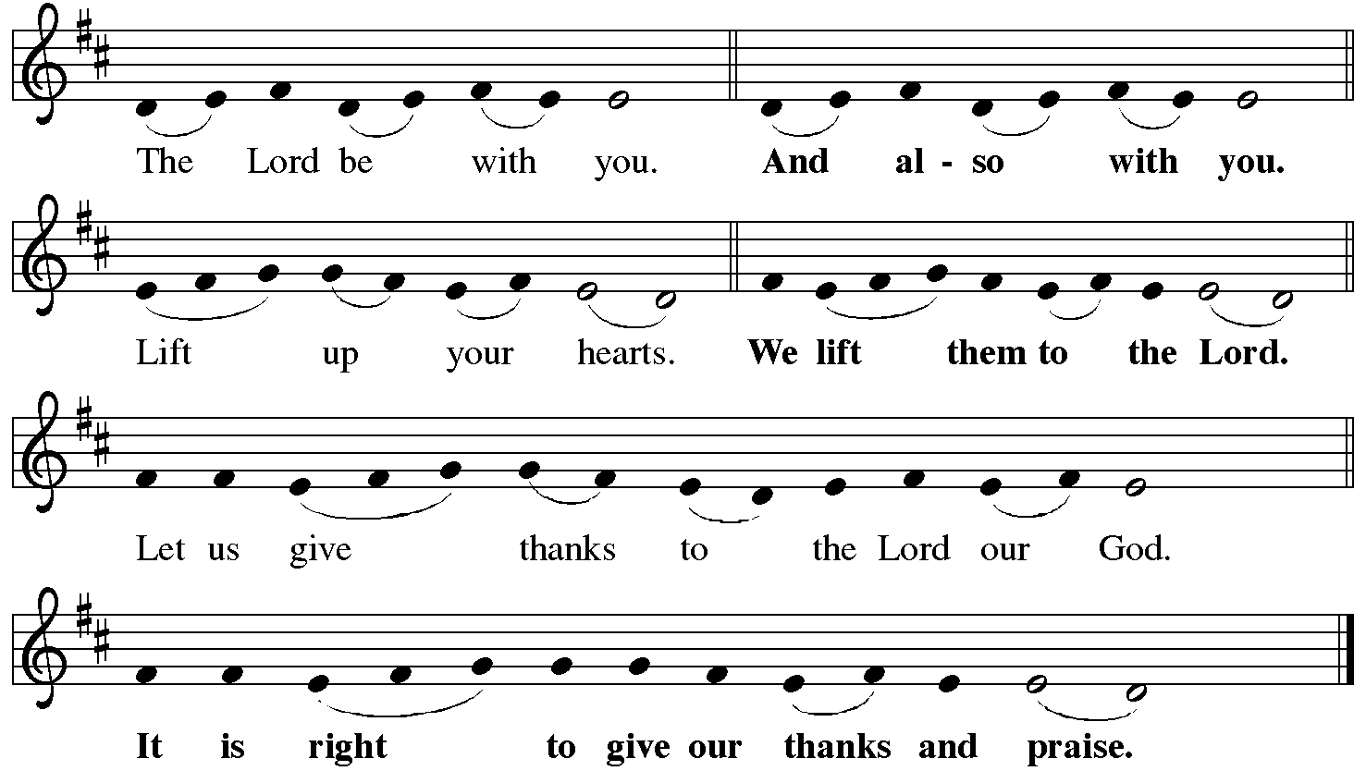
P It is indeed right, our duty and our joy… with the church on earth and the hosts of heaven, we praise your name and join their unending hymn:
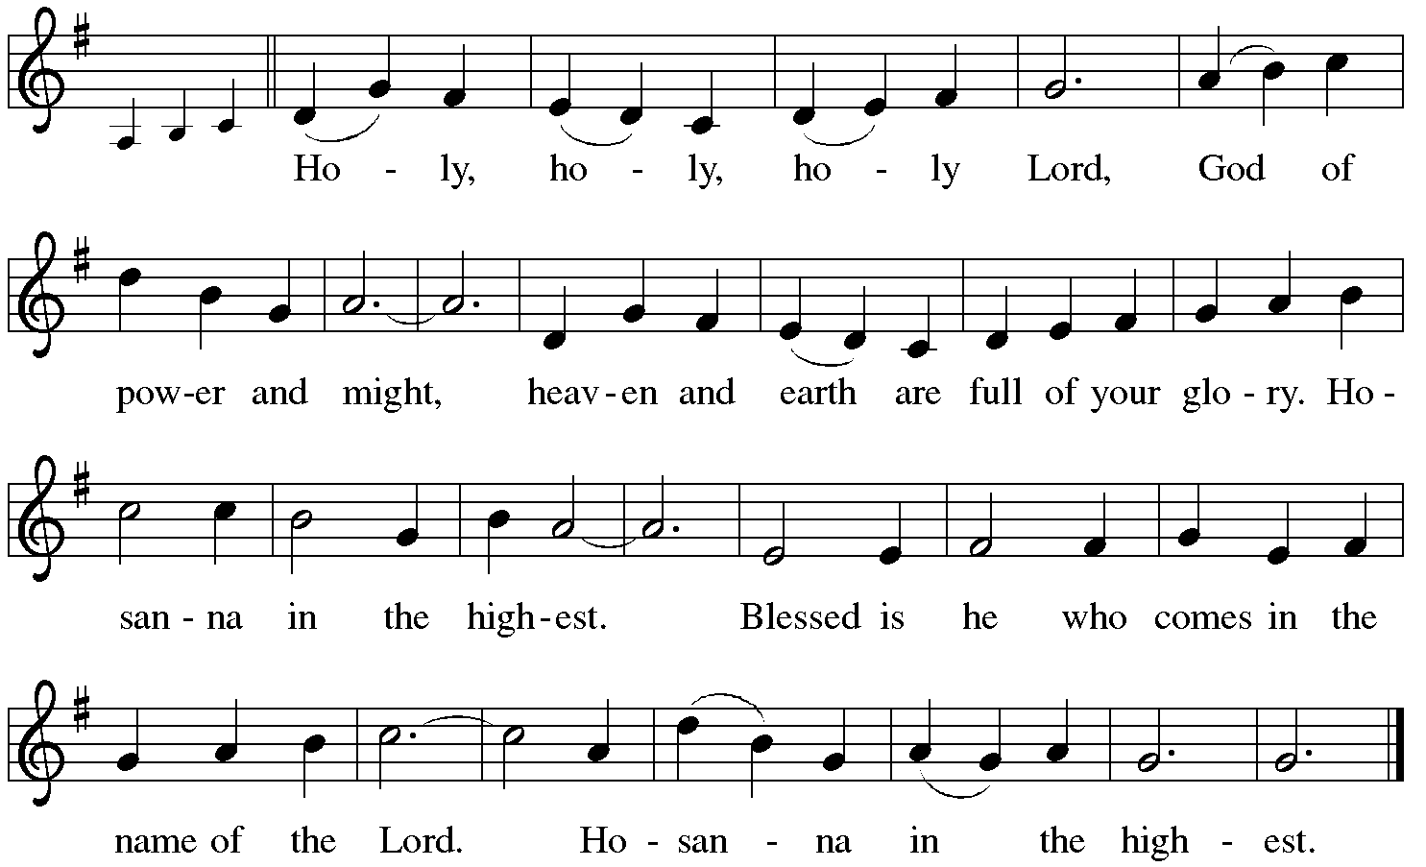

Holy Communion: Preface pp. 108-111 or other Eucharistic prayer

In the night in which he was betrayed,
our Lord Jesus took bread, and gave thanks;
broke it, and gave it to his disciples, saying:
Take and eat; this is my body, given for you.
Do this for the remembrance of me.
Again, after supper, he took the cup, gave thanks,
and gave it for all to drink, saying:
This cup is the new covenant in my blood,
shed for you and for all people for the forgiveness of sin.
Do this for the remembrance of me.
C The Lord's Prayer
Our Father, who art in heaven, hallowed be thy name,
thy kingdom come, thy will be done, on earth as it is in heaven.
Give us this day our daily bread; and forgive us our trespasses,
as we forgive those who trespass against us;
and lead us not into temptation, but deliver us from evil.
For thine is the kingdom, and the power, and the glory,
forever and ever. Amen
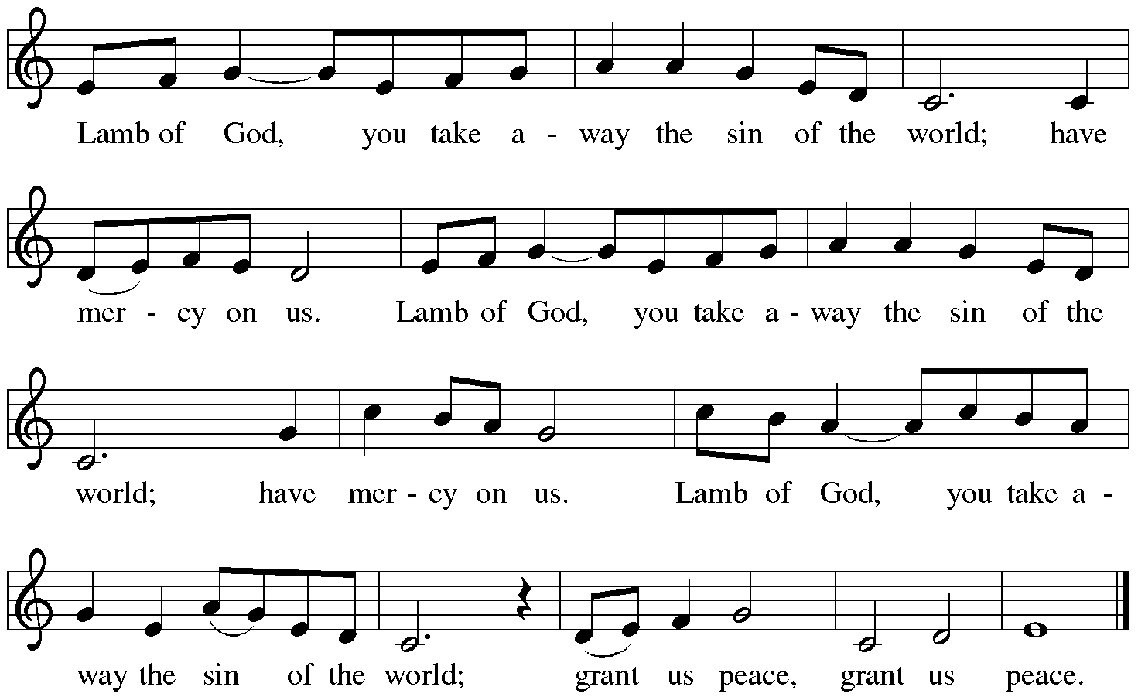

Distribution:

Communion Prayer

Announcements
Blessing
P The Lord bless you and keep you. The Lord make his face shine on you and be gracious to you. The Lord look upon you with favor and + give you peace.
In the name of the Father, and of the Son and of the Holy Spirit.
C Amen

Hymn: “For the Fruit of All Creation” Red Book # 679

Dismissal
A Go in peace. Serve the Lord.
C Thanks be to God!

Liturgy and texts from Sundays and Seasons.com. Copyright 2021 Augsburg Fortress. All rights reserved.
Reprinted by permission under Augsburg Fortress Liturgies Annual License #23628.

