All Saints Anglican Church, Agassiz
6904 Lougheed Highway, BC, V0M 1A0

Bulletin September 13 – September 19, 2021
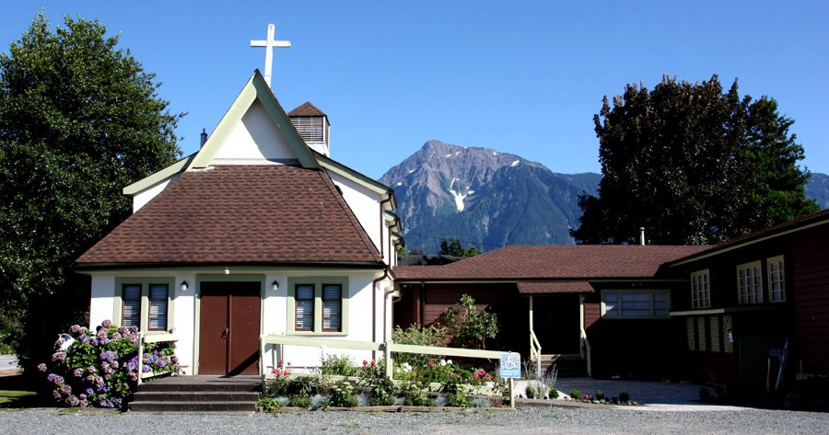

Situated on unceded Sto:lo traditional territory

Phone: 604-796-3553
Website: www.allsaints-agassiz.ca
https://www.facebook.com/groups/AllSaintsFamily

OUR DOOR IS OPEN AND ALL ARE WELCOME
19th September
Holy Eucharist
(17th Sunday after Pentecost)

Priest-in-Charge: The Reverend Philip Barker
Hosts: Graham Featherstone, Fred Watson
Intercessor: Lynn Laughlin
Lay Administrator – Gail Thompson
Announcer: Ginny Jennings
Piano – Fran Froehlich

PLEASE NOTE:

Zoom service will still be available and a link sent out around 09:45 by Graham. Email him at gfeatherstone@shaw.ca if you don’t think you’re on his list.
Vicar’s cell phone: Rev’d Philip Barker. 778-867-2461
Vicar’s Warden: Ginny Jennings. 604-796-2206
People’s Warden: Lynn Laughlin. 604-799-5131
Parish email: www.allsaints-agassiz.ca
Please contact either if you have an issue that needs to be brought to the attention of the Vicar - or contact the Vicar direct (see above for details).

WARDENS’ PITCH
-Wednesday Book Club is at 1600 (4.00 pm) for approximately an hour. We are studying ‘Jesus before Christianity’ by Albert Nolan. Please contact Fred Watson (fredeward@shaw.ca) for Zoom link.
-Evening Prayer with Valerie Hamilton is at 1900 (7.00 pm) on Sunday, Wednesday, and Friday, and can be found on our webpage.
-Those interested in helping with car-pooling on a Sunday morning to help folks get to church, please contact Lynn.
-Prayer requests can be given on a piece of paper to either of the Wardens or the Vicar, or entered into the Prayer Request Book on the piano in the church.
-Requests for hymns and other pieces of music that might enhance our worship are invited. Again, requests either to the Wardens or Vicar.
-Any jokes that are not too risqué are invited for inclusion in the Bulletin to add a little humour to our mix.
-Likewise, any parishioners that have items they wish to dispose of may advertise them in the Bulletin. Please do not price any items, but give a contact number or email address, so that negotiation is not done through this publication.
-Bible study is cancelled until further notice. Updates will be posted when available.
-We have not received any further offers to fill our coffee roster, so some Sundays will be coffee and tea only and maybe a cookie (if we haven’t eaten them all during the week). We appreciate that coffee hosts pay for the food they provide themselves, and what they bring is a donation to all of us. If you have any dietary sensitivities or needs, please bring what you need and we can keep your items in the freezer with your name attached, so that you have what you need each week. If you decide to sign up to host, please let Anthea, Ginny or Lynn know.

Ministerial Meandering 13 September – September 19, 2021

‘The appropriate use of worms’.
Yesterday I sent off a Ministerial Meandering, and barely before the ink had dried on the page, Sheila pounced on it and told me that I couldn’t send it. I was, apparently, using words in an ‘inappropriate’ way.

When our girls were still small I used to tease them about getting their ‘worms’ right - by which I meant ‘words’, of course - but they enjoyed the joke. And it seems as though I still have a problem. I won’t tell you what I was writing about as it is not relevant to what I am writing now, but just tell you that I am amazed at how our use of words changes so fast, and the meanings we attribute to them.

(As an aside, I should mention that my Meanderings will not always have a theological aspect to them, as, despite what you may think, I do not spend all my day in ‘higher thoughts’ - even if you think I should!)

The words that slide so easily off our tongues today contain a significantly different vocabulary than we used 50 or 60 years ago. Everyday words like ‘computer’ and ‘email’ and ‘website’ - and even ‘cellphone’, were unheard of in the 1960’s. My father stopped joining in with the technological advances at about the time that the first cellphone was introduced in April, 1973. At that time it was an enormous piece of kit, and you needed arms like Arnie Schwartznegger to be able to lift it. If you tried to talk to my Dad about emails and so on, he would respond with, “What’s wrong with writing a letter?” He died stubbornly ignorant of so many advances that could have improved his life.

Now we have to be so careful of how we use our ‘worms’. It is so easy to be ‘inappropriate’ without meaning to be. When I was young, the word ‘gay’ meant ‘happy’, and the word ‘queer’ meant ‘strange’ or ‘peculiar’. To take your dogs for a walk with a friend and his or her dogs would be to go ‘dogging’, to me - but now, to go ‘dogging’ means…well, I’ll let you find out for yourselves, but it’s not an activity I would engage in!

The word, ‘appropriate’ itself is fraught with hidden meaning too - as I found out yesterday. I had thought it meant, ‘fitting’, ‘proper’, ‘in line with’, ‘apposite’; I was aware that it could also be used as a verb, ‘to appropriate something’ would be to take possession of something, sometimes without permission of the owner.
But now I find that it has a political meaning or overtone if prefaced by the word, ‘cultural’. Now we are dealing with linguistic dynamite. ‘Cultural appropriation’ is a rather nasty animal and is defined as ‘the unacknowledged or inappropriate adoption of an element or elements of one culture or identity by members of another culture or identity. This can be controversial when members of a dominant culture appropriate from minority cultures.’

And, of course, this is where we can get into difficulty. In South Africa, to wear a Madiba shirt or Zulu beads, or to use Zulu expressions in one’s speech would not be seen as ‘cultural appropriation’, but more as ‘cultural appreciation’ - the black Africans being far numerically superior to the white races. However, here, because of the fewer Indigenous numbers in Canada, use of such practices are seen as derogatory and insulting. How very careful we have to be, despite our best intentions! Let no-one be in any doubt here - we are treading on egg-shells, and unfortunately not ostrich eggs, which you can stand on without them breaking.

In our current political climate (which some might argue has become a little over-sensitive) we must learn to avoid expressions of speech and language that have any hint of cultural appropriation - even if you meant it as cultural appreciation. This trend will pass, however, just as the term ‘jerrycan’ is no longer pejorative for the fuel container made for the German military in the 1930’s.

Just be very careful if you want to invite your friend to walk your dogs together, or - possibly worse - intend to go viewing a few cottages.

Philip

Chuckles
No clean jokes for today so we have a quote
“God gives us relatives; thank God, we can choose our friends.” Addison Mizner

Birthdays

September 17th is Sonja Hill’s Birthday

Sunday Cycle of Prayer

Seventeenth after Pentecost (September 19, 2021)
St. Mathew, Abbotsford – The Reverend Allen Doerksen
Christ Church, Hope – The Reverend Timothy Morgan

Monthly Cycle of Prayer

Holy Trinity Cathedral – The Venerable Richard Leggett
New Westminster The Reverend Carole Neilsen
The Reverend Tasha Carrothers
St. Barnabas, New Westminster - The Reverend Emile Smith
St. Mary the Virgin, Sapperton – The Reverend Arvin Amayag

Anglican Cycle of Prayer

Our Primate, Archbishop Linda Nicholls. For National Indigenous Archbishop, Mark MacDonald, & for the Anglican Council of Indigenous People. We also pray for the Missioner for Indigenous Justice, Kerry Baisley.
In our parish we pray for our priest, Philip, retired priests Mike, Jack, Bryson and Paul.

Collect for 19th September 2021

Almighty God, you have created the heavens and the earth, and ourselves in your image. Teach us to discern your hand in all your works and to serve you with reverence and thanksgiving; through Jesus Christ our Lord, who is alive and reigns with you and the Holy Spirit, one God, now and for ever.

Proverbs 31: 10-31 Hilary Routley

Introduction: The book of Proverbs ends with a poem about a capable wife. Many of the qualities are those of wisdom herself, so this is also a summary of the book.
Reading: A capable wife who can find? She is far more precious than jewels.
The heart of her husband trusts in her, and he will have no lack of gain.
She does him good, and not harm, all the days of her life.
She seeks wool and flax, and works with willing hands.
She is like the ships of the merchant, she brings her food from far away.
She rises while it is still night and provides food for her household and tasks for her servant girls.
She considers a field and buys it; with the fruit of her hands she plants a vineyard.
She girds herself with strength, and makes her arms strong.
She perceives that her merchandise is profitable. Her lamp does not go out at night.
She puts her hands to the distaff, and her hands hold the spindle.
She opens her hand to the poor, and reaches out her hands to the needy.
She is not afraid for her household when it snows, for all her household are clothed in crimson.
She makes herself coverings; her clothing is fine linen and purple.
Her husband is known in the city gates, taking his seat among the elders of the land.
She makes linen garments and sells them; she supplies the merchant with sashes.
Strength and dignity are her clothing, and she laughs at the time to come.
She opens her mouth with wisdom, and the teaching of kindness is on her tongue.
She looks well to the ways of her household, and does not eat the bread of idleness.
Her children rise up and call her happy; her husband too, and he praises her:
"Many women have done excellently, but you surpass them all."
Charm is deceitful, and beauty is vain, but a woman who fears the LORD is to be praised.
Give her a share in the fruit of her hands, and let her works praise her in the city gates.

Psalm 1

Happy are those who do not follow the advice of the wicked, or take the path that sinners tread, or sit in the seat of scoffers;
but their delight is in the law of the LORD, and on his law they meditate day and night.
They are like trees planted by streams of water, which yield their fruit in its season, and their leaves do not wither. In all that they do, they prosper.
The wicked are not so, but are like chaff that the wind drives away.
Therefore the wicked will not stand in the judgment, nor sinners in the congregation of the righteous;
for the LORD watches over the way of the righteous, but the way of the wicked will perish.

James 3: 13-4:3,7-8a Lynn Laughlin

Introduction: According to the author, a sin commonly found in the community is intemperate speech. Another common sin is arrogance. Avoiding arrogance requires shunning earthly wisdom and praying for godly wisdom.
Reading: Who is wise and understanding among you? Show by your good life that your works are done with gentleness born of wisdom.
But if you have bitter envy and selfish ambition in your hearts, do not be boastful and false to the truth.
Such wisdom does not come down from above, but is earthly, unspiritual, devilish.
For where there is envy and selfish ambition, there will also be disorder and wickedness of every kind.
But the wisdom from above is first pure, then peaceable, gentle, willing to yield, full of mercy and good fruits, without a trace of partiality or hypocrisy.
And a harvest of righteousness is sown in peace for those who make peace.
Those conflicts and disputes among you, where do they come from? Do they not come from your cravings that are at war within you?
You want something and do not have it; so you commit murder. And you covet something and cannot obtain it; so you engage in disputes and conflicts. You do not have, because you do not ask.
You ask and do not receive, because you ask wrongly, in order to spend what you get on your pleasures.
Submit yourselves therefore to God. Resist the devil, and he will flee from you.
Draw near to God, and he will draw near to you.

The Gospel - Mark 9:30-37

Introduction: Jesus has told the disciples something they find hard to accept: he, the Son of Man, the Messiah, will suffer. Now he adds that he is to be betrayed and handed over to people who will treat him harshly.
Reading: They went on from there and passed through Galilee. He did not want anyone to know it;
for he was teaching his disciples, saying to them, "The Son of Man is to be betrayed into human hands, and they will kill him, and three days after being killed, he will rise again."
But they did not understand what he was saying and were afraid to ask him.
Then they came to Capernaum; and when he was in the house he asked them, "What were you arguing about on the way?"
But they were silent, for on the way they had argued with one another who was the greatest.
He sat down, called the twelve, and said to them, "Whoever wants to be first must be last of all and servant of all."
Then he took a little child and put it among them; and taking it in his arms, he said to them,
"Whoever welcomes one such child in my name welcomes me, and whoever welcomes me welcomes not me but the one who sent me."

