Faith Evangelical Lutheran Church, Washington, IL
Sixteenth Sunday after Pentecost – Baptismal Anniversary
September 12, 2021

Prelude
Welcome
Remembering our Baptism
We believe that our baptism is the most important day of our lives, because on that day God called us each by name and claimed us as his own forever. The Lord adopts us into his family, and makes us a part of the Body of Christ in the church.
So it is good and important to remember and celebrate that day when our baptism happened. We gather in baptism dates, to try to recognize each of our members.
Today we are recognizing those whom we know were baptized in the first four months of the year. I will read the names of those who are listed with a baptismal anniversary from May through August, so we can recognize them today.
Whenever you give thanks for your baptism, you can dip your finger in water and make the sign of the cross on your forehead as a remembrance of your baptism. We invite each of you to return to the baptismal font and mark that cross for yourself.
You can also light a candle to celebrate the light of faith. We give a lighted candle to each person as they are baptized, saying, “Let your light so shine before others that they may see your good works and give glory to your Father in heaven.”
A reading from Galatians: “In Christ Jesus you are all children of God through faith. As many of you as were baptized into Christ have clothed yourselves with Christ. There is no longer Jew or Greek, there is no longer slave or free, there is no longer male or female; for all of you are one in Christ Jesus.”
When you were baptized you were claimed by God, and marked with the cross of Christ forever. You can remember your baptism with thanksgiving and joy.
Today we affirm that baptism and its ongoing power in our lives. Baptism makes us children of God and followers of Jesus as long as we live and in heaven forever.
Together with all the people of God, I ask you to profess your faith in Christ Jesus, reject sin, and confess the faith of the church.
Faith Lutheran Church
2206 Washington Rd,
Washington, IL 61571
Website and online worship:
www.shareourfaith.org
Church: 309-745-9306
faithlth@shareourfaith.org
Pastor John Rothfusz
Home: 309-745-9282
pastor@shareourfaith.org
Do you renounce the devil and all the forces that defy
God, the powers of this world that rebel against God,
and the ways of sin that draw you from God?

Response:
I renounce them.
Do you believe in God the Father?
I believe in God, the Father almighty,
creator of heaven and earth.
Do you believe in Jesus Christ, the Son of God?
I believe in Jesus Christ, God’s only Son, our Lord,
who was conceived by the Holy Spirit,
born of the virgin Mary,
suffered under Pontius Pilate,
was crucified, died, and was buried;
he descended to the dead.*
On the third day he rose again; he ascended into heaven,
he is seated at the right hand of the Father,
and he will come to judge the living and the dead.
Do you believe in God the Holy Spirit?
I believe in the Holy Spirit,
the holy catholic church, the communion of saints,
the forgiveness of sins, the resurrection of the body,
and the life everlasting.
You have made public profession of your faith. Do you intend to continue in the covenant God made with you in holy baptism:
to live among God’s faithful people,
to hear the word of God and share in the Lord’s supper,
to proclaim the good news of God in Christ through word and deed,
to serve all people, following the example of Jesus,
and to strive for justice and peace in all the earth?
The group makes affirmation:
I do, and I ask God to help and guide me.
The minister addresses the assembly.
I ask all the people of God, do you promise to support and pray for these baptized and for one another in your life in Christ?
We do, and we ask God to help and guide us.
The presiding minister prays for God’s blessing.
Let us pray. Gracious God we thank you for the new life you give us through Holy Baptism. Bless each person here as they mark the anniversary of their baptism. We give you thanks, that through water and the Holy Spirit you give us new birth, cleanse us from sin, and raise us to eternal life. Stir up in all your people the gift of your Holy Spirit: the spirit of wisdom and understanding, the spirit of counsel and might, the spirit of knowledge and the fear of the Lord, the spirit of joy in your presence both now and forever. Make us faithful to follow you as long as we live. In Jesus’ name we pray. Amen.
May you live in God’s peace and follow Jesus as you live out your baptism. The Peace of the Lord be with you always.
C And also with you
Let us share that peace with one another.
*Hymn: “Lord Jesus, You Shall Be My Song” Red Book # 808

Text: Les Petites Soeurs de Jésus and L’Arche Community; tr. Stephen Somerville, b. 1931
Music: LES PETITES SOEURS, Les Petites Soeurs de Jésus and L’Arche Community
Text and music © 1987 Les Petites Soeurs de Jésus Tr. © 1970 Stephen Somerville
Reprinted under OneLicense.net#A-711151

P The grace of our Lord Jesus Christ, the love of God,
and the communion of the Holy Spirit be with you all.
C And also with you.

Hymn of Praise
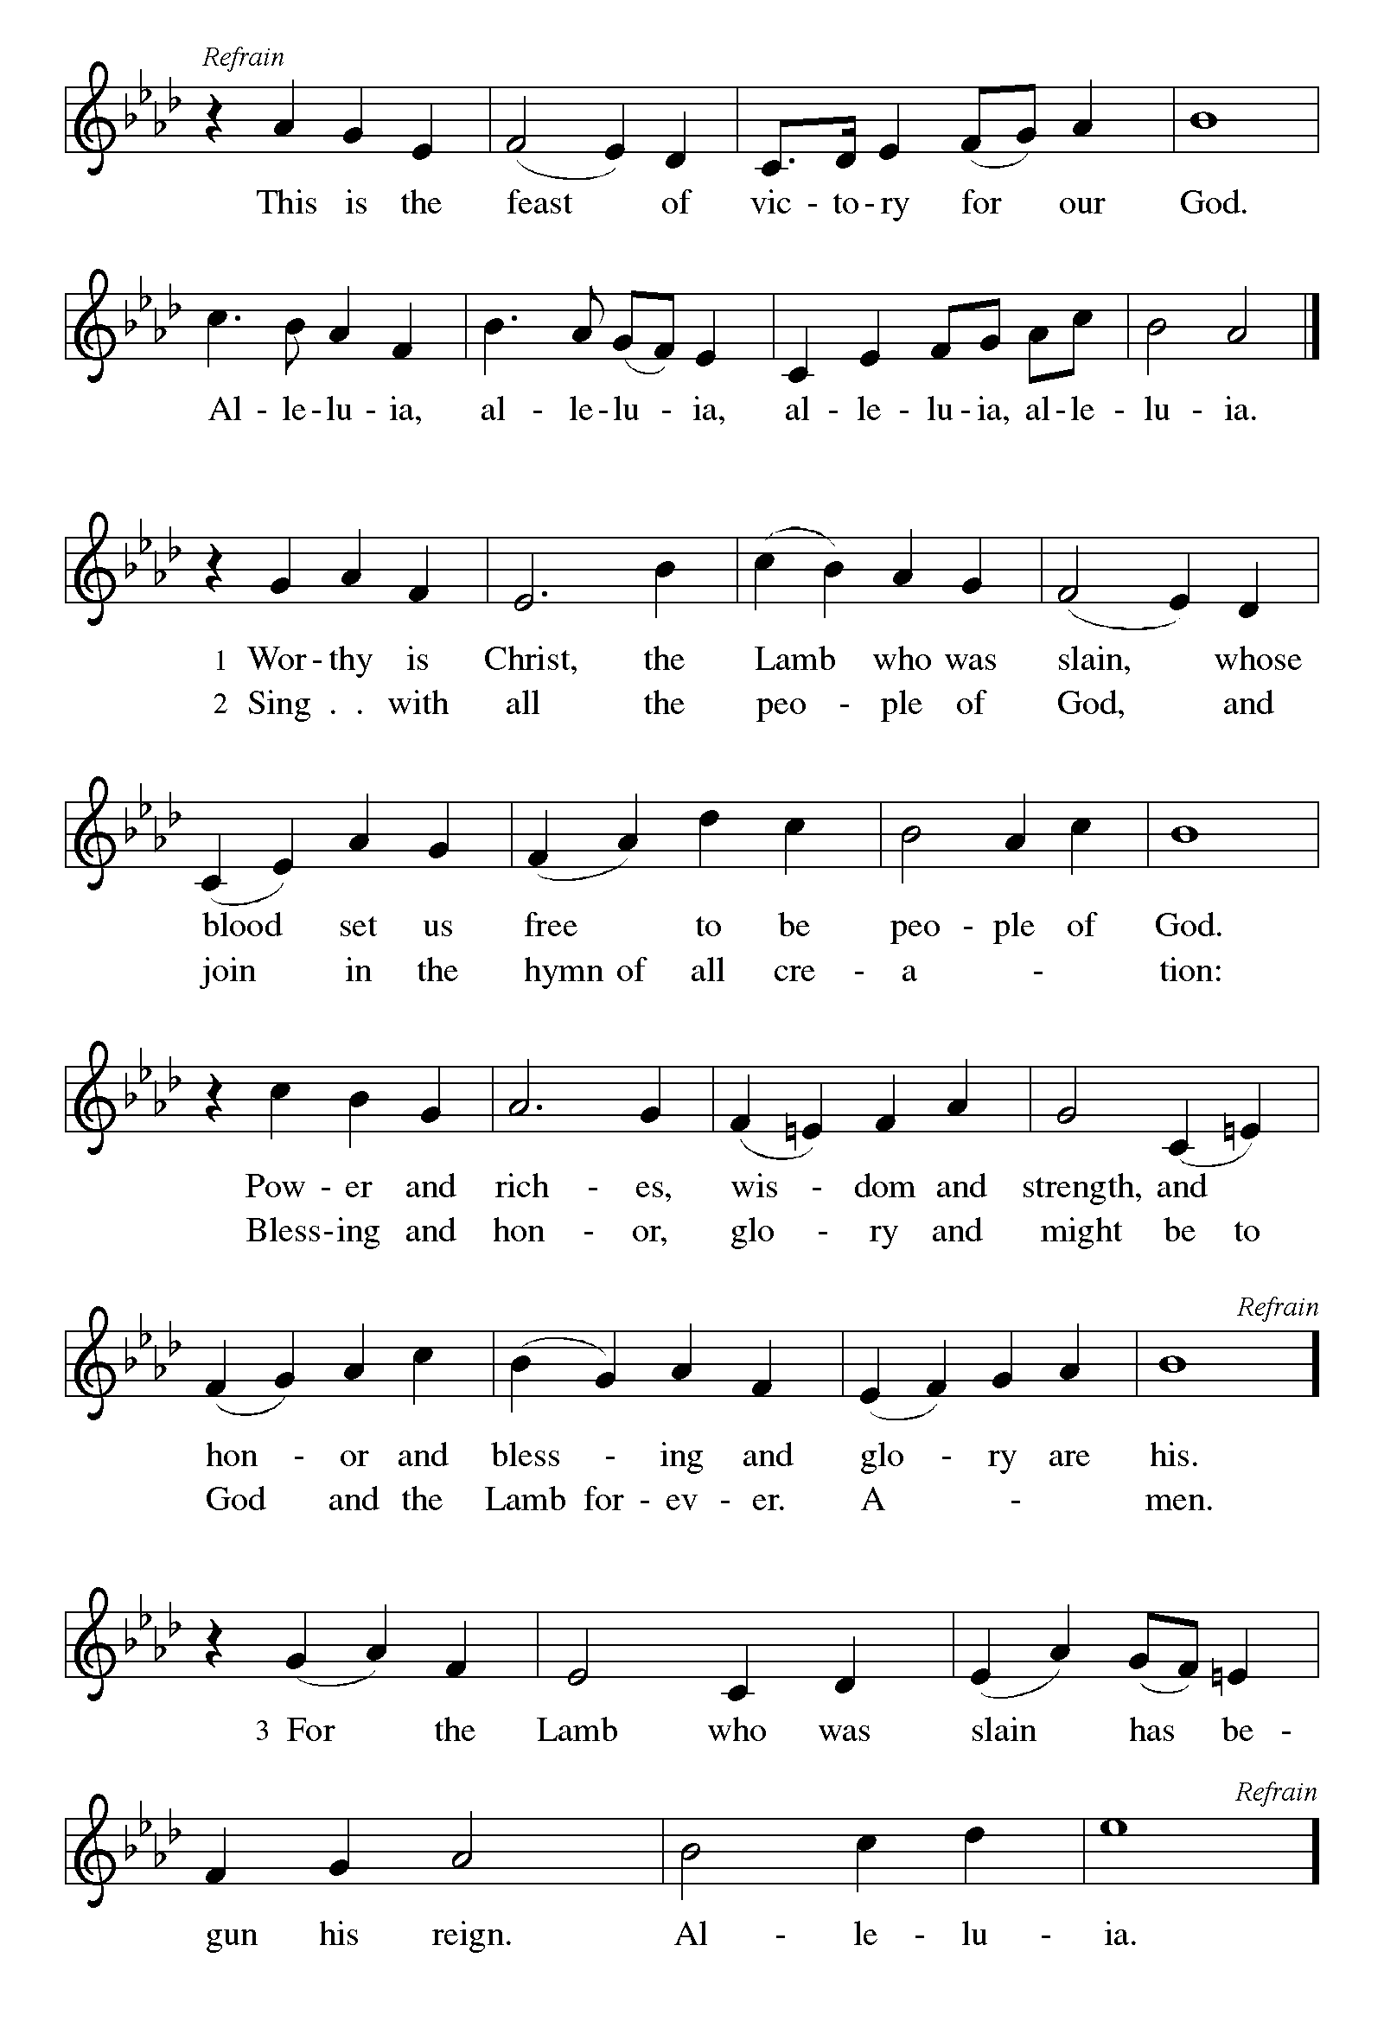

P The Lord be with you
C And also with you.
Let us pray together the Prayer of the Day
O God, through suffering and rejection you bring forth our salvation, and by the glory of the cross you transform our lives. Grant that for the sake of the gospel we may turn from the lure of evil, take up our cross, and follow your Son, Jesus Christ, our Savior and Lord.
Amen.

Children’s Message

First Reading: Isaiah 50:4-9a Pew Bible p. 588
⁴The Lord God has given me the tongue of a teacher, that I may know how to sustain the weary with a word. Morning by morning he wakens—wakens my ear
to listen as those who are taught. ⁵The Lord God has opened my ear, and I was not rebellious, I did not turn backward. ⁶I gave my back to those who struck me, and my cheeks to those who pulled out the beard; I did not hide my face from insult and spitting.
⁷The Lord God helps me; therefore I have not been disgraced; therefore I have set my face like flint, and I know that I shall not be put to shame; ⁸he who vindicates me is near. Who will contend with me? Let us stand up together. Who are my adversaries? Let them confront me. ^{9a}It is the Lord God who helps me;
who will declare me guilty?

R The Word of the Lord
C Thanks be to God

Second Reading: James 3:1-12 Pew Bible p. 984
¹Not many of you should become teachers, my brothers and sisters, for you know that we who teach will be judged with greater strictness. ²For all of us make many mistakes. Anyone who makes no mistakes in speaking is perfect, able to keep the whole body in check with a bridle. ³If we put bits into the mouths of horses to make them obey us, we guide their whole bodies. ⁴Or look at ships: though they are so large that it takes strong winds to drive them, yet they are guided by a very small rudder wherever the will of the pilot directs. ⁵So also the tongue is a small member, yet it boasts of great exploits.
How great a forest is set ablaze by a small fire! ⁶And the tongue is a fire. The tongue is placed among our members as a world of iniquity; it stains the whole body, sets on fire the cycle of nature, and is itself set on fire by hell. ⁷For every species of beast and bird, of reptile and sea creature, can be tamed and has been tamed by the human species, ⁸but no one can tame the tongue—a restless evil, full of deadly poison. ⁹With it we bless the Lord and Father, and with it we curse those who are made in the likeness of God. ¹⁰From the same mouth come blessing and cursing. My brothers and sisters, this ought not to be so. ¹¹Does a spring pour forth from the same opening both fresh and brackish water? ¹²Can a fig tree, my brothers and sisters, yield olives, or a grapevine figs? No more can salt water yield fresh.

R The Word of the Lord
C Thanks be to God

Gospel Reading: Mark 8:27-38 Pew Bible p. 815

C Glory to you, O Lord
²⁷Jesus went on with his disciples to the villages of Caesarea Philippi; and on the way he asked his disciples, “Who do people say that I am?” ²⁸And they answered him, “John the Baptist; and others, Elijah; and still others, one of the prophets.” ²⁹He asked them, “But who do you say that I am?” Peter answered him, “You are the Messiah.” ³⁰And he sternly ordered them not to tell anyone about him.
³¹Then he began to teach them that the Son of Man must undergo great suffering, and be rejected by the elders, the chief priests, and the scribes, and be killed, and after three days rise again. ³²He said all this quite openly. And Peter took him aside and began to rebuke him. ³³But turning and looking at his disciples, he rebuked Peter and said, “Get behind me, Satan! For you are setting your mind not on divine things but on human things.”
³⁴He called the crowd with his disciples, and said to them, “If any want to become my followers, let them deny themselves and take up their cross and follow me. ³⁵For those who want to save their life will lose it, and those who lose their life for my sake, and for the sake of the gospel, will save it. ³⁶For what will it profit them to gain the whole world and forfeit their life? ³⁷Indeed, what can they give in return for their life? ³⁸Those who are ashamed of me and of my words in this adulterous and sinful generation, of them the Son of Man will also be ashamed when he comes in the glory of his Father with the holy angels.”

The Gospel of the Lord
C Praise to you, O Christ
Sermon by Pastor John Rothfusz

Sermon Hymn: “Will You Come and Follow Me” Red Book #798

Text: John L. Bell, b. 1949
Music: KELVINGROVE, Scottish traditional
Text © 1987 Iona Community, GIA Publications, Inc., agent, 7404 S. Mason Ave., Chicago, IL 60638.
www.giamusic.com. 800.442.3358. All rights reserved. Used by permission Reprinted under OneLicense.net#A-711151
Prayers: After each portion of the prayers finishes with “Lord in your mercy,” please respond, “Hear our prayer.”

Offering: Jesus fills us with faith and sends us out as his witnesses. Let us commit ourselves to the Lord and joyfully lift our tithes and offerings to the Lord.

Please take a moment now to make an electronic offering to the church on the website, with the Tithe.ly app on your phone, or write a check and send it in.
Faith Lutheran website link www.shareourfaith.org

A Let us pray. Blessed are you, O God,
C maker of all things. Through your goodness you have blessed us with these gifts: our selves, our time, and our possessions. Use us, and what we have gathered, in feeding the world with your love, through the one who gave himself for us, Jesus Christ, our Savior and Lord. Amen.

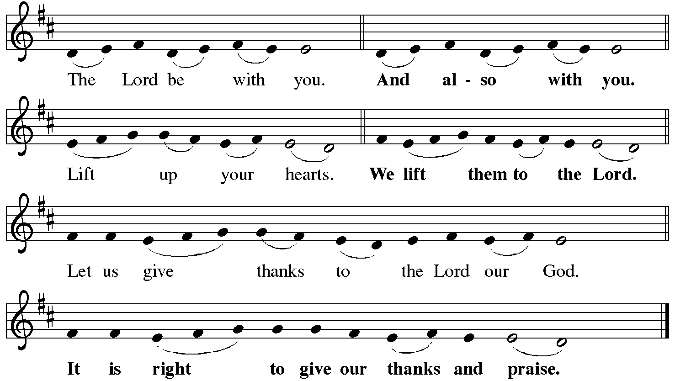

P It is indeed right, our duty and our joy… with the church on earth and the hosts of heaven, we praise your name and join their unending hymn:
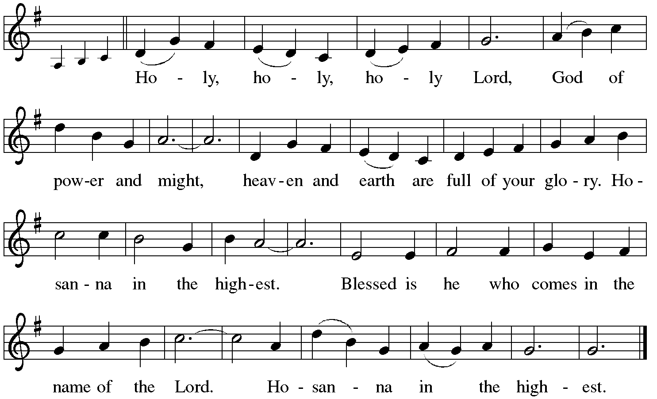

Holy Communion: Preface pp. 108-111 or other Eucharistic prayer

In the night in which he was betrayed,
our Lord Jesus took bread, and gave thanks;
broke it, and gave it to his disciples, saying:
Take and eat; this is my body, given for you.
Do this for the remembrance of me.
Again, after supper, he took the cup, gave thanks,
and gave it for all to drink, saying:
This cup is the new covenant in my blood,
shed for you and for all people for the forgiveness of sin.
Do this for the remembrance of me.
C The Lord's Prayer

Our Father, who art in heaven, hallowed be thy name,
thy kingdom come, thy will be done, on earth as it is in heaven.
Give us this day our daily bread; and forgive us our trespasses,
as we forgive those who trespass against us;
and lead us not into temptation, but deliver us from evil.
For thine is the kingdom, and the power, and the glory,
forever and ever. Amen
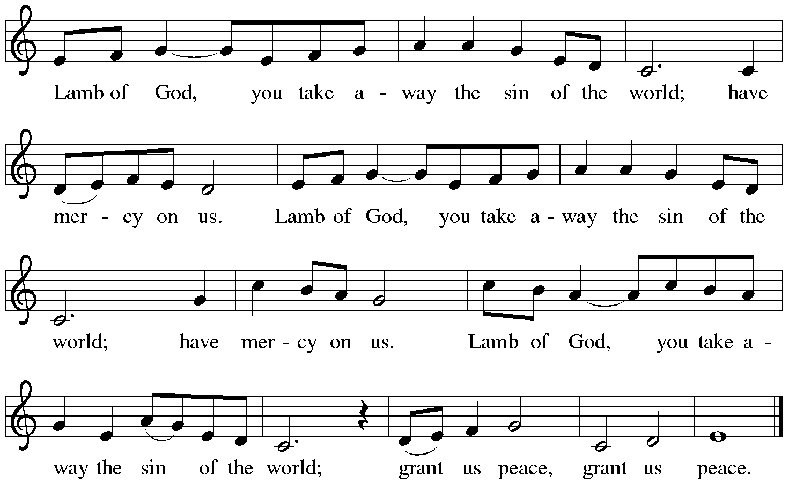

Distribution:

Communion Prayer

Announcements
Blessing
P The Lord bless you and keep you. The Lord make his face shine on you and be gracious to you. The Lord look upon you with favor and + give you peace.
In the name of the Father, and of the Son and of the Holy Spirit.
C Amen

Hymn: “Lift High the Cross” Red Book # 660

Reprinted under OneLicense.net#A-711151

A Go in peace. Serve the Lord.
C Thanks be to God!

Postlude

Liturgy and texts from Sundays and Seasons.com. Copyright 2021 Augsburg Fortress. All rights reserved. Reprinted by permission under Augsburg Fortress Liturgies
Annual License #23628.

