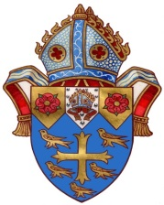
Diocese of New Westminster
REAFFIRMATION Candidate 2021

Please print clearly. All fields must be completed.

Candidate’s legal formal name

First name:____________________________________________________________________

Middle name(s):________________________________________________________________

Surname:_____________________________________________________________________

Preferred name i.e. “Robert” prefers “Bob”, “Ravinder” prefers “Ravi”
(to be used by the Bishop during the Confirmation Service):____________________________

Date of Birth:____________________________ (Day/Month/Year)

Home address/Street:___________________________________________________________

City/town:_____________________________________________________________________

Postal Code:___________________________________________________________________

Parish:________________________________________________________________________

Rector:________________________________________________________________________

Date baptized: _________________________________________________________________
Where baptized (Denomination, Church, City):______________________________________________
Baptized by whom:______________________________________________________________
Date confirmed: ________________________________________________________________
Where confirmed (Anglican Church, City): ____________________________________________
Confirmed by Bishop (name): _______________________________________________________

Note: Reaffirmation available only to those who have been confirmed in the Anglican Communion.

******************************************************************************
To be completed by Bishop’s Office
Date and Location of Reaffirmation Service: Reaffirmed by:

