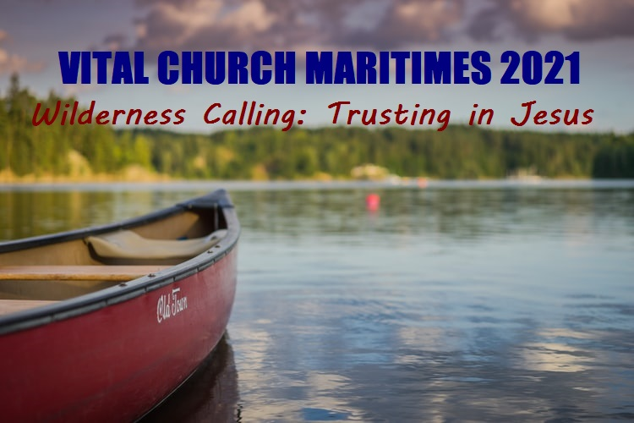  - WILDERNESS CALLING  VCM 2021 Conference  Oct. 14 to Oct. 16 - Truro, Nova Scotia  THE CALL OF THE WILD!  Engaging in ministry these days is like trekking into unknown territory. One popular author describes congregational engagement with our neighbours, saying it is like ‘canoeing the mountains’ – what traditionally and typically worked in years past, is no longer effective. We are called to this ‘wild’ using new approaches, including humble listening and courageous experimentation. Share experiences and ideas in exploring outward-oriented ministry. Step out into an unmapped missional journey, discover the signs of the Spirit's leading, and share best practices for this Holy Hinterland.  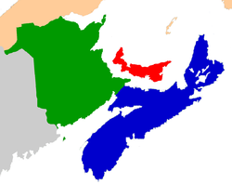  LOCATION: Inn on Prince (former Holiday Inn), Truro, N.S.  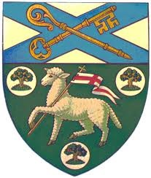  (A limited Zoom offering is available too.) | REGISTER NOW! Special Early Bird Rate!  www.nspeidiocese.ca  ____  Keynote speaker: The Primate, Anglican Church of Canada, Archbishop Linda Nicholls  ____  Also, Dr. Daniel Driver, Old Testament prof., AST  Diocese of Nova Scotia & Prince Edward Island  www.nspeidiocese.ca  Contact:  902-789-4840  lvaughn@nspeidiocese.ca

