The Supremacy of God in Sanctification
8/29/21 - Pastor Darren
Hebrews 5:11-6:8; Galatians 3:10-14
- Justification - _____________ _________________ (2 Cor. 5:21)
- Sanctification – the process of growing in _____________; killing sin, crucifying the flesh, and submitting to the work of the Holy Spirit in us
  - To change, and ______ changed, into the likeness of Christ (active & passive – I am doing something and something is being done in me)

- Why Sanctification?
  - It is commanded (Eph. 5:8; Gal. 5:24-25)
  - It is the Will of God for all Believers (Heb. 13:20-21)
  - It keeps us “Hot”
  - It encourages other believers (and vice versa)

- How Sanctification?
  - Us Fighting for Holiness (to be separate from sin) (Heb. 12:1-2)
*Do Not Confuse Justification and Sanctification! (To get them backwards is to make the same mistake as all other false religions -Piper) (Gal. 3:10-14; James 2:10)
  - __________ Working in Us (1 Cor. 1:30; 1 Peter 1:2)

- Sanctification is the process of the _______ ________ applying the completed work of _________ _________ in our lives

- Behavior ____________________ vs. ___________ Transformation

- Sanctification is _________________________ of our justification (Heb. 10:14)

- The Ultimate Purpose of Sanctification: ___________ ___________
Sanctification is Trinitarian. It comes:
From Him: Provided for in the Person and Work of Jesus Christ
Through Him: Applied in our lives by the Sanctification of the Holy Spirit
To Him: To the Glory of God the Father
³⁶ “For from him and through him and to him are all things. To him be glory forever. Amen” – Romans 11:36
³ “His divine power has granted to us all things that pertain to life and godliness,” -2 Peter 1:3a
²³ “Now may the God of peace himself sanctify you completely, and may your whole spirit and soul and body be kept blameless at the coming of our Lord Jesus Christ. ²⁴ He who calls you is faithful; he will surely do it.” – 1 Thess. 5:23-24

Justification, Sanctification, & Glorification:
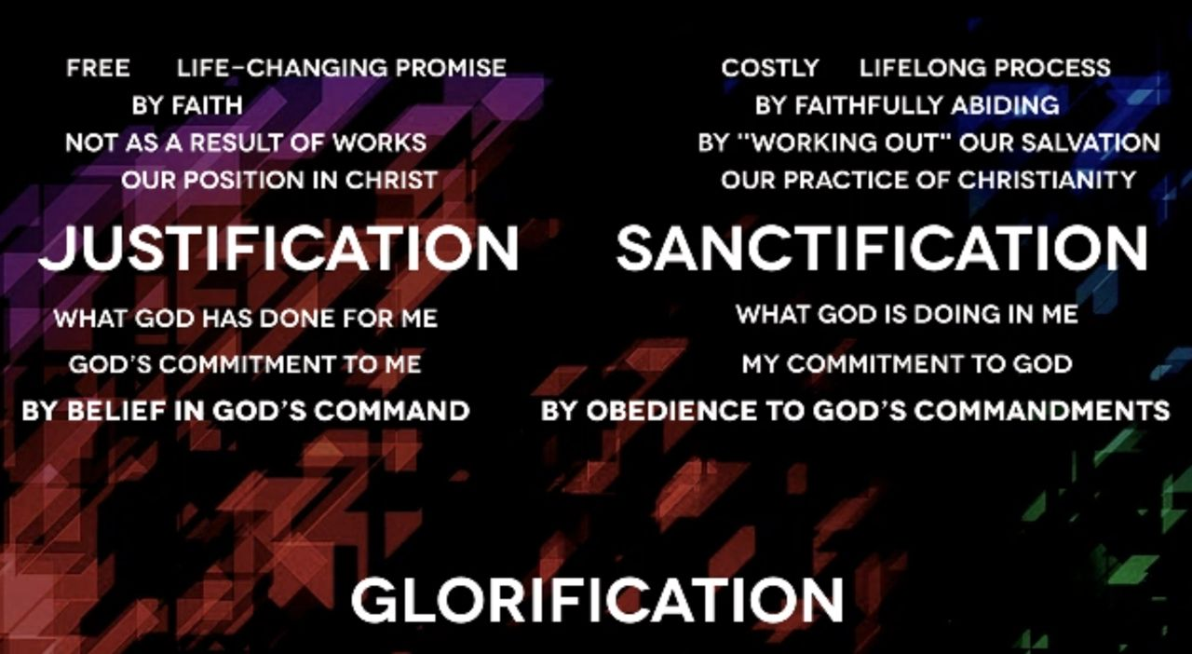
Going Deeper:
- Read Hebrews 6:7-8 – Which type of ground am I? What is my life producing?
- Do I rejoice when I hear about God’s glory? Or does it bother me?
- Am I a sheep or coyote? Are there coyote-like areas of my life that still need to be transformed into sheep?
- Do I work with the Holy Spirit in striving for victory? What/who am I trusting in for my sanctification?
- Am I balanced in my approach to sanctification? Or do I lean too heavily to one side (works-based “try-hard” Christianity) or the other (abusing grace and not taking sin seriously enough)?

