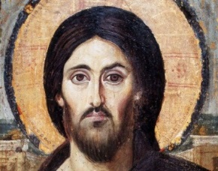
Ordinary Time
Summer
22 August 2021
GATHER
Welcome`
Confession and Forgiveness
Please rise in body or spirit.
P Blessed be the holy Trinity, one God, who has announced the coming of the Kingdom with stories of grateful debtors and rich fools; faithful servants and wayward sons; one God,
C AMEN.
P Let us prepare our hearts for worship, confessing our sins.
Silence is kept for reflection.
P Loving and merciful God,
C we thank you for the community in which you have placed us, for the brothers and sisters with whom we walk this pilgrim journey.
Yet, we confess that we fail to love as you love. We are quick to share our own stories while we ignore the stories of others. We fail to see your Kingdom in parables because we fail to see your Kingdom in each other. We push aside those whom we believe are the least in your Kingdom.
Form in us a new vision of community in which there is neither East nor West, neither South nor North.
Challenge our assumptions, and instill in us a holy dis-ease until all have heard your story. For the sake of your Kingdom that is and is not yet. Amen.
P The Father has rescued us from the power of darkness and transferred us into the kingdom of His beloved Son, in whom we have redemption, the forgiveness of sins (Colossians 1:13-14).
C AMEN
Gathering Song
ELW # 661 “I Love to Tell the Story“
(verse 2a) I love to tell the story of a large and varied catch.
Good fish were tossed in baskets. And the bad fish were thrown back.
When dawns the end of ages, angels will do the same.
They’ll toss the good to heaven; the rest throw in the flame. (refrain)
Greeting and Prayer of the Day
P To all God’s beloved who love to hear and tell the old, old, ever new story of Jesus and His love: Grace to you and peace from God our Father and the Lord Jesus Christ.
C AND ALSO WITH YOU.
P Let us pray.
A brief silence is kept before the prayer.
P Lord Jesus, as we hear and reflect upon the parables that You told the crowds and explained to Your disciples, give us a sensitivity to listen, not just to the parable, but to the responses of our hearts to what we encounter in Your words.
C AMEN.
Please be seated.
WORD
Children’s Time
Psalm & Gloria Psalm 114
Please rise in body or spirit
Preaching Text Matthew 13:47-50
The Word of the Lord/THANKS BE TO GOD.
Please be seated
Sermon “Draw in the Net”
Special Music “No Wind at the Window”
Apostles Creed
C I BELIEVE IN GOD, THE FATHER ALMIGHTY, CREATOR OF HEAVEN AND EARTH.
I BELIEVE IN JESUS CHRIST, HIS ONLY SON, OUR LORD. HE WAS CONCEIVED BY THE POWER OF THE HOLY SPIRIT AND BORN OF THE VIRGIN MARY. HE SUFFERED UNDER PONTIUS PILATE, WAS CRUCIFIED, DIED AND WAS BURIED. HE DESCENDED INTO HELL. ON THE THIRD DAY HE ROSE AGAIN. HE ASCENDED INTO HEAVEN AND IS SEATED AT THE RIGHT HAND OF THE FATHER. HE WILL COME AGAIN TO JUDGE THE LIVING AND THE DEAD.
I BELIEVE IN THE HOLY SPIRIT, THE HOLY CATHOLIC CHURCH, THE COMMUNION OF SAINTS, THE FORGIVENESS OF SINS, THE RESURRECTION OF THE BODY AND THE LIFE EVERLASTING. AMEN.
Prayers of Intercession and Thanksgiving
Please rise in body or spirit
A Almighty God, Your Son Jesus Christ has promised that You will hear us when we ask in faith: receive the prayers we offer.
Word of God. Word of Life. / HEAR OUR PRAYER.
P Hear us, Father, through Jesus Christ our Lord, who lives and reigns with You in the unity of the Holy Spirit, one God, now and forever.
C AMEN.
Please be seated.
MEAL
Offering the Gifts and Tithes
After the offering has been brought to the table,
please stand as you are able.

Offering Prayer
A Let us pray. Lord God, with the action of this offering we tell Your story: how You have dealt generously with us, how You have met our needs, how You have heard our prayers, how Your goodness is from everlasting to everlasting. Bless these offerings which are given in the name of Christ.
C AMEN.
The Thanksgiving
P The Lord be with You
C and also with You.
P Lift up Your hearts.
C We lift them to the Lord.
P Let us give thanks to the Lord our God
C It is right to give our thanks and praise.
P Come, let us gather round the table. Light the candles...
In the night in which He was betrayed....
Lord’s Prayer (using “trespasses”)
p You inspire Your people, teaching us to pray:
C Our Father, who art in heaven...
P The table is ready. All are welcome. Come, for the feast is spread.
Please be seated.
The elements will be brought to your seat.
After all have communed; please rise in body or spirit.
P The body and blood of our Lord Jesus Christ strengthen You and keep You in His grace.
C AMEN.

Prayer after Communion
A Let us pray together. O God, as a mother comforts her child,
C SO YOU COMFORT YOUR PEOPLE, CARRYING US IN YOUR ARMS AND SATISFYING US WITH THIS FOOD AND DRINK, THE BODY AND BLOOD OF CHRIST. SEND US NOW AS YOUR DISCIPLES, ANNOUNCING PEACE, TELLING STORIES, AND PROCLAIMING THAT THE KINGDOM OF GOD HAS COME NEAR; THROUGH JESUS CHRIST, OUR SAVIOR AND LORD. AMEN.
SEND
Sending of Communion
P Eternal God, whose... in Jesus Christ our Lord.
C AMEN.
Benediction
P The Lord bless you and keep you.
The Lord's face shine upon you with grace and mercy.
The Lord look upon you with favor
and give you peace.
C AMEN.
Sending Song
ELW # 550 “On What Has Now Been Sown”
Announcements and Dismissal
A Go now to love and serve the world loved by Christ our Lord. As you go, be the feet of Christ, the hands of Christ, the voice of Christ.
As you go, share stories of a sheep, a coin, and a son gone astray, tell tales of tenants and talents, slaves and masters, and a rich young fool.
Yes, tell these stories. Share your own story. And listen to those of others
C THANKS BE TO GOD.

Remembering
Bishop Dr. David W. Preus
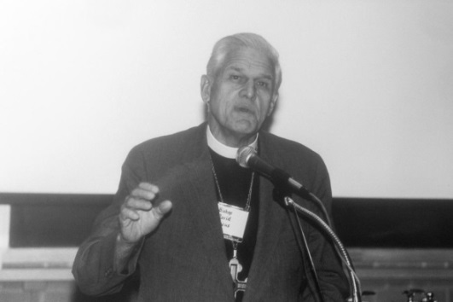
Bishop Dr David W. Preus, Vice-President of the LWF, February 1987. Photo: LWF/Emily Demuth
(LWI) - The Lutheran World Federation (LWF) joins the Evangelical Lutheran Church in America (ELCA) in giving thanks for the life and service of Bishop Dr David Walter Preus, a former LWF Vice-President who died in the United States on 23 July at the age of 99.
Born in 1922, Preus was ordained in 1950. From 1973 to1987 he served as Presiding Bishop of the American Lutheran Church (ALC), one of three American Lutheran denominations that eventually merged to form the ELCA in 1988. Known as a calming presence and a seeker of common grounds, Preus led the denomination into the merger.
In words of remembrance delivered at the bishop’s funeral service, ELCA Presiding Bishop and LWF Vice-President Elizabeth A. Eaton said, "We stand on the shoulders of giants, and that is certainly true of Bishop Preus. He lived a life of service. He was faithful and steadfast.”
At the 1970 LWF Assembly in Evian, France, Preus was appointed an LWF Executive Committee member representing the ALC. At the 1977 LWF Assembly in Dar es Salaam, Tanzania he was appointed LWF Vice-President, serving in that role until 1984.
Bishop Dr David Walter Preus was also a member of the Central Committee of the World Council of Churches. LWF/A. Gray

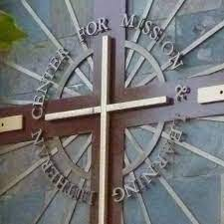
About the Pacifica Synod

of the Evangelical Church in America
With nearly 10,000 congregations across the U.S., Puerto Rico, and the Virgin Islands, and nearly 4 million members, the Evangelical Lutheran Church in America (ELCA) is a community of faith that shares a passion for making positive changes in the world. Our faith is built around a strong belief in God as made known to us in Jesus Christ. Through worship, service, and education, we practice our faith, grow our relationship with God and experience God’s grace in our lives. We also work hard to put our faith into action. In today’s complex world, we strive to make a difference in practical, realistic ways.
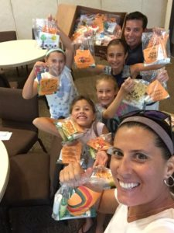
The ELCA is organized into 65 synods (64 geographical and one non-geographical) located in nine regions. Each synod (a Greek word meaning “a way together”) is led by a bishop.
Our synod is the Pacifica Synod includes the state of Hawaii and portions of Southern California, including the counties of Orange, San Bernardino, Riverside, San Diego, Imperial and part of Los Angeles County. The number of ELCA congregations in the Pacifica Synod is currently 110, comprised of nearly 25,139 baptized members (2019 Synod totals based on congregational reports submitted). Our Bishop is the Rev. Dr. Andrew Taylor.
These congregations are organized into nine conferences, each consisting of about a dozen churches. Each conference is led by a dean.
Our Conference is the West San Diego Conference. Pastor Richard is the dean of our conference.

