Faith Evangelical Lutheran Church, Washington, IL
Twelfth Sunday after Pentecost
August 15, 2021

Prelude
Welcome
Confession and Forgiveness

P: In the name of the Father, and of the + Son, and of the Holy Spirit.
C: Amen.
You may make the sign of the cross as a reminder of your baptism.
P: Almighty God, to whom all hearts are open, all desires known, and from whom no secrets are hid: cleanse the thoughts of our hearts by the inspiration of your Holy Spirit, that we may perfectly love you and worthily magnify your holy name, through Jesus Christ our Lord.
C: Amen.
P: Let us confess our sin in the presence of God and of one another.
Please keep silence for reflection
P: Most merciful God,
C: we confess that we are captive to sin and cannot free ourselves. We have sinned against you in thought, word, and deed, by what we have done and by what we have left undone. We have not loved you with our whole heart; we have not loved our neighbors as ourselves. For the sake of your Son, Jesus Christ, have mercy on us. Forgive us, renew us, and lead us, so that we may delight in your will and walk in your ways, to the glory of your holy name. Amen.
P: In the mercy of almighty God, Jesus Christ was given to die for us, and for his sake God forgives us all our sins. As a called and ordained minister of the church of Christ, and by his authority, I therefore declare to you the entire forgiveness of all your sins, in the name of the Father, and of the + Son, and of the Holy Spirit.
C: Amen.
Faith Lutheran Church
2206 Washington Rd,
Washington, IL 61571
Website and online worship:
www.shareourfaith.org
Church: 309-745-9306
faithlth@shareourfaith.org
Pastor John Rothfusz
Home: 309-745-9282
pastor@shareourfaith.org

Peace: As forgiven children of God, we have peace
with God, and peace with one another.
P The peace of the Lord be with you always.
C And also with you.
P Let us share that peace with one another.

*Hymn: “Gather Us In” Red Book #532

Text: Marty Haugen, b. 1950
Music: GATHER US IN, Marty Haugen
Text and music © 1982 GIA Publications Inc., 7404 S. Mason Ave., Chicago, IL 60638. www.giamusic.com. 800.442.3358.
All rights reserved. Used by permission. Reprinted under OneLicense.net#A-711151
P The grace of our Lord Jesus Christ, the love of God,
and the communion of the Holy Spirit be with you all.
C And also with you.

Hymn of Praise
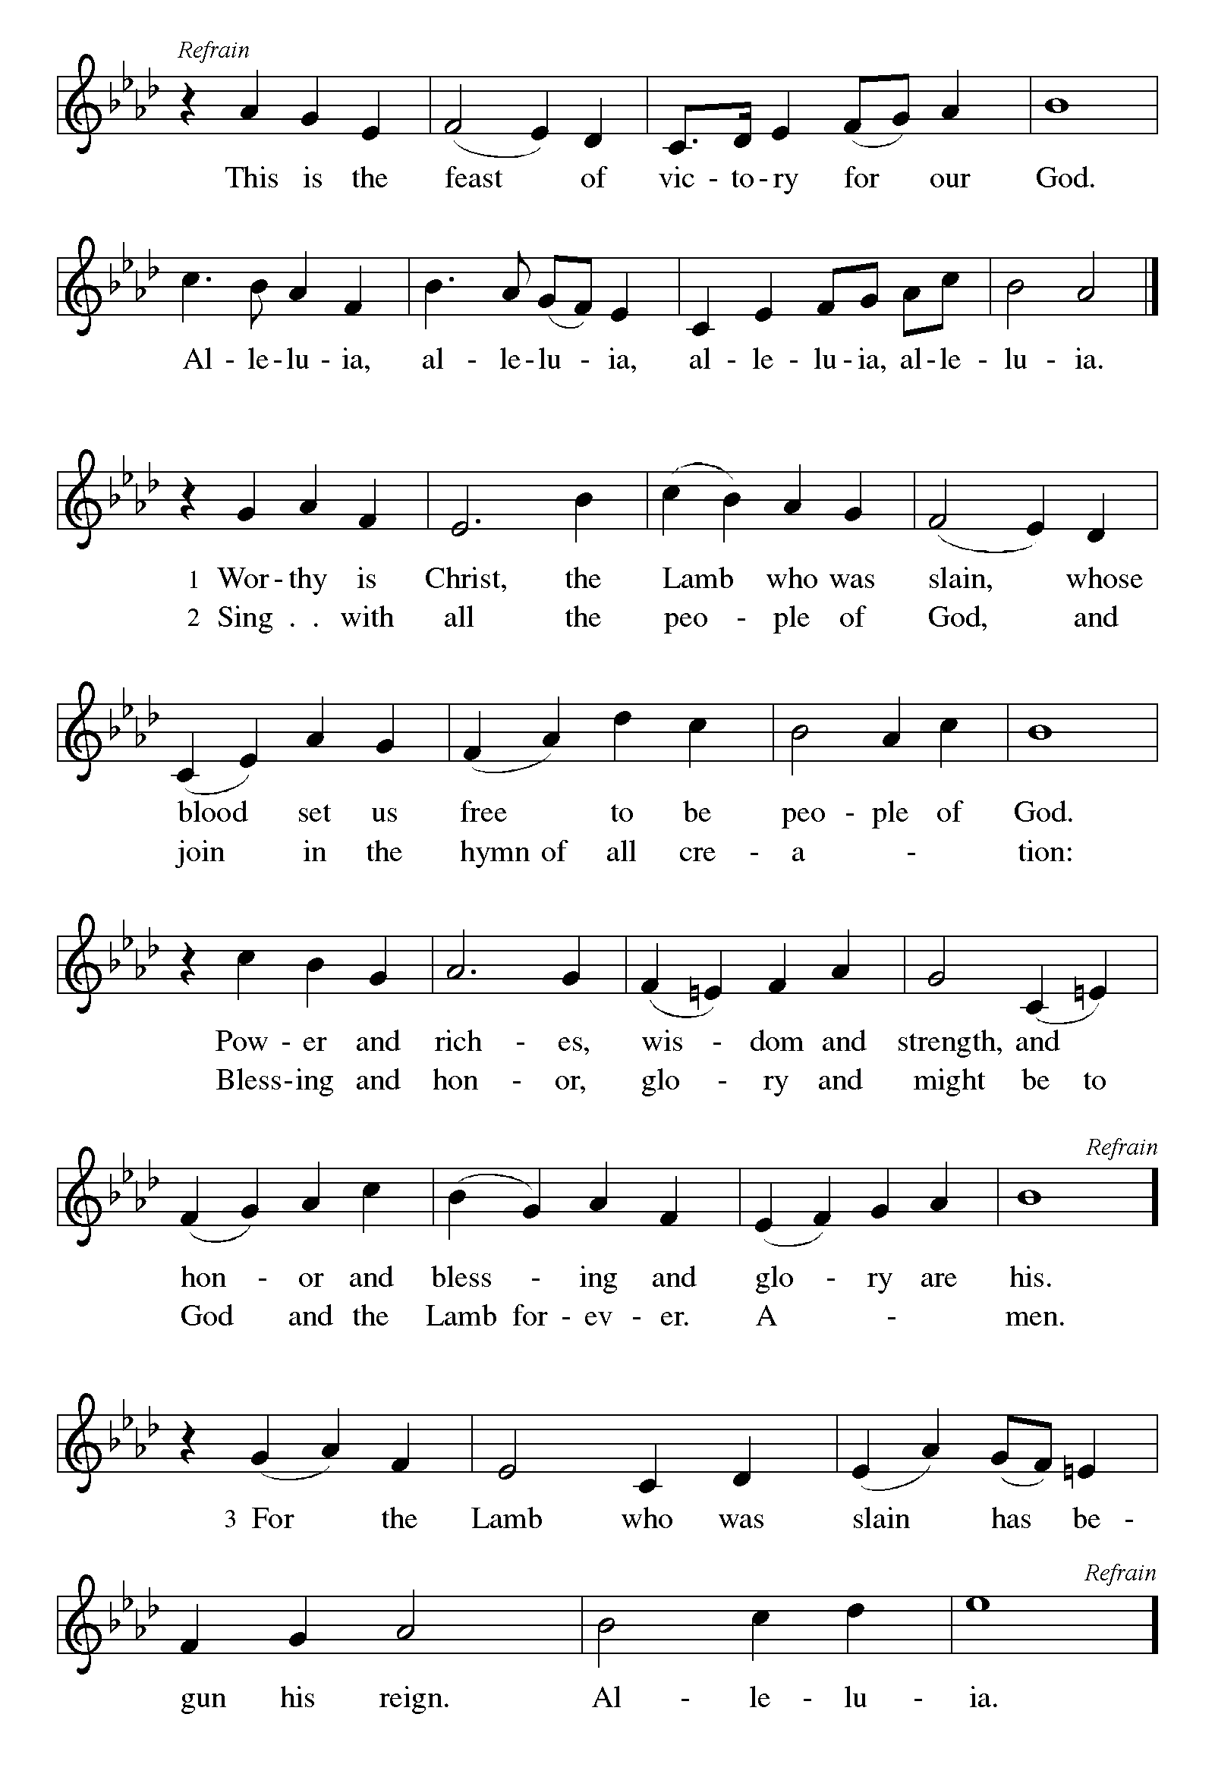

P The Lord be with you
C And also with you.
Let us pray together the Prayer of the Day
Ever-loving God, y our Son gives himself as living bread for the life of the world. Fill us with such a knowledge of his presence that we may be strengthened and sustained by his risen life to serve you continually, through Jesus Christ, our Savior and Lord. Amen.

Children’s Message

Reading: Proverbs 9:1-6 Pew Bible p. 516

¹Wisdom has built her house, she has hewn her seven pillars. ²She has slaughtered her animals, she has mixed her wine, she has also set her table. ³She has sent out her servant-girls, she calls from the highest places in the town, ⁴"You that are simple, turn in here!" To those without sense she says, ⁵"Come, eat of my bread and drink of the wine I have mixed. ⁶Lay aside immaturity, and live, and walk in the way of insight."
R The Word of the Lord
C Thanks be to God

Gospel Reading: John 6:51-58 Pew Bible p. 864

C Glory to you, O Lord

⁵¹I am the living bread that came down from heaven. Whoever eats of this bread will live forever; and the bread that I will give for the life of the world is my flesh."
⁵²The Jews then disputed among themselves, saying, "How can this man give us his flesh to eat?" ⁵³So Jesus said to them, "Very truly, I tell you, unless you eat the flesh of the Son of Man and drink his blood, you have no life in you. ⁵⁴Those who eat my flesh and drink my blood have eternal life, and I will raise them up on the last day; ⁵⁵for my flesh is true food and my blood is true drink. ⁵⁶Those who eat my flesh and drink my blood abide in me, and I in them. ⁵⁷Just as the living Father sent me, and I live because of the Father, so whoever eats me will live because of me. ⁵⁸This is the bread that came down from heaven, not like that which your ancestors ate, and they died. But the one who eats this bread will live forever."
The Gospel of the Lord
C Praise to you, O Christ
Sermon by Pastor John Rothfusz
Sermon Hymn: “Be Thou My Vision” Red Book #793
Text: Irish, 8th cent.; vers. Eleanor H. Hull, 1860-1935, alt.; tr. Mary E. byrne, 1880-1932
Music; SLANE, Irish traditional Public Domain

Apostles’ Creed
C: I believe in God, the Father almighty,
creator of heaven and earth.
I believe in Jesus Christ, God's only Son, our Lord,
who was conceived by the Holy Spirit,
born of the virgin Mary,
suffered under Pontius Pilate,
was crucified, died, and was buried;
he descended to the dead.
On the third day he rose again;
he ascended into heaven,
he is seated at the right hand of the Father,
and he will come to judge the living and the dead.
I believe in the Holy Spirit,
the holy catholic church, the communion of saints,
the forgiveness of sins, the resurrection of the body,
and the life everlasting. Amen.

Prayers: After each portion of the prayers finishes with “Lord in your mercy,” please respond, “Hear our prayer.”

Offering: Jesus fills us with faith and sends us out as his witnesses. Let us commit ourselves to the Lord and joyfully lift our tithes and offerings to the Lord.

Please take a moment now to make an electronic offering to the church on the website, with the Tithe.ly app on your phone, or write a check and send it in.
Faith Lutheran website link www.shareourfaith.org

A Let us pray. Blessed are you, O God,
C maker of all things. Through your goodness you have blessed us with these gifts: our selves, our time, and our possessions. Use us, and what we have gathered, in feeding the world with your love, through the one who gave himself for us, Jesus Christ, our Savior and Lord. Amen.

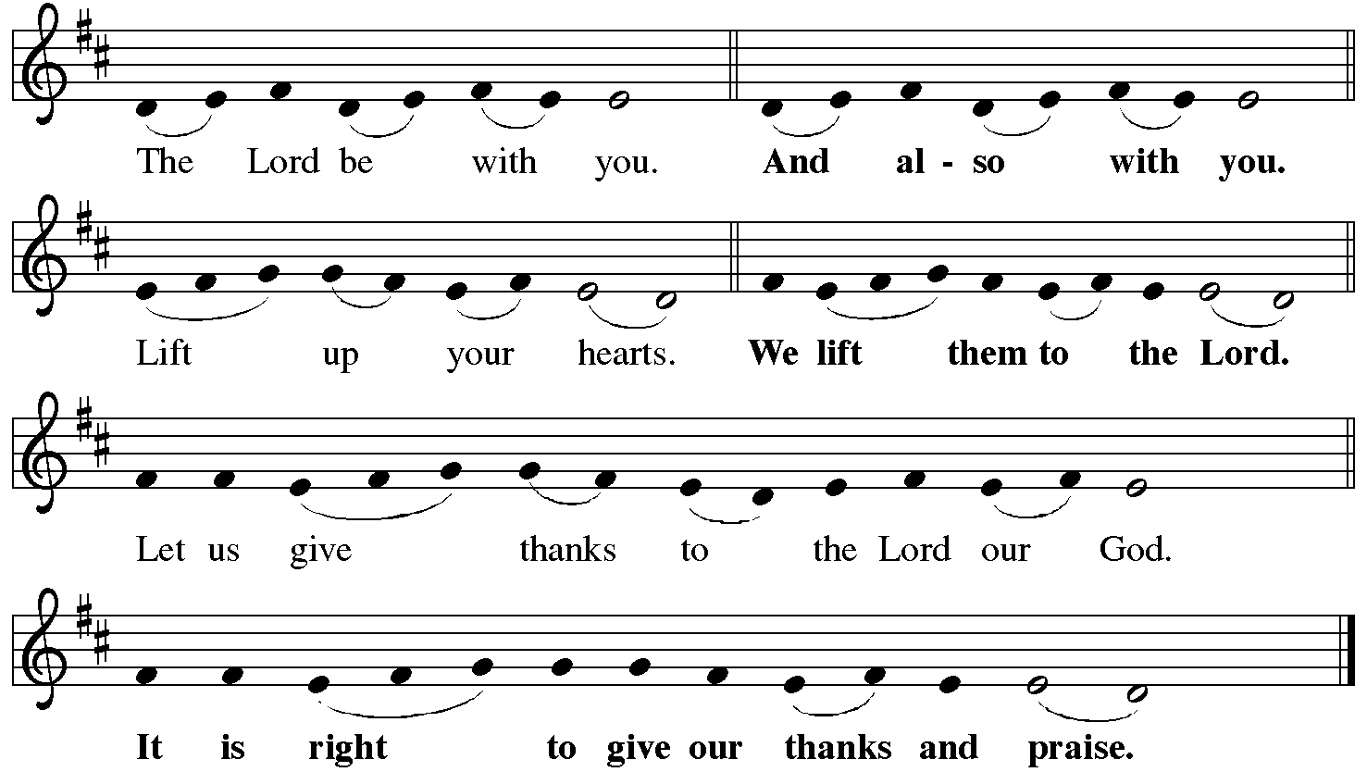
P It is indeed right, our duty and our joy… with the church on earth and the hosts of heaven, we praise your name and join their unending hymn:
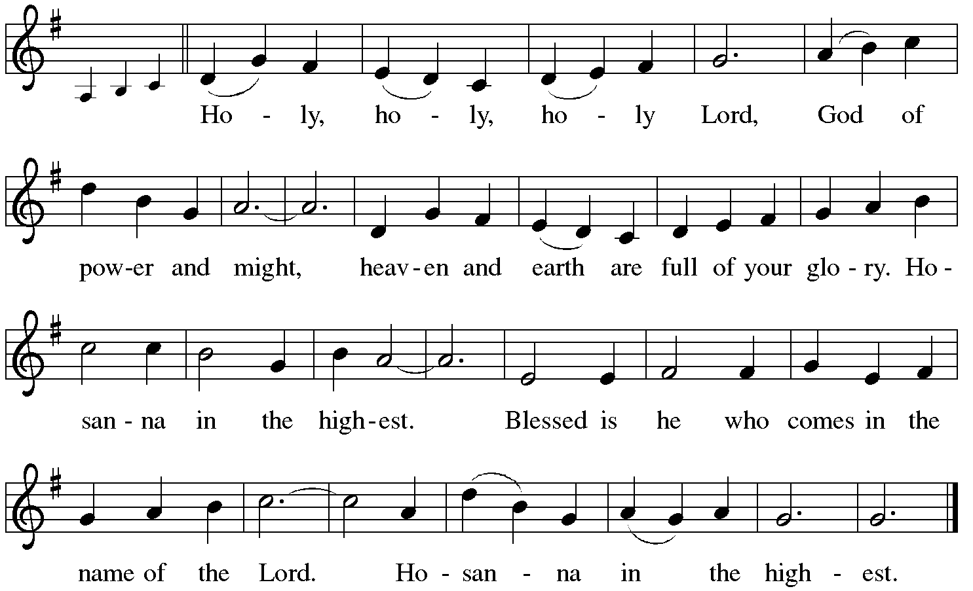

Holy Communion: Preface pp. 108-111 or other Eucharistic prayer

In the night in which he was betrayed,
our Lord Jesus took bread, and gave thanks;
broke it, and gave it to his disciples, saying:
Take and eat; this is my body, given for you.
Do this for the remembrance of me.
Again, after supper, he took the cup, gave thanks,
and gave it for all to drink, saying:
This cup is the new covenant in my blood,
shed for you and for all people for the forgiveness of sin.
Do this for the remembrance of me.
C The Lord's Prayer
Our Father, who art in heaven, hallowed be thy name,
thy kingdom come, thy will be done, on earth as it is in heaven.
Give us this day our daily bread; and forgive us our trespasses,
as we forgive those who trespass against us;
and lead us not into temptation, but deliver us from evil.
For thine is the kingdom, and the power, and the glory,
forever and ever. Amen
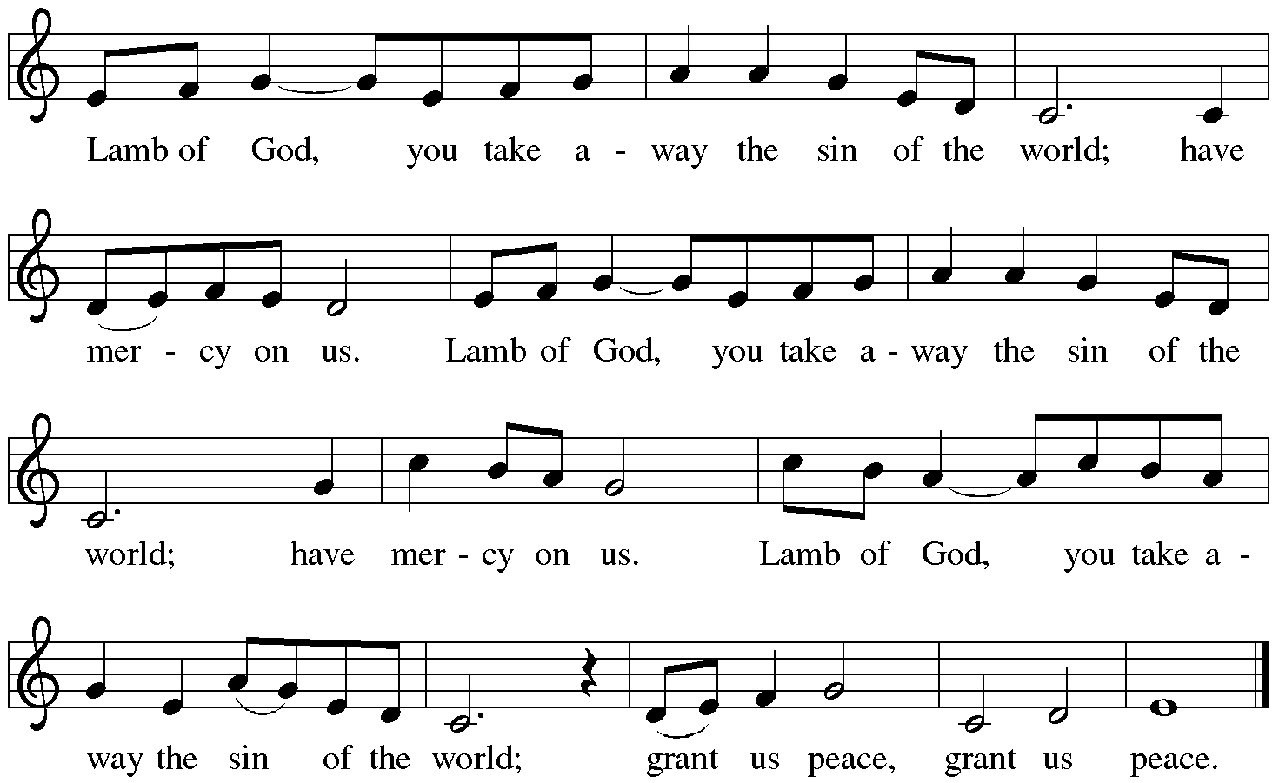

Distribution:

Communion Prayer

Announcements
Blessing
P The Lord bless you and keep you. The Lord make his face shine on you and be gracious to you. The Lord look upon you with favor and + give you peace.
In the name of the Father, and of the Son and of the Holy Spirit.
C Amen
Hymn: “On Our Way Rejoicing” Red Book # 537
Public Domain

Dismissal

A Go in peace. Serve the Lord.
C Thanks be to God!

Postlude
Liturgy and texts from Sundays and Seasons.com. Copyright 2021 Augsburg Fortress. All rights reserved.
Reprinted by permission under Augsburg Fortress Liturgies Annual License #23628.

