Faith Evangelical Lutheran Church, Washington, IL
Tenth Sunday after Pentecost
August 1, 2021
Online Worship

Prelude
Welcome
Confession and Forgiveness

P: In the name of the Father, and of the + Son, and of the Holy Spirit.
C: Amen.
You may make the sign of the cross as a reminder of your baptism.
P: Almighty God, to whom all hearts are open, all desires known, and from whom no secrets are hid: cleanse the thoughts of our hearts by the inspiration of your Holy Spirit, that we may perfectly love you and worthily magnify your holy name, through Jesus Christ our Lord.
C: Amen.
P: Let us confess our sin in the presence of God and of one another.
Please keep silence for reflection
P: Most merciful God,
C: we confess that we are captive to sin and cannot free ourselves. We have sinned against you in thought, word, and deed, by what we have done and by what we have left undone. We have not loved you with our whole heart; we have not loved our neighbors as ourselves. For the sake of your Son, Jesus Christ, have mercy on us. Forgive us, renew us, and lead us, so that we may delight in your will and walk in your ways, to the glory of your holy name. Amen.
P: In the mercy of almighty God, Jesus Christ was given to die for us, and for his sake God forgives us all our sins. As a called and ordained minister of the church of Christ, and by his authority, I therefore declare to you the entire forgiveness of all your sins, in the name of the Father, and of the + Son, and of the Holy Spirit.
C: Amen.
Faith Lutheran Church
2206 Washington Rd,
Washington, IL 61571
Website and online worship:
www.shareourfaith.org
Church: 309-745-9306
faithlth@shareourfaith.org
Pastor John Rothfusz
Home: 309-745-9282
pastor@shareourfaith.org

Peace: As forgiven children of God, we have peace
with God, and peace with one another.
P The peace of the Lord be with you always.
C And also with you.
P Let us share that peace with one another.
*Hymn: “My Hope is Built on Nothing Less” Red Book #597
Public Domain

P The grace of our Lord Jesus Christ, the love of God,
and the communion of the Holy Spirit be with you all.
C And also with you.

Hymn of Praise
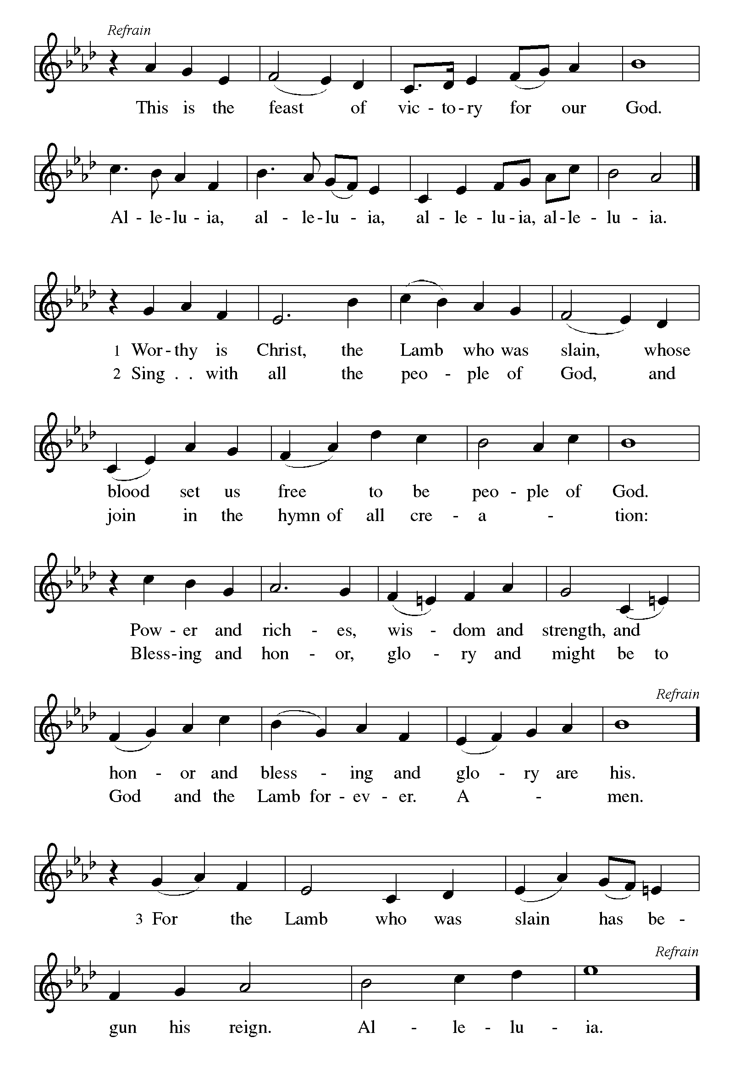

P The Lord be with you
C And also with you.
Let us pray together the Prayer of the Day
O God, eternal goodness, immeasurable love, you place your gifts before us; we eat and are satisfied. Fill us and this world in all its need with the life that comes only from you, through Jesus Christ, our Savior and Lord. Amen.
Children’s Message

Reading: Ephesians 4:1-16 Pew Bible p. 949
¹I therefore, the prisoner in the Lord, beg you to lead a life worthy of the calling to which you have been called, ²with all humility and gentleness, with patience, bearing with one another in love, ³making every effort to maintain the unity of the Spirit in the bond of peace. ⁴There is one body and one Spirit, just as you were called to the one hope of your calling, ⁵one Lord, one faith, one baptism, ⁶one God and Father of all, who is above all and through all and in all.
⁷But each of us was given grace according to the measure of Christ’s gift. ⁸Therefore it is said, “When he ascended on high he made captivity itself a captive;
he gave gifts to his people.”
⁹(When it says, “He ascended,” what does it mean but that he had also descended into the lower parts of the earth? ¹⁰He who descended is the same one who ascended far above all the heavens, so that he might fill all things.) ¹¹The gifts he gave were that some would be apostles, some prophets, some evangelists, some pastors and teachers, ¹²to equip the saints for the work of ministry, for building up the body of Christ, ¹³until all of us come to the unity of the faith and of the knowledge of the Son of God, to maturity, to the measure of the full stature of Christ. ¹⁴We must no longer be children, tossed to and fro and blown about by every wind of doctrine, by people’s trickery, by their craftiness in deceitful scheming. ¹⁵But speaking the truth in love, we must grow up in every way into him who is the head, into Christ, ¹⁶from whom the whole body, joined and knit together by every ligament with which it is equipped, as each part is working properly, promotes the body’s growth in building itself up in love.
R The Word of the Lord
C Thanks be to God
Gospel Reading: John 6:24-35 Pew Bible p. 863

C Glory to you, O Lord
²⁴When the crowd saw that neither Jesus nor his disciples were [beside the sea,] they themselves got into the boats and went to Capernaum looking for Jesus.
²⁵When they found him on the other side of the sea, they said to him, “Rabbi, when did you come here?” ²⁶Jesus answered them, “Very truly, I tell you, you are looking for me, not because you saw signs, but because you ate your fill of the loaves. ²⁷Do not work for the food that perishes, but for the food that endures for eternal life, which the Son of Man will give you. For it is on him that God the Father has set his seal.” ²⁸Then they said to him, “What must we do to perform the works of God?” ²⁹Jesus answered them, “This is the work of God, that you believe in him whom he has sent.” ³⁰So they said to him, “What sign are you going to give us then, so that we may see it and believe you? What work are you performing? ³¹Our ancestors ate the manna in the wilderness; as it is written, ‘He gave them bread from heaven to eat.’ ” ³²Then Jesus said to them, “Very truly, I tell you, it was not Moses who gave you the bread from heaven, but it is my Father who gives you the true bread from heaven. ³³For the bread of God is that which comes down from heaven and gives life to the world.” ³⁴They said to him, “Sir, give us this bread always.”
³⁵Jesus said to them, “I am the bread of life. Whoever comes to me will never be hungry, and whoever believes in me will never be thirsty.”
The Gospel of the Lord
C Praise to you, O Christ
Sermon by Pastor John Rothfusz

Sermon Hymn: “The Church’s One Foundation” Red Book #654
Public Domain
Apostles’ Creed
C: I believe in God, the Father almighty,
creator of heaven and earth.
I believe in Jesus Christ, God's only Son, our Lord,
who was conceived by the Holy Spirit,
born of the virgin Mary,
suffered under Pontius Pilate,
was crucified, died, and was buried;
he descended to the dead.
On the third day he rose again;
he ascended into heaven,
he is seated at the right hand of the Father,
and he will come to judge the living and the dead.
I believe in the Holy Spirit,
the holy catholic church, the communion of saints,
the forgiveness of sins, the resurrection of the body,
and the life everlasting. Amen.
Prayers: After each portion of the prayers finishes with “Lord in your mercy,” please respond, “Hear our prayer.”
C The Lord's Prayer
Our Father, who art in heaven, hallowed be thy name,
thy kingdom come, thy will be done, on earth as it is in heaven.
Give us this day our daily bread; and forgive us our trespasses,
as we forgive those who trespass against us;
and lead us not into temptation, but deliver us from evil.
For thine is the kingdom, and the power, and the glory,
forever and ever. Amen
Offering: Jesus fills us with faith and sends us out as his witnesses. Let us commit ourselves to the Lord and joyfully lift our tithes and offerings to the Lord.
Please take a moment now to make an electronic offering to the church on the website, with the Tithe.ly app on your phone, or write a check and send it in.
Faith Lutheran website link www.shareourfaith.org
Announcements
Blessing
P The Lord bless you and keep you.
The Lord make his face shine on you and be gracious to you.
The Lord look upon you with favor and + give you peace.
In the name of the Father, and of the Son and of the Holy Spirit.
C Amen
Hymn: “Through the Night of Doubt and Sorrow” Red Book # 327
All rights reserved. Used by permission. Reprinted under OneLicense.net #A-711151

Dismissal
A Go in peace. Serve the Lord.
C Thanks be to God!

Postlude

Liturgy and texts from Sundays and Seasons.com. Copyright 2021 Augsburg Fortress. All rights reserved.
Reprinted by permission under Augsburg Fortress Liturgies Annual License #23628.

