Children’s Page

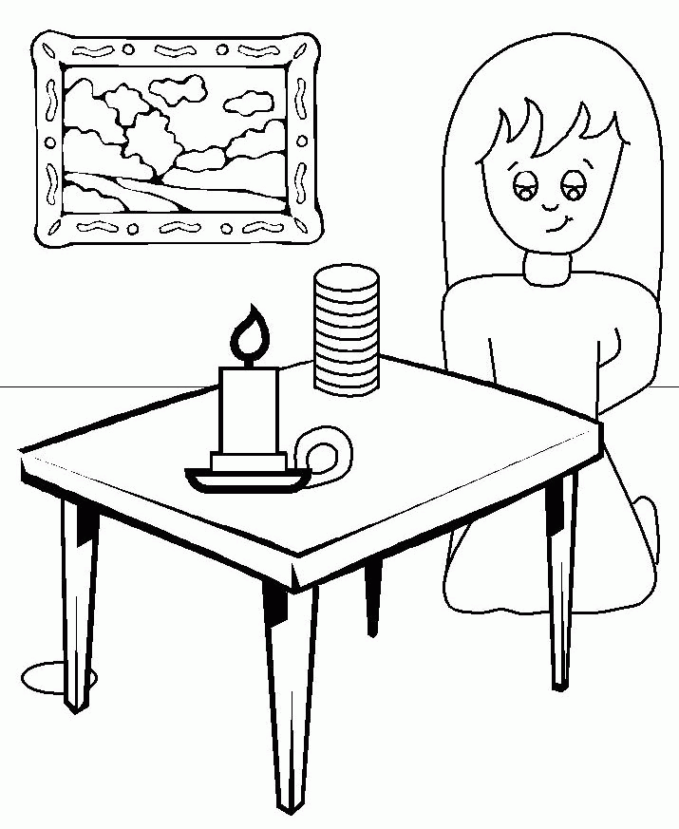
Read Luke 15:8-10
1. What has the woman lost? Can you find it?
2. What does she do?
3. What is missing from this picture?
4. What does she do when she finds it?

