Faith Evangelical Lutheran Church, Washington, IL
Eighth Sunday after Pentecost
July 18, 2021
Online Worship
Prelude
Welcome
*Hymn: “Gather Us In” Red Book #532
All rights reserved. Used by permission. Reprinted under OneLicense.net #A-711151

Confession and Forgiveness

P: In the name of the Father, and of the + Son, and of the Holy Spirit.
C: Amen.
You may make the sign of the cross as a reminder of your baptism.
P: Almighty God, to whom all hearts are open, all desires known, and from whom no secrets are hid: cleanse the thoughts of our hearts by the inspiration of your Holy Spirit, that we may perfectly love you and worthily magnify your holy name, through Jesus Christ our Lord.
C: Amen.
P: Let us confess our sin in the presence of God and of one another.
Please keep silence for reflection
P: Most merciful God,
C: we confess that we are captive to sin and cannot free ourselves. We have sinned against you in thought, word, and deed, by what we have done and by what we have left undone. We have not loved you with our whole heart; we have not loved our neighbors as ourselves. For the sake of your Son, Jesus Christ, have mercy on us. Forgive us, renew us, and lead us, so that we may delight in your will and walk in your ways, to the glory of your holy name. Amen.
A: God, who is rich in mercy, loved us even when we were dead in sin, and made us alive together with Christ. By grace you have been saved. In the name of Jesus Christ your sins are forgiven. Almighty God strengthen you with power through the Holy Spirit, that Christ may live in your hearts through faith.

C: Amen.
Faith Lutheran Church
2206 Washington Rd,
Washington, IL 61571
Website and online worship:
www.shareourfaith.org
Church: 309-745-9306
faithlth@shareourfaith.org
Pastor John Rothfusz
Home: 309-745-9282
pastor@shareourfaith.org
Peace:
P The peace of the Lord be with you always.
C And also with you.
P Let us share that peace with one another.

Hymn of Praise: “The Lord’s My Shepherd” Red Book #778
All rights reserved. Used by permission. Reprinted under OneLicense.net #A-711151
P The Lord be with you
C And also with you.
Let us pray together the Prayer of the Day
O God, powerful and compassionate, you shepherd your people, faithfully feeding and protecting us. Heal each of us, and make us a whole people, that we may embody the justice and peace of your Son, Jesus Christ, our Savior and Lord. Amen.
Psalm: Psalm 23 Read in unison
The LORD is my shepherd, I shall not be in want.
He makes me lie down in green pastures;
he leads me beside still waters; he restores my soul.
He leads me in paths of righteousness for his name's sake.
Even though I walk through the valley of the shadow of death, I fear no evil, for you are with me; your rod and your staff -- they comfort me.
You prepare a table before me in the presence of my enemies;
You anoint my head with oil; my cup overflows.
Surely goodness and mercy shall follow me all the days of my life,
and I shall dwell in the house of the LORD forever.

Gospel Reading: Mark 6:30-34, 53-56

C Glory to you, O Lord
³⁰The apostles gathered around Jesus, and told him all that they had done and taught. ³¹He said to them, “Come away to a deserted place all by yourselves and rest a while.” For many were coming and going, and they had no leisure even to eat. ³²And they went away in the boat to a deserted place by themselves. ³³Now many saw them going and recognized them, and they hurried there on foot from all the towns and arrived ahead of them. ³⁴As he went ashore, he saw a great crowd; and he had compassion for them, because they were like sheep without a shepherd; and he began to teach them many things.
⁵³When they had crossed over, they came to land at Gennesaret and moored the boat. ⁵⁴When they got out of the boat, people at once recognized him, ⁵⁵and rushed about that whole region and began to bring the sick on mats to wherever they heard he was. ⁵⁶And wherever he went, into villages or cities or farms, they laid the sick in the marketplaces, and begged him that they might touch even the fringe of his cloak; and all who touched it were healed.
The Gospel of the Lord
C Praise to you, O Christ
Sermon by Pastor John and the Faithful Innovation Team
Dwelling in the Word
1 Kings 17:8-16
⁸Then the word of the LORD came to him, saying, ⁹Go now to Zarephath, which belongs to Sidon, and live there; for I have commanded a widow there to feed you. ¹⁰So he set out and went to Zarephath. When he came to the gate of the town, a widow was there gathering sticks; he called to her and said, "Bring me a little water in a vessel, so that I may drink." ¹¹As she was going to bring it, he called to her and said, "Bring me a morsel of bread in your hand."
¹²But she said, "As the LORD your God lives, I have nothing baked, only a handful of meal in a jar, and a little oil in a jug; I am now gathering a couple of sticks, so that I may go home and prepare it for myself and my son, that we may eat it, and die." ¹³Elijah said to her, "Do not be afraid; go and do as you have said; but first make me a little cake of it and bring it to me, and afterwards make something for yourself and your son. ¹⁴For thus says the LORD the God of Israel: The jar of meal will not be emptied and the jug of oil will not fail until the day that the LORD sends rain on the earth." ¹⁵She went and did as Elijah said, so that she as well as he and her household ate for many days. ¹⁶The jar of meal was not emptied, neither did the jug of oil fail, according to the word of the LORD that he spoke by Elijah.
What do I notice? or What captures my attention?
What do I wonder?
Where might God’s Spirit be nudging us?

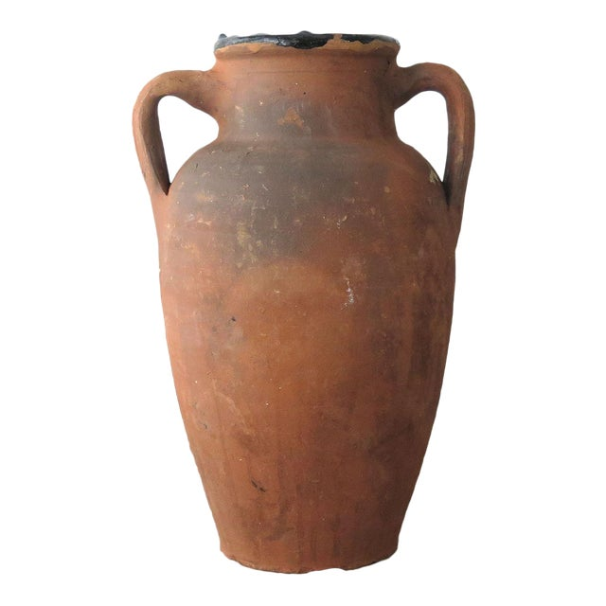

Sermon Hymn: “Lord, Speak to Us, That We May Speak” Red Book #676
Public Domain

Apostles’ Creed
C: I believe in God, the Father almighty,
creator of heaven and earth.
I believe in Jesus Christ, God's only Son, our Lord,
who was conceived by the Holy Spirit,
born of the virgin Mary,
suffered under Pontius Pilate,
was crucified, died, and was buried;
he descended to the dead.
On the third day he rose again;
he ascended into heaven,
he is seated at the right hand of the Father,
and he will come to judge the living and the dead.
I believe in the Holy Spirit,
the holy catholic church, the communion of saints,
the forgiveness of sins, the resurrection of the body,
and the life everlasting. Amen.

Offering: The Lord is with us to bring hope and new life. Let us show our thanks and praise as we lift up our tithes and offerings to the Lord.
Please take a moment now to make an electronic offering to the church on the website, with the Tithe.ly app on your phone, or write a check and send it in.
Faith Lutheran website link www.shareourfaith.org

Prayers: After each portion of the prayers finishes with “Lord in your mercy,” please respond, “Hear our prayer.”
Lord’s Prayer
Our Father, who art in heaven, hallowed be thy name,
thy kingdom come, thy will be done, on earth as it is in heaven.
Give us this day our daily bread; and forgive us our trespasses,
as we forgive those who trespass against us;
and lead us not into temptation, but deliver us from evil.
For thine is the kingdom, and the power, and the glory,
forever and ever. Amen
Announcements

Blessing
The Lord bless you and keep you.
The Lord make his face to shine upon you and be gracious unto you.
The Lord look upon you with favor, and give you peace.
In the name of the Father, and of the Son and of the Holy Spirit.
C Amen

Hymn: “The Spirit Sends Us Forth To Serve” Red Book # 551
All rights reserved. Used by permission. Reprinted under OneLicense.net #A-711151

Dismissal
A Go in peace. Serve the Lord.
C Thanks be to God!

Postlude

