Faith Evangelical Lutheran Church, Washington, IL
Seventh Sunday after Pentecost
July 11, 2021
Online Worship

Prelude
Welcome
Confession and Forgiveness

P: In the name of the Father, and of the + Son, and of the Holy Spirit.
C: Amen.
You may make the sign of the cross as a reminder of your baptism.
P: Almighty God, to whom all hearts are open, all desires known, and from whom no secrets are hid: cleanse the thoughts of our hearts by the inspiration of your Holy Spirit, that we may perfectly love you and worthily magnify your holy name, through Jesus Christ our Lord.
C: Amen.
P: Let us confess our sin in the presence of God and of one another.
Please keep silence for reflection
P: Most merciful God,
C: we confess that we are captive to sin and cannot free ourselves. We have sinned against you in thought, word, and deed, by what we have done and by what we have left undone. We have not loved you with our whole heart; we have not loved our neighbors as ourselves. For the sake of your Son, Jesus Christ, have mercy on us. Forgive us, renew us, and lead us, so that we may delight in your will and walk in your ways, to the glory of your holy name. Amen.
P: In the mercy of almighty God, Jesus Christ was given to die for us, and for his sake God forgives us all our sins. As a called and ordained minister of the church of Christ, and by his authority, I therefore declare to you the entire forgiveness of all your sins, in the name of the Father, and of the + Son, and of the Holy Spirit.
C: Amen.
Faith Lutheran Church
2206 Washington Rd,
Washington, IL 61571
Website and online worship:
www.shareourfaith.org
Church: 309-745-9306
faithlth@shareourfaith.org
Pastor John Rothfusz
Home: 309-745-9282
pastor@shareourfaith.org

Peace: As forgiven children of God, we have peace
with God, and peace with one another.
P The peace of the Lord be with you always.
C And also with you.
P Let us share that peace with one another.
*Hymn: “Come, Thou Fount of Every Blessing” Red Book #807
Public Domain

P The grace of our Lord Jesus Christ, the love of God,
and the communion of the Holy Spirit be with you all.
C And also with you.

Hymn of Praise
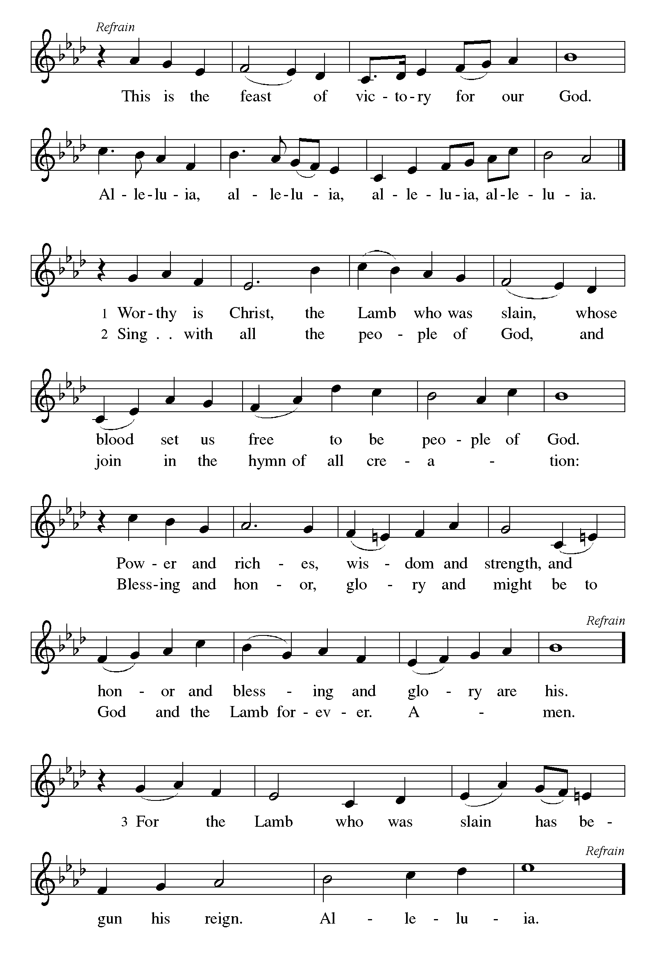

P The Lord be with you
C And also with you.
Let us pray together the Prayer of the Day
O God, from you come all holy desires, all good counsels, and all just works. Give to us, your servants, that peace which the world cannot give, that our hearts may be set to obey your commandments; and also that we, being defended from the fear of our enemies, may live in peace and quietness, through Jesus Christ, our Savior and Lord. Amen.

Children’s Message

Reading: Amos 7:7-15 Pew Bible p. 740
⁷This is what [the Lord God] showed me: the Lord was standing beside a wall built with a plumb line, with a plumb line in his hand. ⁸And the Lord said to me, “Amos, what do you see?” And I said, “A plumb line.” Then the Lord said,
“See, I am setting a plumb line in the midst of my people Israel;
I will never again pass them by;
⁹the high places of Isaac shall be made desolate,
and the sanctuaries of Israel shall be laid waste,
and I will rise against the house of Jeroboam with the sword.”
¹⁰Then Amaziah, the priest of Bethel, sent to King Jeroboam of Israel, saying, “Amos has conspired against you in the very center of the house of Israel; the land is not able to bear all his words. ¹¹For thus Amos has said,
‘Jeroboam shall die by the sword, and Israel must go into exile
away from his land.’ ”
¹²And Amaziah said to Amos, “O seer, go, flee away to the land of Judah, earn your bread there, and prophesy there; ¹³but never again prophesy at Bethel, for it is the king’s sanctuary, and it is a temple of the kingdom.”
¹⁴Then Amos answered Amaziah, “I am no prophet, nor a prophet’s son; but I am a herdsman, and a dresser of sycamore trees, ¹⁵and the Lord took me from following the flock, and the Lord said to me, ‘Go, prophesy to my people Israel.’ ”
R The Word of the Lord
C Thanks be to God
Gospel Reading: Mark 6:14-29 Pew Bible p. 812

C Glory to you, O Lord
¹⁴King Herod heard of [the disciples’ preaching,] for Jesus’ name had become known. Some were saying, “John the baptizer has been raised from the dead; and for this reason these powers are at work in him.” ¹⁵But others said, “It is Elijah.” And others said, “It is a prophet, like one of the prophets of old.” ¹⁶But when Herod heard of it, he said, “John, whom I beheaded, has been raised.”
¹⁷For Herod himself had sent men who arrested John, bound him, and put him in prison on account of Herodias, his brother Philip’s wife, because Herod had married her. ¹⁸For John had been telling Herod, “It is not lawful for you to have your brother’s wife.” ¹⁹And Herodias had a grudge against him, and wanted to kill him. But she could not, ²⁰for Herod feared John, knowing that he was a righteous and holy man, and he protected him. When he heard him, he was greatly perplexed; and yet he liked to listen to him. ²¹But an opportunity came when Herod on his birthday gave a banquet for his courtiers and officers and for the leaders of Galilee. ²²When his daughter Herodias came in and danced, she pleased Herod and his guests; and the king said to the girl, “Ask me for whatever you wish, and I will give it.” ²³And he solemnly swore to her, “Whatever you ask me, I will give you, even half of my kingdom.” ²⁴She went out and said to her mother, “What should I ask for?” She replied, “The head of John the baptizer.” ²⁵Immediately she rushed back to the king and requested, “I want you to give me at once the head of John the Baptist on a platter.” ²⁶The king was deeply grieved; yet out of regard for his oaths and for the guests, he did not want to refuse her. ²⁷Immediately the king sent a soldier of the guard with orders to bring John’s head. He went and beheaded him in the prison, ²⁸brought his head on a platter, and gave it to the girl. Then the girl gave it to her mother. ²⁹When his disciples heard about it, they came and took his body, and laid it in a tomb.
The Gospel of the Lord
C Praise to you, O Christ
Sermon by Pastor John Rothfusz

Sermon Hymn: “Let Streams of Living Justice” Red Book #710
Apostles’ Creed
C: I believe in God, the Father almighty,
creator of heaven and earth.
I believe in Jesus Christ, God's only Son, our Lord,
who was conceived by the Holy Spirit,
born of the virgin Mary,
suffered under Pontius Pilate,
was crucified, died, and was buried;
he descended to the dead.
On the third day he rose again;
he ascended into heaven,
he is seated at the right hand of the Father,
and he will come to judge the living and the dead.
I believe in the Holy Spirit,
the holy catholic church, the communion of saints,
the forgiveness of sins, the resurrection of the body,
and the life everlasting. Amen.
Prayers: After each portion of the prayers finishes with “Lord in your mercy,” please respond, “Hear our prayer.”
C The Lord's Prayer
Our Father, who art in heaven, hallowed be thy name,
thy kingdom come, thy will be done, on earth as it is in heaven.
Give us this day our daily bread; and forgive us our trespasses,
as we forgive those who trespass against us;
and lead us not into temptation, but deliver us from evil.
For thine is the kingdom, and the power, and the glory,
forever and ever. Amen
Offering: Jesus fills us with faith and sends us out as his witnesses. Let us commit ourselves to the Lord and joyfully lift our tithes and offerings to the Lord.
Please take a moment now to make an electronic offering to the church on the website, with the Tithe.ly app on your phone, or write a check and send it in.
Faith Lutheran website link www.shareourfaith.org
Announcements
Blessing
P The Lord bless you and keep you.
The Lord make his face shine on you and be gracious to you.
The Lord look upon you with favor and + give you peace.
In the name of the Father, and of the Son and of the Holy Spirit.
C Amen
Hymn: “Lead On, O King Eternal” Red Book # 805
Public Domain

Dismissal
A Go in peace. Serve the Lord.
C Thanks be to God!

Postlude

Liturgy and texts from Sundays and Seasons.com. Copyright 2021 Augsburg Fortress. All rights reserved.
Reprinted by permission under Augsburg Fortress Liturgies Annual License #23628.

