Faith Evangelical Lutheran Church, Washington, IL
Fifth Sunday after Pentecost
June 27, 2021
Online Worship

Prelude
Welcome
Confession and Forgiveness

P: In the name of the Father, and of the + Son, and of the Holy Spirit.
C: Amen.
You may make the sign of the cross as a reminder of your baptism.
P: Almighty God, to whom all hearts are open, all desires known, and from whom no secrets are hid: cleanse the thoughts of our hearts by the inspiration of your Holy Spirit, that we may perfectly love you and worthily magnify your holy name, through Jesus Christ our Lord.
C: Amen.
P: Let us confess our sin in the presence of God and of one another.
Please keep silence for reflection
P: Most merciful God,
C: we confess that we are captive to sin and cannot free ourselves. We have sinned against you in thought, word, and deed, by what we have done and by what we have left undone. We have not loved you with our whole heart; we have not loved our neighbors as ourselves. For the sake of your Son, Jesus Christ, have mercy on us. Forgive us, renew us, and lead us, so that we may delight in your will and walk in your ways, to the glory of your holy name. Amen.
P: In the mercy of almighty God, Jesus Christ was given to die for us, and for his sake God forgives us all our sins. As a called and ordained minister of the church of Christ, and by his authority, I therefore declare to you the entire forgiveness of all your sins, in the name of the Father, and of the + Son, and of the Holy Spirit.
C: Amen.
Faith Lutheran Church
2206 Washington Rd,
Washington, IL 61571
Website and online worship:
www.shareourfaith.org
Church: 309-745-9306
faithlth@shareourfaith.org
Pastor John Rothfusz
Home: 309-745-9282
pastor@shareourfaith.org

Peace: As forgiven children of God, we have peace
with God, and peace with one another.
P The peace of the Lord be with you always.
C And also with you.
P Let us share that peace with one another.
*Hymn: “I’m So Glad, Jesus Lifted Me” Red Book #860
All rights reserved. Used by permission. Reprinted under OneLicense.net #A-711151

P The grace of our Lord Jesus Christ, the love of God,
and the communion of the Holy Spirit be with you all.
C And also with you.
Hymn of Praise
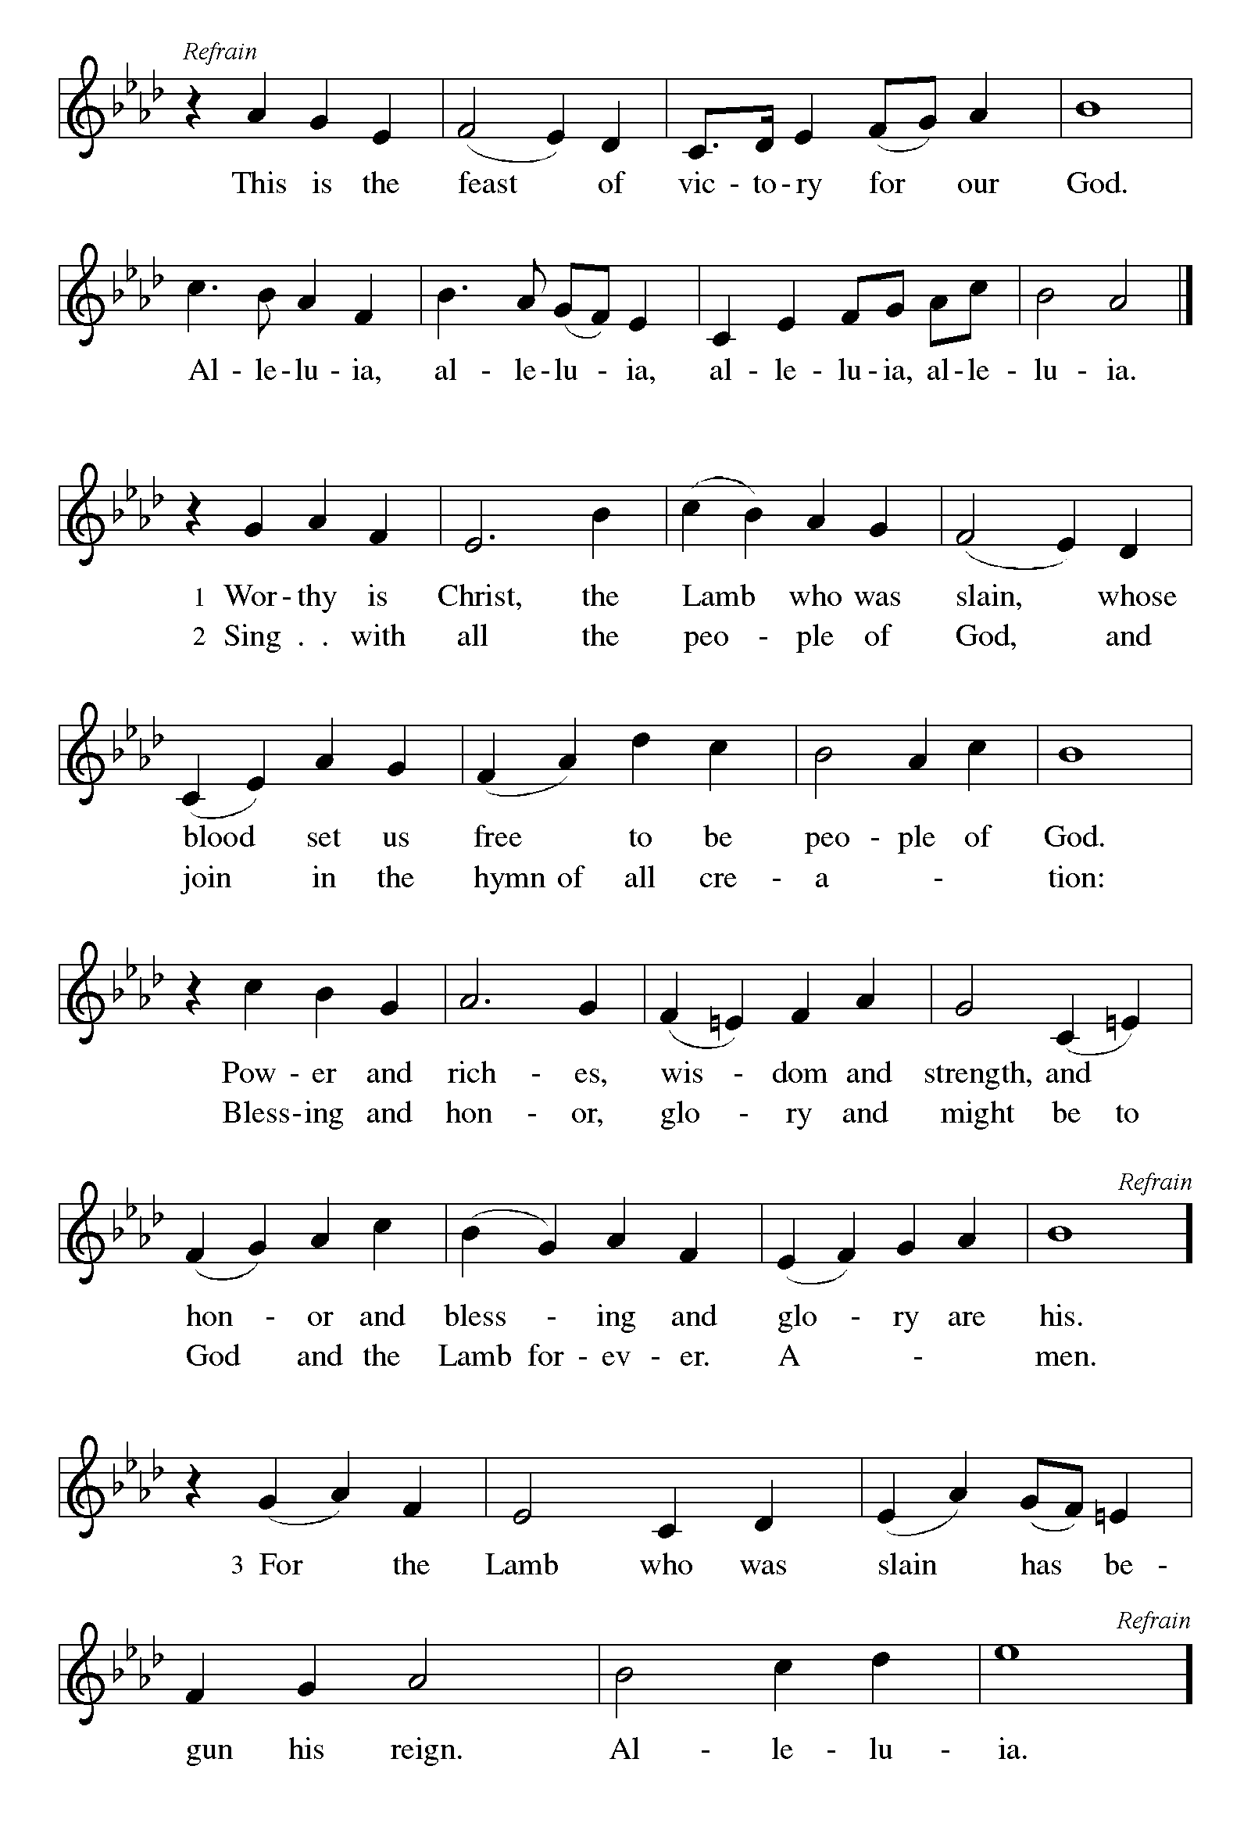

P The Lord be with you
C And also with you.
Let us pray together the Prayer of the Day
Almighty and merciful God, we implore you to hear the prayers of your people. Be our strong defense against all harm and danger, that we may live and grow in faith and hope, through Jesus Christ, our Savior and Lord. Amen.
Children’s Message

Reading: Lamentations 3:22-33 Pew Bible p. 661
²²The steadfast love of the Lord never ceases, his mercies never come to an end;
²³they are new every morning; great is your faithfulness.
²⁴“The Lord is my portion,” says my soul, “therefore I will hope in him.”
²⁵The Lord is good to those who wait for him, to the soul that seeks him.
²⁶It is good that one should wait quietly for the salvation of the Lord.
²⁷It is good for one to bear the yoke in youth,
²⁸to sit alone in silence when the Lord has imposed it,
²⁹to put one’s mouth to the dust (there may yet be hope),
³⁰to give one’s cheek to the smiter, and be filled with insults.
³¹For the Lord will not reject forever.
³²Although he causes grief, he will have compassion
according to the abundance of his steadfast love;
³³for he does not willingly afflict or grieve anyone.
R The Word of the Lord
C Thanks be to God
Gospel Reading: Mark 5:21-43 Pew Bible p. 811

C Glory to you, O Lord
²¹When Jesus had crossed again in the boat to the other side, a great crowd gathered around him; and he was by the sea. ²²Then one of the leaders of the synagogue named Jairus came and, when he saw him, fell at his feet ²³and begged him repeatedly, “My little daughter is at the point of death. Come and lay your hands on her, so that she may be made well, and live.” ²⁴So he went with him.
And a large crowd followed him and pressed in on him. ²⁵Now there was a woman who had been suffering from hemorrhages for twelve years. ²⁶She had endured much under many physicians, and had spent all that she had; and she was no better, but rather grew worse. ²⁷She had heard about Jesus, and came up behind him in the crowd and touched his cloak, ²⁸for she said, “If I but touch his clothes, I will be made well.” ²⁹Immediately her hemorrhage stopped; and she felt in her body that she was healed of her disease. ³⁰Immediately aware that power had gone forth from him, Jesus turned about in the crowd and said, “Who touched my clothes?” ³¹And his disciples said to him, “You see the crowd pressing in on you; how can you say, ‘Who touched me?’ ” ³²He looked all around to see who had done it. ³³But the woman, knowing what had happened to her, came in fear and trembling, fell down before him, and told him the whole truth. ³⁴He said to her, “Daughter, your faith has made you well; go in peace, and be healed of your disease.”
³⁵While he was still speaking, some people came from the leader’s house to say, “Your daughter is dead. Why trouble the teacher any further?” ³⁶But overhearing what they said, Jesus said to the leader of the synagogue, “Do not fear, only believe.” ³⁷He allowed no one to follow him except Peter, James, and John, the brother of James. ³⁸When they came to the house of the leader of the synagogue, he saw a commotion, people weeping and wailing loudly. ³⁹When he had entered, he said to them, “Why do you make a commotion and weep? The child is not dead but sleeping.” ⁴⁰And they laughed at him. Then he put them all outside, and took the child’s father and mother and those who were with him, and went in where the child was. ⁴¹He took her by the hand and said to her, “Talitha cum,” which means, “Little girl, get up!” ⁴²And immediately the girl got up and began to walk about (she was twelve years of age). At this they were overcome with amazement. ⁴³He strictly ordered them that no one should know this, and told them to give her something to eat.
The Gospel of the Lord
C Praise to you, O Christ
Sermon by Pastor John Rothfusz
Sermon Hymn: “Healer of Our Every Ill” Red Book #612
All rights reserved. Used by permission. Reprinted under OneLicense.net #A-711151

Apostles’ Creed
C: I believe in God, the Father almighty,
creator of heaven and earth.
I believe in Jesus Christ, God's only Son, our Lord,
who was conceived by the Holy Spirit,
born of the virgin Mary,
suffered under Pontius Pilate,
was crucified, died, and was buried;
he descended to the dead.
On the third day he rose again;
he ascended into heaven,
he is seated at the right hand of the Father,
and he will come to judge the living and the dead.
I believe in the Holy Spirit,
the holy catholic church, the communion of saints,
the forgiveness of sins, the resurrection of the body,
and the life everlasting. Amen.

Prayers: After each portion of the prayers finishes with “Lord in your mercy,” please respond, “Hear our prayer.”

C The Lord's Prayer
Our Father, who art in heaven, hallowed be thy name,
thy kingdom come, thy will be done, on earth as it is in heaven.
Give us this day our daily bread; and forgive us our trespasses,
as we forgive those who trespass against us;
and lead us not into temptation, but deliver us from evil.
For thine is the kingdom, and the power, and the glory,
forever and ever. Amen

Offering: Jesus lifts us up and gives us new life by his power. Let us use our lives, our selves, and our possessions to give thanks for all that our Lord does for us. We do that now as we joyfully lift our tithes and offerings to the Lord.
Faith Lutheran website link www.shareourfaith.org
Please take a moment now to make an electronic offering to the church on the website, with the Tithe.ly app on your phone, or write a check and send it in.

Announcements

Blessing
P The Lord bless you and keep you.
The Lord make his face shine on you and be gracious to you.
The Lord look upon you with favor and + give you peace.
In the name of the Father, and of the Son and of the Holy Spirit.
C Amen

Hymn: “Oh, For a Thousand Tongues To Sing” Red Book # 886
Public Domain

Dismissal
A Go in peace. Serve the Lord.
C Thanks be to God!

Postlude
Liturgy and texts from Sundays and Seasons.com. Copyright 2021 Augsburg Fortress. All rights reserved.
Reprinted by permission under Augsburg Fortress Liturgies Annual License #23628.

