Children’s Page

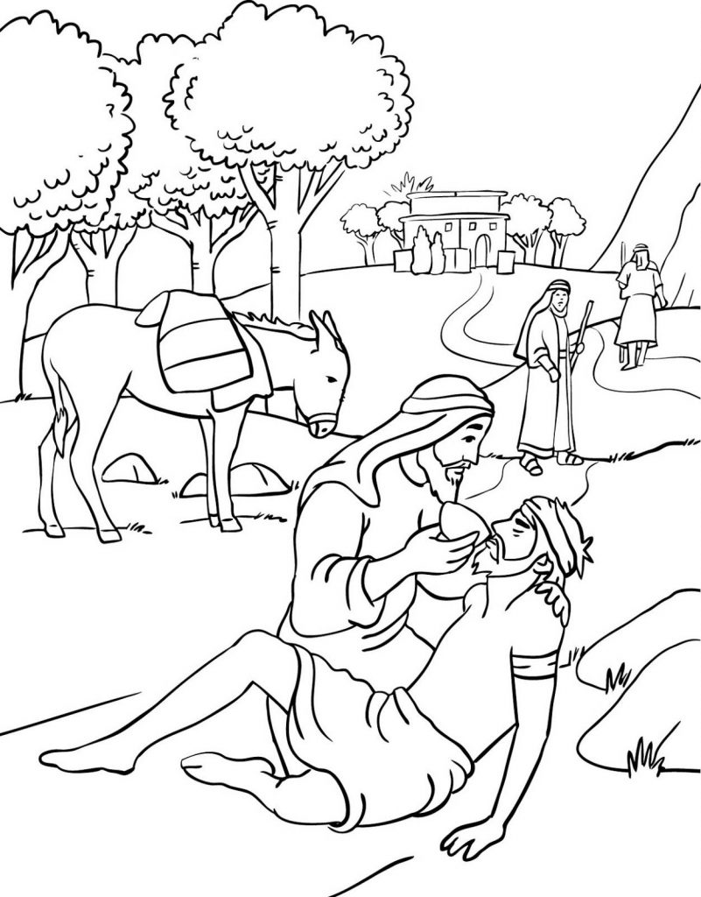
Read Luke 10:30-37
- What happened to the man on the ground?
- Who are the two men walking away?
- Who is the man helping the man on the ground?
- Who do you think is the man on the ground’s “neighbor?”

