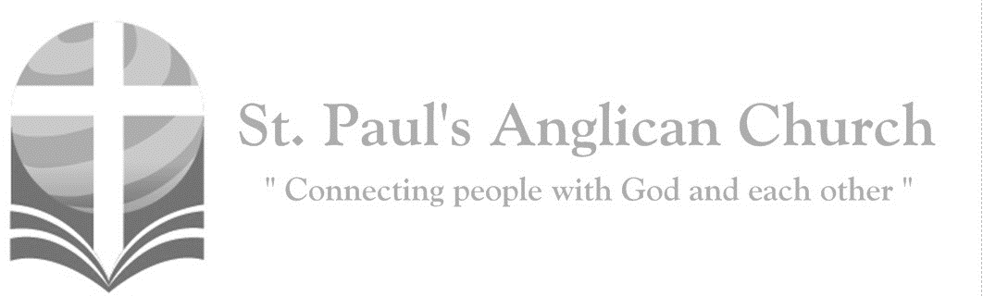
Sunday, June 27, 2021: 5th Sunday After Pentecost

Our Saviour Jesus Christ has abolished death, and brought life and immortality to light through the gospel. (2 Timothy 1:10)

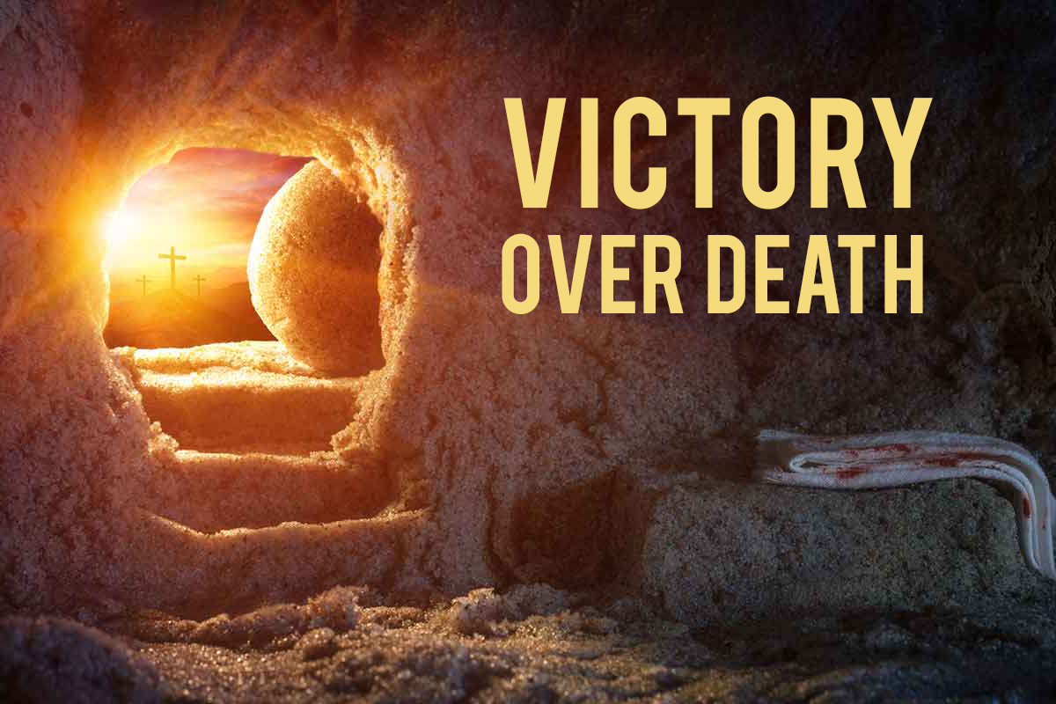

ST. PAUL’S COVID-19 RESPONSE
Welcome!! During this unique time in history, services will look a bit different than normal and will likely be different for quite a while. We want to care for the whole parish during this time and one way to care for one another is keeping each other safe. As such, we ask you to follow these guidelines while worshiping with us:
- Experiencing Cough, Fever, or Other Symptom/s? Go home immediately and please stay home for fourteen days following the end of your symptoms.
- Wear a Mask. All parishioners must wear a mask to all services (as per City of Edmonton bylaw 19408). Exceptions to this include children under the age of two and those with a medical condition where wearing a mask is not possible. Masks may be removed when taking communion but must be replaced immediately following. If you do not have a mask, we have cloth masks available in the foyer.
- Maintain Physical Distance. At all times, please remain a minimum of six feet (three seat spaces) from all other individuals not part of your family unit. You will find tape on the floor six feet apart in multiple locations to help you maintain this distance. Please also maintain physical distance outside.
- Listen to the Ushers. There will be ushers inside and outside to help direct these new procedures. Please heed their direction as they are trying to keep everyone safe and healthy.
- Sign-In Upon Arrival. Please sign-in with the designated usher when you arrive onsite. This will help us track who is in attendance just in case we do have to notify the parish if someone tests Covid positive following a service.
- Sanitize Hands Frequently. Please sanitize your hands upon entry and before taking communion. You may also sanitize as often as you would like during the service. Please also try to refrain from touching surfaces and your face.
- Refrain from Singing. At this time, congregational singing is not allowed by the government of Alberta. Please listen to the lyrics being sung by the leader/s and meditate upon them. You may also hum along to the music as long as your mouth remains closed.
- Recycle Bulletins. Please do not leave bulletins in the pews. A recycle bin is available at the exit door. You may also take the bulletin home.
- Use of Washroom. The only washroom available at this time is located at the back of the Sanctuary (just North of the Main Entry doors). Please wipe down all surfaces (including toilet and handle, counter, and faucet) following use.
- Parts of Building Closed. At this time, the only accessible parts of the building are the Sanctuary, Sanctuary washroom, and alley foyer. All other rooms are closed for use including the main washrooms, hall, basement, and chapel. Please do not access any closed section of the building without permission.

Opening Song: Sing for You

Come let us sing for joy
Come let us shout aloud
To the Rock of our salvation
Come let us sing
Come with a thankful heart
Into His presence now
To make a joyful noise to Him
Come let us sing

In His hands He holds creation
Highest mountains, deepest seas
And on His hands He bears the scars
Of His great love for you and me

(Chorus) For everything You are
For everything You've done
We sing for You, we sing for You
With every breath of life
You're breathing into us
We sing for You, we sing for You
The glory of Your grace
The wonders of Your love
A million songs of praise
Will never be enough
Forever and forever we sing for You

So we come now to give You praise
With how we love and how we obey
We want our lives to be a song
We sing for You

We sing with the saints and angels
Gathered now before Your throne
As we sing holy, holy, holy
You are God and God alone (To Chorus)

The Gathering of the Community
Celebrant: The grace of our Lord Jesus Christ, and the love of God, and the fellowship of the Holy Spirit, be with you all.
People: And also with you.
Celebrant: Almighty God,
All: to you all hearts are open, all desires known, and from you no secrets are hidden. Cleanse the thoughts of our hearts by the inspiration of your Holy Spirit that we may perfectly love you, and worthily magnify your holy name; through Christ our Lord. Amen.
Celebrant: Almighty God, you have taught us through your Son that love fulfils the law. May we love you with all our heart, all our soul, all our mind, and all our strength, and may we love our neighbours as ourselves; through Jesus Christ our Lord, who lives and reigns with you and the Holy Spirit, one God, now and for ever.
People: Amen.

The Reading of Scripture
First Reading: 2 Samuel 1:1, 17-27
After the death of Saul, when David had returned from defeating the Amalekites, David remained two days in Ziklag. David intoned this lamentation over Saul and his son Jonathan. (He ordered that The Song of the Bow be taught to the people of Judah; it is written in the Book of Jashar.) He said: Your glory, O Israel, lies slain upon your high places! How the mighty have fallen! Tell it not in Gath, proclaim it not in the streets of Ashkelon; or the daughters of the Philistines will rejoice, the daughters of the uncircumcised will exult. You mountains of Gilboa, let there be no dew or rain upon you, nor bounteous fields! For there the shield of the mighty was defiled, the shield of Saul, anointed with oil no more. From the blood of the slain, from the fat of the mighty, the bow of Jonathan did not turn back, nor the sword of Saul return empty. Saul and Jonathan, beloved and lovely! In life and in death they were not divided; they were swifter than eagles, they were stronger than lions. O daughters of Israel, weep over Saul, who clothed you with crimson, in luxury, who put ornaments of gold on your apparel. How the mighty have fallen in the midst of the battle! Jonathan lies slain upon your high places. I am distressed for you, my brother Jonathan; greatly beloved were you to me; your love to me was wonderful, passing the love of women. How the mighty have fallen, and the weapons of war perished!

Reader: The Word of the Lord.
People: Thanks be to God.

Canticle: Psalm 130
Out of the depths have I called you, O Lord; Lord, hear my voice; *
let your ears consider well the voice of my supplication.
If you, Lord, were to note what is done amiss, *
O Lord, who could stand?
For there is forgiveness with you; *
therefore, you shall be feared.
I wait for the Lord; my soul waits for him; *
in his word is my hope.
My soul waits for the Lord, more than watchmen for the morning, *
more than watchmen for the morning.
O Israel, wait for the Lord, *
for with the Lord there is mercy;

With him there is plenteous redemption, *
and he shall redeem Israel from all their sins.
Prayer: Rescue us, O God for whom we wait, from the depths of depression and despair. May we trust in your mercy, know the fullness of your redemption, and share in the glory of your kingdom; through our Saviour Jesus Christ.

Second Reading: 2 Corinthians 8:7-15
Now as you excel in everything--in faith, in speech, in knowledge, in utmost eagerness, and in our love for you – so we want you to excel also in this generous undertaking. I do not say this as a command, but I am testing the genuineness of your love against the earnestness of others. For you know the generous act of our Lord Jesus Christ, that though he was rich, yet for your sakes he became poor, so that by his poverty you might become rich. And in this matter I am giving my advice: it is appropriate for you who began last year not only to do something but even to desire to do something – now finish doing it, so that your eagerness may be matched by completing it according to your means. For if the eagerness is there, the gift is acceptable according to what one has – not according to what one does not have. I do not mean that there should be relief for others and pressure on you, but it is a question of a fair balance between your present abundance and their need, so that their abundance may be for your need, in order that there may be a fair balance. As it is written, "The one who had much did not have too much, and the one who had little did not have too little."
Reader: The Word of the Lord.
People: Thanks be to God.

Processional Chorus – Alleluia, Alleluia, Give Thanks to the Risen Lord

Alleluia, alleluia
Give thanks to the Risen Lord
Alleluia, alleluia
Give praise to His Name

The Gospel Reading
Reader: The Lord be with you.
People: And also with you.
Reader: The Holy Gospel of our Lord Jesus Christ according to St. Mark.
People: Glory to you, Lord Jesus Christ.
Gospel Reading: Mark 5:21-43
When Jesus had crossed again in the boat to the other side, a great crowd gathered around him; and he was by the sea. Then one of the leaders of the synagogue named Jairus came and, when he saw him, fell at his feet and begged him repeatedly, "My little daughter is at the point of death. Come and lay your hands on her, so that she may be made well, and live." So he went with him. And a large crowd followed him and pressed in on him. Now there was a woman who had been suffering from hemorrhages for twelve years. She had endured much under many physicians, and had spent all that she had; and she was no better, but rather grew worse. She had heard about Jesus, and came up behind him in the crowd and touched his cloak, for she said, "If I but touch his clothes, I will be made well." Immediately her hemorrhage stopped; and she felt in her body that she was healed of her disease. Immediately aware that power had gone forth from him, Jesus turned about in the crowd and said, "Who touched my clothes?" And his disciples said to him, "You see the crowd pressing in on you; how can you say, 'Who touched me?'" He looked all around to see who had done it. But the woman, knowing what had happened to her, came in fear and trembling, fell down before him, and told him the whole truth. He said to her, "Daughter, your faith has made you well; go in peace, and be healed of your disease." While he was still speaking, some people came from the leader's house to say, "Your daughter is dead. Why trouble the teacher any further?" But overhearing what they said, Jesus said to the leader of the synagogue, "Do not fear, only believe." He allowed no one to follow him except Peter, James, and John, the brother of James. When they came to the house of the leader of the synagogue, he saw a commotion, people weeping and wailing loudly. When he had entered, he said to them, "Why do you make a commotion and weep? The child is not dead but sleeping." And they laughed at him. Then he put them all outside, and took the child's father and mother and those who were with him, and went in where the child was. He took her by the hand and said to her, "Talitha cum," which means, "Little girl, get up!" And immediately the girl got up and began to walk about (she was twelve years of age). At this they were overcome with amazement. He strictly ordered them that no one should know this, and told them to give her something to eat.
Reader: The Gospel of Christ.
People: Praise to you, Lord Jesus Christ.

Worship Through Song

Come as You Are
Come out of sadness
From wherever you've been
Come broken-hearted, let rescue begin
Come find your mercy
O sinner come kneel
Earth has no sorrow
That Heaven can't heal
Earth has no sorrow
That Heaven can't heal (cont. next page)
(Chorus) Lay down your burdens
Lay down your shame
All who are broken, lift up your face
O wanderer come home
You're not too far
So lay down your hurt
Lay down your heart
Come as you are

There's hope for the hopeless
And all those who've strayed
Come sit at the table
Come taste the grace
There's rest for the weary
Rest that endures
Earth has no sorrow
That Heaven can't cure (To Chorus)

Come as you are, fall in His arms
Come as you are
There's joy for the morning
O sinner be still
Earth has no sorrow
That Heaven can't heal
Earth has no sorrow
That Heaven can't heal (To Chorus)

Hallelujah, You are Good
We are standing in-between
Hope and despair
Believing in Your grace
And the faith to declare

(Chorus) You are with us, Hallelujah
Hallelujah, You are good

In the ashes and the dust
The sorrow and pain
Lies the promise of Your word
And the power of Your name
(To Chorus)

And when faith gives way to fear
I will trust Your heart
I will trust Your heart
When I cannot feel You near
I will trust Your heart
I will trust Your heart

There's a message being written
With the morning sun
And a new song for the broken
Death has lost, love has won (To Chorus)

Listening Time

Sermon by the Rev. Dr. Myron B. Penner – Sermon Notes:
________________________________________________________________________________________________________________________________________________________________________________________________________________________________________________________________________________________________________________________________________________________________________________________________________________________________________________________________________________________________________________________
________________________________________________________________________________________________________________________________________________________________________________________________________________________
________________________________________________________________________________________________________________________________________________________________________________________________________________________________________________________________________________________________________________________________________________________________________________________________________________________________________________________________________________________________________________________________________________________________________________________________________________________________________________________________________________________________________________________________________________________________________________________________________________________

Affirmation of Faith – Christ Accompanies Us
Celebrant: Let us confess our faith, as we say,
All: We believe in God, Creator of all things, heavenly father, Soul of infinite love, wisdom, and power, ruler of all that is and all that is to come, who is mystery, yet revealed. We follow Christ, God’s chosen one, who loved and served humbly, who healed the broken and included the outcast, who chose to suffer rather than harm for the sake of the healing of all Creation, who gave his life for our redemption, and who was raised by God to new life. In his teaching, in his death and resurrection, and in his presence with us in all circumstances, he reveals God to us. He calls us to serve him for the sake of proclaiming God’s grace. We trust that he accompanies us and will help, guide, heal, and defend us through all difficulty and suffering. We believe the Holy Spirit sustains us, and guides us and empowers us as servants of God’s grace. We live as the body of Christ, in the power of forgiveness and the reality of resurrection, and the light of eternal life. Amen.

Prayers of the People
Leader: Let us offer our prayers to the source of all love and all life, saying, “Lord, hear our prayer.” Merciful Lord, we pray for all who call themselves Christians: that we may become a royal priesthood, a holy nation, to the praise of Christ Jesus our Saviour.
All: Lord, hear our prayer.
Leader: We pray for Jane our bishop, and for all bishops and other ministers: that they may remain faithful to their calling and rightly proclaim the word of truth. Lord, hear our prayer. We pray for Elizabeth our Queen, for the leaders of the nations, and all in authority: that your people may lead quiet and peaceable lives.
All: Lord, hear our prayer.
Leader: We pray for this city and those who live here, the poor and the rich, the elderly and the young, men and women. Remembering also those in our St. Paul’s Cycle of Prayer: Chandra Singham, Hannah David, and Tisha Raj; Jim and Karen Egeto; Lorraine Bednar; and Dee Cartledge; as well as of those in the Anglican Cycle of Prayer: that you will show your goodwill to all.
All: Lord, hear our prayer.
Leader: We pray for the victims of our society and those who minister to them: that you will be their help and defence.
All: Lord, hear our prayer.
Leader: We pray for those preparing for baptism and confirmation and for those recently baptized or confirmed: that they may be strengthened in the faith.
All: Lord, hear our prayer.
Leader: We give thanks for all the saints who have found favour in your sight from earliest times, prophets, apostles, martyrs, and those whose names are known to you alone: and we pray that we too may be counted among your faithful witnesses.
All: Lord, hear our prayer. Amen.

Confession of Sin
Celebrant: Dear friends in Christ, God is steadfast in love and infinite in mercy; he welcomes sinners and invites them to his table. Let us confess our sins, confident in God’s forgiveness.
Silent Confession
Celebrant: Almighty God,
All: Father of our Lord Jesus Christ, you made all things, and you call everyone to account. With shame we admit that we have sinned against you, in what we have thought, said, and done, and we deserve your judgment. We turn from our sins and are truly sorry for them. Have mercy on us, most merciful Father. For the sake of your Son, our Lord Jesus Christ, forgive us all that is past. Enable us to serve and please you in new life, to your honour and glory, through Jesus Christ our Lord. Amen.
Celebrant: Almighty God have mercy upon you, pardon and deliver you from all your sins, confirm and strengthen you in all goodness and keep you in eternal life through Jesus Christ our Lord.
People: Amen.

The Peace
Celebrant: The peace of the Lord be always with you.
People: And also with you.

Preparation of the Table – Humble King

Oh, kneel me down again
Here at Your feet
Show me how much You love humility
Oh, Spirit be the star that leads me to
The humble heart of love I see in You

('Cause) You are the God of the broken
The friend of the weak
You wash the feet of the weary
Embrace the ones in need
I want to be like You Jesus
To have this heart in me
You are the God of the humble
You are the humble King

Prayer Over the Gifts
Celebrant: God of wisdom,
All: receive all we offer you this day. Enrich our lives with the gifts of your Spirit, that we may follow the way of our Lord Jesus Christ, and serve one another in freedom. We ask this in his name. Amen.

Eucharistic Prayer
Celebrant: The Lord be with you.
People: And also with you.
Celebrant: Lift up your hearts.
People: We lift them to the Lord.
Celebrant: Let us give thanks to the Lord our God.
People: It is right to give our thanks and praise.
Celebrant: Blessed are you, gracious God, creator of heaven and earth; we give you thanks and praise through Jesus Christ our Lord, who on this first day of the week overcame death and the grave, and by his glorious resurrection opened to us the way of everlasting life. In our unending joy we echo on earth the song of the angels in heaven as we raise our voices to proclaim the glory of your name.
All: Holy, holy, holy Lord, God of power and might,
heaven and earth are full of your glory. Hosanna in the highest.
Blessed is he who comes in the name of the Lord.
Hosanna in the highest.
Celebrant: We give thanks to you, Lord our God, for the goodness and love you have made known to us in creation; in calling Israel to be your people; in your Word spoken through the prophets; and above all in the Word made flesh, Jesus your Son. For in these last days you sent him to be incarnate from the Virgin Mary, to be the Saviour and Redeemer of the world. In him, you have delivered us from evil, and made us worthy to stand before you. In him, you have brought us out of error into truth, out of sin into righteousness, out of death into life. On the night he was handed over to suffering and death, a death he freely accepted, our Lord Jesus Christ took bread; and when he had given thanks to you, he broke it, and gave it to his disciples, and said, “Take, eat: this is my body which is given for you. Do this for the remembrance of me.” After supper he took the cup of wine; and when he had given thanks, he gave it to them, and said, “Drink this, all of you: this is my blood of the new covenant, which is shed for you and for many for the forgiveness of sins. Whenever you drink it, do this for the remembrance of me.” Therefore, Father, according to his command,
All: we remember his death, we proclaim his resurrection, we await his coming in glory;
Celebrant: and we offer our sacrifice of praise and thanksgiving to you, Lord of all; presenting to you, from your creation, this bread and this wine. We pray you, gracious God, to send your Holy Spirit upon these gifts, that they may be the sacrament of the body of Christ and his blood of the new covenant. Unite us to your Son in his sacrifice, that we, made acceptable in him, may be sanctified by the Holy Spirit. In the fullness of time, reconcile all things in Christ, and make them new, and bring us to that city of light where you dwell with all your sons and daughters; through Jesus Christ our Lord, the firstborn of all creation, the head of the Church, and the author of our salvation; by whom, and with whom, and in whom, in the unity of the Holy Spirit, all honour and glory are yours, almighty Father, now and for ever.
All: Amen.

Celebrant: As our Saviour taught us, let us pray,
All: Our Father in heaven, hallowed be your name. Your kingdom come, your will be done, on earth as in heaven. Give us today our daily bread. Forgive us our sins as we forgive those who sin against us. Save us from the time of trial, and deliver us from evil. For the kingdom, the power, and the glory are yours, now and for ever. Amen.

Celebrant: We break this bread to share in the body of Christ.
All: We, being many, are one body, for we all share in the one bread.

The Communion
Please listen carefully to the verbal instructions given. You are welcome to receive communion or come forward for a blessing. Gluten-free wafers are also available. Please sanitize your hands as you approach the front of the church. If you prefer to receive a blessing, please fold your arms over your chest. If you would like to make an offering, please do so after you take the bread.
Lamb of God
(Said by congregation) Lamb of God, you take away the sins of the world.
Lamb of God, you take away the sins of the world.
Lord have mercy, Christ have mercy, Lord have mercy on us.

Communion Music

Only by Grace
Only by grace can we enter
Only by grace can we stand
Not by our human endeavour
But by the blood of the Lamb
Into Your presence You call us
You call us to come
Into Your presence You draw us
And now by Your grace we come
Now by Your grace we come

Lord if You mark our transgressions
Who would stand
Thanks to Your grace we are cleansed
By the blood of the Lamb

Prayer After Communion
Celebrant: God of power,
All: we are nourished by the riches of your grace. Raise us to new life in your Son Jesus Christ and fit us for his eternal kingdom, that all the world may call him Lord. We ask this in his name. Amen.

Celebrant: Glory to God,
All: whose power, working in us, can do infinitely more than we can ask or imagine. Glory to God from generation to generation, in the Church and in Christ Jesus, for ever and ever. Amen.

Blessing

Congregational Announcements (Rev. Myron)

Closing Song: Jesus Shall Reign

Jesus shall reign where'er the sun
Does its successive journeys run
His kingdom stretch from shore to shore
Till sun shall rise and set no more
Blessings abound where'er He reigns
The prisoner leaps to lose his chains
The weary find eternal rest
And all the sons of want are blessed
(continued on next page)
(Chorus) To our King be highest praise
Rising through eternal days
Just and faithful, He shall reign
Jesus shall reign

People and realms of every tongue
Dwell on His love with sweetest song
And infant voices shall proclaim
Their early blessings on His name

Let every creature rise and bring
Blessing and honour to our King
Angels descend with songs again
And earth repeat the loud amen
(To Chorus)

The Dismissal
Celebrant: Go in peace to love and serve the Lord.
All: Thanks be to God. Amen.
In-Person Sunday Services – Pre-Registration No Longer Required
As the Province of Alberta has entered Stage Two of the Provincial Reopening plan, St. Paul’s will no longer require pre-registration for attendance on Sunday morning. Masking and Physical Distancing will still be required onsite for all activities. Youth and Children's Ministries will still only be available online.

Eucharist Serving During Services
Going forward, the communion host (wafer) will be served hand to hand instead of being set in individual cups. If you prefer your host to be set in an individual cup, please contact the office no later than Friday at noon each week.

Staff Holidays Over the Summer
Below is a listing of staff holidays and the coverage during that time:
- Rev. Myron: Away July 5-26. Coverage for pastoral emergencies will be announced next week. For other matters that need swift attention, please contact either RJ or Michelle (on the weeks they are here).
- Michelle: Away July 12-16. RJ will be in the office Tuesday and Thursday morning from 9:30-noon this week and will check email daily Monday-Thursday.
- RJ: Away July 19-23: Michelle will be in the office 9-11AM Monday-Thursday and is available on her cell or by email throughout the day.
- Abigail: Away all of July and August. There are no youth activities running during this period.

Office Hours Over July Holidays
- July 5-18: Office open Tuesday and Thursday morning from 9:30-noon
- July 19-27: Office open Monday-Thursday from 9:00-11:00AM
St. Paul’s Accepting Gently Used or New Board Games and Puzzles
If you have gently used board games or puzzles you would like to donate to St. Paul’s, please drop them by St. Paul’s anytime we are open over the next couple of months.
Community Corner for June 27
Today is our Year End Picnic at Sir Wilfred Laurier Park (by the zoo) Pack yourself a picnic and come out for some time together as we launch into summer. There will be some treats available (COVID conscious!) and games and prizes. We look forward to seeing everyone there.

Mark your calendars this summer for Popsicles on the Patio – We have invited the community of Grovenor to enjoy a free popsicle on the church patio on July 21 and August 18 between 6-7 pm. We want you to be a part of it! Just drop by to enjoy a cool, refreshing treat with us – bring a friend!

Indigenous Canada is a Massive Open Online Course (MOOC) from the Faculty of Native Studies at the University of Alberta that explores Indigenous histories and contemporary issues in Canada. They have partnered with Coursera to offer this course for free. Please see this link for more information and to register https://www.ualberta.ca/admissions-programs/online-courses/indigenous-canada/index.html. Michelle is taking this course and willing to form a discussion group for parishioners who are interested.

Community Corner needs your help. You have many good ideas and interests that need to be featured here! Take a minute RIGHT NOW and email, text or call Michelle with your thoughts. We miss every shot we don’t take, and your thoughts are needed.

Anglican Cycle of Prayer:
Diocese of Athabasca: the Rt. Rev. David Greenwood, Bishop. Diocesan Rural Ministry: Chelsy Bouwman, Canon Pastor for Rural Ministry. Buyé Diocese, Gashikanwa (St. Paul) Parish: Leonidas Nizigiyimana, Rector. Frog Lake First Nation.

Next Week’s Ministry Teams:
Music: Adele and Team
Service Team: B and Jackson Teams
Reader/Prayers: Francis and Jennifer B.

This Week’s Ministry Teams:
Music: Andrew and Team
Service Team: Parker and Heritage
Reader/Prayers: Carol R.

St. Paul’s Cycle of Prayer:
Chandra Singham, Hannah David,
and Tisha Raj;
Jim and Karen Egeto;
Lorraine Bednar;
Dee Cartledge
St. Paul’s Anglican Church
10127 145 Street, Edmonton T5N 2X6
Phone: (780) 455-0771; Email: office@stpauls-anglican.ca
Website: www.stpauls-anglican.ca
Office Hours:
Monday-Thursday: 9:00AM-12:00PM
Closed: Fri/Sat/Sun and Stat Holidays
facebook.com/stpachurchedmonton
@StEdmonton
For Care/Concern Team
or other prayer requests, email:
office@stpauls-anglican.ca
For urgent prayer requests call
the church office: (780) 455-0771
For pastoral emergencies call:
(587) 334-2130

St. Paul’s Vestry:
Paul Dowie, Rector’s Warden
Margot Byer, People’s Warden
David Heritage, Treasurer
Barb Dixon, Vestry Member
John Green, Vestry Member
David Parker, Vestry Member
Connie Pistawka, Vestry Member

St. Paul’s Staff:
Rector: The Rev. Myron B. Penner
Community Outreach: Michelle Schurek
Youth Leader: Abigail Harding
Office Administrator: RJ Chambers

