Ordinary Time
Summer
27 June 2021
GATHER
Welcome`
Confession and Forgiveness
Please rise in body or spirit.
P Blessed be the holy Trinity, one God, who has announced the coming of the Kingdom with stories of grateful debtors and rich fools; faithful servants and wayward sons; one God,
C AMEN.
P Let us prepare our hearts for worship, confessing our sins.
Silence is kept for reflection.
P Loving and merciful God,
C we thank you for the community in which you have placed us, for the brothers and sisters with whom we walk this pilgrim journey.
Yet, we confess that we fail to love as you love. We are quick to share our own stories while we ignore the stories of others. We fail to see your Kingdom in parables because we fail to see your Kingdom in each other. We push aside those whom we believe are the least in your Kingdom.
Form in us a new vision of community in which there is neither East nor West, neither South nor North.
Challenge our assumptions, and instill in us a holy dis-ease until all have heard your story. For the sake of your Kingdom that is and is not yet. Amen.
P The Father has rescued us from the power of darkness and transferred us into the kingdom of His beloved Son, in whom we have redemption, the forgiveness of sins (Colossians 1:13-14).
C AMEN
Gathering Song
ELW # 661 “I Love to Tell the Story“
(verse 2a) I love to tell the story of someone left for dead
Two righteous men walked by him, at his need each turned their head.
A third man looked straight at him, compassion in his eyes
An unexpected stranger didn’t leave him there to die. (refrain)
Greeting and Prayer of the Day
P To all God’s beloved who love to hear and tell the old, old, ever new story of Jesus and His love: Grace to you and peace from God our Father and the Lord Jesus Christ.
C AND ALSO WITH YOU.
P Let us pray.
A brief silence is kept before the prayer.
P Lord Jesus, as we hear and reflect upon the parables that You told the crowds and explained to Your disciples, give us a sensitivity to listen, not just to the parable, but to the responses of our hearts to what we encounter in Your words.
C AMEN.
Please be seated.
WORD
Children’s Time
Psalm & Gloria Psalm 95 repeat verse 1
Please rise in body or spirit
Preaching Text Luke 10:30-37
The Word of the Lord/THANKS BE TO GOD.
Please be seated
Sermon “The Good Samaritan”
Special Music
Apostles Creed
C I BELIEVE IN GOD, THE FATHER ALMIGHTY, CREATOR OF HEAVEN AND EARTH.
I BELIEVE IN JESUS CHRIST, HIS ONLY SON, OUR LORD. HE WAS CONCEIVED BY THE POWER OF THE HOLY SPIRIT AND BORN OF THE VIRGIN MARY. HE SUFFERED UNDER PONTIUS PILATE, WAS CRUCIFIED, DIED AND WAS BURIED. HE DESCENDED INTO HELL. ON THE THIRD DAY HE ROSE AGAIN. HE ASCENDED INTO HEAVEN AND IS SEATED AT THE RIGHT HAND OF THE FATHER. HE WILL COME AGAIN TO JUDGE THE LIVING AND THE DEAD.
I BELIEVE IN THE HOLY SPIRIT, THE HOLY CATHOLIC CHURCH, THE COMMUNION OF SAINTS, THE FORGIVENESS OF SINS, THE RESURRECTION OF THE BODY AND THE LIFE EVERLASTING. AMEN.
Prayers of Intercession and Thanksgiving
Please rise in body or spirit
A Almighty God, Your Son Jesus Christ has promised that You will hear us when we ask in faith: receive the prayers we offer.
Word of God. Word of Life. / HEAR OUR PRAYER.
P Hear us, Father, through Jesus Christ our Lord, who lives and reigns with You in the unity of the Holy Spirit, one God, now and forever.
C AMEN.
Please be seated.
MEAL
Offering the Gifts and Tithes
After the offering has been brought to the table,
please stand as you are able.

Offering Prayer
A Let us pray. Lord God, with the action of this offering we tell Your story: how You have dealt generously with us, how You have met our needs, how You have heard our prayers, how Your goodness is from everlasting to everlasting. Bless these offerings which are given in the name of Christ.
C AMEN.
The Thanksgiving
P The Lord be with You
C and also with You.
P Lift up Your hearts.
C We lift them to the Lord.
P Let us give thanks to the Lord our God
C It is right to give our thanks and praise.
P Come, let us gather round the table. Light the candles...
In the night in which He was betrayed....
Lord’s Prayer (using “trespasses”)
p You inspire Your people, teaching us to pray:
C Our Father, who art in heaven...
P The table is ready. All are welcome. Come, for the feast is spread.
Please be seated.
The elements will be brought to your seat.
After all have communed; please rise in body or spirit.
P The body and blood of our Lord Jesus Christ strengthen You and keep You in His grace.
C AMEN.
Prayer after Communion
A Let us pray together. O God, as a mother comforts her child,
C SO YOU COMFORT YOUR PEOPLE, CARRYING US IN YOUR ARMS AND SATISFYING US WITH THIS FOOD AND DRINK, THE BODY AND BLOOD OF CHRIST. SEND US NOW AS YOUR DISCIPLES, ANNOUNCING PEACE, TELLING STORIES, AND PROCLAIMING THAT THE KINGDOM OF GOD HAS COME NEAR; THROUGH JESUS CHRIST, OUR SAVIOR AND LORD. AMEN.
SEND
Sending of Communion
P Eternal God, whose... in Jesus Christ our Lord.
C AMEN.
Benediction
P The Lord bless you and keep you.
The Lord's face shine upon you with grace and mercy.
The Lord look upon you with favor
and give you peace.
C AMEN.
Sending Song
ELW # 536 “God Be with You Till we Meet Again”
Announcements and Dismissal
A Go now to love and serve the world loved by Christ our Lord. As you go, be the feet of Christ, the hands of Christ, the voice of Christ.
As you go, share stories of a sheep, a coin, and a son gone astray, tell tales of tenants and talents, slaves and masters, and a rich young fool.
Yes, tell these stories. Share your own story. And listen to those of others
C THANKS BE TO GOD.
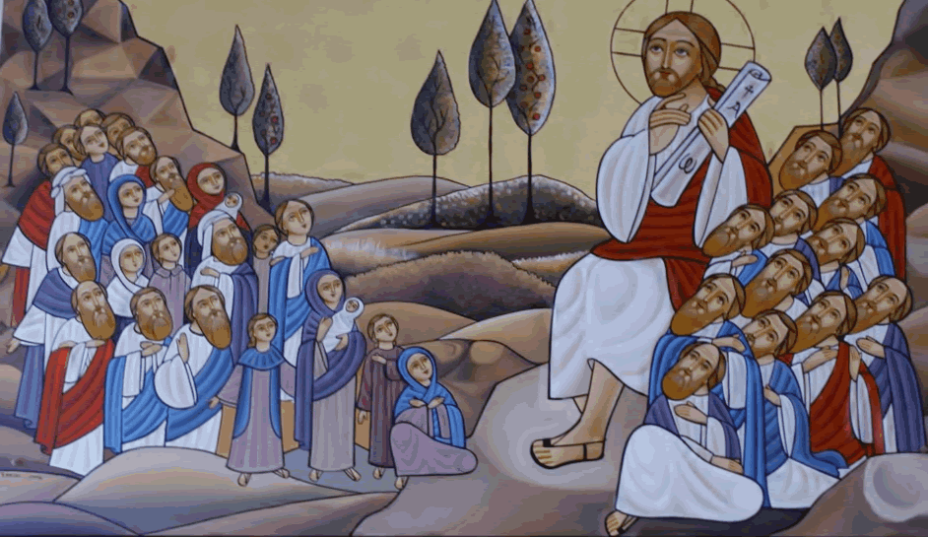

St. John’s Evangelical Lutheran Church
1430 Melody Lane El Cajon, CA 92019
619.444.11272
www.stjohnslutheranelcajon.org
The Church Office is open Tuesday - Thursday
from 9:00a-1:00p

WORSHIP LEADERS - This Week
Presiding Minister the Rev. Dr. Richard W. Vevia, Jr
Assisting Minister Kristine Hurtado-Bergstrom
Reader Tracy Vevia
Church Musician Jennifer Airy
Ensemble Members Kristine Hurtado-Bergstrom, Susanne O’Grady, and Tracy Vevia
Usher John Hoffman
Videographer Lilly Airy
Altar Guild Laura Stephens

Bible study
“Parables of Jesus” meets on Thursday @ 9:30a (Zoom)
This week: “The Rich Fool” - Luke 12:16-21
Meetings this week.
Worship Committee meets on Thursday @ 3:30p
Sunday Worship
In-person and live streamed on Facebook @ 8:30 a.m.
Lutheran Retreats, Camps and Conferences News!
SUMMER CAMP 2021 IS BACK!
We are thrilled to be able to open up camp safely this summer for campers and families. We want to see you at camp this summer so you can DISCOVER and experience the joy of camp again! our theme is 'Discover,' an exploration into the abundant love of God through Christ, both seen and unseen! Our theme verse is Jeremiah 33:3, "Call to me and I will answer you and tell you great and unsearchable things you do not know.”
With COVID-19 protocols, space will be LIMITED. Please make sure to sign up early to reserve your spot!
For dates, registration, and information regarding Summer Camp 2021 please visit www.lrcchome.com/summer-camp-2021.
What is the H.E.L.P. CAMP-aign?
The H.E.L.P. CAMP-aign is our recovery plan. H.E.L.P. is an acronym:
- Help kids get to camp
- Encourage young adults to be counselors
- ﻿Lean into your camp's financial recovery
- Pray for God’s blessing
Thank you to the congregations of the Pacifica Synod for supporting Lutheran Retreats, Camps and Conferences' H.E.L.P. CAMP-aign Resolution at their Synod Assembly. The same resolution will go before the Southwest California Synod in early June.
The real impact of the Covid-19 pandemic closures of our local Lutheran Bible camps has resulted in over $1,000,000 dollars in lost revenue. Thankfully our donors responded generously, but we still have a long way to go.
You will hear more about the H.E.L.P. CAMP-aign in the next few months. How can you help today? H: Help kids get to camp!
It's time to fill our Bible camps this summer with campers. Our summer staff is excited and ready to go!

