Faith Evangelical Lutheran Church, Washington, IL
Fourth Sunday after Pentecost
June 20, 2021
Online Worship

Prelude
Welcome
Confession and Forgiveness

P: In the name of the Father, and of the + Son, and of the Holy Spirit.
C: Amen.
You may make the sign of the cross as a reminder of your baptism.
P: Almighty God, to whom all hearts are open, all desires known, and from whom no secrets are hid: cleanse the thoughts of our hearts by the inspiration of your Holy Spirit, that we may perfectly love you and worthily magnify your holy name, through Jesus Christ our Lord.
C: Amen.
P: Let us confess our sin in the presence of God and of one another.
Please keep silence for reflection
P: Most merciful God,
C: we confess that we are captive to sin and cannot free ourselves. We have sinned against you in thought, word, and deed, by what we have done and by what we have left undone. We have not loved you with our whole heart; we have not loved our neighbors as ourselves. For the sake of your Son, Jesus Christ, have mercy on us. Forgive us, renew us, and lead us, so that we may delight in your will and walk in your ways, to the glory of your holy name. Amen.
P: In the mercy of almighty God, Jesus Christ was given to die for us, and for his sake God forgives us all our sins. As a called and ordained minister of the church of Christ, and by his authority, I therefore declare to you the entire forgiveness of all your sins, in the name of the Father, and of the + Son, and of the Holy Spirit.
C: Amen.
Faith Lutheran Church
2206 Washington Rd,
Washington, IL 61571
Website and online worship:
www.shareourfaith.org
Church: 309-745-9306
faithlth@shareourfaith.org
Pastor John Rothfusz
Home: 309-745-9282
pastor@shareourfaith.org

Peace: As forgiven children of God, we have peace
with God, and peace with one another.
P The peace of the Lord be with you always.
C And also with you.
P Let us share that peace with one another.
*Hymn: “When Peace Like a River” Red Book #785
Public Domain

P The grace of our Lord Jesus Christ, the love of God,
and the communion of the Holy Spirit be with you all.
C And also with you.

Hymn of Praise
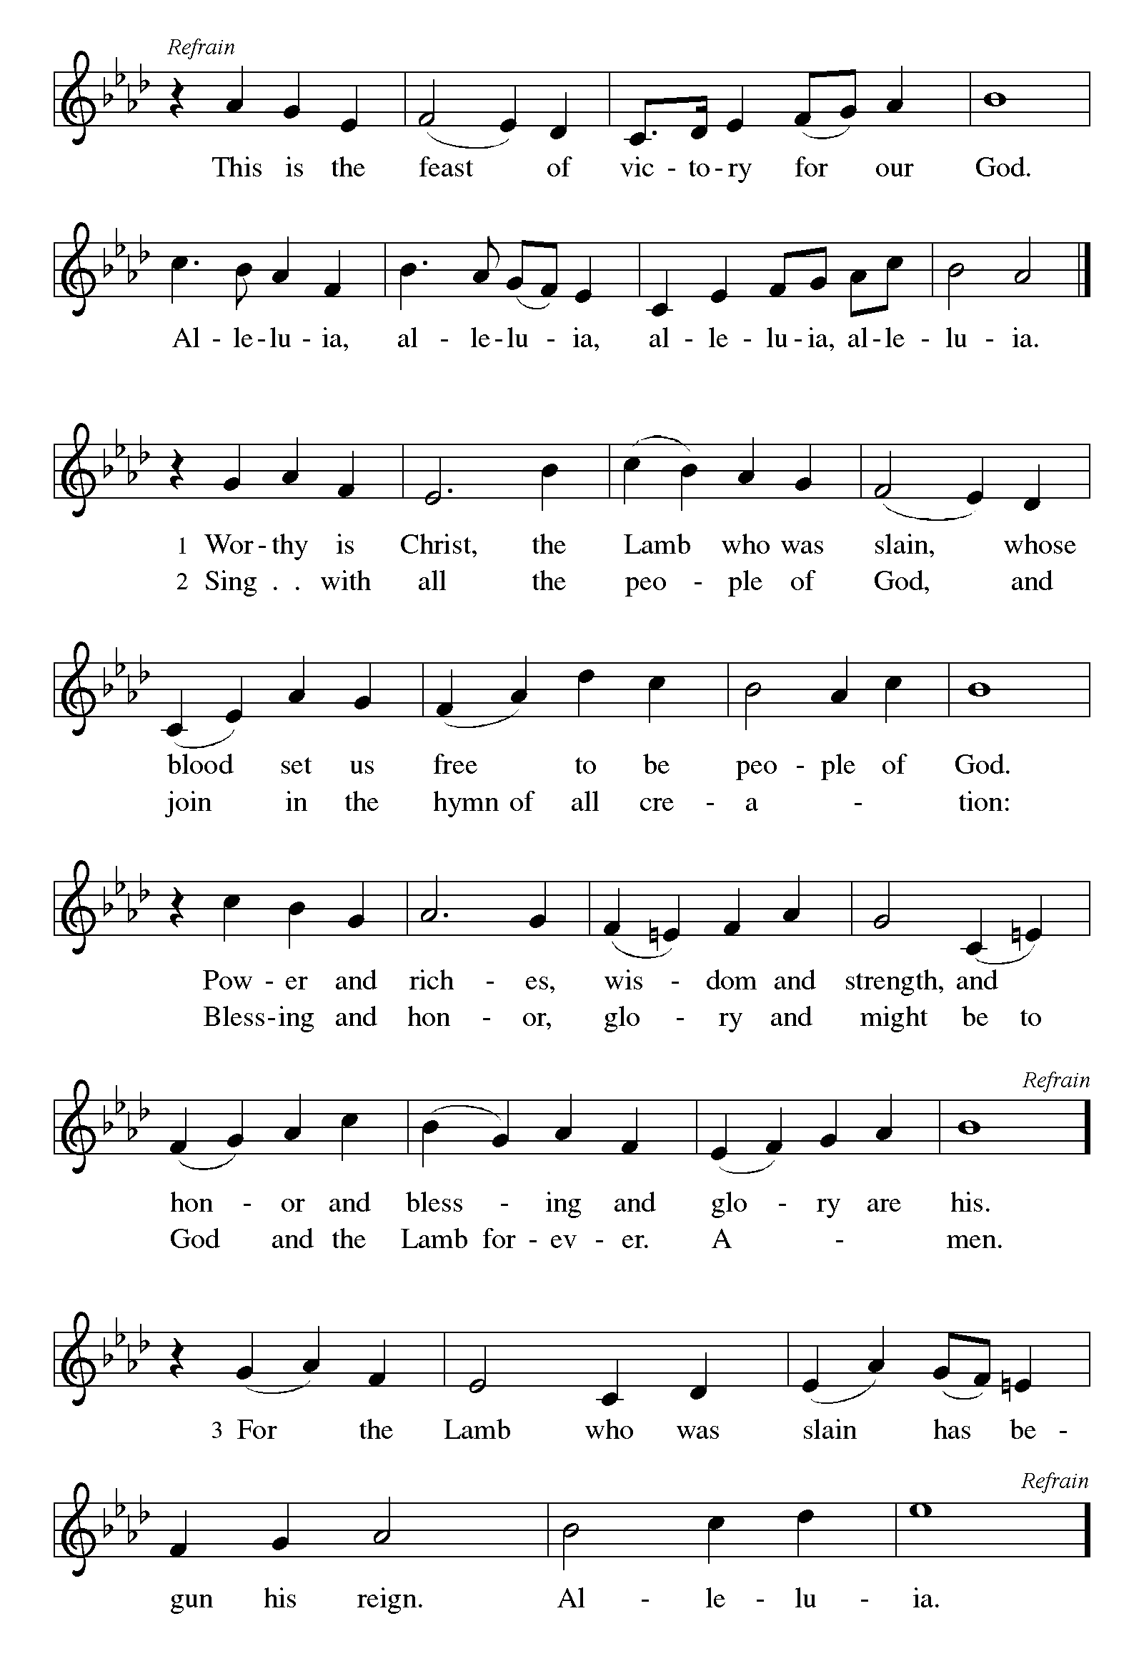

P The Lord be with you
C And also with you.
Let us pray together the Prayer of the Day
O God of creation, eternal majesty, you preside over land and sea, sunshine and storm. By your strength pilot us, by your power preserve us, by your wisdom instruct us, and by your hand protect us, through Jesus Christ, our Savior and Lord. Amen.
Children’s Message

Reading: 2 Corinthians 6:1-13 Pew Bible p. 937
¹As we work together with him, we urge you also not to accept the grace of God in vain. ²For he says,
“At an acceptable time I have listened to you,
and on a day of salvation I have helped you.”
See, now is the acceptable time; see, now is the day of salvation! ³We are putting no obstacle in anyone’s way, so that no fault may be found with our ministry, ⁴but as servants of God we have commended ourselves in every way: through great endurance, in afflictions, hardships, calamities, ⁵beatings, imprisonments, riots, labors, sleepless nights, hunger; ⁶by purity, knowledge, patience, kindness, holiness of spirit, genuine love, ⁷truthful speech, and the power of God; with the weapons of righteousness for the right hand and for the left; ⁸in honor and dishonor, in ill repute and good repute. We are treated as impostors, and yet are true; ⁹as unknown, and yet are well known; as dying, and see—we are alive; as punished, and yet not killed; ¹⁰as sorrowful, yet always rejoicing; as poor, yet making many rich; as having nothing, and yet possessing everything.
¹¹We have spoken frankly to you Corinthians; our heart is wide open to you. ¹²There is no restriction in our affections, but only in yours. ¹³In return—I speak as to children—open wide your hearts also.
R The Word of the Lord
C Thanks be to God

Gospel Reading: Mark 4:35-41 Pew Bible p. 811

C Glory to you, O Lord
³⁵When evening had come, [Jesus said to the disciples,] “Let us go across to the other side.” ³⁶And leaving the crowd behind, they took him with them in the boat, just as he was. Other boats were with him. ³⁷A great windstorm arose, and the waves beat into the boat, so that the boat was already being swamped. ³⁸But he was in the stern, asleep on the cushion; and they woke him up and said to him, “Teacher, do you not care that we are perishing?” ³⁹He woke up and rebuked the wind, and said to the sea, “Peace! Be still!” Then the wind ceased, and there was a dead calm. ⁴⁰He said to them, “Why are you afraid? Have you still no faith?” ⁴¹And they were filled with great awe and said to one another, “Who then is this, that even the wind and the sea obey him?”
The Gospel of the Lord
C Praise to you, O Christ
Sermon by Pastor John Rothfusz

Sermon Hymn: “Eternal Father, Strong to Save” Red Book #756
Public Domain

Apostles’ Creed
C: I believe in God, the Father almighty,
creator of heaven and earth.
I believe in Jesus Christ, God's only Son, our Lord,
who was conceived by the Holy Spirit,
born of the virgin Mary,
suffered under Pontius Pilate,
was crucified, died, and was buried;
he descended to the dead.
On the third day he rose again;
he ascended into heaven,
he is seated at the right hand of the Father,
and he will come to judge the living and the dead.
I believe in the Holy Spirit,
the holy catholic church, the communion of saints,
the forgiveness of sins, the resurrection of the body,
and the life everlasting. Amen.

Prayers: After each portion of the prayers finishes with “Lord in your mercy,” please respond, “Hear our prayer.”

C The Lord's Prayer
Our Father, who art in heaven, hallowed be thy name,
thy kingdom come, thy will be done, on earth as it is in heaven.
Give us this day our daily bread; and forgive us our trespasses,
as we forgive those who trespass against us;
and lead us not into temptation, but deliver us from evil.
For thine is the kingdom, and the power, and the glory,
forever and ever. Amen

Offering: The God who stills the storm has power to sustain us in every time of trouble. Let us praise God with all of our lives as we lift up our tithes and offerings to the Lord.
Please take a moment now to make an electronic offering to the church on the website, with the Tithe.ly app on your phone, or write a check and send it in.
Faith Lutheran website link www.shareourfaith.org

Announcements
Blessing
P The Lord bless you and keep you.
The Lord make his face shine on you and be gracious to you.
The Lord look upon you with favor and + give you peace.
In the name of the Father, and of the Son and of the Holy Spirit.
C Amen

Hymn: “My Life Flows on in Endless Song” Red Book # 763
Public Domain
Dismissal
A Go in peace. Serve the Lord.
C Thanks be to God!

Postlude
From Sundays and Seasons.com. Copyright 2021 Augsburg Fortress. All rights reserved.
Reprinted by permission under Augsburg Fortress Liturgies Annual License #23628.

