Celebrating the Life of
David Michael Ormerod
November 15, 1976 – June 2, 2021

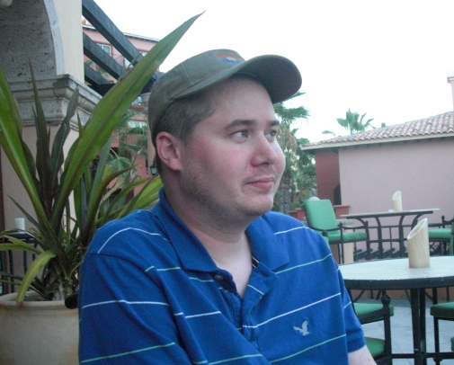

Saturday, June 19, 2021
St Agnes Memorial Garden

Celebrating the Life of
David Omerod

Welcome & Prayer: The Venerable Stephen Muir

Sentences
I am Resurrection and I am Life, says the Lord.
Whoever has faith in me shall have life,
even though he die.
And everyone who has life,
and is committed to me in faith,
shall not die for ever. John 11:25-26

Let not your hearts be troubled;
believe in God, believe also in me.
In my Father’s house are many rooms;
if it were not so, would I have told you
that I go to prepare a place for you?
And when I go and prepare a place for you,
I will come again and will take you to myself,
that where I am you may be also. John 14:1-3

I am sure that neither death, nor life,
nor angels, nor principalities,
nor things present, nor things to come,
nor powers, nor height, nor depth,
nor anything else in all creation,
will be able to separate us from the love of God
in Christ Jesus our Lord. Romans 8:38-39

Let us pray.
God of all consolation,
in your unending love and mercy
you turn the darkness of death into the dawn of new life.
Show compassion to your people in their sorrow.
Be our refuge and our strength
to lift us from the darkness of grief
to the peace and light of your presence.
Your Son, our Lord Jesus Christ,
by dying for us, conquered death
and by rising again, restored life.
May we then go forward eagerly to meet him,
and after our life on earth
be reunited with our brothers and sisters
where every tear will be wiped away.
We ask this through Jesus Christ, the Lord. Amen.

Eulogy: David Gifford

Psalm 23

The Lord is my shepherd; I shall not want.
He maketh me to lie down in green pastures:
he leadeth me beside the still waters.
He restoreth my soul: he leadeth me in the paths of righteousness for his name’s sake.
Yea, though I walk through the valley of the shadow of death, I will fear no evil: for thou art with me; thy rod and thy staff they comfort me.
Thou preparest a table before me in the presence of mine enemies: thou anointest my head with oil;
my cup runneth over.
Surely goodness and mercy shall follow me all the days of my life: and I will dwell in the house of the Lord for ever.

2 Corinthians 4:16-5:1 read by Eric Bozman.
So we do not lose heart. Even though our outer nature is wasting away, our inner nature is being renewed day by day. For this slight momentary affliction is preparing us for an eternal weight of glory beyond all measure, because we look not at what can be seen but at what cannot be seen; for what can be seen is temporary, but what cannot be seen is eternal. For we know that if the earthly tent we live in is destroyed, we have a building from God, a house not made with hands, eternal in the heavens.
The Word of the Lord
All Thanks be to God.

Homily The Venerable Stephen Muir

A Prayer for David

God of grace and glory, we thank you for David,
who was so near and dear to us, and who has now
been taken from us.

We thank you for the friendship he gave and for the
strength and peace he brought. We thank you for the
love he offered and received while he was with us on earth.

We pray that nothing good in David’s life will be lost,
but will be of benefit to the world; that all that was
important to him will be respected by those who follow;
and that everything in which he was great will continue
to mean much to us now that he is dead.

We ask you that he may go on living in his
family and friends; in their hearts and minds,
in their courage and their consciences.

We ask you that we who were close to him may now,
because of his death, be even closer to each other,
and that we may, in peace and friendship here on earth,
always be deeply conscious of your promise to be faithful to us in death.

We pray for ourselves, who are saddened by this
death, that we do not try to minimize this loss, or seek
refuge from it in words alone, and also that we do not
brood over it so that it overwhelms us and isolates us from others.

May God grant us courage and confidence in the new life of Christ. We ask this in the name of the risen Lord. Amen.

Celebrant Into your hands, O merciful Saviour,
we commend your servant David.
Acknowledge, we pray, a sheep of your own fold,
a lamb of your own flock,
a sinner of your own redeeming.
Receive him into the arms of your mercy,
into the blessed rest of everlasting peace,
and into the glorious company of the saints in light.
People Amen.

Celebrant Rest eternal grant to him, O Lord.
People And let light perpetual shine upon him.

Celebrant May his soul,
and the souls of all the departed,
through the mercy of God, rest in peace.
People Amen.

The ashes are interred in the earth.

Everyone is invited to take some soil and place it in the garden.

Celebrant Into the darkness and warmth of the earth
People We lay you down
Celebrant Into the sadness and smiles of our memories
People We lay you down
Celebrant Into the cycle of living and dying and rising again
People We lay you down
Celebrant May you rest in peace, in fulfillment, in love
People May you run straight home into God’s embrace.
Celebrant Into the freedom of wind and sunshine
People We let you go
Celebrant Into the dance of the stars and the planets
People We let you go
Celebrant Into the wind’s breath and the hands of the Starmaker
People We let you go
Celebrant We love you, we miss you, we want you to be eternally happy
People Go safely, go dancing, go running home.
- Ruth Burgess

Celebrant In sure and certain hope of the resurrection to eternal life through our Lord Jesus Christ, we commend to almighty God our brother David and we commit his ashes to the ground, earth to earth, ashes to ashes, dust to dust. The Lord bless him and keep him. The Lord make his face to shine upon him and be gracious to him. The Lord lift up his countenance upon him and give him peace.
People Amen

Celebrant As our Saviour taught us; let us pray,

All Our Father in heaven,
hallowed be your name,
your kingdom come,
your will be done,
on earth as in heaven.
Give us today our daily bread.
Forgive us our sins
as we forgive those who sin against us.
Save us from the time of trial,
and deliver us from evil.
For the kingdom, the power,
and the glory are yours,
now and for ever. Amen.

Celebrant May the God of peace
who brought again from the dead our Lord Jesus,
the great shepherd of the sheep,
by the blood of the eternal covenant,
equip you with everything good
that you may do his will,
working in you that which is pleasing in his sight,
through Jesus Christ,
to whom be glory for ever and ever.
People Amen.

Celebrant Go forth in the name of Christ.
People Thanks be to God.

David Michael Ormerod
November 15, 1976 – June 2, 2021

David was born on Monday, November 15th 1976 at Scarborough General Hospital in Toronto to parents Sue and Brian Ormerod. He was a healthy 7 pounds 8 oz. As a small boy he loved playing outside, running around and generally causing mayhem. When David was 3 years old he moved to Vancouver with his mum after his parents split up. David had lots of family in Vancouver who he enjoyed visiting with and developed close relationships with his aunts, Karen, Deborah and Marion as well as his maternal grandmother, to name a few.

In 1983, Sue married Ken Washburn and Dave got a stepfather. The family moved to Surrey until 1984 then moved back to Toronto where Dave’s brother Nigel was born. Dave made lots of friends in Toronto and enjoyed riding his bike and playing various sports. In 1985, David was diagnosed with Muscular Dystrophy, which helped him understand why he was having so many problems with walking and using his muscles. He was originally told that he had Duchenne Muscular Dystrophy, however the diagnosis was changed to Becker MD as he grew older.

In 1986, David was very excited to meet Mr. T from the television show The A Team. Mr. T was filming close by and David was able to hang off Mr. T’s arms and touch the many gold chains that he wore around his neck.

It was also in 1986 when Dave fell in love with the Toronto Blue Jays. He attended several games with his family and loved following the stats and the players. Dave was very knowledgeable about the team, giving yearly predictions that usually turned out to be true! This love of the Jays lasted all his life.

His family moved back again to Vancouver in 1988 where David attended Carson Graham Secondary. Dave was having serious health issues at this time, quite often falling and not being able to walk for any length of time. Around this time Dave fell at school and broke his arm for the 1st time, not more than 6 months later he fell once more and broke his arm for the 2nd time. The two casts were orange and green to match a game he was playing! Around this time, David got involved with the Easter Seals program and attended a youth camp for a few years where he made a lasting impression with staff and fellow campers. He led by example and even participated in the Leaders in Training program. He was an inspiration to some of the younger children, proving life could be done differently; filled with humour and more of the fun things in life. He showed a lot of us that living with a disability wasn’t the end of the world.

His love of the Blue Jays continued and Dave went to Seattle with his family for several years to see them play the Mariners, always staying at the same hotel.

David’s father Brian also remarried. Anita had two children of her own so Dave became a stepbrother to Rob and Michelle. Brian and Anita also had two sons, Craig and Sean and David had two more brothers to horse around with! Dave often stayed with Brian and his family, once travelling across Canada together in their RV.

When he was 19, David moved out on his own to an apartment he shared with Chris in North Vancouver. He met and fell in love with Becky. He moved again into a different apartment with a new roommate, Steve. Becky joined them in the apartment shortly thereafter.

Dave’s apartment was the source of so much laughter. The place was often full of people with music playing and good times being had by all. A place where everyone got along and Dave’s disability was never brought up. He had his spot in the kitchen on his black chair and entertained everyone into the wee hours. He shared his love of music and introduced people to many tracks from classic rock songs to obscure hip-hop artists no one had heard of yet. His CD collection was rivalled by none and the car stereo was also often heard thumping. Oh, the late 90’s!
In 2003 Dave’s health took turn for the worse and he was admitted to Lions Gate Hospital with heart failure. He spent 3 weeks in the hospital with Becky by his side until his heart was stabilized. Released with 18% heart function and told he had only 18 months to live, he returned home and gradually became more dependant on a wheelchair until it became permanent due to serious heart function problems. In order to try and live more comfortably, Dave and Becky decided to move in with her parents Kathryn and Eric. In 2006, with his health stable, Dave and Becky got married at a local church and held a big reception at the Holiday Inn in North Vancouver.

With his health being comfortable, they had a chance to travel; enjoyed several trips to Mexico, a trip to California and also a trip to Toronto to see Dave’s beloved Blue Jays. While in Toronto, Dave was able to touch base with an old friend from the time he lived there in the 80’s.

Dave and Becky also followed the Jays to Seattle a few times, even taking the Amtrak train one time as an added adventure. Never a dull moment!

Dave was a great gamer and had every PlayStation game ever made! Some of his favourite games were Grand Turismo, Call of Duty, and he particularly enjoyed the Assassins Creed series because he loved the history aspect of the game.

Although Dave and Becky didn’t have children, Dave was a fantastic cat dad. He had a special relationship with his apartment cat Princess. She had kittens Buddy and Sylvester (who is still with us today). After losing buddy, Dave and Becky adopted Felix.

Theirs was a special bond and David loved Felix like any parent loves a child. They were inseparable, Felix provided comfort while Becky was away at work all day and the bond created was extremely special. Felix even came to visit Dave while he was in the hospital!
Sadly, Dave’s health began to slip again in December 2020. He suffered a gall bladder attack at Christmas and in January 2021 he was rushed to Emergency. Admitted to the Lions Gate Hospital with serious pancreatitis, he spent 128 days in the Intensive Care Unit. Becky spent every day at the hospital and was inspirational in keeping Dave’s spirits up. In early May, David decided to become baptized into the Anglican church because he wanted to feel at peace.

After several months in the ICU and little progress being made, Dave decided it was time to leave the hospital. He was tired of all the tests, the medical equipment he was attached to and not being able to have friends and family visit him. He wasn’t sure how he would feel at home but was not very happy with the decline in his health and knew he couldn’t be there anymore.

He was released into Becky’s care and was able to say good bye to his closest friends and family in the few days he was at home. Dave made the very difficult decision to use the MAID (medical assistance in dying) program to end his life. He was suffering more than any of us could imagine and although it’s hard to see him go, Dave lived his life on his terms and this was his final message of strength to all of us.

On Wednesday June 2nd at 12:01pm Dave passed away with his wife Becky, mom Sue, father-in-law Eric, stepfather Ken and Father Stephen by his side. Dave was finally free of pain and the much hated breathing support machines that took his favourite things from him.

Dave will be incredibly missed by all of his large extended family as well as his wife and his sets of parents, all his aunts, uncles, brothers and sister. David will also be missed by all his loyal friends who feel as lost without their friend as everyone else does.
May he rest in peace and watch over us, until we meet again.

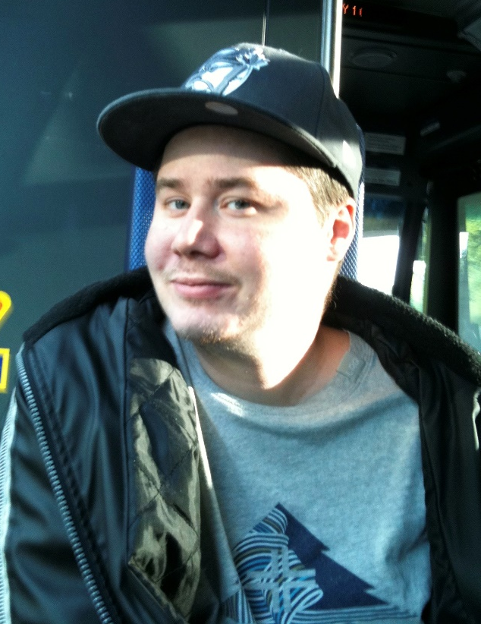

Celebrant: The Venerable Stephen Muir
Rector, St Agnes’ Anglican Church

St. Agnes’ Anglican Church
530 12th Street East,
North Vancouver, BC V7L 2K4
Phone: 604 987 0432
office@saintagnes.ca

