Wednesday after the 3rd Sunday after Pentecost
Commemoration of Joseph Butler, Bishop of Durham
16 June 2021

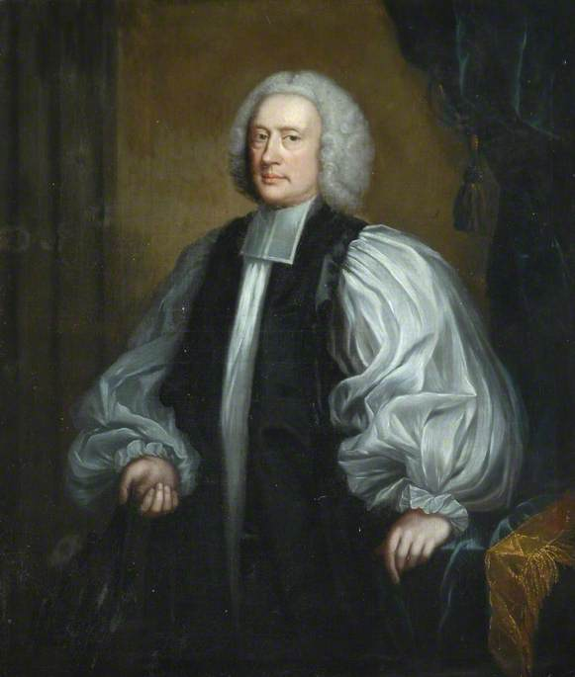

The Gathering of the Community

The Greeting

Presider
Blessed be the holy and undivided Trinity, one God:
the Author of creation,
the Word of redemption and
the Spirit of wisdom. Amen.

Kyrie

Deacon
May your loving-kindness come to us, O Lord,
and your salvation according to your word:
Lord, have mercy upon us.

Your word is a lantern to our feet and a light to our path:
Christ, have mercy upon us.

Let your mercy come to us so that we may live,
for your law is our delight:
Lord, have mercy upon us.

Collect of the Day

Presider
Let us pray.

O God, by your Holy Spirit you give to some the word of wisdom, to others the word of knowledge and to others the word of faith. We praise your name for the gifts of grace manifested in your servant Joseph Butler, and we pray that by his teaching we may know you, the only true God, and Jesus Christ, your only and eternal Son, who lives and reigns with you and the Holy Spirit, one God, now and for ever. Amen.

The Proclamation of the Word

The First Reading: 1 Kings 3.10-15

Reader
A reading from the 1st Book of Kings.

It pleased the Lord that Solomon had asked [for wisdom]. God said to him, “Because you have asked this, and have not asked for yourself long life or riches, or for the life of your enemies, but have asked for yourself understanding to discern what is right, I now do according to your word. Indeed I give you a wise and discerning mind; no one like you has been before you and no one like you shall arise after you. I give you also what you have not asked, both riches and honour all your life; no other king shall compare with you. If you will walk in my ways, keeping my statutes and my commandments, as your father David walked, then I will lengthen your life.”

Then Solomon awoke; it had been a dream. He came to Jerusalem where he stood before the ark of the covenant of the Lord. He offered up burnt offerings and offerings of well-being, and provided a feast for all his servants.

Reader
Hear what the Spirit is saying to the Church.
Thanks be to God.

The Psalm of the Day: Psalm 119.97-104

Psalmist
Through your commandments I gain understanding.
Through your commandments I gain understanding.

⁹⁷ Oh, how I love your law! *
All the day long it is in my mind.
⁹⁸ Your commandment has made me wiser than my enemies, *
and it is always with me.

Through your commandments I gain understanding.

⁹⁹ I have more understanding than all my teachers, *
for your decrees are my study.
¹⁰⁰ I am wiser than the elders, *
because I observe your commandments.

Through your commandments I gain understanding.

¹⁰¹ I restrain my feet from every evil way, *
that I may keep your word.
¹⁰² I do not shrink from your judgements, *
because you yourself have taught me.

Through your commandments I gain understanding.

¹⁰³ How sweet are your words to my taste! *
They are sweeter than honey to my mouth.
¹⁰⁴ Through your commandments I gain understanding; *
therefore I hate every lying way.

Through your commandments I gain understanding.

Gradual Verse

Deacon
Alleluia. Alleluia.
I will give you a wise and discerning mind,
so that we may walk in the ways of God.
Alleluia. Alleluia.

The Gospel of the Day: Mark 4.21-25

Deacon
The Lord be with you.
And also with you.
The Holy Gospel of our Lord Jesus Christ according to Mark.
Glory to you, Lord Jesus Christ.

[Jesus] said to [the twelve], “Is a lamp brought in to be put under the bushel basket, or under the bed, and not on the lampstand? For there is nothing hidden, except to be disclosed; nor is anything secret, except to come to light. Let anyone with ears to hear listen!” And he said to them, “Pay attention to what you hear; the measure you give will be the measure you get, and still more will be given you. For to those who have, more will be given; and from those who have nothing, even what they have will be taken away.”

Deacon
The Gospel of Christ.
Praise to you, Lord Jesus Christ.

Sermon

The Prayers of the Community

Litany of Healing

Leader of the Prayers
Let us pray.

Loving God, our source and our final home,
we give you thanks for the gifts of life on earth,
for our human bodies and all you have created.
In your great mercy, hear us, O God.

Merciful God, by the wounds of your Son we are healed.
Bring your saving health to all people.
In your great mercy, hear us, O God.

Holy God, your Spirit came upon us in the waters of baptism
and brought us into the communion of saints.
Renew in us the grace of baptism,
by which we share in Christ’s death and resurrection.
In your great mercy, hear us, O God.

Mighty God, your Son Jesus brought healing and wholeness to all.
Bring your healing presence now to all who are sick or in pain.
Grant hope to all who are discouraged or in despair.
In your great mercy, hear us, O God.

Compassionate God, the strength of those who suffer,
bring hope and peace to all
who are in mental, physical or spiritual distress.
In your great mercy, hear us, O God.

Almighty God, source of human knowledge,
give skill, wisdom and compassion to all who provide medical care.
In your great mercy, hear us, O God.

Loving God, our creator and redeemer,
give gentleness and courage
to family members, friends and caregivers of those who suffer.
In your great mercy, hear us, O God.

Other petitions may be offered, including particular needs and requests for healing.

God of great and abundant mercy,
with your presence sustain all for whom we pray.
Drive away their suffering, give them firm hope,
and strengthen their trust in you;
through Jesus Christ, our Saviour and Lord. Amen.

The Exchange of the Peace

Presider
May the peace of the risen and ascended Christ be with you all.
And also with you.

The Holy Communion

The Prayer over the Gifts

Presider
Let us pray.

Lord God, receive all we offer this day, so that joining your servant Joseph Butler we may share in your eternal Wisdom and lay hold upon the reason for the hope you have set in our hearts. We ask this in the name of Jesus Christ the Lord. Amen.

The Great Thanksgiving

Presider
The Lord be with you.
And also with you.
Lift up your hearts.
We lift them to the Lord.
Let us give thanks to the Lord our God.
It is right to give our thanks and praise.

Blessed are you, gracious God, creator of heaven and earth; we give you thanks and praise through Jesus Christ our Lord, because in the fellowship of your saints you have given us a glorious pledge of the hope of our calling. Therefore we join our voices with theirs as earth and heaven unite to proclaim the glory of your name.

Holy, holy, holy Lord,
God of power and might,
heaven and earth are full of your glory.
Hosanna in the highest.

Blessed is he who comes in the name of the Lord.
Hosanna in the highest.

Holy, mighty and merciful Lord, heaven and earth are full of your glory.

In great love you sent us Jesus, your Son, who reached out to heal the sick and suffering, who preached good news to the poor and who, on the cross, opened his arms to all.

In the night in which he was betrayed, our Lord Jesus took bread and gave thanks; broke it, and gave it to his disciples, saying: Take and eat; this is my body given for you. Do this for the remembrance of me.

Again, after supper, he took the cup, gave thanks and gave it for all to drink, saying: This cup is the new covenant in my blood, shed for you and for all people for the forgiveness of sin. Do this for the remembrance of me.

Remembering, therefore, his death, resurrection and ascension, we await his coming in glory.

Pour out upon us the Spirit of your love, O Lord, and unite the wills of all who share this heavenly food, the body and blood of Jesus Christ our Lord; to whom, with you and the Holy Spirit, be all glory and honour, now and for ever. Amen.

The Lord’s Prayer

Presider
As our Saviour taught us, let us pray:
Our Father, who art in heaven,
hallowed be thy name,
thy kingdom come, thy will be done,
on earth as it is in heaven.
Give us this day our daily bread.
And forgive us our trespasses,
as we forgive those who trespass against us.
And lead us not into temptation,
but deliver us from evil.
For thine is the kingdom, the power,
and the glory, for ever and ever. Amen.

The Breaking of the Bread

Presider
Creator of all,
you gave us golden fields of wheat,
whose many grains we have gathered
and made into this one bread.

So may your Church be gathered
from the ends of the earth
into your promised reign of justice and peace.

Dear friends in Christ, God bids you welcome to this table. Here we are strengthened for the journey. Here strangers become friends and the seeker finds God’s wisdom speaking to them. See who you are and become what you see.

These are the gifts of God for the people of God.
Thanks be to God.

The Communion

If you are not physically receiving Communion, then offer this prayer.

In union, O God, with all your faithful people gathered wherever the eucharist is celebrated this day, I offer you praise and thanksgiving for creation and all the blessings of this life, for the redemption given to us through the life, death and resurrection of Christ, and for the means of grace and the hope of glory. I pray you come into my heart, my soul and my mind. Let nothing separate me from you. May I serve you in this life until, by your grace, I come to your promised reign of justice and peace; through Christ and in the unity of the Spirit. Amen.

The Sending Forth of the Communion

The Prayer after Communion

Presider
Let us pray.

Eternal God, whose love is sealed upon us by this feast, grant us so to follow your servant Joseph Butler that we may never be anxious when our faith is challenged nor ever be wanting when we are called upon to speak your Word. This we ask through Jesus Christ our Lord. Amen.

The Doxology

Presider
Glory to God,
whose power, working in us,
can do infinitely more
than we can ask or imagine.
Glory to God from generation to generation,
in the Church and in Christ Jesus,
for ever and ever. Amen.

The Dismissal

Deacon
Go forth to share the wisdom of God with the world.
Thanks be to God.

* * * * *

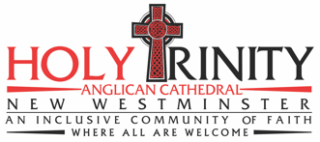

514 Carnarvon Street
New Westminster, BC V3L 1C4
(604) 521-2511
www.holytrinitycathedral.ca
Livestream: facebook.com/holytrinitycathedralnewwest

