**Parish Prayer PartnerS**

***“More things are wrought by prayer than this world dreams of”***

**Did you know that our Diocese has a *Parish Prayer Partner Ministry*?**

**Yes, a *Prayer Partner Ministry* for the whole parish.**

It was initiated at Synod 2017 by the Anglican Church Women Board,

but is not just for the women!

Further details and where to find your ***Parish Prayer Partner*** are on the ***Board’s webpage*** under ***Ministries*** of the Diocesan website:

[www.nspeidiocese.ca](http://www.nspeidiocese.ca)

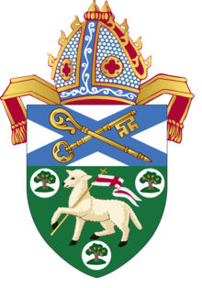

**The**

**Lord’’s Prayer**



Our Father which art in heaven, hallowed be thy name.

Thy kingdom come,

Thy will be done in earth,

as in heaven.

Give us this day our daily bread.

And forgive us our debts, as we forgive our debtors. And lead us not into temptation, but deliver us from evil: For thine is the kingdom, and the power, and the glory, forever. Amen

Mathew 6:9-13