[](https://www.google.ca/imgres?imgurl=http://static.wixstatic.com/media/6af1ee_3ef587e68d17d74322ed604cf4103119.jpg_512&imgrefurl=http://fyiinph.wix.com/fyi&tbnid=8wKA8e1-MUuuxM&vet=10CB8QMyhzahcKEwiY5aWj-5DpAhUAAAAAHQAAAAAQBA..i&docid=w-THm_JVLbXanM&w=967&h=405&itg=1&q=For%20your%20information%20clipart&hl=en&authuser=0&ved=0CB8QMyhzahcKEwiY5aWj-5DpAhUAAAAAHQAAAAAQBA) Diocese of Saskatchewan

1410 Bishop McLean Crescent

PO Box 23125 Prince Albert SK S6V 8A7



June 2021

The Synod Office opens to the public on June 8th, 2021.

**Office Hours will be:**

**Tuesday, Wednesday & Thursdays from 9am to Noon and 1-4pm.**

**Please call (306)763-2455 for more information.**

**Apportionment and Ministry**

The Executive Committee has forgone and forgiven ~500,000 in Apportionment and Ministry and 2020 and 2021.  Much of this has been covered by support through federal programs, especially CEWS (Canada Emergency Wage Subsidy).  The most recent meeting of the Executive Committee resolved to forgive Apportionment for the months of April, May, June, July & August 2021.  Your Executive Committee has demonstrated real concern and support for the financial stresses of your congregation.  We are blessed by their leadership.  Ministry will still be 100% payable for this time. Starting September 1st, Ministry and Apportionment will be payable in full.  We are most grateful for the majority of Parishes who have kept current with their Apportionment and Ministry and for those who have prepaid.

[](https://www.google.ca/imgres?imgurl=https://static.wixstatic.com/media/94193b_1ed7aa0c46a74802b92011689bb1bd39~mv2.jpg&imgrefurl=https://www.kincheschapelcc.com/events-1/vbs-on-friday&tbnid=Zs8tjDmhDmh9iM&vet=10CBgQxiAoBGoXChMI4Iiwm_-Q6QIVAAAAAB0AAAAAEAc..i&docid=9JUT1BXYwpgxAM&w=685&h=520&itg=1&q=vbs%20clipart&hl=en&authuser=0&ved=0CBgQxiAoBGoXChMI4Iiwm_-Q6QIVAAAAAB0AAAAAEAc)

Spread the word! We need to hire 4 students to facilitate VBS, and work in the Diocese for nine weeks. If you know of someone under the age of 30 who could work for us this summer, please have them call the office or check out our website and/or Facebook page.

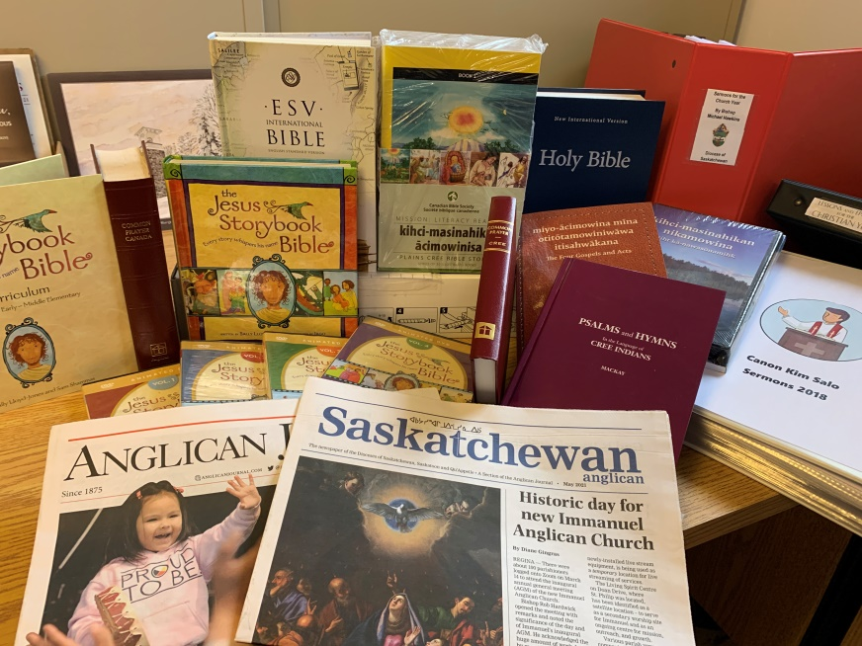



The Synod office has many resources to assist you in ministry. Printed sermons from Bishop Michael and Canon Kim Salo, Large Print BCPs, Bibles (KJV, NIV and Childrens), Cree Psalms and Hymns, Lessons & Epistles for the Christian Year, Cree Language Gospels, Cree Bible Stories for Kids. Drop by the Synod Office to see whats available.

Your congregation continues to need your regular and generous financial support**.**

[](https://www.google.ca/imgres?imgurl=https://i1.wp.com/wlaumc.com/wp-content/uploads/2017/06/Tithes-Offerings-2-e1497366128216.jpg?fit%3D918,409&imgrefurl=http://wlaumc.com/spring-appeal/tithes-offerings-2/&tbnid=Vbx69aHKngIRgM&vet=12ahUKEwjb04LIgZHpAhWCf6wKHe83CxoQMygnegQIARB1..i&docid=46oMVcJUi-CnSM&w=500&h=223&q=tithes%20and%20offrngs&hl=en&authuser=0&ved=2ahUKEwjb04LIgZHpAhWCf6wKHe83CxoQMygnegQIARB1)**We hope that with loosening restrictions, reduced transmission and increased vaccinations; everyone will be back to regular in person Sunday worship over the summer and that by September much of our regular life as congregations will resume.**

**Thank you for your patience, your faithfulness, & your generosity**.

[](https://www.google.ca/imgres?imgurl=http://clipart-library.com/images/LTdo5jdkc.png&imgrefurl=http://clipart-library.com/hand-washing-clipart.html&tbnid=PZ2LGBjO7ChDYM&vet=10CHAQMyiZAWoXChMI4MSby_2Q6QIVAAAAAB0AAAAAEAI..i&docid=eWnVq94vrczeIM&w=600&h=549&q=wash%20your%20hands%20clipart&hl=en&authuser=0&ved=0CHAQMyiZAWoXChMI4MSby_2Q6QIVAAAAAB0AAAAAEAI)The directives around hand sanitizing, social distancing and the receiving of Holy Communion remain in force as we resume public worship. **Intinction will remain prohibited**. We recognize that this will be hard for some to accept, however communion will only be administered in one kind (the consecrated bread). These precautions are necessary for the safety of all.



The Reverend Dr. David Butorac has been inducted in the Bishop McLean Canonry and also as Rector of the Cathedral of St. Alban’s the Martyr.

**Welcome to the Diocese Ted Williams and Thomas McCallum.**  Ted, a Wycliffe College graduate, will be serving in the Parishes of Nipawin /Arborfield for the summer.

Thomas, a music director from All Saints, Toronto will be assisting in the Diocese for the month of July.

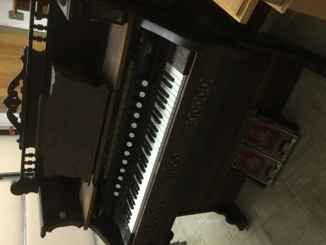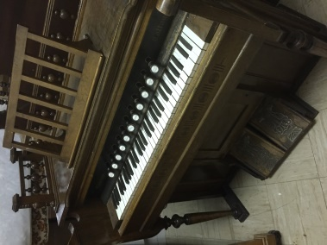

These two beautiful pump organs

need homes asap!

Please spread the word.

Call the office for details.

(306) 763-2455

[](https://www.google.ca/imgres?imgurl=https://us.123rf.com/450wm/vectorshots/vectorshots1504/vectorshots150400108/38542642-stock-vector-rolling-eyes-cartoon-eyes.jpg?ver%3D6&imgrefurl=https://www.123rf.com/clipart-vector/eyes.html&docid=J0J8457h7UIpAM&tbnid=vQQ-pMDuX_IdvM:&vet=10ahUKEwimtLjmpJTkAhVJd6wKHWeyAI8QMwiNASgcMBw..i&w=450&h=345&hl=en&bih=588&biw=1006&q=look%20clipart&ved=0ahUKEwimtLjmpJTkAhVJd6wKHWeyAI8QMwiNASgcMBw&iact=mrc&uact=8)Check out our website! [skdiocese.com](http://skdiocese.com)

[](https://www.google.ca/imgres?imgurl=http://40.media.tumblr.com/c2fbca3d108f42fe7e699666500ea6b8/tumblr_nkc2ri8hWt1s2sieno1_1280.png&imgrefurl=http://humanrightsnorthkorea.tumblr.com/post/112048060445/click-the-icon-to-like-us-on-facebook&h=258&w=800&tbnid=QgtLNuDAHV71oM:&docid=-BdE-1xpKN3JWM&ei=l2CzVtDJKIfve-m2jKAH&tbm=isch&ved=0ahUKEwiQ8Yilqd7KAhWH9x4KHWkbA3QQMwg5KAgwCA) [**https://www.facebook.com/skdiocese**](https://www.facebook.com/skdiocese)

