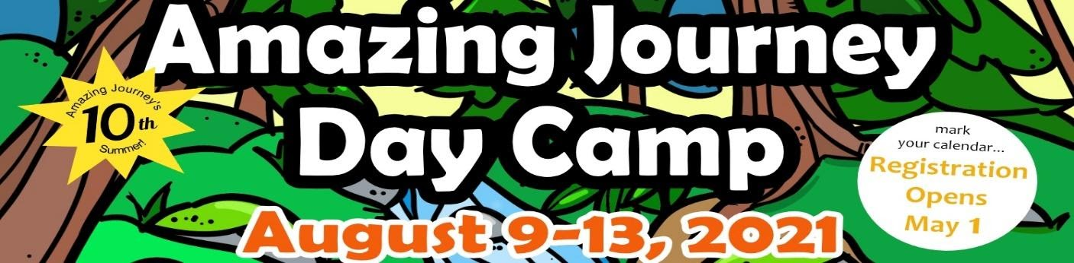

Children who have completed grades 1 to 5 are eligible to participate.
When: August 9th to 13th, 2021

Where: St. George’s Anglican Church
3909 St. George’s Ln, Victoria, BC V8N 4E3

Cost: Early Bird Registration (Deadline June 30, 2021) $30.00 1st child
$25.00 2nd child
$20.00 3rd and additional child

After June 30th, 2021
$40.00 1st child
$35.00 2nd child
$30.00 3rd and additional child

Registration Deadline August 2, 2021

Children with special needs may attend.

Registration forms (with payment) can be returned to:
St. Luke Cedar Hill Anglican Church: 3821 Cedar Hill Cross Rd, Victoria, BC V8P 2M6
Lutheran Church of the Cross Anglican Church: 3787 Cedar Hill Rd, Victoria, BC V8P 3Z4
St. George’s Anglican Church: 3909 St. George’s Ln, Victoria, BC V8N 4E3

Completed registration forms can also be scanned and e-mailed to amazing4kids17@gmail.com

On line registration form available at: https://www.jotform.com/build/201096136801246
Make cheques payable to: Lutheran Church of the Cross. Please write “Amazing Journey” on the memo line.

If you wish to make an e-transfer please contact Lutheran Church of the Cross at lutheranchurchofthecross@shaw.ca or call 250-477-6222

Visit our Facebook page at Amazing Journey Summer Day Camp at:
https://www.facebook.com/amazingjourneysummercamp/

AMAZING JOURNEY 2021 REGISTRATION FORM
Child’s Name |  |  | Pronoun |  | Date of Birth  (YY/MM/DD) |  | Grade Completed
1.
2.

3.

4.

Allergies, diet restrictions, or health challenges: (list individually for each child)
Things we can do to make your child more comfortable at camp:

Parent(s)/Guardian(s) First and Last Name:
Relation:

Address:

City: | Postal Code: |  | Home Phone: |  |  | Cell Phone #
E-mail:
Contact # in case of emergency: | Name: |  |  | Relationship:
 | Daytime Phone #: |  |  | Alternate Phone #:
Person(s) picking child(ren) up | Note: Children will only be released to those listed on this form.
 | Name: |  | Name:
 | Phone #: |  | Phone #:
How did you hear of this program? | Church _____ Which Church? ________________________________________  (Pre) School ____ Which (Pre) School __________________________________  E-Mail _____ Advertising ____ Where? _______________  Friend ____ Attended Previous Years _____  Other (Specify) _______________ ______________________________
I GIVE permission for my child(ren) to be part of the Amazing Journey Program ____

Photograph/Video permission: We intend to take pictures and video recordings during this event to be used for future promotion, including newsletters and our websites.

I GIVE permission for my child(ren) to be photographed/video recorded ____

I DO NOT GIVE permission for my child to be photographed/video recorded ______

Signature of Parent or Guardian Date
Office Use Only |  | Paid ____ Amount Paid ________ Payment Format _________

