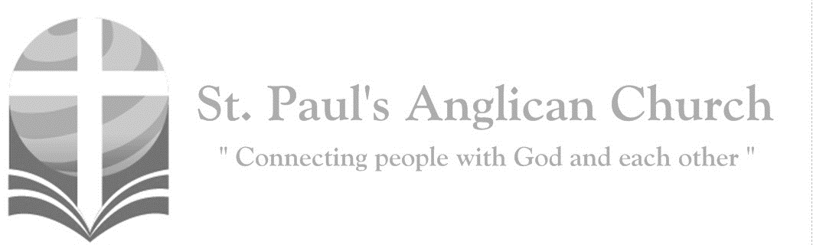
Sunday, April 25, 2021: 4th Sunday of Easter

I am the good shepherd, says the Lord:
I know my own and my own know me. (John 10:14)

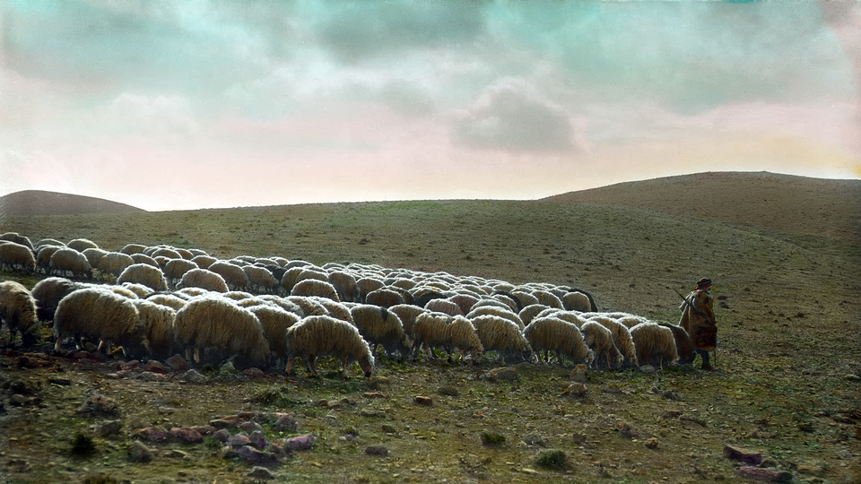

ST. PAUL’S COVID-19 RESPONSE
Welcome!! During this unique time in history, services will look a bit different than normal and will likely be different for quite a while. We want to care for the whole parish during this time and one way to care for one another is keeping each other safe. As such, we ask you to follow these guidelines while worshiping with us:
- Experiencing Cough, Fever, or Other Symptom/s? Go home immediately and please stay home for fourteen days following the end of your symptoms.
- Wear a Mask. All parishioners must wear a mask to all services (as per City of Edmonton bylaw 19408). Exceptions to this include children under the age of two and those with a medical condition where wearing a mask is not possible. Masks may be removed when taking communion but must be replaced immediately following. If you do not have a mask, we have cloth masks available in the foyer.
- Maintain Physical Distance. At all times, please remain a minimum of six feet (three seat spaces) from all other individuals not part of your family unit. You will find tape on the floor six feet apart in multiple locations to help you maintain this distance. Please also maintain physical distance outside.
- Listen to the Ushers. There will be ushers inside and outside to help direct these new procedures. Please heed their direction as they are trying to keep everyone safe and healthy.
- Sign-In Upon Arrival. Please sign-in with the designated usher when you arrive onsite. This will help us track who is in attendance just in case we do have to notify the parish if someone tests Covid positive following a service.
- Sanitize Hands Frequently. Please sanitize your hands upon entry and before taking communion. You may also sanitize as often as you would like during the service. Please also try to refrain from touching surfaces and your face.
- Refrain from Singing. At this time, congregational singing is not allowed by the government of Alberta. Please listen to the lyrics being sung by the leader/s and meditate upon them. You may also hum along to the music as long as your mouth remains closed.
- Recycle Bulletins. Please do not leave bulletins in the pews. A recycle bin is available at the exit door. You may also take the bulletin home.
- Use of Washroom. The only washroom available at this time is located at the back of the Sanctuary (just North of the Main Entry doors). Please wipe down all surfaces (including toilet and handle, counter, and faucet) following use.
- Parts of Building Closed. At this time, the only accessible parts of the building are the Sanctuary, Sanctuary washroom, and alley foyer. All other rooms are closed for use including the main washrooms, hall, basement, and chapel. Please do not access any closed section of the building without permission.

Opening Song: Crown Him with Many Crowns

Crown Him with many crowns
The Lamb upon His throne
Hark! How the heavenly anthem drowns
All music but its own
Awake my soul and sing
Of Him who died for thee
And hail Him as thy matchless King
Through all eternity

Crown Him the Lord of love
Behold His hands and side
Rich wounds, yet visible above
In beauty glorified
All hail, Redeemer, hail
For Thou hast died for me
Thy praise and glory shall not fail
Throughout eternity
Crown Him the Lord of life
Who triumphed o'er the grave
Who rose victorious in the strife
For those He came to save
His glories now we sing
Who died and rose on high
Who died eternal life to bring
And lives that death may die

Crown Him the Lord of heav'n
One with the Father known
One with the Spirit through Him giv'n
From yonder glorious throne
To Thee be endless praise
For Thou for us hast died
Be Thou, O Lord, through endless days
Adored and magnified

The Gathering of the Community
Celebrant: Alleluia! Christ is risen.
People: The Lord is risen indeed. Alleluia!
Celebrant: May his grace and peace be with you.
People: May he fill our hearts with joy.
Celebrant: Almighty God,
All: to you all hearts are open, all desires known, and from you no secrets are hidden. Cleanse the thoughts of our hearts by the inspiration of your Holy Spirit that we may perfectly love you, and worthily magnify your holy name; through Christ our Lord. Amen.
Celebrant: O God of peace, who brought again from the dead our Lord Jesus Christ, that great shepherd of the sheep, by the blood of the eternal covenant, make us perfect in every good work to do your will, and work in us that which is well-pleasing in your sight; through Jesus Christ our Lord.
People: Amen.

The Reading of Scripture
First Reading: Acts 4:5-12
The next day their rulers, elders, and scribes assembled in Jerusalem, with Annas the high priest, Caiaphas, John, and Alexander, and all who were of the high-priestly family. When they had made the prisoners stand in their midst, they inquired, "By what power or by what name did you do this?" Then Peter, filled with the Holy Spirit, said to them, "Rulers of the people and elders, if we are questioned today because of a good deed done to someone who was sick and are asked how this man has been healed, let it be known to all of you, and to all the people of Israel, that this man is standing before you in good health by the name of Jesus Christ of Nazareth, whom you crucified, whom God raised from the dead. This Jesus is 'the stone that was rejected by you, the builders; it has become the cornerstone.' There is salvation in no one else, for there is no other name under heaven given among mortals by which we must be saved."

Reader: The Word of the Lord.
People: Thanks be to God.

Canticle: Psalm 23 (sung)

The Lord's my Shepherd I'll not want
He makes me down to lie
In pastures green He leadeth me
The quiet waters by

My soul He doth restore again
And me to walk doth make
Within the paths of righteousness
E'en for His own name's sake

Yea though I walk in death's dark vale
Yet will I fear no ill
For Thou art with me and Thy rod
And staff me comfort still

My table Thou hast furnished
In presence of my foes
My head Thou dost with oil anoint
And my cup overflows

Goodness and mercy all my life
Shall surely follow me
And in God's house for evermore
My dwelling place shall be

Second Reading: 1 John 3:16-24
We know love by this, that he laid down his life for us--and we ought to lay down our lives for one another. How does God's love abide in anyone who has the world's goods and sees a brother or sister in need and yet refuses help? Little children, let us love, not in word or speech, but in truth and action. And by this we will know that we are from the truth and will reassure our hearts before him whenever our hearts condemn us; for God is greater than our hearts, and he knows everything. Beloved, if our hearts do not condemn us, we have boldness before God; and we receive from him whatever we ask, because we obey his commandments and do what pleases him. And this is his commandment, that we should believe in the name of his Son Jesus Christ and love one another, just as he has commanded us. All who obey his commandments abide in him, and he abides in them. And by this we know that he abides in us, by the Spirit that he has given us.
Reader: The Word of the Lord.
People: Thanks be to God.

Processional Chorus – Holy is Our God

Holy is our God
Holy is Your Name
Mighty are Your works and deeds
And wondrous are Your ways
All that You have made
Shall return and give You glory Lord

The Gospel Reading
Reader: The Lord be with you.
People: And also with you.
Reader: The Holy Gospel of our Lord Jesus Christ according to St. John.
People: Glory to you, Lord Jesus Christ.
Gospel Reading: John 10:11-18
"I am the good shepherd. The good shepherd lays down his life for the sheep. The hired hand, who is not the shepherd and does not own the sheep, sees the wolf coming and leaves the sheep and runs away--and the wolf snatches them and scatters them. The hired hand runs away because a hired hand does not care for the sheep. I am the good shepherd. I know my own and my own know me, just as the Father knows me and I know the Father. And I lay down my life for the sheep. I have other sheep that do not belong to this fold. I must bring them also, and they will listen to my voice. So there will be one flock, one shepherd. For this reason, the Father loves me, because I lay down my life in order to take it up again. No one takes it from me, but I lay it down of my own accord. I have power to lay it down, and I have power to take it up again. I have received this command from my Father."
Reader: The Gospel of Christ.
People: Praise to you, Lord Jesus Christ.

Worship Through Song

Holy is Our God
Lift up His Name within the sanctuary
Lift up His Name among the people
Who are gathered here
To sing His praise
Who are gathered here
To sing His praise

(Chorus) Holy is our God
Holy is Your Name
Mighty are Your works and deeds
And wondrous are Your ways
All that You have made
Shall return and give You glory Lord

The earth, the sky, the sea
And all within them
This universe beyond the sight
Of mortal men
All subject to His reign
All creation subject to His reign
(To Chorus)

The great I Am, no end and no beginning
You were and are
And evermore You shall be
All my days are in Your hands
All my days are in Your hands
(To Chorus)

King of Love
With the hands that formed the world
You washed our feet
Kneeling down
You laid aside Your majesty
And You said for us to go
And do the same
So we serve for the glory of our King

You left Heaven's throne
To rescue what was lost
Stretching out Your mighty arms
To bear the cross
Then You rolled away the stone
The victory won
And You said go and tell the world
What love has done

(Chorus) King of love
Let Your kingdom come
Reign in us
Your daughters and Your sons
Fill us up 'til we overflow
With Your love
Until the whole world knows
You are the King of love

Give us hearts that long
To see Your justice done
And let the river of Your mercy
Flow through us
And let compassion
Be the loudest song we sing
'Til the day when every tongue
Declares You King (To Chorus)

Listening Time

Sermon by the Rev. Dr. Myron B. Penner – Sermon Notes:
________________________________________________________________________________________________________________________________________________________________________________________________________________________________________________________________________________________________________________________________________________________________________________________________________________________________________________________________________________________________________________________
________________________________________________________________________________________________________________________________________________________________________________________________________________________
________________________________________________________________________________________________________________________________________________________________________________________________________________________________________________________________________________________________
________________________________________________________________________________________________________________________________________________
________________________________________________________________________
________________________________________________________________________________________________________________________________________________

Affirmation of Faith – The Nicene Creed
Celebrant: Let us confess our faith, as we say,
All: We believe in one God, the Father, the Almighty, maker of heaven and earth, of all that is, seen and unseen. We believe in one Lord, Jesus Christ, the only Son of God, eternally begotten of the Father, God from God, Light from Light, true God from true God, begotten, not made, of one being with the Father. Through him all things were made. For us and for our salvation he came down from heaven: by the power of the Holy Spirit he became incarnate from the Virgin Mary, and was made man. For our sake he was crucified under Pontius Pilate; he suffered death and was buried. On the third day he rose again in accordance with the scriptures; he ascended into heaven and is seated at the right hand of the Father. He will come again in glory to judge the living and the dead, and his kingdom will have no end. We believe in the Holy Spirit, the Lord, the giver of life, who proceeds from the Father. With the Father and the Son he is worshipped and glorified. He has spoken through the prophets. We believe in one holy catholic and apostolic Church. We acknowledge one baptism for the forgiveness of sins. We look for the resurrection of the dead, and the life of the world to come. Amen.

Prayers of the People
Leader: In joy and hope let us pray to the source of all life, saying, “Hear us, Lord of glory!” That our risen Saviour may fill us with the joy of his holy and life-giving resurrection, let us pray to the Lord.
All: Hear us, Lord of glory!
Leader: Remembering today those in our St. Paul’s Cycle of Prayer: Andrew, Nancy, Greg, Tim, and Emily Whistance-Smith; Francis and Jennifer Bossé; Edwin and Elvie Exconde; and Patience Oduro; as well as all of those in the Anglican Cycle of Prayer. That isolated and persecuted churches may find fresh strength in the Easter gospel, let us pray to the Lord.
All: Hear us, Lord of glory!
Leader: That he may grant us humility to be subject to one another in Christian love, let us pray to the Lord.
All: Hear us, Lord of glory!
Leader: That he may provide for those who lack food, work, or shelter, let us pray to the Lord.
All: Hear us, Lord of glory!
Leader: That by his power wars and famine may cease through all the earth, let us pray to the Lord.
All: Hear us, Lord of glory!
Leader: That he may reveal the light of his presence to the sick, the weak, and the dying, that they may be comforted and strengthened, let us pray to the Lord.
All: Hear us, Lord of glory!
Leader: That he may send the fire of the Holy Spirit upon his people, that we may bear faithful witness to his resurrection, let us pray to the Lord.
All: Hear us, Lord of glory! Amen.

Confession of Sin
Celebrant: Dear friends in Christ, God is steadfast in love and infinite in mercy; he welcomes sinners and invites them to his table. Let us confess our sins, confident in God’s forgiveness.
Silent Confession
Celebrant: Almighty God, our heavenly Father,
All: we have sinned against you and against others, in thought and word and deed, through negligence, through weakness, through our own deliberate fault. We are truly sorry and repent of all our sins. For the sake of your Son Jesus Christ, who died for us, forgive us all that is past; and grant that we may serve you in newness of life to the glory of your name. Amen.
Celebrant: Almighty God have mercy upon you, pardon and deliver you from all your sins, confirm and strengthen you in all goodness and keep you in eternal life through Jesus Christ our Lord.
People: Amen.

The Peace
Celebrant: The peace of the Lord be always with you.
People: And also with you.

Prayer Over the Gifts
Celebrant: God of loving care,
All: you spread before us the table of life, and give us the cup of salvation to drink. Keep us always in the fold of your Son Jesus Christ, our Saviour and our shepherd. Amen.

Eucharistic Prayer
Celebrant: The Lord be with you.
People: And also with you.
Celebrant: Lift up your hearts.
People: We lift them to the Lord.
Celebrant: Let us give thanks to the Lord our God.
People: It is right to give our thanks and praise.

Celebrant: Blessed are you, gracious God, creator of heaven and earth; we give you thanks and praise for the glorious resurrection of your Son Jesus Christ our Lord; for he is the true paschal lamb who has taken away the sin of the world. By his death he destroyed death, and by his rising to life again he has won for us eternal life. Therefore, joining our voices with the whole company of heaven, we sing our joyful hymn of praise to proclaim the glory of your name.
All: Holy, holy, holy Lord, God of power and might,
heaven and earth are full of your glory. Hosanna in the highest.
Blessed is he who comes in the name of the Lord.
Hosanna in the highest.
Celebrant: We give thanks to you, Lord our God, for the goodness and love you have made known to us in creation; in calling Israel to be your people; in your Word spoken through the prophets; and above all in the Word made flesh, Jesus your Son. For in these last days you sent him to be incarnate from the Virgin Mary, to be the Saviour and Redeemer of the world. In him, you have delivered us from evil, and made us worthy to stand before you. In him, you have brought us out of error into truth, out of sin into righteousness, out of death into life. On the night he was handed over to suffering and death, a death he freely accepted, our Lord Jesus Christ took bread; and when he had given thanks to you, he broke it, and gave it to his disciples, and said, “Take, eat: this is my body which is given for you. Do this for the remembrance of me.” After supper he took the cup of wine; and when he had given thanks, he gave it to them, and said, “Drink this, all of you: this is my blood of the new covenant, which is shed for you and for many for the forgiveness of sins. Whenever you drink it, do this for the remembrance of me.” Therefore, Father, according to his command,
All: we remember his death, we proclaim his resurrection, we await his coming in glory;
Celebrant: and we offer our sacrifice of praise and thanksgiving to you, Lord of all; presenting to you, from your creation, this bread and this wine. We pray you, gracious God, to send your Holy Spirit upon these gifts, that they may be the sacrament of the body of Christ and his blood of the new covenant. Unite us to your Son in his sacrifice, that we, made acceptable in him, may be sanctified by the Holy Spirit. In the fullness of time, reconcile all things in Christ, and make them new, and bring us to that city of light where you dwell with all your sons and daughters; through Jesus Christ our Lord, the firstborn of all creation, the head of the Church, and the author of our salvation; by whom, and with whom, and in whom, in the unity of the Holy Spirit, all honour and glory are yours, almighty Father, now and for ever.
All: Amen.

Celebrant: As our Saviour taught us, let us pray,
All: Our Father in heaven, hallowed be your name. Your kingdom come, your will be done, on earth as in heaven. Give us today our daily bread. Forgive us our sins as we forgive those who sin against us. Save us from the time of trial, and deliver us from evil. For the kingdom, the power, and the glory are yours, now and for ever. Amen.

Celebrant: Lord, we died with you on the cross.
All: Now we are raised to life.
Celebrant: We were buried in your tomb.
All: Now we share in your resurrection.
Celebrant: Live in us, that we may live in you.

Celebrant: The gifts of God for the People of God.
People: Thanks be to God.

The Communion
Please listen carefully to the verbal instructions given. You are welcome to receive communion or come forward for a blessing. Gluten-free wafers are also available. Please sanitize your hands as you approach the front of the church. If you prefer to receive a blessing, please fold your arms over your chest. If you would like to make an offering, please do so after you take the bread.

Lamb of God
(Said by congregation) Lamb of God, you take away the sins of the world.
Lamb of God, you take away the sins of the world.
Lord have mercy, Christ have mercy, Lord have mercy on us.

Communion Music (Instrumental)

Prayer After Communion
Celebrant: God of steadfast love,
All: watch over the Church redeemed by the blood of your Son. May we who share in these holy mysteries come safely to your eternal kingdom, where there is one flock and one shepherd. We ask this in the name of Jesus Christ the risen Lord. Amen.

Celebrant: Glory to God,
All: whose power, working in us, can do infinitely more than we can ask or imagine. Glory to God from generation to generation, in the Church and in Christ Jesus, for ever and ever. Amen.

Blessing

Congregational Announcements (Rev. Myron)

Closing Song: Across the Lands

You're the Word of God the Father
From before the world began
Every star and every planet
Has been fashioned by Your hand
All creation holds together
By the power of Your voice
Let the skies declare Your glory
Let the land and seas rejoice

(Chorus) You're the author of creation
You're the Lord of every man
And Your cry of love rings out
Across the lands

Yet You left the gaze of angels
Came to seek and save the lost
And exchanged the joy of heaven
For the anguish of a cross
With a prayer You fed the hungry
With a word You stilled the sea
Yet how silently You suffered
That the guilty may go free (To Chorus)

With a shout You rose victorious
Wresting victory from the grave
And ascended into heaven
Leading captives in Your wake
Now You stand before the Father
Interceding for Your own
From each tribe and tongue and nation
You are leading sinners home
(To Chorus)

The Dismissal
Celebrant: Go in peace to love and serve the Lord.
All: Thanks be to God. Alleluia.

In-Person Sunday Services – Pre-Registration Required
WEEKLY PRE-REGISTRATION WILL BE REQUIRED for those attending in-person services. The pre-registration link for the Sunday service will be made available on Tuesday (by email and the website) of each week and will close at noon on Friday. For individuals who are immunocompromised or otherwise unable to attend services, you may contact the office to set up an individual time to take the eucharist.

Community Corner for April 25

Hope Mission hands out many bottles of water every day, more than 9 flats a day. One of our parishioners asked for our help in this as he has volunteered with Hope Mission and knows what a difference this makes. We will be collecting flats of water at the church up to and including May 2, after which they will be delivered to Hope Mission. Contact Michelle if you are able to donate to this. Curious about Hope Mission? Please visit https://hopemission.com/home/ to learn more.

The Edmonton Valley Zoo is a great place to spend an afternoon or meet up with friends for an outdoor get together that respects COVID restrictions. You must book your tickets in advance. Go to https://movelearnplay.edmonton.ca/COE/public/category/browse/MEMBERATT for more information.

Pandemic Support Group – Michelle is hosting an adult support group at St Paul's on Thursday evenings from 7-8:30 pm starting April 29, 2021. This group is meeting to support members through some of the emotional and social challenges encountered during the pandemic. It is a peer support group, and, as such, does not promote itself as a therapeutic or counselling group. We gather IN PERSON to listen to one another and offer encouragement. Support groups are still permitted to meet in person, per provincial guidelines and restrictions. Weekly pre-registration is required and is open now (in this week’s email). Group participation guidelines will be sent out upon registration.

Notice of Electoral Synod
Notice is hereby given that the 67th meeting of Synod, to elect the 11th Bishop of Edmonton, will be held on Saturday, June 26 at 10:00AM. More details to come.
Woman Looking for a Room to Rent
George Jakeway knows a lady from Ukraine who is hoping to return to Canada after visiting her mother in Ukraine. She needs a room to rent for a month or two to get re-settled. If this is something you can help with, please contact George Jakeway
at 780-952-8025.
St. Paul’s Accepting Gently Used or New Board Games and Puzzles
To be prepared for the eventual ease in gathering restrictions, St. Paul’s is starting to collect board games and puzzles to have on hand for future games/activity nights. If you have board games or puzzles you would like to donate to this collection, please drop them by St. Paul’s anytime we are open over the next couple of months.

We are only accepting items that are gently used (or new) and have all of their pieces and instructions. Any items donated that do not achieve this standard will be discarded. Puzzles left over (with all of their pieces) from the puzzle exchange will be moved to this new collection as well (and puzzles missing pieces will be recycled).
St. Paul’s Special Congregational Meeting – Tuesday, May 4 at 7:00PM
St. Paul’s will be holding a Special Congregational Meeting on May 4 at 7:00PM to present the proposal for the kitchen renovation. This meeting will be held on Zoom:
Zoom Meeting ID: 863 3006 5001 Passcode: 471943
The meeting will open at 6:45PM so that all are able to join for a 7:00PM meeting start.
Same as the AGM, we will ask all to remain muted through the meeting and type questions into the chat. We look forward to seeing you there!!
Wholeness Through Christ Prayer Ministry Course
WTC is offering their first ever fully virtual prayer ministry course May 25-30, 2021. Spaces are limited so if you are interested, you should register soon. Cost for this course is $250.00. Application to register can be found at the bottom of this page: http://www.wholenessthroughchrist.com/index.php/about/our-events. Or, you can email Administrator@wholenessthroughchrist.com for more information.

Anglican Cycle of Prayer:
The Territory of the People: the Rt. Rev. Lincoln McKeon, Bishop. Immanuel, Wetaskiwin: Hugh Matheson (s. Fiona Brownlee), Rector. Buyé Synod Office: the Rt. Rev. Sixbert Macumi, Bishop; Audace Kwizera, Diocesan Secretary; Leonidas Nizigiyimana, Treasurer, Archdeacon of Buyé; Jean Berchmans Mweningoma, Development Officer; Damascene Bagirubwira, Vice-Development Officer; Nehemie Mbonyimpano, Diocesan Typist. Samson Cree Nation.

Next Week’s Ministry Teams:
Music: Asher and Team
Service Team: B and Jackson Teams
Reader/Prayers: Renée J.

This Week’s Ministry Teams:
Music: Andrew and Team
Service Team: Parker and Heritage
Reader/Prayers: Andrew and Nancy

St. Paul’s Cycle of Prayer:
Andrew, Nancy, Greg, Tim,
and Emily Whistance-Smith;
Francis and Jennifer Bossé;
Edwin and Elvie Exconde;
Patience Oduro
St. Paul’s Anglican Church
10127 145 Street, Edmonton T5N 2X6
Phone: (780) 455-0771; Email: office@stpauls-anglican.ca
Website: www.stpauls-anglican.ca
Office Hours:
Monday-Thursday: 9:00AM-12:00PM
Closed: Fri/Sat/Sun and Stat Holidays
facebook.com/stpachurchedmonton
@StEdmonton
For Care/Concern Team
or other prayer requests, email:
office@stpauls-anglican.ca
For urgent prayer requests call
the church office: (780) 455-0771
For pastoral emergencies call:
(587) 334-2130

St. Paul’s Vestry:
Paul Dowie, Rector’s Warden
Margot Byer, People’s Warden
David Heritage, Treasurer
Barb Dixon, Vestry Member
John Green, Vestry Member
David Parker, Vestry Member
Connie Pistawka, Vestry Member

St. Paul’s Staff:
Rector: The Rev. Myron B. Penner
Community Outreach: Michelle Schurek
Youth Leader: Abigail Harding
Office Administrator: RJ Chambers

