Children’s Page
Coloring Page
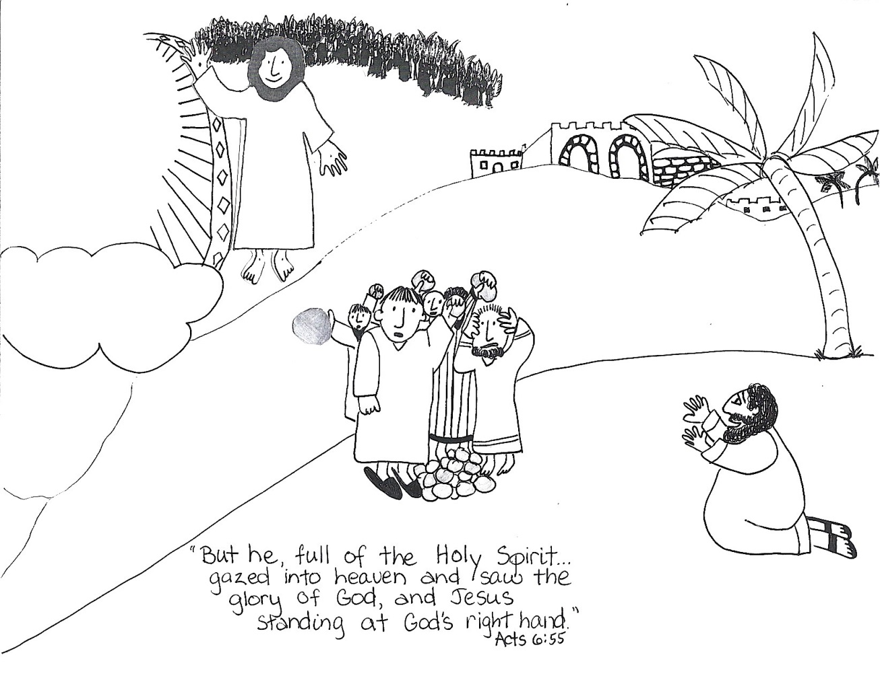
Read Acts 6:1-7:2a, 44-60
Stephen was faithful. He was known for his love and wisdom. When the people in the church asked him to serve and help take care of those in need, Stephen agreed. The word “deacon” means servant. As one of the first deacons, Stephen ministered to the people and taught them about Jesus.
The enemies of Jesus hated Stephen. They lied about him, and put Stephen on trial for his faith. Stephen responded with courage. He faced their lies with the truth speaking boldly of God’s faithfulness to Israel, and he condemned them for killing Jesus.
Stephen’s words made the council so mad that they attacked him, but Jesus was with Stephen. Scripture says he gazed into heaven and said, “Look, I see the heavens opened, and the Son of Man standing at the right hand of God!” His words further angered his enemies. They attacked him, took him outside the city, and stoned him.
As they were stoning Stephen, he called out to Jesus. His final words were, “Lord, do not charge them with this sin!” Even when he faced his enemies and saw their hatred, God’s love flowed through him. His final thought was that those who were killing him would find forgiveness in Christ.

