Children’s Page
Coloring Page
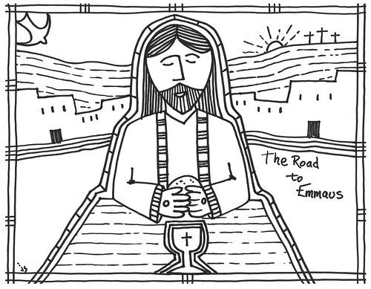
Read Luke 24:13-35
This is another Easter story
- Two men were walking from Jerusalem to Emmaus.
  - What had happened in Jerusalem? How did they feel?
  - Why were they going to Emmaus? What were they going to do?
- Jesus met them on the road. They didn’t recognize Him.
  - He asked them what they were talking about. What did they say?
  - After they finished, He shook His head. What did He say then?
- When they arrived at Emmaus they invited Him to dinner.
  - ‘Stay with us, because it is almost evening and the day is now nearly over.’
  - What happened at dinner?
  - And what did the two men do after Jesus vanished?

