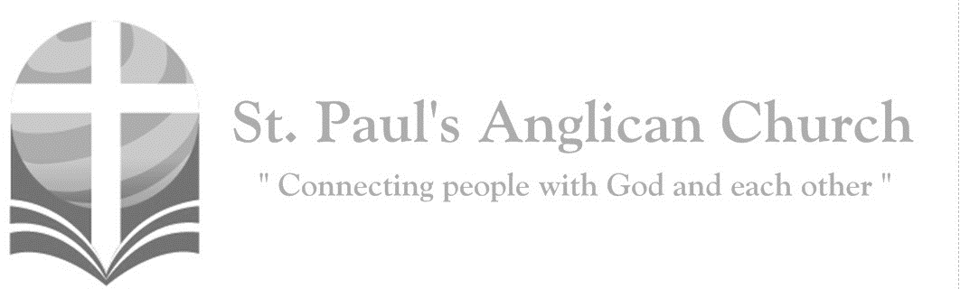
Sunday, April 11, 2021: 2nd Sunday of Easter

Have you believed, Thomas, because you have seen me? Blessed are those who have not seen and yet believe. (John 20:29)

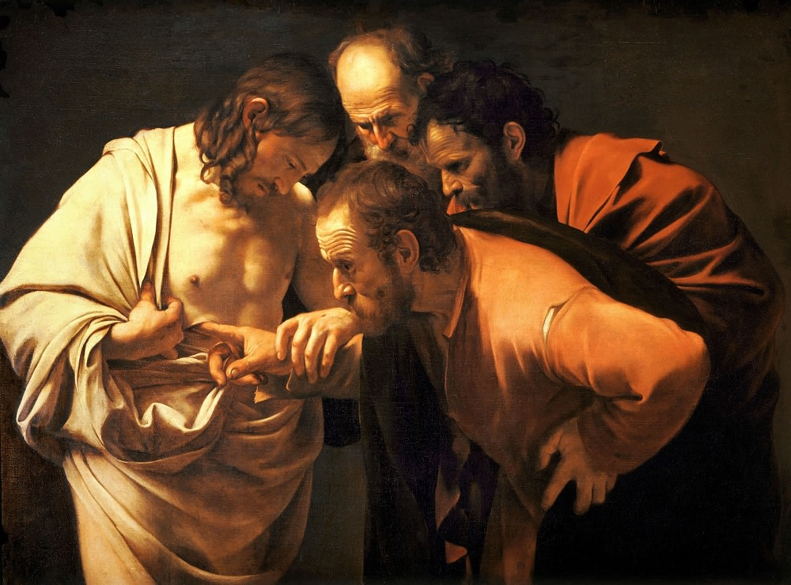

ST. PAUL’S COVID-19 RESPONSE
Welcome!! During this unique time in history, services will look a bit different than normal and will likely be different for quite a while. We want to care for the whole parish during this time and one way to care for one another is keeping each other safe. As such, we ask you to follow these guidelines while worshiping with us:
- Experiencing Cough, Fever, or Other Symptom/s? Go home immediately and please stay home for fourteen days following the end of your symptoms.
- Wear a Mask. All parishioners must wear a mask to all services (as per City of Edmonton bylaw 19408). Exceptions to this include children under the age of two and those with a medical condition where wearing a mask is not possible. Masks may be removed when taking communion but must be replaced immediately following. If you do not have a mask, we have cloth masks available in the foyer.
- Maintain Physical Distance. At all times, please remain a minimum of six feet (three seat spaces) from all other individuals not part of your family unit. You will find tape on the floor six feet apart in multiple locations to help you maintain this distance. Please also maintain physical distance outside.
- Listen to the Ushers. There will be ushers inside and outside to help direct these new procedures. Please heed their direction as they are trying to keep everyone safe and healthy.
- Sign-In Upon Arrival. Please sign-in with the designated usher when you arrive onsite. This will help us track who is in attendance just in case we do have to notify the parish if someone tests Covid positive following a service.
- Sanitize Hands Frequently. Please sanitize your hands upon entry and before taking communion. You may also sanitize as often as you would like during the service. Please also try to refrain from touching surfaces and your face.
- Refrain from Singing. At this time, congregational singing is not allowed by the government of Alberta. Please listen to the lyrics being sung by the leader/s and meditate upon them. You may also hum along to the music as long as your mouth remains closed.
- Recycle Bulletins. Please do not leave bulletins in the pews. A recycle bin is available at the exit door. You may also take the bulletin home.
- Use of Washroom. The only washroom available at this time is located at the back of the Sanctuary (just North of the Main Entry doors). Please wipe down all surfaces (including toilet and handle, counter, and faucet) following use.
- Parts of Building Closed. At this time, the only accessible parts of the building are the Sanctuary, Sanctuary washroom, and alley foyer. All other rooms are closed for use including the main washrooms, hall, basement, and chapel. Please do not access any closed section of the building without permission.

Opening Song: Morning Has Broken

Morning has broken
Like the first morning
Blackbird has spoken like the first bird
Praise for the singing
Praise for the morning
Praise for them springing
Fresh from the Word

Sweet the rain's new fall
Sunlit from heaven
Like the first dew fall on the first grass
Praise for the sweetness
Of the wet garden
Sprung in completeness
Where His feet pass

Mine is the sunlight
Mine is the morning
Born of the one light
Eden saw play
Praise with elation
Praise every morning
God's recreation
Of the new day

The Gathering of the Community
Celebrant: Alleluia! Christ is risen.
People: The Lord is risen indeed. Alleluia!
Celebrant: May his grace and peace be with you.
People: May he fill our hearts with joy.
Celebrant: Almighty God,
All: to you all hearts are open, all desires known, and from you no secrets are hidden. Cleanse the thoughts of our hearts by the inspiration of your Holy Spirit that we may perfectly love you, and worthily magnify your holy name; through Christ our Lord. Amen.
Celebrant: Almighty and eternal God, the strength of those who believe and the hope of those who doubt, may we, who have not seen, have faith and receive the fullness of Christ’s blessing, who is alive and reigns with you and the Holy Spirit, one God, now and for ever.
People: Amen.

The Reading of Scripture
First Reading: Acts 4:32-35
Now the whole group of those who believed were of one heart and soul, and no one claimed private ownership of any possessions, but everything they owned was held in common. With great power the apostles gave their testimony to the resurrection of the Lord Jesus, and great grace was upon them all. There was not a needy person among them, for as many as owned lands or houses sold them and brought the proceeds of what was sold. They laid it at the apostles' feet, and it was distributed to each as any had need.

Reader: The Word of the Lord.
People: Thanks be to God.

Canticle: Psalm 133
Oh, how good and pleasant it is, *
when brethren live together in unity!
It is like fine oil upon the head *
that runs down upon the beard,
Upon the beard of Aaron, *
and runs down upon the collar of his robe.
It is like the dew of Hermon *
that falls upon the hills of Zion.
For there the Lord has ordained the blessing: *
life for evermore.
Prayer: Creator of the universe, from whom all things come, to whom all things return, give your people such unity of heart and mind, that all the world may grow in the life of your eternal kingdom, through Jesus Christ our Lord.

Second Reading: 1 John 1:1-2:2
We declare to you what was from the beginning, what we have heard, what we have seen with our eyes, what we have looked at and touched with our hands, concerning the word of life – this life was revealed, and we have seen it and testify to it, and declare to you the eternal life that was with the Father and was revealed to us – we declare to you what we have seen and heard so that you also may have fellowship with us; and truly our fellowship is with the Father and with his Son Jesus Christ. We are writing these things so that our joy may be complete. This is the message we have heard from him and proclaim to you, that God is light and in him there is no darkness at all. If we say that we have fellowship with him while we are walking in darkness, we lie and do not do what is true; but if we walk in the light as he himself is in the light, we have fellowship with one another, and the blood of Jesus his Son cleanses us from all sin. If we say that we have no sin, we deceive ourselves, and the truth is not in us. If we confess our sins, he who is faithful and just will forgive us our sins and cleanse us from all unrighteousness. If we say that we have not sinned, we make him a liar, and his word is not in us. My little children, I am writing these things to you so that you may not sin. But if anyone does sin, we have an advocate with the Father, Jesus Christ the righteous; and he is the atoning sacrifice for our sins, and not for ours only but also for the sins of the whole world.
Reader: The Word of the Lord.
People: Thanks be to God.

Processional Chorus – Glorious

Glorious
My eyes have seen the glory of the Lord
Glorious
He stands above the rulers of the earth
Glorious, glorious
Lord, You are glorious

The Gospel Reading
Reader: The Lord be with you.
People: And also with you.
Reader: The Holy Gospel of our Lord Jesus Christ according to St. John.
People: Glory to you, Lord Jesus Christ.
Gospel Reading: John 20:19-31
When it was evening on that day, the first day of the week, and the doors of the house where the disciples had met were locked for fear of the Jews, Jesus came and stood among them and said, "Peace be with you." After he said this, he showed them his hands and his side. Then the disciples rejoiced when they saw the Lord. Jesus said to them again, "Peace be with you. As the Father has sent me, so I send you." When he had said this, he breathed on them and said to them, "Receive the Holy Spirit. If you forgive the sins of any, they are forgiven them; if you retain the sins of any, they are retained." But Thomas (who was called the Twin), one of the twelve, was not with them when Jesus came. So the other disciples told him, "We have seen the Lord." But he said to them, "Unless I see the mark of the nails in his hands, and put my finger in the mark of the nails and my hand in his side, I will not believe." A week later his disciples were again in the house, and Thomas was with them. Although the doors were shut, Jesus came and stood among them and said, "Peace be with you." Then he said to Thomas, "Put your finger here and see my hands. Reach out your hand and put it in my side. Do not doubt but believe." Thomas answered him, "My Lord and my God!" Jesus said to him, "Have you believed because you have seen me? Blessed are those who have not seen and yet have come to believe." Now Jesus did many other signs in the presence of his disciples, which are not written in this book. But these are written so that you may come to believe that Jesus is the Messiah, the Son of God, and that through believing you may have life in his name.
Reader: The Gospel of Christ.
People: Praise to you, Lord Jesus Christ.

Worship Through Song

Glorious
Look inside the mystery
See the empty cross
See the risen Saviour
Victorious and strong
No one else above Him
None as strong to save
He alone has conquered
The power of the grave

(Chorus) Glorious
My eyes have seen the glory of the Lord
Glorious
He stands above the rulers of the earth
Glorious, glorious
Lord, You are glorious

Look beyond the tombstone
See the living God
See the resurrected Ruler of my heart
No one else above Him
None to match His worth
The hope of His returning
Fills the universe (To Chorus)

The Lion and the Lamb
He's coming on the clouds
Kings and kingdoms will bow down
And every chain will break
As broken hearts declare His praise
For who can stop the Lord Almighty

(Chorus) Our God is the Lion
The Lion of Judah
He's roaring with power
And fighting our battles
And every knee will bow before Him
Our God is the Lamb
The Lamb that was slain
For the sins of the world
His blood breaks the chains
And every knee will bow before
The Lion and the Lamb
Every knee will bow before Him

So open up the gates
Make way before the King of kings
The God who comes to save
Is here to set the captives free
For who can stop the Lord Almighty
(To Chorus)

Who can stop the Lord Almighty
Who can stop the Lord Almighty
(To Chorus)

Listening Time
Sermon by the Rev. Dr. Myron B. Penner – Sermon Notes:
________________________________________________________________________________________________________________________________________________________________________________________________________________________________________________________________________________________________________________________________________________________________________________________________________________________________________________________________________________________________________________________
________________________________________________________________________________________________________________________________________________________________________________________________________________________
________________________________________________________________________________________________________________________________________________________________________________________________________________________________________________________________________________________________
________________________________________________________________________________________________________________________________________________
________________________________________________________________________
________________________________________________________________________________________________________________________________________________

Affirmation of Faith – The Nicene Creed
Celebrant: Let us confess our faith, as we say,
All: We believe in one God, the Father, the Almighty, maker of heaven and earth, of all that is, seen and unseen. We believe in one Lord, Jesus Christ, the only Son of God, eternally begotten of the Father, God from God, Light from Light, true God from true God, begotten, not made, of one being with the Father. Through him all things were made. For us and for our salvation he came down from heaven: by the power of the Holy Spirit he became incarnate from the Virgin Mary, and was made man. For our sake he was crucified under Pontius Pilate; he suffered death and was buried. On the third day he rose again in accordance with the scriptures; he ascended into heaven and is seated at the right hand of the Father. He will come again in glory to judge the living and the dead, and his kingdom will have no end. We believe in the Holy Spirit, the Lord, the giver of life, who proceeds from the Father. With the Father and the Son he is worshipped and glorified. He has spoken through the prophets. We believe in one holy catholic and apostolic Church. We acknowledge one baptism for the forgiveness of sins. We look for the resurrection of the dead, and the life of the world to come. Amen.

Prayers of the People
Leader: In joy and hope let us pray to the source of all life, saying, “Hear us, Lord of glory!” That our risen Saviour may fill us with the joy of his holy and life-giving resurrection, let us pray to the Lord.
All: Hear us, Lord of glory!
Leader: Remembering today those in our St. Paul’s Cycle of Prayer: Gary and Carol George; Mack and Abigail Harding; and Gordon and Pat Stretch; as well as all of those in the Anglican Cycle of Prayer. That isolated and persecuted churches may find fresh strength in the Easter gospel, let us pray to the Lord.
All: Hear us, Lord of glory!
Leader: That he may grant us humility to be subject to one another in Christian love, let us pray to the Lord.
All: Hear us, Lord of glory!
Leader: That he may provide for those who lack food, work, or shelter, let us pray to the Lord.
All: Hear us, Lord of glory!
Leader: That by his power wars and famine may cease through all the earth, let us pray to the Lord.
All: Hear us, Lord of glory!
Leader: That he may reveal the light of his presence to the sick, the weak, and the dying, that they may be comforted and strengthened, let us pray to the Lord.
All: Hear us, Lord of glory!
Leader: That he may send the fire of the Holy Spirit upon his people, that we may bear faithful witness to his resurrection, let us pray to the Lord.
All: Hear us, Lord of glory! Amen.

Confession of Sin
Celebrant: Dear friends in Christ, God is steadfast in love and infinite in mercy; he welcomes sinners and invites them to his table. Let us confess our sins, confident in God’s forgiveness.
Silent Confession
Celebrant: Have mercy upon us,
All: most merciful Father; in your compassion, forgive us our sins, known and unknown, things done and left undone; and so uphold us by your Spirit that we may live and serve you in newness of life to the honour and glory of your name; through Jesus Christ our Lord. Amen.
Celebrant: Almighty God have mercy upon you, pardon and deliver you from all your sins, confirm and strengthen you in all goodness and keep you in eternal life through Jesus Christ our Lord.
People: Amen.

The Peace
Celebrant: The peace of the Lord be always with you.
People: And also with you.

Prayer Over the Gifts
Celebrant: God of grace,
All: you have freed us from our sins and made us a kingdom in your Son Jesus Christ our Lord. Accept all we offer you this day, and strengthen us in the new life you have given us, through Jesus Christ our Lord. Amen.

Eucharistic Prayer
Celebrant: The Lord be with you.
People: And also with you.
Celebrant: Lift up your hearts.
People: We lift them to the Lord.
Celebrant: Let us give thanks to the Lord our God.
People: It is right to give our thanks and praise.

Celebrant: Blessed are you, gracious God, creator of heaven and earth; we give you thanks and praise for the glorious resurrection of your Son Jesus Christ our Lord; for he is the true paschal lamb who has taken away the sin of the world. By his death he destroyed death, and by his rising to life again he has won for us eternal life. Therefore, joining our voices with the whole company of heaven, we sing our joyful hymn of praise to proclaim the glory of your name.
All: Holy, holy, holy Lord, God of power and might,
heaven and earth are full of your glory. Hosanna in the highest.
Blessed is he who comes in the name of the Lord.
Hosanna in the highest.
Celebrant: We give thanks to you, Lord our God, for the goodness and love you have made known to us in creation; in calling Israel to be your people; in your Word spoken through the prophets; and above all in the Word made flesh, Jesus your Son. For in these last days you sent him to be incarnate from the Virgin Mary, to be the Saviour and Redeemer of the world. In him, you have delivered us from evil, and made us worthy to stand before you. In him, you have brought us out of error into truth, out of sin into righteousness, out of death into life. On the night he was handed over to suffering and death, a death he freely accepted, our Lord Jesus Christ took bread; and when he had given thanks to you, he broke it, and gave it to his disciples, and said, “Take, eat: this is my body which is given for you. Do this for the remembrance of me.” After supper he took the cup of wine; and when he had given thanks, he gave it to them, and said, “Drink this, all of you: this is my blood of the new covenant, which is shed for you and for many for the forgiveness of sins. Whenever you drink it, do this for the remembrance of me.” Therefore, Father, according to his command,
All: we remember his death, we proclaim his resurrection, we await his coming in glory;
Celebrant: and we offer our sacrifice of praise and thanksgiving to you, Lord of all; presenting to you, from your creation, this bread and this wine. We pray you, gracious God, to send your Holy Spirit upon these gifts, that they may be the sacrament of the body of Christ and his blood of the new covenant. Unite us to your Son in his sacrifice, that we, made acceptable in him, may be sanctified by the Holy Spirit. In the fullness of time, reconcile all things in Christ, and make them new, and bring us to that city of light where you dwell with all your sons and daughters; through Jesus Christ our Lord, the firstborn of all creation, the head of the Church, and the author of our salvation; by whom, and with whom, and in whom, in the unity of the Holy Spirit, all honour and glory are yours, almighty Father, now and for ever.
All: Amen.

Celebrant: As our Saviour taught us, let us pray,
All: Our Father in heaven, hallowed be your name. Your kingdom come, your will be done, on earth as in heaven. Give us today our daily bread. Forgive us our sins as we forgive those who sin against us. Save us from the time of trial, and deliver us from evil. For the kingdom, the power, and the glory are yours, now and for ever. Amen.

Celebrant: Lord, we died with you on the cross.
All: Now we are raised to life.
Celebrant: We were buried in your tomb.
All: Now we share in your resurrection.
Celebrant: Live in us, that we may live in you.

Celebrant: The gifts of God for the People of God.
People: Thanks be to God.

The Communion
Please listen carefully to the verbal instructions given. You are welcome to receive communion or come forward for a blessing. Gluten-free wafers are also available. Please sanitize your hands as you approach the front of the church. If you prefer to receive a blessing, please fold your arms over your chest. If you would like to make an offering, please do so after you take the bread.

Lamb of God
(Said by congregation) Lamb of God, you take away the sins of the world.
Lamb of God, you take away the sins of the world.
Lord have mercy, Christ have mercy, Lord have mercy on us.

Communion Music

Come to the Table
Come to the table of mercy
Prepared with the wine and the bread
All who are hungry and thirsty
Come and your souls will be fed

Come at the Lord's invitation
Receive from His nail-scarred hand
Eat of the bread of salvation
Drink of the blood of the Lamb

Highest Price
Prince of Heaven. King of all
He descended from His throne
Into the world this Son of God
Was born in my frame

He bore the cross, despised the shame
Clothed in sin, His robe was stained
And by His blood now I am free
Now I am saved

(Chorus)
For my Jesus paid the highest price
The Lamb of God was crucified
And He deserves my love
He deserves my life
For Jesus paid the highest price

All of Heaven held its breath
And creation mourned His death
But then Jesus rose
And now that He lives
I am alive

And there's no greater sacrifice
Lord I'm laying down my life
I surrender all (repeat)
(To Chorus)

Prayer After Communion
Celebrant: Father,
All: we have seen with our eyes and touched with our hands the bread of life. Strengthen our faith that we may grow in love for you and for each other; through Jesus Christ the risen Lord. Amen.

Celebrant: Glory to God,
All: whose power, working in us, can do infinitely more than we can ask or imagine. Glory to God from generation to generation, in the Church and in Christ Jesus, for ever and ever. Amen.

Blessing

Congregational Announcements (Rev. Myron)
Closing Song: You Shine

Why should I fear man
When You made the heavens
Why should I be afraid
When You put the stars in place
Why should I lose heart
When I know how great You are
Why should I give up
When Your plans are full of love

In this world we will have trouble
But You have overcome the world

You shine
Brighter than the brightest star
Your love, purer than the purest heart
You shine
Filling us with courage and strength
To follow You

The Dismissal
Celebrant: Go in peace to love and serve the Lord.
All: Thanks be to God. Alleluia.

Community Corner for April 11
Registration for the St. Paul’s Church Retreat continues! Please register using the link in the weekly email. We aim to deliver a new, refreshing encounter with God in our everyday lives and surroundings. We have developed a flexible program that allows you to participate as you are able and feel lead. The retreat runs April 22-25. Questions? Email Michelle at michelle@stpauls-anglican.ca
Pandemic Support Group – Michelle will be hosting an adult support group at St Paul's on Thursday evenings from 7-8:30 pm starting April 29, 2021. This group is meeting to support members through some of the emotional and social challenges encountered during the pandemic. It is a peer support group, and, as such, does not promote itself as a therapeutic or counselling group. We gather IN-PERSON to listen to one another and offer encouragement. Support groups are still permitted to meet in person, per provincial guidelines and restrictions. Weekly pre-registration is required and will open April 23. Group participation guidelines will be sent out upon registration.

In-Person Sunday Services – Pre-Registration Required
WEEKLY PRE-REGISTRATION WILL BE REQUIRED for those attending in-person services. The pre-registration link for the Sunday service will be made available on Tuesday (by email and the website) of each week and will close at noon on Friday. For individuals who are immunocompromised or otherwise unable to attend services, you may contact the office to set up an individual time to take the eucharist.

Notice of Electoral Synod
Notice is hereby given that the 67th meeting of Synod, to elect the 11th Bishop of Edmonton, will be held on Saturday, June 26 at 10:00AM. More details to come.
Focus on Missions April Blog
Focus on Missions has submitted a blog post written by Renée Jackson talking about Ratanak and the work they are doing to rescue children from human trafficking. Please check it out by visiting the St. Paul’s website, click on “Blog” and then click on the Missions Connections Blog for April.

Wholeness Through Christ Prayer Ministry Course
WTC is offering their first ever fully virtual prayer ministry course May 25-30, 2021. Spaces are limited so if you are interested, you should register soon. Cost for this course is $250.00. Application to register can be found at the bottom of this page: http://www.wholenessthroughchrist.com/index.php/about/our-events. Or, you can email Administrator@wholenessthroughchrist.com for more information.

Thank You to Tidying/Moving Volunteers
Thank you to all who helped move and tidy things at St. Paul’s over the last few weeks. So many people helped that we had to cancel our final date as there was nothing left to do!! Thanks again to Andrew, Connie, Janette, RJ, Margot, Barb M., Wendell, Deanna, Jim, Gary, Carol G., and Terry!!
Bishop Jane’s Farewell Service
A virtual Farewell Service of thanksgiving for Bishop Jane’s episcopal leadership will be held on Saturday, April 17, at 3:00PM. Details about the live stream to come.
Thank You to Laura Rogers
A big THANK-YOU to Laura Rogers who crafted and sent out Easter cards to our St. Paul's community. Laura also coordinates the Hands-to-Hearts Ministry which provides handmade cards available in the entrance foyer at the church. If you need a card to encourage or celebrate someone in your life, please help yourself.

Anglican Cycle of Prayer:
Diocese of Saskatchewan: the Rt. Rev. Michael Hawkins, Bishop; the Rt. Rev. Adam Halkett, Bishop of Missinipi; the Rt. Rev. Isaiah Larry Beardy, Assisting Bishop of Missinipi. St. Matthew, Viking: Interim Ministry. The retired pastors of Buyé: Joel Minani, Osee Niyibizi. Paul First Nation.

Next Week’s Ministry Teams:
Music: Adele and Team
Service Team: Green and Tilburn Teams
Reader/Prayers: Carol R.

This Week’s Ministry Teams:
Music: Adele and Team
Service Team: B and Jackson Teams
Reader/Prayers: Francis and Jennifer B.

St. Paul’s Cycle of Prayer:
Gary and Carol George;
Mack and Abigail Harding;
Gordon and Pat Stretch
St. Paul’s Anglican Church
10127 145 Street, Edmonton T5N 2X6
Phone: (780) 455-0771; Email: office@stpauls-anglican.ca
Website: www.stpauls-anglican.ca
Office Hours:
Monday-Thursday: 9:00AM-12:00PM
Closed: Fri/Sat/Sun and Stat Holidays
facebook.com/stpachurchedmonton
@StEdmonton
For Care/Concern Team
or other prayer requests, email:
office@stpauls-anglican.ca
For urgent prayer requests call
the church office: (780) 455-0771
For pastoral emergencies call:
(587) 334-2130

St. Paul’s Vestry:
Paul Dowie, Rector’s Warden
Margot Byer, People’s Warden
David Heritage, Treasurer
Barb Dixon, Vestry Member
John Green, Vestry Member
David Parker, Vestry Member
Connie Pistawka, Vestry Member

St. Paul’s Staff:
Rector: The Rev. Myron B. Penner
Community Outreach: Michelle Schurek
Youth Leader: Abigail Harding
Office Administrator: RJ Chambers

