Faith Evangelical Lutheran Church, Washington, IL
The Fifth Sunday of Lent
March 21, 2021

Welcome

Hymn: “Christ, the Life of All the Living” Red Book #339
Public Domain

Confession and Forgiveness

P: In the name of the Father, and of the + Son, and of the Holy Spirit.
C: Amen.
You may dip your finger in water and make the sign of the cross on your forehead as a reminder of your baptism.
God hears us when we cry, and draws us close in Jesus Christ. Let us return to the one who is full of compassion.
You may keep silence for reflection

Fountain of living water,
pour out your mercy over us. Our sin is heavy, and we long to be free.
Rebuild what we have ruined and mend what we have torn.
Wash us in your cleansing flood.
Make us alive in the Spirit to follow in the way of Jesus,
as healers and restorers of the world you so love.
Amen.
Beloved, God’s word never fails. The promise rests on grace:
by the saving love of Jesus Christ, the wisdom and power of God,
your sins are ☩ forgiven, and God remembers them no more.
Journey in the way of Jesus.
Amen.

Peace:
P As forgiven people, we have peace with God, and peace with one another.
The peace of the Lord be with you always.
C And also with you.
P Let us share that peace with one another. Please take a moment to share God’s peace with those near to you, and say a prayer of peace for those at a distance.

P The grace of our Lord Jesus Christ, the love of God,
and the communion of the Holy Spirit be with you all.
C And also with you.
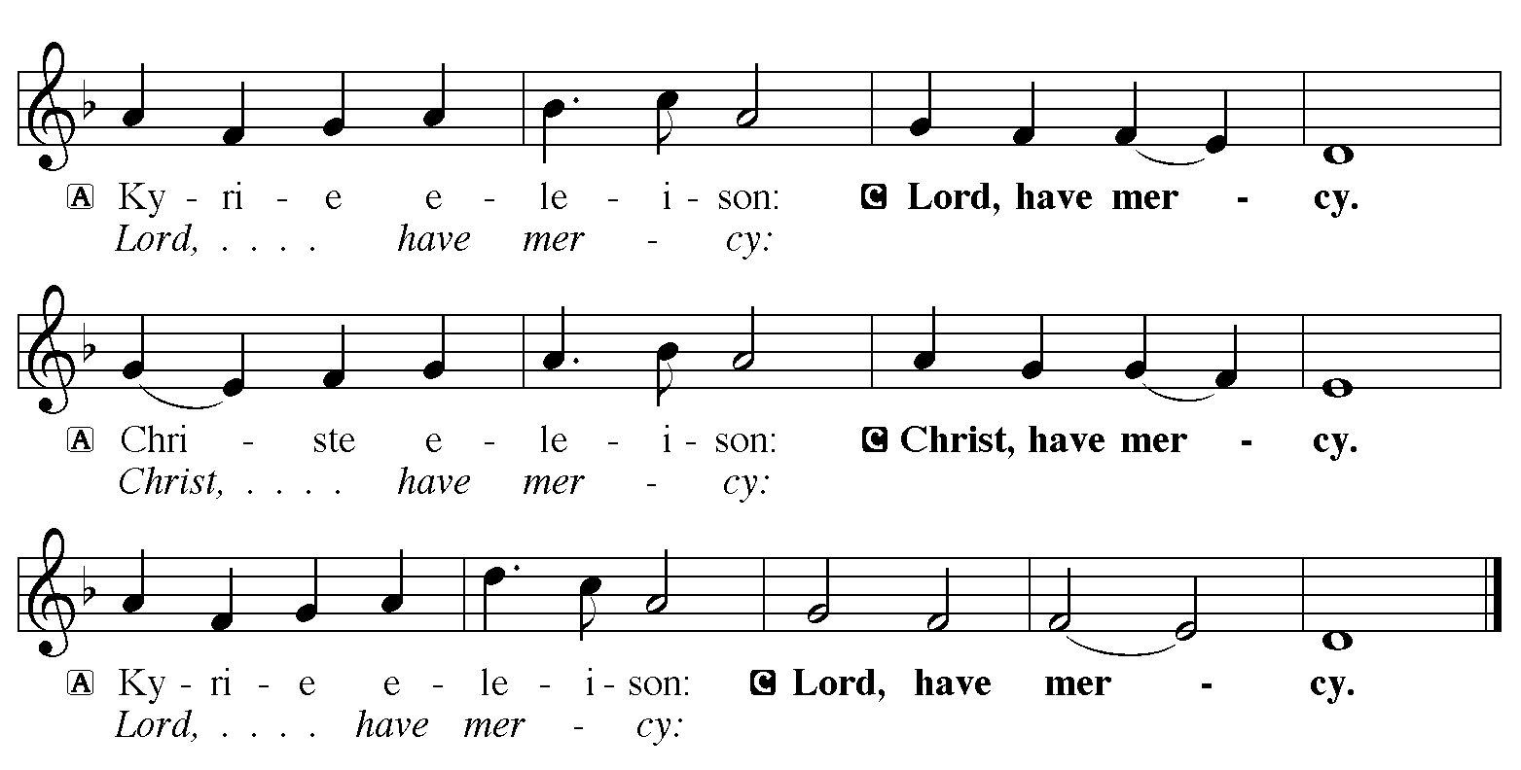

Hymn of Praise: “When I Survey the Wondrous Cross” Green Book # 482
Public Domain

P The Lord be with you
C And also with you
Let us pray together the Prayer of the Day
O God, with steadfast love you draw us to yourself, and in mercy you receive our prayers. Strengthen us to bring forth the fruits of the Spirit, that through life and death we may live in your Son, Jesus Christ, our Savior and Lord, who lives and reigns with you and the Holy Spirit, one God, now and forever. Amen.

Children’s Message

Reading: Jeremiah 31:31-34
³¹The days are surely coming, says the Lord, when I will make a new covenant with the house of Israel and the house of Judah. ³²It will not be like the covenant that I made with their ancestors when I took them by the hand to bring them out of the land of Egypt—a covenant that they broke, though I was their husband, says the Lord. ³³But this is the covenant that I will make with the house of Israel after those days, says the Lord: I will put my law within them, and I will write it on their hearts; and I will be their God, and they shall be my people. ³⁴No longer shall they teach one another, or say to each other, “Know the Lord,” for they shall all know me, from the least of them to the greatest, says the Lord; for I will forgive their iniquity, and remember their sin no more.
The Word of the Lord
C Thanks be to God

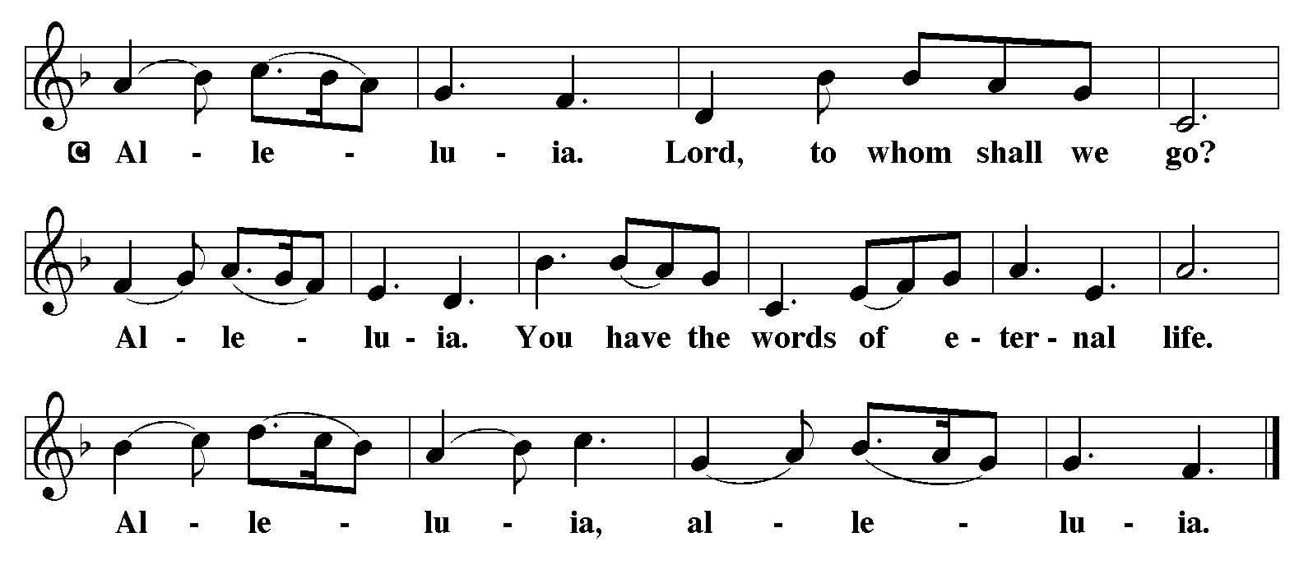

Holy Gospel: John 12:20-33

C Glory to you, O Lord
²⁰Now among those who went up to worship at the festival were some Greeks. ²¹They came to Philip, who was from Bethsaida in Galilee, and said to him, “Sir, we wish to see Jesus.” ²²Philip went and told Andrew; then Andrew and Philip went and told Jesus. ²³Jesus answered them, “The hour has come for the Son of Man to be glorified. ²⁴Very truly, I tell you, unless a grain of wheat falls into the earth and dies, it remains just a single grain; but if it dies, it bears much fruit. ²⁵Those who love their life lose it, and those who hate their life in this world will keep it for eternal life. ²⁶Whoever serves me must follow me, and where I am, there will my servant be also. Whoever serves me, the Father will honor.
²⁷“Now my soul is troubled. And what should I say—‘Father, save me from this hour’? No, it is for this reason that I have come to this hour. ²⁸Father, glorify your name.” Then a voice came from heaven, “I have glorified it, and I will glorify it again.” ²⁹The crowd standing there heard it and said that it was thunder. Others said, “An angel has spoken to him.” ³⁰Jesus answered, “This voice has come for your sake, not for mine. ³¹Now is the judgment of this world; now the ruler of this world will be driven out. ³²And I, when I am lifted up from the earth, will draw all people to myself.” ³³He said this to indicate the kind of death he was to die.
The Gospel of the Lord
C Praise to you, O Christ
Sermon by Pastor John Rothfusz

Sermon Hymn: “Now the Green Blade Rises” Red book # 379
All rights reserved. Used by permission. Reprinted under OneLicense.net #A-711151

Apostles’ Creed
C: I believe in God, the Father almighty,
creator of heaven and earth.
I believe in Jesus Christ, God's only Son, our Lord,
who was conceived by the Holy Spirit,
born of the virgin Mary,
suffered under Pontius Pilate,
was crucified, died, and was buried;
he descended to the dead.
On the third day he rose again;
he ascended into heaven,
he is seated at the right hand of the Father,
and he will come to judge the living and the dead.
I believe in the Holy Spirit,
the holy catholic church, the communion of saints,
the forgiveness of sins, the resurrection of the body,
and the life everlasting. Amen.

Offering: Jesus leads us through death to new life in him. Let us offer ourselves to God with thanks as we lift our tithes and offerings to the Lord. Please take a moment now to make an electronic offering to the church on the website, with the Tithe.ly app or write a check and send it in.

Offering Hymn: “I Heard the Voice of Jesus Say” Red Book # 332
Public Domain
Prayers: After each portion of the prayers finishes with “Lord in your mercy,” please respond, “Hear our prayer.”
Lord’s Prayer
Our Father, who art in heaven, hallowed be thy name,
thy kingdom come, thy will be done, on earth as it is in heaven.
Give us this day our daily bread; and forgive us our trespasses,
as we forgive those who trespass against us;
and lead us not into temptation, but deliver us from evil.
For thine is the kingdom, and the power, and the glory,
forever and ever. Amen
Announcements
Benediction: The Lord bless you and keep you. The Lord make his face to shine upon you and be gracious to you. The Lord look on you with favor and give you peace. In the name of the Father, and of the Son, and of the Holy Spirit. Amen.

Hymn: “O Sacred Head Now Wounded” Red Book # 351
Public Domain
*Dismissal
P Go in peace, serve the Lord.
C Thanks be to God!

