Faith Evangelical Lutheran Church, Washington, IL
The Second Sunday of Lent
February 28, 2021

Prelude
Welcome

Hymn: “Lord Jesus, You Shall Be My Song” Red Book #808
All rights reserved. Used by permission. Reprinted under OneLicense.net #A-711151

Confession and Forgiveness

P: In the name of the Father, and of the + Son, and of the Holy Spirit.
C: Amen.
You may dip your finger in water and make the sign of the cross on your forehead as a reminder of your baptism.
God hears us when we cry, and draws us close in Jesus Christ. Let us return to the one who is full of compassion.
You may keep silence for reflection
Fountain of living water,
pour out your mercy over us. Our sin is heavy, and we long to be free.
Rebuild what we have ruined and mend what we have torn.
Wash us in your cleansing flood.
Make us alive in the Spirit to follow in the way of Jesus,
as healers and restorers of the world you so love.
Amen.
Beloved, God’s word never fails. The promise rests on grace:
by the saving love of Jesus Christ, the wisdom and power of God,
your sins are ☩ forgiven, and God remembers them no more.
Journey in the way of Jesus.
Amen.

Peace:
P As forgiven people, we have peace with God, and peace with one another.
The peace of the Lord be with you always.
C And also with you.
P Let us share that peace with one another. Please take a moment to share God’s peace with those near to you, and say a prayer of peace for those at a distance.

P The grace of our Lord Jesus Christ, the love of God,
and the communion of the Holy Spirit be with you all.
C And also with you.
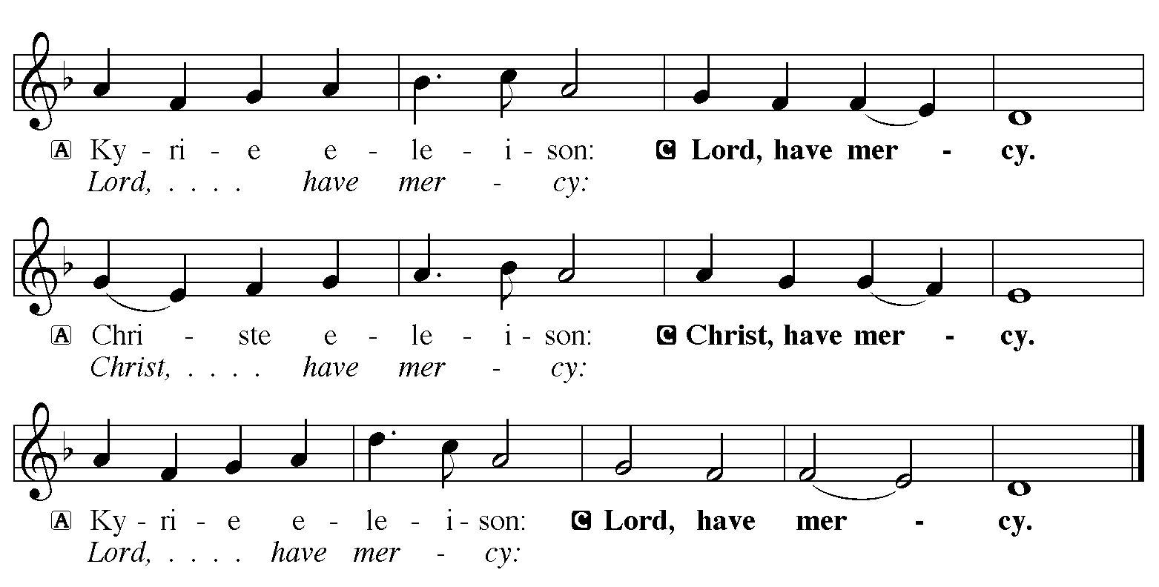

Hymn of Praise: “God Loved the World” Red Book # 323
Public Domain
P The Lord be with you
C And also with you
Let us pray together the Prayer of the Day
O God, by the passion of your blessed Son you made an instrument of shameful death to be for us the means of life. Grant us so to glory in the cross of Christ that we may gladly suffer shame and loss for the sake of your Son, Jesus Christ, our Savior and Lord, who lives and reigns with you and the Holy Spirit, one God, now and forever. Amen.
Children’s Message

First Reading: Genesis 17:1-7, 15-16
¹When Abram was ninety-nine years old, the Lord appeared to Abram, and said to him, “I am God Almighty; walk before me, and be blameless. ²And I will make my covenant between me and you, and will make you exceedingly numerous.” ³Then Abram fell on his face; and God said to him, ⁴“As for me, this is my covenant with you: You shall be the ancestor of a multitude of nations. ⁵No longer shall your name be Abram, but your name shall be Abraham; for I have made you the ancestor of a multitude of nations. ⁶I will make you exceedingly fruitful; and I will make nations of you, and kings shall come from you. ⁷I will establish my covenant between me and you, and your offspring after you throughout their generations, for an everlasting covenant, to be God to you and to your offspring after you.”
¹⁵God said to Abraham, “As for Sarai your wife, you shall not call her Sarai, but Sarah shall be her name. ¹⁶I will bless her, and moreover I will give you a son by her. I will bless her, and she shall give rise to nations; kings of peoples shall come from her.”
The Word of the Lord
C Thanks be to God

Second Reading: Romans 4:13-25
¹³The promise that he would inherit the world did not come to Abraham or to his descendants through the law but through the righteousness of faith. ¹⁴If it is the adherents of the law who are to be the heirs, faith is null and the promise is void. ¹⁵For the law brings wrath; but where there is no law, neither is there violation.
¹⁶For this reason it depends on faith, in order that the promise may rest on grace and be guaranteed to all his descendants, not only to the adherents of the law but also to those who share the faith of Abraham (for he is the father of all of us, ¹⁷as it is written, “I have made you the father of many nations”)—in the presence of the God in whom he believed, who gives life to the dead and calls into existence the things that do not exist.
¹⁸Hoping against hope, he believed that he would become “the father of many nations,” according to what was said, “So numerous shall your descendants be.” ¹⁹He did not weaken in faith when he considered his own body, which was already as good as dead (for he was about a hundred years old), or when he considered the barrenness of Sarah’s womb. ²⁰No distrust made him waver concerning the promise of God, but he grew strong in his faith as he gave glory to God, ²¹being fully convinced that God was able to do what he had promised. ²²Therefore his faith “was reckoned to him as righteousness.” ²³Now the words, “it was reckoned to him,” were written not for his sake alone, ²⁴but for ours also. It will be reckoned to us who believe in him who raised Jesus our Lord from the dead, ²⁵who was handed over to death for our trespasses and was raised for our justification.
The Word of the Lord
C Thanks be to God
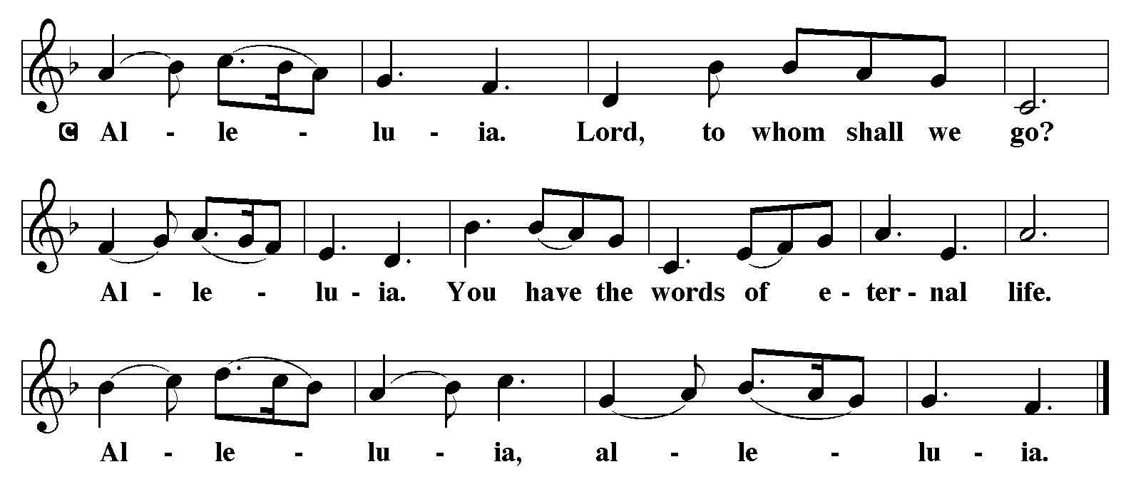

Holy Gospel: Mark 8:31-38
C Glory to you, O Lord
³¹[Jesus] began to teach them that the Son of Man must undergo great suffering, and be rejected by the elders, the chief priests, and the scribes, and be killed, and after three days rise again.³²He said all this quite openly. And Peter took him aside and began to rebuke him. ³³But turning and looking at his disciples, he rebuked Peter and said, “Get behind me, Satan! For you are setting your mind not on divine things but on human things.”
³⁴He called the crowd with his disciples, and said to them, “If any want to become my followers, let them deny themselves and take up their cross and follow me. ³⁵For those who want to save their life will lose it, and those who lose their life for my sake, and for the sake of the gospel, will save it. ³⁶For what will it profit them to gain the whole world and forfeit their life? ³⁷Indeed, what can they give in return for their life? ³⁸Those who are ashamed of me and of my words in this adulterous and sinful generation, of them the Son of Man will also be ashamed when he comes in the glory of his Father with the holy angels.”
The Gospel of the Lord
C Praise to you, O Christ
Sermon by Pastor John Rothfusz

Sermon Hymn: “How Firm a Foundation” Red book # 796
Public Domain
Apostles’ Creed
C: I believe in God, the Father almighty,
creator of heaven and earth.
I believe in Jesus Christ, God's only Son, our Lord,
who was conceived by the Holy Spirit,
born of the virgin Mary,
suffered under Pontius Pilate,
was crucified, died, and was buried;
he descended to the dead.
On the third day he rose again;
he ascended into heaven,
he is seated at the right hand of the Father,
and he will come to judge the living and the dead.
I believe in the Holy Spirit,
the holy catholic church, the communion of saints,
the forgiveness of sins, the resurrection of the body,
and the life everlasting. Amen.

Offering: Jesus calls us to take up our cross and follow him in the way of life. Let us offer ourselves to God with thanks as we lift our tithes and offerings to the Lord. Please take a moment now to make an electronic offering to the church on the website, with the Tithe.ly app or write a check and send it in.

Offering Hymn: “Beneath the Cross of Jesus” Red Book # 338
Public Domain

Prayers: After each portion of the prayers finishes with “Lord in your mercy,” please respond, “Hear our prayer.”

Lord’s Prayer
Our Father, who art in heaven, hallowed be thy name,
thy kingdom come, thy will be done, on earth as it is in heaven.
Give us this day our daily bread; and forgive us our trespasses,
as we forgive those who trespass against us;
and lead us not into temptation, but deliver us from evil.
For thine is the kingdom, and the power, and the glory,
forever and ever. Amen
Announcements
Benediction: The Lord bless you and keep you. The Lord make his face to shine upon you and be gracious to you. The Lord look on you with favor and give you peace. In the name of the Father, and of the Son, and of the Holy Spirit. Amen.

Hymn: “Through the Night of Doubt and Sorrow” Red Book # 327

Arr. © 1969 Concordia Publishing House. All rights reserved. Used by permission. Reprinted under OneLicense.net #A-711151

*Dismissal
P Go in peace, serve the Lord.
C Thanks be to God!
Postlude

