
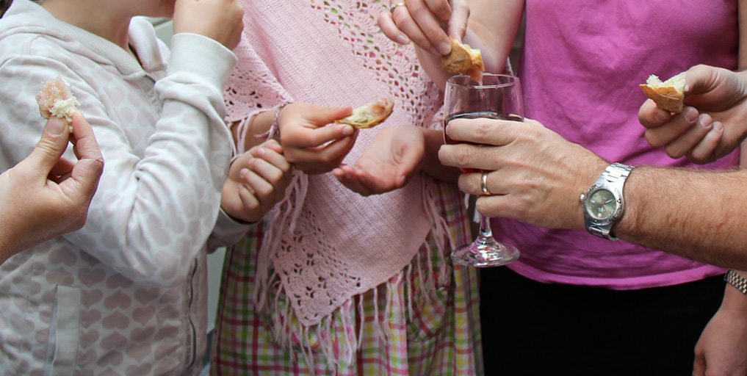
Money, Faith & Worship:

Bank Balance as of Jan 31st 2016 $19,349
Break Even Monthly Target $12,750
January Giving $8,951
Shortfall for January $3,799

Please be aware:

- - Insure if you're giving through "Canada Helps" that it's still happening
- - Consider changing from using "Canada Helps" to using PAD (automatic debit from your account / PAD forms are at the Book Table)
- - Consider a regular giving schedule to smooth out the bumps in the road that the church endures.

For further questions please contact Steve Klassen. R.C. Treasurer
www.intheriver.ca 604.848.8007



City Wide Gathering
February 28th 2016
River Kids Program
Little Dippers Pre-School Program
Pre-Service Prayer 9:00 – 9:45 am

City Wide Gatherings
March 6th
March 13th
March 20th

Office/Study Locations:
Eagle Run Village
301-41340 Government Rd.
Above Bean Brackendale

Pastoral Staff: D&K Reimer
Lead Pastor: Darcy
Kids & Counseling Pastor: Kenda

Pastor

About Us: The River Church values relationships over programs; after all ministry is relationships. What that means is that we encourage people to meet in small groups of 2-3 or more on a regular basis. In the larger context we as a church gather every Sunday in what we call City Wide Gatherings; where we come together in order to purposefully re-connect with one another, and together engage the Trinity in worship and biblical teaching.
Identity Statement: We are a network of Simple Churches: immersed in the grace of God, listening to the Spirit, freed to live out Jesus’ love.
Our Vision is Jesus. We value being a people who are: Refreshingly Grace Filled, Joyfully Engaging, Undividedly Truthful, Wholly Relational, Unashamedly Experiential, Wildly Authentic, and Practically Loving.
Mission Statement: Live by faith, known by love, voice of hope…

www.intheriver.ca
Mailing Address:
PO Box 665
Brackendale, BC
V0N 1H0


Living Out Jesus’ Love

News & Events
Fueling Thought
“At the centre of the universe is a relationship. That is the most fundamental truth I know. At the centre of the universe is a community. It is out of that relationship that you and I were created and redeemed. And it is for that relationship that you and I were created and redeemed. And it turns out that there is a three-fold-ness to that relationship. It turns out that the community is a Trinity. The centre of that reality is Father, Son and Holy Spirit.”
Darrell W. Johnson Experiencing the Trinity

Women’s Retreat: April 1st – 3rd at Camp Stillwood just outside Chilliwack. Miriam Charter will be speaking on “Facing Our Giants” from the David & Goliath story - one of the giants will be anxiety. For more information please check out www.nsac.bc.ca or talk to Pastor Kenda.

Lasting Intimacy & Friendship: Gary Thomas, author of Sacred Marriage, will be speaking based on his new book “A Lifelong Love - how to have lasting Intimacy, Friendship and Purpose in Your Marriage”. Event is on Tuesday March 8th at 7:30pm. The event begins with a comedian and then Gary speaks. The tickets are $15 so if you want to attend please contact Anne Thicke at NSAC @ 604-984-6422 to secure tickets (they have been given 200). Tickets are more expensive on-line. Poster and post-card invites available at the book table. You can check out funandfaith.ca for more info.
Deep Stream Teaching Event: Have you hit a wall in your faith journey? Are you longing for more? Then this course is for you. This multi night Deep Stream will be broken into several consecutive week-nights covering Ruth Barton’s book Sacred Rhythms. Prerequisite for the course is that you buy the book and read the corresponding chapter before each evening. There will be some teaching but the main purpose of the course is that we leave lots of room for dialogue, questions, clarification and practice.
The course will cover the chapter headings: Longing for More / Solitude / Prayer / Honoring the Body / Self Examination / Discernment / Sabbath / Rule of Life. Dates to follow…
World Day of Prayer: Friday March 4th at 7:00 pm at St. John’s. The theme…CUBA!!!
Local Missions
Global Missions
CMA Families: Part of your general giving helps to fund one Canadian CMA missionary family worldwide. We have adopted Gaileen who is working in the Caribbean Sun Region. To receive her prayer updates please check out our website.
Children’s Programs
River Kids

The Vision of River Kids is or kids to have a safe place where they know God’s love, learn what it means to be like Jesus and experience the power of the Holy Spirit in their lives.

Leaders: All leaders/teachers in our children’s programs are members of the River Church and have completed criminal record checks. For safety, we follow the policies and procedures outlined in Plan To Protect. If you have any questions regarding our children’s ministries please contact Kenda Reimer at kendar@intheriver.ca

River Kids: Preschool - Gr.7 These kids are dismissed from the service and meet in the gym.

Age 3 - Kindergarten: meet in one half of the gym and are led by a rotation of teens/young adults. Parents will be found to help their child who needs bathroom help.
Gr 1-7: meet in the other half of the gym and are led by a rotation of adults.

Little Dippers: Nursery/Toddlers. This room is located in the classroom across the hall from the gym. You are welcome to either drop off your child or stay in the room with them. Parents are responsible for trips to the bathroom and diaper changes. This room is run by a rotation of parents and possibly some pre-teen helpers. Parents need to sign in/out their own child.

Youth Outreach
If you’re a teen ages 13-18 and looking to connect with other youth city wide who follow Jesus or are interested in Jesus please contact Mat Chamberlain, our Young Life Leader at matchamberlain@mac.com or at www.facebook.com/pages/Squamish-YoungLife.
“In the Flow” Kid’s Mt Bike Riding Camp: Riding Camp had their first ride May 16th so we’ve begun another season! Please get your registration forms in and your bike’s tuned up!

Small Groups
We will always embrace the idea of meeting in small and large groups. We need both.
Prayerfully consider being a part of a small group, whether it be 3 or more people.

Optional Groups Available:

Tantalus – Sunday 5:30pm
Roaming/Shared Contact: Jim & Grace Neudorf mail4jimn@gmail.com or 604.898.4277

