Faith Evangelical Lutheran Church, Washington, IL
The Transfiguration of our Lord
February 14, 2021

Prelude
Welcome

Hymn: “Swing Low, Sweet Chariot”
Public Domain

Confession and Forgiveness

P: In the name of the Father, and of the + Son, and of the Holy Spirit.
C: Amen.
You may dip your finger in water and make the sign of the cross on your forehead as a reminder of your baptism.
P: Almighty God, to whom all hearts are open, all desires known, and from whom no secrets are hid: cleanse the thoughts of our hearts by the inspiration of your Holy Spirit, that we may perfectly love you and worthily magnify your holy name, through Jesus Christ our Lord.
C: Amen.

P: Let us confess our sin in the presence of God and of one another.
Please keep silence for reflection
P: Most merciful God,
C: we confess that we are captive to sin and cannot free ourselves. We have sinned against you in thought, word, and deed, by what we have done and by what we have left undone. We have not loved you with our whole heart; we have not loved our neighbors as ourselves. For the sake of your Son, Jesus Christ, have mercy on us. Forgive us, renew us, and lead us, so that we may delight in your will and walk in your ways, to the glory of your holy name. Amen.

P: In the mercy of almighty God, Jesus Christ was given to die for us, and for his sake God forgives us all our sins. As a called and ordained minister of the church of Christ, and by his authority, I therefore declare to you the entire forgiveness of all your sins, in the name of the Father, and of the + Son, and of the Holy Spirit.
C: Amen.

Peace:
P As forgiven people, we have peace with God, and peace with one another.
The peace of the Lord be with you always.
C And also with you.
P Let us share that peace with one another. Please take a moment to share God’s peace with those near to you, and say a prayer of peace for those at a distance.
P The grace of our Lord Jesus Christ, the love of God,
and the communion of the Holy Spirit be with you all.
C And also with you.
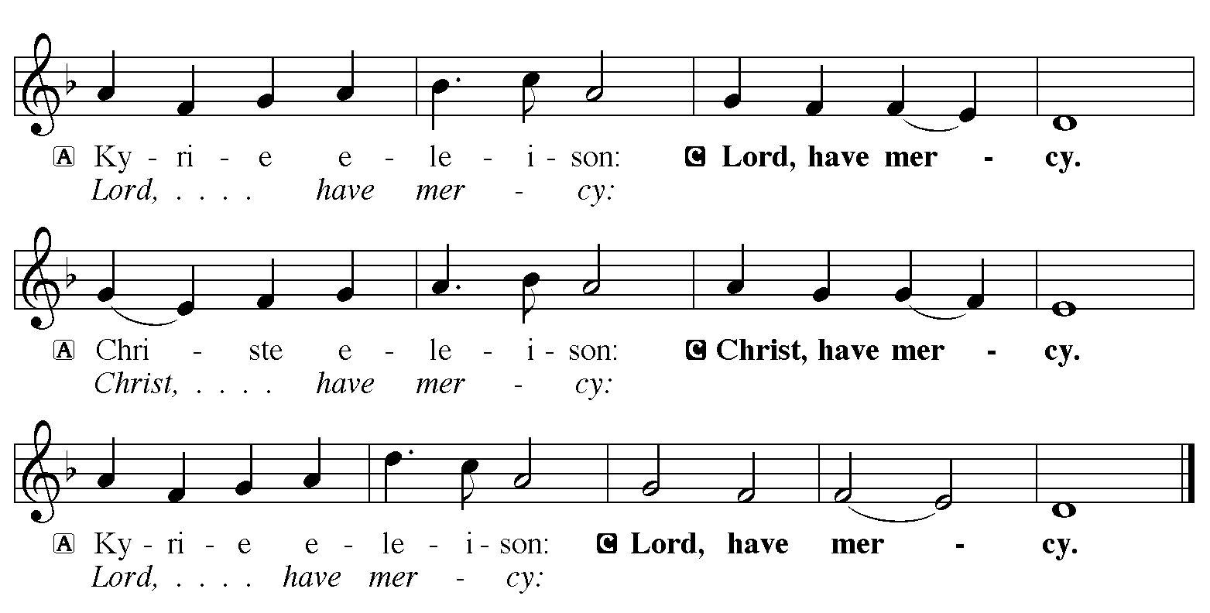

Hymn of Praise: “Christ Be Our Light” Red Book # 715
All rights reserved. Used by permission. Reprinted under OneLicense.net #A-711151
P The Lord be with you
C And also with you
Let us pray together the Prayer of the Day
Almighty God, the resplendent light of your truth shines from the mountaintop into our hearts. Transfigure us by your beloved Son, and illumine the world with your image, through Jesus Christ, our Savior and Lord, who lives and reigns with you and the Holy Spirit, one God, now and forever. Amen.

Children’s Message

First Reading: 2 Kings 2:1-12
¹Now when the Lord was about to take Elijah up to heaven by a whirlwind, Elijah and Elisha were on their way from Gilgal. ²Elijah said to Elisha, “Stay here; for the Lord has sent me as far as Bethel.” But Elisha said, “As the Lord lives, and as you yourself live, I will not leave you.” So they went down to Bethel. ³The company of prophets who were in Bethel came out to Elisha, and said to him, “Do you know that today the Lord will take your master away from you?” And he said, “Yes, I know; keep silent.”
⁴Elijah said to him, “Elisha, stay here; for the Lord has sent me to Jericho.” But he said, “As the Lord lives, and as you yourself live, I will not leave you.” So they came to Jericho. ⁵The company of prophets who were at Jericho drew near to Elisha, and said to him, “Do you know that today the Lord will take your master away from you?” And he answered, “Yes, I know; be silent.”
⁶Then Elijah said to him, “Stay here; for the Lord has sent me to the Jordan.” But he said, “As the Lord lives, and as you yourself live, I will not leave you.” So the two of them went on. ⁷Fifty men of the company of prophets also went, and stood at some distance from them, as they both were standing by the Jordan. ⁸Then Elijah took his mantle and rolled it up, and struck the water; the water was parted to the one side and to the other, until the two of them crossed on dry ground.
⁹When they had crossed, Elijah said to Elisha, “Tell me what I may do for you, before I am taken from you.” Elisha said, “Please let me inherit a double share of your spirit.” ¹⁰He responded, “You have asked a hard thing; yet, if you see me as I am being taken from you, it will be granted you; if not, it will not.” ¹¹As they continued walking and talking, a chariot of fire and horses of fire separated the two of them, and Elijah ascended in a whirlwind into heaven. ¹²Elisha kept watching and crying out, “Father, father! The chariots of Israel and its horsemen!” But when he could no longer see him, he grasped his own clothes and tore them in two pieces.
The Word of the Lord
C Thanks be to God

Second Reading: 2 Corinthians 4:3-6
³Even if our gospel is veiled, it is veiled to those who are perishing. ⁴In their case the god of this world has blinded the minds of the unbelievers, to keep them from seeing the light of the gospel of the glory of Christ, who is the image of God. ⁵For we do not proclaim ourselves; we proclaim Jesus Christ as Lord and ourselves as your slaves for Jesus’ sake. ⁶For it is the God who said, “Let light shine out of darkness,” who has shone in our hearts to give the light of the knowledge of the glory of God in the face of Jesus Christ.
The Word of the Lord
C Thanks be to God
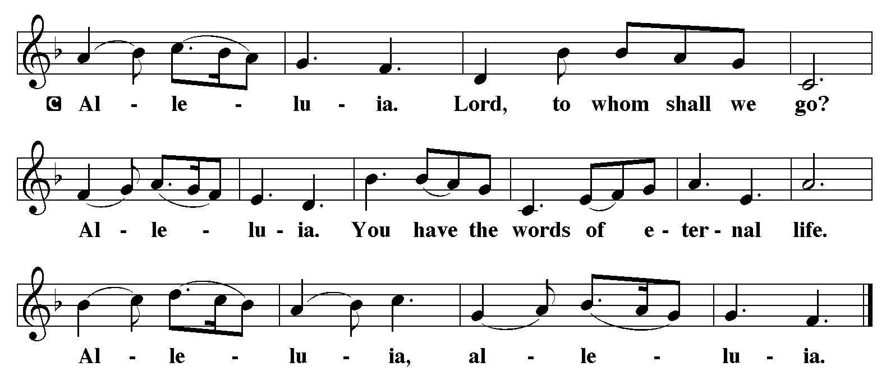

Holy Gospel: Mark 9:2-9
C Glory to you, O Lord
²Six days later, Jesus took with him Peter and James and John, and led them up a high mountain apart, by themselves. And he was transfigured before them, ³and his clothes became dazzling white, such as no one on earth could bleach them. ⁴And there appeared to them Elijah with Moses, who were talking with Jesus. ⁵Then Peter said to Jesus, “Rabbi, it is good for us to be here; let us make three dwellings, one for you, one for Moses, and one for Elijah.” ⁶He did not know what to say, for they were terrified. ⁷Then a cloud overshadowed them, and from the cloud there came a voice, “This is my Son, the Beloved; listen to him!” ⁸Suddenly when they looked around, they saw no one with them any more, but only Jesus.
⁹As they were coming down the mountain, he ordered them to tell no one about what they had seen, until after the Son of Man had risen from the dead.
The Gospel of the Lord
C Praise to you, O Christ

Sermon by Pastor Ken Sandlin – Assistant to the Bishop
of the Central/Southern Illinois Synod

Sermon Hymn: “How Good Lord to be Here” Red book # 315
Public Domain

Apostles’ Creed
C: I believe in God, the Father almighty,
creator of heaven and earth.
I believe in Jesus Christ, God's only Son, our Lord,
who was conceived by the Holy Spirit,
born of the virgin Mary,
suffered under Pontius Pilate,
was crucified, died, and was buried;
he descended to the dead.
On the third day he rose again;
he ascended into heaven,
he is seated at the right hand of the Father,
and he will come to judge the living and the dead.
I believe in the Holy Spirit,
the holy catholic church, the communion of saints,
the forgiveness of sins, the resurrection of the body,
and the life everlasting. Amen.

Offering: On the Mountain we can see that Jesus is truly God with us. Let us offer ourselves to God with thanks as we lift our tithes and offerings to the Lord. Please take a moment now to make an electronic offering to the church on the website, with the Tithe.ly app or write a check and send it in.

Offering Hymn: “Beautiful Savior” Red Book # 838
Public Domain

Prayers: After each portion of the prayers finishes with “Lord in your mercy,” please respond, “Hear our prayer.”
Lord’s Prayer
Our Father, who art in heaven, hallowed be thy name,
thy kingdom come, thy will be done, on earth as it is in heaven.
Give us this day our daily bread; and forgive us our trespasses,
as we forgive those who trespass against us;
and lead us not into temptation, but deliver us from evil.
For thine is the kingdom, and the power, and the glory,
forever and ever. Amen
Announcements
Benediction: The Lord bless you and keep you. The Lord make his face to shine upon you and be gracious to you. The Lord look on you with favor and give you peace. In the name of the Father, and of the Son, and of the Holy Spirit. Amen.

Hymn: “Thy Strong Word” Verses 1-5 Red Book # 511
All rights reserved. Used by permission. Reprinted under OneLicense.net #A-711151
*Dismissal
P Go in peace, serve the Lord.
C Thanks be to God!
Postlude

