Faith Evangelical Lutheran Church, Washington, IL
Fourth Sunday after Epiphany
January 31, 2021

Prelude
Welcome

Hymn: “Songs of Thankfulness and Praise” Red Book # 310
Public Domain
Confession and Forgiveness

P: In the name of the Father, and of the + Son, and of the Holy Spirit.
C: Amen.
You may dip your finger in water and make the sign of the cross on your forehead as a reminder of your baptism.
P: Almighty God, to whom all hearts are open, all desires known, and from whom no secrets are hid: cleanse the thoughts of our hearts by the inspiration of your Holy Spirit, that we may perfectly love you and worthily magnify your holy name, through Jesus Christ our Lord.
C: Amen.

P: Let us confess our sin in the presence of God and of one another.
Please keep silence for reflection
P: Most merciful God,
C: we confess that we are captive to sin and cannot free ourselves. We have sinned against you in thought, word, and deed, by what we have done and by what we have left undone. We have not loved you with our whole heart; we have not loved our neighbors as ourselves. For the sake of your Son, Jesus Christ, have mercy on us. Forgive us, renew us, and lead us, so that we may delight in your will and walk in your ways, to the glory of your holy name. Amen.

P: In the mercy of almighty God, Jesus Christ was given to die for us, and for his sake God forgives us all our sins. As a called and ordained minister of the church of Christ, and by his authority, I therefore declare to you the entire forgiveness of all your sins, in the name of the Father, and of the + Son, and of the Holy Spirit.
C: Amen.
Peace:
P As forgiven people, we have peace with God, and peace with one another.
The peace of the Lord be with you always.
C And also with you.
P Let us share that peace with one another. Please take a moment to share God’s peace with those near to you, and say a prayer of peace for those at a distance.
P The grace of our Lord Jesus Christ, the love of God,
and the communion of the Holy Spirit be with you all.
C And also with you.
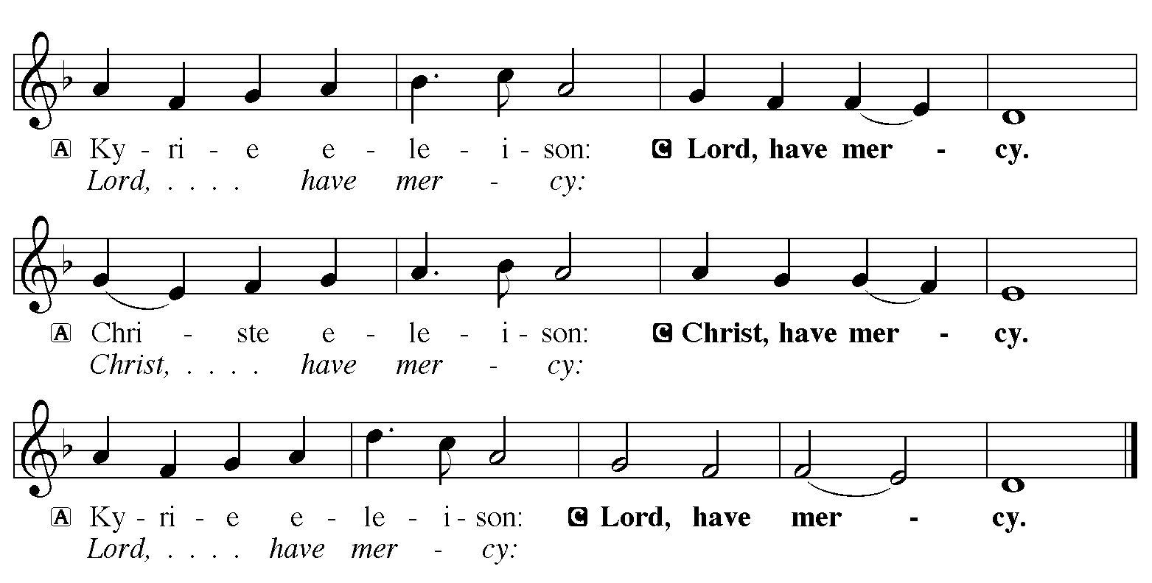

Hymn of Praise: “Rise, Shine, You People!” Red Book # 665
All rights reserved. Used by permission. Reprinted under OneLicense.net #A-711151

P The Lord be with you
C And also with you
Let us pray together the Prayer of the Day
Compassionate God, you gather the whole universe into your radiant presence and continually reveal your Son as our Savior. Bring wholeness to all that is broken and speak truth to us in our confusion, that all creation will see and know your Son, Jesus Christ, our Savior and Lord. Amen.

Children’s Message

First Reading: Deuteronomy 18:15-20
[Moses said:] ¹⁵The Lord your God will raise up for you a prophet like me from among your own people; you shall heed such a prophet. ¹⁶This is what you requested of the Lord your God at Horeb on the day of the assembly when you said: “If I hear the voice of the Lord my God any more, or ever again see this great fire, I will die.” ¹⁷Then the Lord replied to me: “They are right in what they have said. ¹⁸I will raise up for them a prophet like you from among their own people; I will put my words in the mouth of the prophet, who shall speak to them everything that I command. ¹⁹Anyone who does not heed the words that the prophet shall speak in my name, I myself will hold accountable. ²⁰But any prophet who speaks in the name of other gods, or who presumes to speak in my name a word that I have not commanded the prophet to speak—that prophet shall die.”
The Word of the Lord
C Thanks be to God

Psalm: Psalm 111– Sing in unison
¹Hallelujah! I will give thanks to the Lord with | my whole heart,
in the assembly of the upright, in the | congregation.
²Great are your | works, O Lord,
pondered by all who de- | light in them.
³Majesty and splendor | mark your deeds,
and your righteousness en- | dures forever.
⁴You cause your wonders to | be remembered;
you are gracious and full | of compassion.
⁵You give food to | those who fear you,
remembering forev- | er your covenant.
⁶You have shown your people the power | of your works
in giving them the lands | of the nations.
⁷The works of your hands are faithful- | ness and justice;
all of your pre- | cepts are sure.
⁸They stand fast forev- | er and ever,
because they are done in | truth and equity.
⁹You sent redemption to your people and commanded your cove- | nant forever;
holy and awesome | is your name.
¹⁰The fear of the Lord is the begin- | ning of wisdom;
all who practice this have a good understanding. God’s praise en- | dures forever.

Second Reading: 1 Corinthians 8:1-13
¹Now concerning food sacrificed to idols: we know that “all of us possess knowledge.” Knowledge puffs up, but love builds up. ²Anyone who claims to know something does not yet have the necessary knowledge; ³but anyone who loves God is known by him.
⁴Hence, as to the eating of food offered to idols, we know that “no idol in the world really exists,” and that “there is no God but one.” ⁵Indeed, even though there may be so-called gods in heaven or on earth—as in fact there are many gods and many lords—⁶yet for us there is one God, the Father, from whom are all things and for whom we exist, and one Lord, Jesus Christ, through whom are all things and through whom we exist.
⁷It is not everyone, however, who has this knowledge. Since some have become so accustomed to idols until now, they still think of the food they eat as food offered to an idol; and their conscience, being weak, is defiled. ⁸“Food will not bring us close to God.” We are no worse off if we do not eat, and no better off if we do. ⁹But take care that this liberty of yours does not somehow become a stumbling block to the weak. ¹⁰For if others see you, who possess knowledge, eating in the temple of an idol, might they not, since their conscience is weak, be encouraged to the point of eating food sacrificed to idols? ¹¹So by your knowledge those weak believers for whom Christ died are destroyed. ¹²But when you thus sin against members of your family, and wound their conscience when it is weak, you sin against Christ. ¹³Therefore, if food is a cause of their falling, I will never eat meat, so that I may not cause one of them to fall.
The Word of the Lord
C Thanks be to God
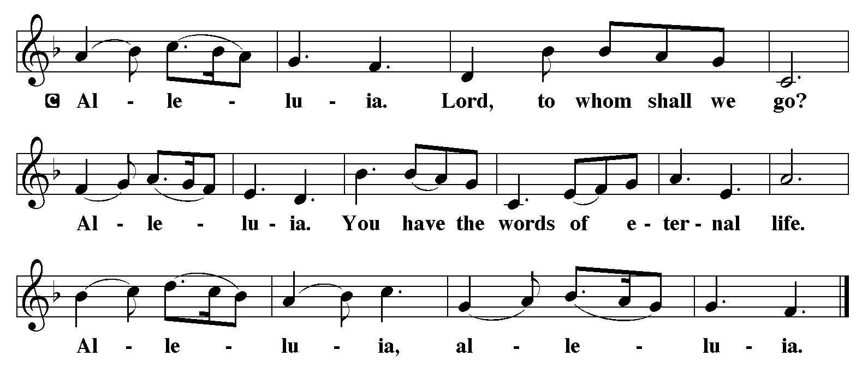

Holy Gospel: Mark 1:21-28
C Glory to you, O Lord
²¹[Jesus and his disciples] went to Capernaum; and when the sabbath came, he entered the synagogue and taught.²²They were astounded at his teaching, for he taught them as one having authority, and not as the scribes. ²³Just then there was in their synagogue a man with an unclean spirit, ²⁴and he cried out, “What have you to do with us, Jesus of Nazareth? Have you come to destroy us? I know who you are, the Holy One of God.” ²⁵But Jesus rebuked him, saying, “Be silent, and come out of him!” ²⁶And the unclean spirit, convulsing him and crying with a loud voice, came out of him. ²⁷They were all amazed, and they kept on asking one another, “What is this? A new teaching—with authority! He commands even the unclean spirits, and they obey him.” ²⁸At once his fame began to spread throughout the surrounding region of Galilee.
The Gospel of the Lord
C Praise to you, O Christ
Sermon by Pastor John Rothfusz

Sermon Hymn: “Jesu, Jesu, Fill Us With Your Love” Red book # 708
Reprinted under OneLicense.net #A-711151

Apostles’ Creed
C: I believe in God, the Father almighty,
creator of heaven and earth.
I believe in Jesus Christ, God's only Son, our Lord,
who was conceived by the Holy Spirit,
born of the virgin Mary,
suffered under Pontius Pilate,
was crucified, died, and was buried;
he descended to the dead.
On the third day he rose again;
he ascended into heaven,
he is seated at the right hand of the Father,
and he will come to judge the living and the dead.
I believe in the Holy Spirit,
the holy catholic church, the communion of saints,
the forgiveness of sins, the resurrection of the body,
and the life everlasting. Amen.

Offering: Jesus calls us to follow him, to share in his work in the world. Let us offer ourselves to God with thanks as we lift our tithes and offerings to the Lord. Please take a moment now to make an electronic offering to the church on the website, with the Tithe.ly app or write a check and send it in.

Offering Hymn: “Holy, Holy, Holy” Sing 3 times Red Book # 473
Public Domain

Prayers: After each portion of the prayers finishes with “Lord in your mercy,” please respond, “Hear our prayer.”
Lord’s Prayer
Our Father, who art in heaven, hallowed be thy name,
thy kingdom come, thy will be done, on earth as it is in heaven.
Give us this day our daily bread; and forgive us our trespasses,
as we forgive those who trespass against us;
and lead us not into temptation, but deliver us from evil.
For thine is the kingdom, and the power, and the glory,
forever and ever. Amen
Announcements
Benediction: The Lord bless you and keep you. The Lord make his face to shine upon you and be gracious to you. The Lord look on you with favor and give you peace. In the name of the Father, and of the Son, and of the Holy Spirit. Amen.

Hymn: “O God of Light” Red Book # 507
All rights reserved. Used by permission. Reprinted under OneLicense.net #A-711151
*Dismissal
P Go in peace, serve the Lord.
C Thanks be to God!
Postlude

