Faith Evangelical Lutheran Church, Washington, IL
Third Sunday after Epiphany
January 24, 2021

Prelude
Welcome

Hymn: “Arise, Your Light Has Come!” Red Book # 314
Reprinted under OneLicense.net #A-711151

Confession and Forgiveness

P: In the name of the Father, and of the + Son, and of the Holy Spirit.
C: Amen.
You may dip your finger in water and make the sign of the cross on your forehead as a reminder of your baptism.
P: Almighty God, to whom all hearts are open, all desires known, and from whom no secrets are hid: cleanse the thoughts of our hearts by the inspiration of your Holy Spirit, that we may perfectly love you and worthily magnify your holy name, through Jesus Christ our Lord.
C: Amen.

P: Let us confess our sin in the presence of God and of one another.
Please keep silence for reflection
P: Most merciful God,
C: we confess that we are captive to sin and cannot free ourselves. We have sinned against you in thought, word, and deed, by what we have done and by what we have left undone. We have not loved you with our whole heart; we have not loved our neighbors as ourselves. For the sake of your Son, Jesus Christ, have mercy on us. Forgive us, renew us, and lead us, so that we may delight in your will and walk in your ways, to the glory of your holy name. Amen.

P: In the mercy of almighty God, Jesus Christ was given to die for us, and for his sake God forgives us all our sins. As a called and ordained minister of the church of Christ, and by his authority, I therefore declare to you the entire forgiveness of all your sins, in the name of the Father, and of the + Son, and of the Holy Spirit.
C: Amen.
Peace:
P As forgiven people, we have peace with God, and peace with one another.
The peace of the Lord be with you always.
C And also with you.
P Let us share that peace with one another. Please take a moment to share God’s peace with those near to you, and say a prayer of peace for those at a distance.
P The grace of our Lord Jesus Christ, the love of God,
and the communion of the Holy Spirit be with you all.
C And also with you.
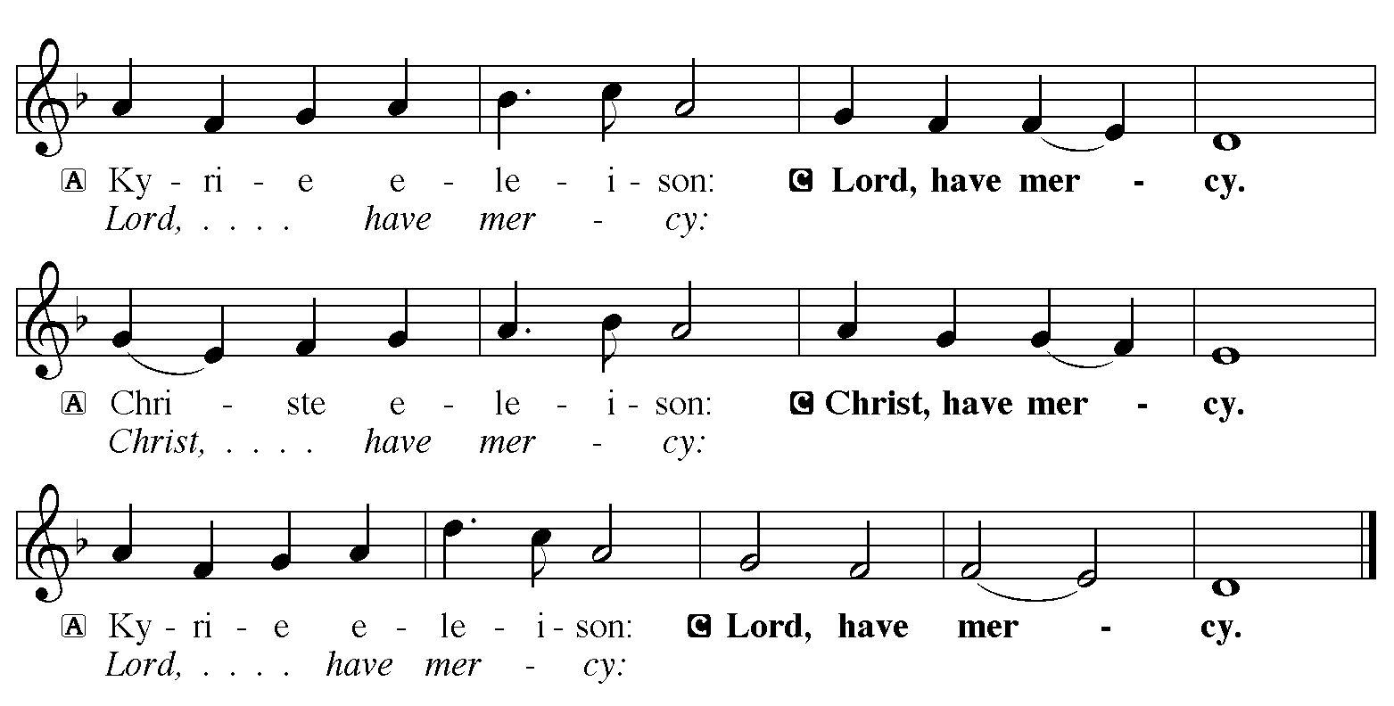

Hymn of Praise: “Jesus Come! For We Invite You” Red Book # 312
All rights reserved. Used by permission. Reprinted under OneLicense.net #A-711151

P The Lord be with you
C And also with you
Let us pray together the Prayer of the Day
Almighty God, by grace alone you call us and accept us in your service. Strengthen us by your Spirit, and make us worthy of your call, through Jesus Christ, our Savior and Lord. Amen.

Children’s Message

First Reading: Jonah 3:1-5, 10
¹The word of the Lord came to Jonah a second time, saying, ²“Get up, go to Nineveh, that great city, and proclaim to it the message that I tell you.” ³So Jonah set out and went to Nineveh, according to the word of the Lord. Now Nineveh was an exceedingly large city, a three days’ walk across. ⁴Jonah began to go into the city, going a day’s walk. And he cried out, “Forty days more, and Nineveh shall be overthrown!” ⁵And the people of Nineveh believed God; they proclaimed a fast, and everyone, great and small, put on sackcloth.
¹⁰When God saw what they did, how they turned from their evil ways, God changed his mind about the calamity that he had said he would bring upon them; and he did not do it.
The Word of the Lord
C Thanks be to God

Psalm 65:6-14 – Sing in unison
⁶For God alone my soul in | silence waits;
truly, my hope | is in him.
⁷He alone is my rock and | my salvation,
my stronghold, so that I shall | not be shaken.
⁸In God is my safety | and my honor;
God is my strong rock | and my refuge.
⁹Put your trust in him al- | ways, O people,
pour out your hearts before him, for God | is our refuge.
¹⁰Those of high degree are but a | fleeting breath,
even those of low estate can- | not be trusted.
¹¹On the scales they are lighter | than a breath,
all of | them together.
¹²Put no trust in extortion; in robbery take no | empty pride;
though wealth increase, set not your | heart upon it.
¹³God has spoken once, twice | have I heard it,
that power be- | longs to God.
¹⁴Steadfast love is | yours, O Lord,
for you repay everyone according | to his deeds.

Second Reading: 1 Corinthians 7:29-31
²⁹Brothers and sisters, the appointed time has grown short; from now on, let even those who have wives be as though they had none, ³⁰and those who mourn as though they were not mourning, and those who rejoice as though they were not rejoicing, and those who buy as though they had no possessions, ³¹and those who deal with the world as though they had no dealings with it. For the present form of this world is passing away.
The Word of the Lord
C Thanks be to God
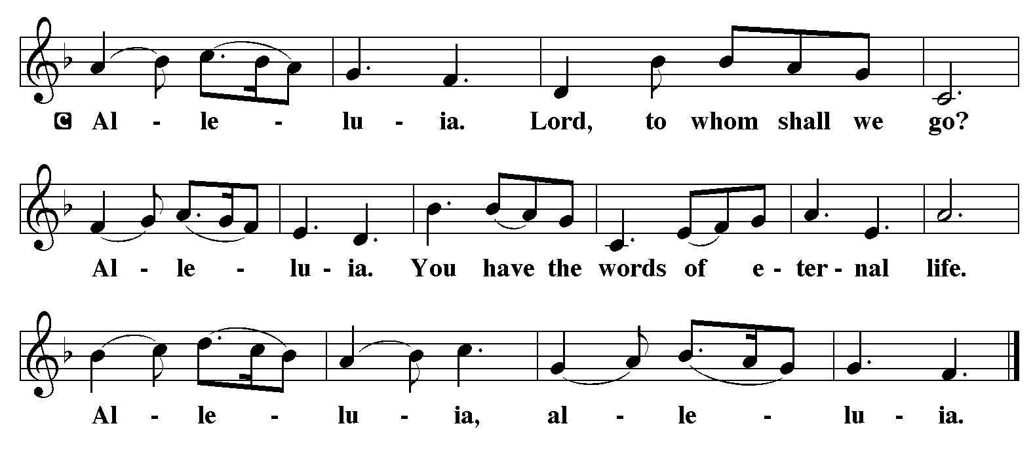

Holy Gospel: Mark 1:14-20
C Glory to you, O Lord
¹⁴Now after John was arrested, Jesus came to Galilee, proclaiming the good news of God, ¹⁵and saying, “The time is fulfilled, and the kingdom of God has come near; repent, and believe in the good news.”
¹⁶As Jesus passed along the Sea of Galilee, he saw Simon and his brother Andrew casting a net into the sea—for they were fishermen. ¹⁷And Jesus said to them, “Follow me and I will make you fish for people.” ¹⁸And immediately they left their nets and followed him. ¹⁹As he went a little farther, he saw James son of Zebedee and his brother John, who were in their boat mending the nets. ²⁰Immediately he called them; and they left their father Zebedee in the boat with the hired men, and followed him.
The Gospel of the Lord
C Praise to you, O Christ
Sermon by Pastor John Rothfusz
Sermon Hymn: “You Have Come Down to the Lakeshore” Red book # 817
Used by permission. Reprinted under OneLicense.net #A-711151
Apostles’ Creed
C: I believe in God, the Father almighty,
creator of heaven and earth.
I believe in Jesus Christ, God's only Son, our Lord,
who was conceived by the Holy Spirit,
born of the virgin Mary,
suffered under Pontius Pilate,
was crucified, died, and was buried;
he descended to the dead.
On the third day he rose again;
he ascended into heaven,
he is seated at the right hand of the Father,
and he will come to judge the living and the dead.
I believe in the Holy Spirit,
the holy catholic church, the communion of saints,
the forgiveness of sins, the resurrection of the body,
and the life everlasting. Amen.

Offering: Jesus calls us to follow him, to share in his work in the world. Let us offer ourselves to God with thanks as we lift our tithes and offerings to the Lord. Please take a moment now to make an electronic offering to the church on the website, with the Tithe.ly app or write a check and send it in.

Offering Hymn: “In Thee is Gladness” Red Book # 867
Public Domain

Prayers: After each portion of the prayers finishes with “Lord in your mercy,” please respond, “Hear our prayer.”
Lord’s Prayer
Our Father, who art in heaven, hallowed be thy name,
thy kingdom come, thy will be done, on earth as it is in heaven.
Give us this day our daily bread; and forgive us our trespasses,
as we forgive those who trespass against us;
and lead us not into temptation, but deliver us from evil.
For thine is the kingdom, and the power, and the glory,
forever and ever. Amen
Announcements
Benediction: The Lord bless you and keep you. The Lord make his face to shine upon you and be gracious to you. The Lord look on you with favor and give you peace. In the name of the Father, and of the Son, and of the Holy Spirit. Amen.

Hymn: “Lead on, O King Eternal” Red Book # 805
Public Domain
*Dismissal
P Go in peace, serve the Lord.
C Thanks be to God!
Postlude

