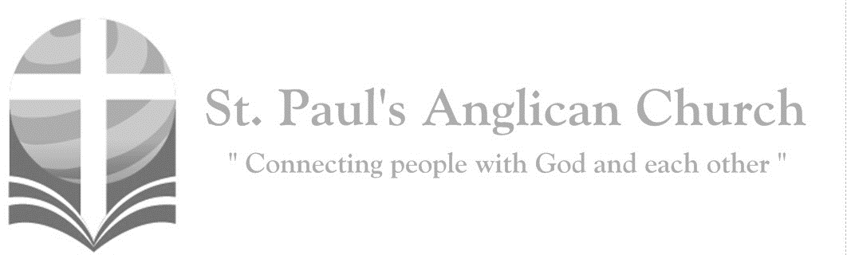
Sunday, January 10, 2021: Baptism of the Lord
A voice came from heaven, saying, “This is my beloved Son
with whom I am well pleased.” (Matthew 3:17)

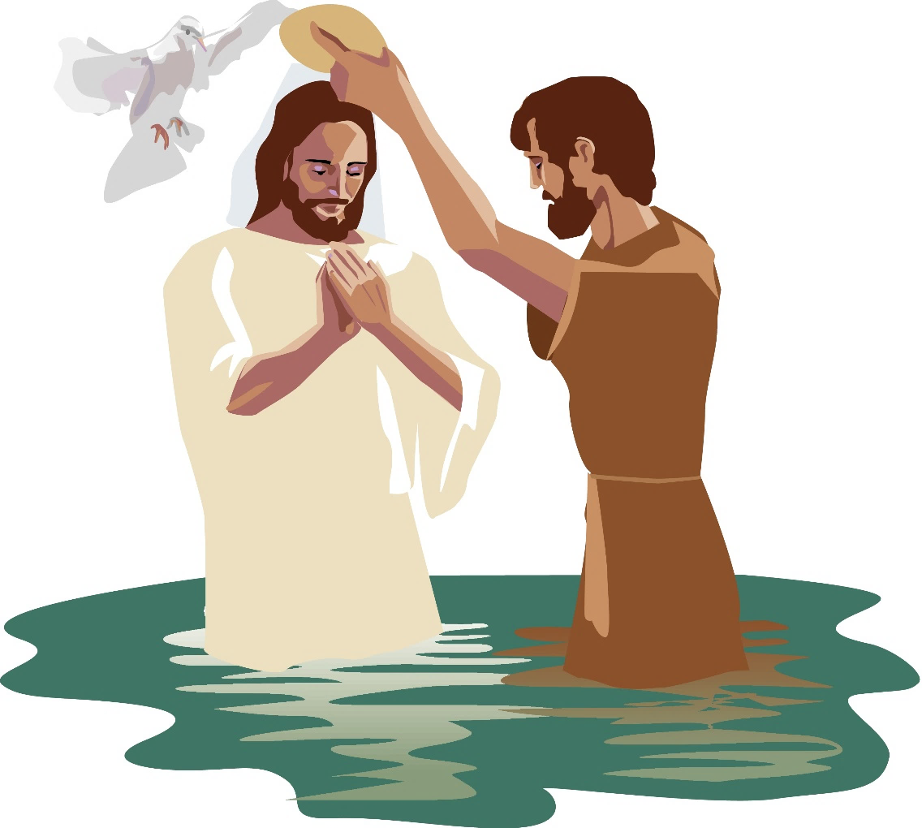

Opening Song: So Will I
God of creation
There at the start
Before the beginning of time
With no point of reference
You spoke to the dark
And fleshed out the wonder of light

And as You speak
A hundred billion galaxies are born
In the vapour of Your breath
The planets form
If the stars were made to worship
So will I
I can see Your heart
In everything You've made
Every burning star a signal fire of grace
If creation sings Your praises, so will I

God of Your promise
You don't speak in vain
No syllable empty or void
For once You have spoken
All nature and science
Follow the sound of Your voice

And as You speak
A hundred billion creatures
Catch Your breath
Evolving in pursuit of what You said
If it all reveals Your nature, so will I
I can see Your heart
In everything You say
Every painted sky a canvas of Your grace
If creation still obeys You, so will I

If the stars were made to worship
So will I
If the mountains bow in reverence
So will I
If the oceans roar Your greatness
So will I
For if everything exists to lift You high
So will I
If the wind goes where You send it
So will I
If the rocks cry out in silence, so will I
If the sum of all our praises still falls shy
Then we'll sing again
A hundred billion times

God of salvation
You chased down my heart
Through all of my failure and pride
On a hill You created
The light of the world
Abandoned in darkness to die

And as You speak
A hundred billion failures disappear
Where You lost Your life
So I could find it here
If You left the grave behind You, so will I
I can see Your heart
In everything You've done
Every part designed
In a work of art called love
If You gladly chose surrender, so will I
(continued on next page)

I can see Your heart
Eight billion different ways
Every precious one a child
You died to save
If You gave Your life to love them
So will I
Like You would again
A hundred billion times
But what measure
Could amount to Your desire
You're the One
Who never leaves the one behind

Penitential Rite
Leader: Dear friends in Christ, as we prepare to worship almighty God, let us with penitent and obedient hearts confess our sins, that we may obtain forgiveness by his infinite goodness and mercy.
Silence is Kept
All: Most merciful God, we confess that we have sinned against you in thought, word, and deed, by what we have done and by what we have left undone. We have not loved you with our whole heart; we have not loved our neighbours as ourselves. We are truly sorry and we humbly repent. For the sake of your Son Jesus Christ, have mercy on us and forgive us, that we may delight in your will, and walk in your ways, to the glory of your name. Amen.
Leader: Almighty God have mercy upon you, pardon and deliver you from all your sins, confirm and strengthen you in all goodness, and keep you in eternal life; through Jesus Christ our Lord.
All: Amen.

Morning Prayer
Leader: Lord, open our lips,
All: And our mouth shall proclaim your praise.
Leader: O God, make speed to save us.
All: O Lord, make haste to help us. Glory to the Father, and to the Son, and to the Holy Spirit: as it was in the beginning, is now, and will be for ever. Amen. Alleluia!

Leader: The kingdom of God is at hand: O come, let us worship.
All: Be joyful in the Lord, all you lands; serve the Lord with gladness and come before his presence with a song. Know this: The Lord himself is God; he himself has made us, and we are his; we are his people and the sheep of his pasture. Enter his gates with thanksgiving; go into his courts with praise; give thanks to him and call upon his name. For the Lord is good; his mercy is everlasting; and his faithfulness endures from age to age.

The Reading of Scripture
First Reading: Genesis 1:1-5
In the beginning when God created the heavens and the earth, the earth was a formless void and darkness covered the face of the deep, while a wind from God swept over the face of the waters. Then God said, "Let there be light"; and there was light. And God saw that the light was good; and God separated the light from the darkness. God called the light Day, and the darkness he called Night. And there was evening and there was morning, the first day.
Reader: The Word of the Lord.
People: Thanks be to God.

Canticle: Psalm 29
1 Ascribe to the Lord, you gods, *
ascribe to the Lord glory and strength.
2 Ascribe to the Lord the glory due his name; *
worship the Lord in the beauty of holiness.
3 The voice of the Lord is upon the waters; the God of glory thunders; *
the Lord is upon the mighty waters.
4 The voice of the Lord is a powerful voice; *
the voice of the Lord is a voice of splendour.
5 The voice of the Lord breaks the cedar trees; *
the Lord breaks the cedars of Lebanon;
6 He makes Lebanon skip like a calf, *
and Mount Hermon like a young wild ox.
7 The voice of the Lord splits the flames of fire; the voice of the Lord shakes the
wilderness; *
the Lord shakes the wilderness of Kadesh.
8 The voice of the Lord makes the oak trees writhe *
and strips the forests bare.
9 And in the temple of the Lord *
all are crying, “Glory!”
10 The Lord sits enthroned above the flood; *
the Lord sits enthroned as king for evermore.
11 The Lord shall give strength to his people; *
the Lord shall give his people the blessing of peace.
Prayer: God of mystery and power, open our eyes to the flame of your love, and open our ears to the thunder of your justice, that we may receive your gifts of blessing and peace, to the glory of your name; through Jesus Christ our Lord.

Second Reading: Acts 19:1-7
While Apollos was in Corinth, Paul passed through the interior regions and came to Ephesus, where he found some disciples. He said to them, "Did you receive the Holy Spirit when you became believers?" They replied, "No, we have not even heard that there is a Holy Spirit." Then he said, "Into what then were you baptized?" They answered, "Into John's baptism." Paul said, "John baptized with the baptism of repentance, telling the people to believe in the one who was to come after him, that is, in Jesus." On hearing this, they were baptized in the name of the Lord Jesus. When Paul had laid his hands on them, the Holy Spirit came upon them, and they spoke in tongues and prophesied-- altogether there were about twelve of them.
Reader: The Word of the Lord.
People: Thanks be to God.

Processional Chorus – Spirit of the Living God

Spirit of the living God, fall afresh on me
Spirit of the living God, fall afresh on me
Melt me, mold me
Fill me, use me

The Gospel Reading
Leader: The Lord be with you.
People: And also with you.
Leader: The Holy Gospel of our Lord Jesus Christ according to St. Mark.
People: Glory to you, Lord Jesus Christ.
Gospel Reading: Mark 1:4-11
John the baptizer appeared in the wilderness, proclaiming a baptism of repentance for the forgiveness of sins. And people from the whole Judean countryside and all the people of Jerusalem were going out to him, and were baptized by him in the river Jordan, confessing their sins. Now John was clothed with camel's hair, with a leather belt around his waist, and he ate locusts and wild honey. He proclaimed, "The one who is more powerful than I is coming after me; I am not worthy to stoop down and untie the thong of his sandals. I have baptized you with water; but he will baptize you with the Holy Spirit." In those days Jesus came from Nazareth of Galilee and was baptized by John in the Jordan. And just as he was coming up out of the water, he saw the heavens torn apart and the Spirit descending like a dove on him. And a voice came from heaven, "You are my Son, the Beloved; with you I am well pleased."
Leader: The Gospel of Christ.
People: Praise to you, Lord Jesus Christ.

Worship Through Song

Spirit of the Living God
Spirit of the living God, fall afresh on me
Spirit of the living God, fall afresh on me
Melt me, mold me
Fill me, use me (repeat all)
It Is Well
Grander earth has quaked before
Moved by the sound of His voice
And seas that are shaken and stirred
Can be calmed
And broken for my regard

(Chorus)
And through it all, through it all
My eyes are on You
And through it all, through it all
It is well
And through it all, through it all
My eyes are on You
And it is well, with me

Far be it from me to not believe
Even when my eyes can't see
And this mountain that's in front of me
Will be thrown into the midst of the sea
(To Chorus)

Let go my soul and trust in Him
The waves and wind still know His name
Let go my soul and trust in Him
The waves and wind still know His name

It is well with my soul
It is well, it is well with my soul
(To Chorus)

Listening Time

Sermon by the Rev. Dr. Myron Penner – Sermon Notes:
________________________________________________________________________________________________________________________________________________________________________________________________________________________________________________________________________________________________________________________________________________________________________________________________________________________________________________________________________________________________________________________
________________________________________________________________________________________________________________________________________________
________________________________________________________________________________________________________________________________________________
________________________________________________________________________________________________________________________________________________
________________________________________________________________________________________________________________________________________________

Affirmation of Faith – The Nicene Creed
All: We believe in one God, the Father, the Almighty, maker of heaven and earth, of all that is, seen and unseen. We believe in one Lord, Jesus Christ, the only Son of God, eternally begotten of the Father, God from God, Light from Light, true God from true God, begotten, not made, of one being with the Father. Through him all things were made. For us and for our salvation he came down from heaven: by the power of the Holy Spirit he became incarnate from the Virgin Mary, and was made man. For our sake he was crucified under Pontius Pilate; he suffered death and was buried. On the third day he rose again in accordance with the scriptures; he ascended into heaven and is seated at the right hand of the Father. He will come again in glory to judge the living and the dead, and his kingdom will have no end. We believe in the Holy Spirit, the Lord, the giver of life, who proceeds from the Father. With the Father and the Son he is worshipped and glorified. He has spoken through the prophets. We believe in one holy catholic and apostolic Church. We acknowledge one baptism for the forgiveness of sins. We look for the resurrection of the dead, and the life of the world to come. Amen.
Prayers of the People
Leader: Let us pray with confidence to the Lord, saying, “Lord hear our prayer.”
O Lord, guard and direct your Church in the way of unity, service, and praise.
All: Lord, hear our prayer.
Leader: Remembering today from the St. Paul’s Cycle of prayer: Andrew, Nancy, Greg, Tim, and Emily Whistance-Smith; Chuck and Kjeryn Allard; Cheryl Critchell; and Patti Nicholl; as well as all of those in the Anglican Cycle of Prayer. Give to all nations an awareness of the unity of the human family.
All: Lord, hear our prayer.
Leader: Cleanse our hearts of prejudice and selfishness, and inspire us to hunger and thirst for what is right.
All: Lord, hear our prayer.
Leader: Teach us to use your creation for your greater praise, that all may share the good things you provide.
All: Lord, hear our prayer.
Leader: Strengthen all who give their energy or skill for the healing of those who are sick in body or in mind.
All: Lord, hear our prayer.
Leader: Set free all who are bound by fear and despair.
All: Lord, hear our prayer.
Leader: Grant a peaceful end and eternal rest to all who are dying, and your comfort to those who mourn.
All: Lord, hear our prayer. Amen.

The Collect
Leader: Eternal Father, who at the baptism of Jesus revealed him to be your Son, anointing him with the Holy Spirit, keep your children, born of water and the Spirit, faithful to their calling; through Jesus Christ our Lord, who lives and reigns with you and the Holy Spirit, one God, now and for ever.
All: Amen.

The Lord’s Prayer
Leader: And now, as our Saviour Christ has taught us, we are bold to say,
All: Our Father, who art in heaven, hallowed be thy name, thy kingdom come, thy will be done, on earth as it is in heaven. Give us this day our daily bread. And forgive us our trespasses, as we forgive those who trespass against us. And lead us not into temptation, but deliver us from evil. For thine is the kingdom, the power, and the glory, for ever and ever. Amen.

Congregational Announcements (Rev. Myron)

Closing Song: Doxology
Praise God from whom all blessings flow
Praise Him, all creatures here below
Praise Him, above you, heavenly hosts
Praise Father, Son and Holy Ghost
Amen, amen, amen
God, we praise You
God, we praise You

The Dismissal
Celebrant: Go forth in the name of Christ.
All: Thanks be to God. Amen.

No In-Person Services at St. Paul’s until Further Notice
Following the Government of Alberta declaring a state of public health emergency, along with stricter, mandatory measures to limit the spread of COVID-19, Bishop Jane has made the decision to keep church buildings in the Diocese closed until further notice.

We will provide additional information as soon as we have it.

AGM Reports
The AGM Report package with the 2021 AGM Agenda will be sent out to the parish by email in the next weekly email. Please take the time to read the reports prior to the AGM if possible.

AGM on February 7, 2021 – Held on Zoom
St. Paul’s 2021 will be held on February 7. Due to unknowns about returning to in-person meetings, the AGM will be held virtually using Zoom. The specific time for this meeting will be sent out sometime in the next week.

Giving Options

Many of you have asked how to give while the building is closed for in-person services. The following giving options are available:

- E-transfer: E-transfers may be emailed to office@stpauls-anglican.ca.
- Credit Transaction (one time or monthly): If you would like to set up a one-time or monthly credit gift, please email the office and RJ will send you the correct form.
- Pre-Authorized Debit (one time or monthly): If you would like to set up a one-time or monthly pre-authorized debit giving, please email the office and RJ will send you the correct form.
- Cash or Cheque: Cash can be dropped off at the church. Please check in with RJ or Myron before coming to make sure we are onsite. Cheques can be left in the church mailbox, dropped off during open hours, or mailed to the church office at any time. Please do not leave cash in the mailbox.

2021 Offering Envelopes
2021 Offering envelopes are available to pick up in the foyer (when the church is open again). If you would like offering envelopes, please contact the office.
Community Corner for January 10

Call a friend! Is there someone from our congregation who has been on your mind? Why not pick up the phone and give them a call? In our current state of being apart, it is hard for any of us to know that other people are wondering how we are doing. Be brave – even sending an email or mailing a card will make a bigger impression than you might know. Need the church directory? Just contact RJ for a copy.

Along the same lines, are you missing out on dinner-time company? Reach out to another person or two in our congregation to set up a time online to share mealtime. You might be surprised at how easy this turns out to be! Contact Michelle if you are interested but don’t know who to invite. Otherwise, call or email someone you are missing to find out if they want to “come over” for dinner, virtually!

Don’t forget about our Netflix Group. They meet again this coming Tuesday, January 12 at 7:00pm to review the show “Hillbilly Elegy.” Please contact Michelle if you are interested in joining.

Giving Options At This Time
Many of you have asked how to give while the building is closed for in-person services. The following giving options are available:
- E-transfer: E-transfers may be emailed to office@stpauls-anglican.ca.
- Credit Transaction (one time or monthly): If you would like to set up a one-time or monthly credit gift, please email the office and RJ will send you the correct form.
- Pre-Authorized Debit (one time or monthly): If you would like to set up a one-time or monthly pre-authorized debit giving, please email the office and RJ will send you the correct form.
- Cash or Cheque: Cash can be dropped off at the church. Please check in with RJ or Myron before coming to make sure we are onsite. Cheques can be left in the church mailbox, dropped off during open hours, or mailed to the church office at any time. Please do not leave cash in the mailbox.

Anglican Cycle of Prayer:
Diocese of Huron: the Rt. Rev. Dr. Todd Townsend, Bishop. Emmanuel, Gibbons and St. Mary, Redwater: Anthony Kwaw (s. Denise), Rector. Buyé Diocese, Kigufi Parish: Audace Gahungu, Rector. Samson Cree Nation.

Next Week’s Ministry Teams:
Music: Adele and Team
Service Team: B and Jackson (if we are able to meet in person)
Reader/Prayers: Adele’s Team/Service Team

This Week’s Ministry Teams:
Music: Asher and Team
Service Team: None
Reader/Prayers: Asher’s Team

St. Paul’s Cycle of Prayer:
Andrew, Nancy, Greg, Tim, and Emily Whistance-Smith;
Chuck and Kjeryn Allard;
Cheryl Critchell;
Patti Nicholl

For Care/Concern Team
or other prayer requests, email:
office@stpauls-anglican.ca
For urgent prayer requests call
the church office: (780) 455-0771
For pastoral emergencies call:
(587) 334-2130

@StEdmonton
facebook.com/stpachurchedmonton
St. Paul’s Vestry:
Paul Dowie, Rector’s Warden
Margot Byer, People’s Warden
David Heritage, Treasurer
Barb Dixon, Vestry Member
John Green, Vestry Member
Deanna Kalles, Vestry Member
David Parker, Vestry Member
Carol Rudat, Vestry Member

Office Hours:
Monday-Thursday: 9:00AM-12:00PM
Closed: Fri/Sat/Sun and Stat Holidays
St. Paul’s Anglican Church
10127 145 Street, Edmonton T5N 2X6
Phone: (780) 455-0771; Email: office@stpauls-anglican.ca
Website: www.stpauls-anglican.ca

St. Paul’s Staff:
Rector: The Rev. Myron B. Penner
Community Outreach: Michelle Schurek
Youth Leader: Abigail Harding
Office Administrator: RJ Chambers

