Blessing of homes
for the Feast of the Epiphany
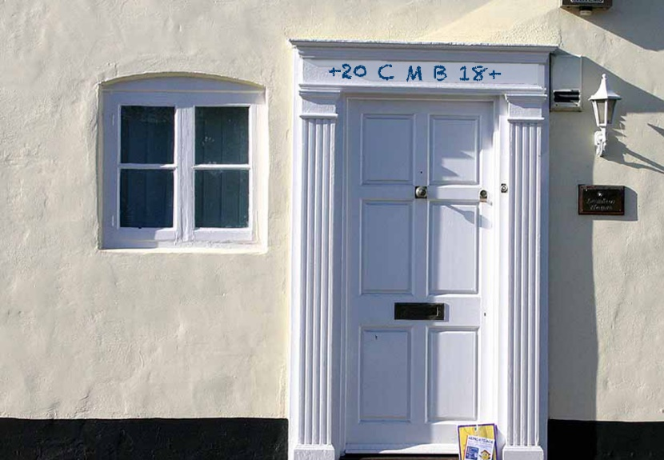

Blessing the Home
One Voice: Peace be to this house.
All: And all who dwell in it.
Using the blessed chalk, a family member or resident writes on the door frame 20 + C + M + B + 21 as somebody says:
The three Wise Kings, Caspar, Melchior, and Balthazar followed a star to find the Christ Child, who according to tradition, was born two thousand and nineteen years ago.
Visit, O blessed Lord, this home with the gladness of your presence. Bless it and all who live or visit here with the gift of your love; and grant that we may show your love to each other and all whose lives we touch. Lord Jesus Christ, be with us now and for ever. Amen.
Blessing of Chalk and Home submitted to Church Times by Sarah Lenton, published 26 February 2016
An Alternative Blessing for the Home at Epiphany
Taken from The Anglican Family Prayer Book by Anne E Kitch, published by Morehouse Publishing, 2004.

God bless this house,
From door to door,
From wall to wall,
From room to room,
From basement to roof,
From beginning to end.

God bless this house
And all who enter here,
All who eat here,
All who work here,
All who play here,
All who sleep here,
All who visit here,
All who abide here. Amen
A Room by Room Blessing
If you are blessing each room in your home, ask God to be present in each space for all the things you do in that space: that God may bless you with deep rest and renewal in your bedroom, for example. You could begin or end with this prayer:
Blessed are you, O God, for you framed the universe as the dwelling-place of your glory and your Word pitched a tent in our midst. Grant that those who dwell in this place may find only harmony and pace. May they, and all who search for you, find shelter in your presence. This we ask through Jesus Christ our Lord. Amen.

About the Practice of Blessing Homes at Epiphany
The blessing and distribution of chalks with which houses are marked with a special logo commemorating the visit of the Magi is a custom that seems to have originated in and spread from Central Europe at the end of the Middle Ages.
On or near the feast of the Epiphany, and conveniently close to the beginning of a New Year, the tradition has been to ask God’s blessing on homes and mark the door post or lintel with chalks that have been blessed for that purpose. The doors are chalked with the legendary names or initials of the three Magi, and the numerals of the New Year, connected with a series of crosses. The initials C, M, and B commemorate the Magi, Caspar, Melchior, and Balthasar, but also stand for the Latin prayer-request Christus Mansionem Benedicat: “May Christ bless this house.” In this way, the door of a house would be marked as follows: 20+C+M+B+19.
This domestic ritual can be performed as a family gathers together around the main entrance of a house, and a senior member of the household does the chalking with appropriate words: that “as the three Wise Men followed the star of God’s Son who became man, may Christ bless our home and remain with us through the New Year.” If there is sufficient space over the door, the full names of the Magi are often displayed, and children are invited to decorate the names with three crowns.
This Epiphany ceremony is a simple but meaningful act of witness which symbolises Christian willingness to offer hospitality and shelter to the Magi on their journey to Bethlehem, and also, by extension in today’s world, to welcome all and sundry who love or are seeking the Lord’s Christ.
As a valuable link between church and home and family, this old custom deserves to be better known by Anglicans. It is, moreover, a constant reminder that Christ is incarnate in the love and care we show each other in our ordinary lives together, and also our relationship with friends and strangers who cross the threshold of our homes in the course of the year.
(Canon) Terry Palmer
Magor, Monmouthshire, Wales
Church Times, 26 February 2016 (with updates for 2019)

