“From Sea to Sea”

Rev. Stephen Milton
Sermon on Epiphany Sunday
January 5th, 2019
Lawrence Park Community Church, Toronto.

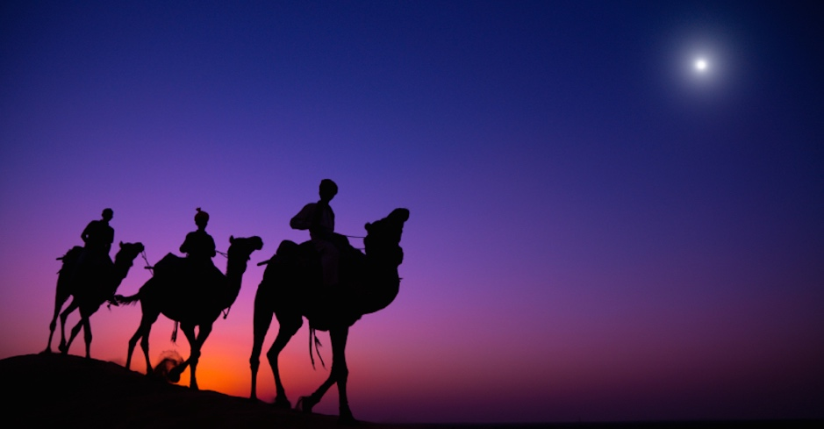

Today we celebrate Epiphany, a word that means the revealing of God’s presence. On Epiphany, we remember the day when a group of Magi arrived from the East to pay homage to Jesus, who they recognized as the newly born king of the Jews. They came from the East. They appear to have been familiar with Hebrew prophecies that a world ruler would be born in Judea, so they brought gifts fit for a king – gold, frankincense and myrrh. In the Gospel of Matthew’s account, they are simply called Magi – astrologers – from the East. The gospel account is vague – we aren’t told where in the East they had come from, or how many of them there were.

As we all know, these figures became known as the three kings. We sing about them in carols like “We Three Kings of Orient Are”. Josh sang about them as kings in his anthem. But how did mysterious, numberless Magi become three kings? Early Christians spent a lot of time reading through the Hebrew Scriptures, looking for predictions of Christ’s coming. The Jews had expected a warrior king who would defeat their oppressors. The Christians knew that Christ was a completely different kind of messiah, and they needed proof that he was the one God had promised.

So, they poured over the prophecies in the Hebrew scriptures to find evidence that God had promised a peaceful messiah. In Micah’s prophecy they found mention that the messiah would be born in the humble town of Bethlehem (Micah 5:2). In Isaiah they found the promise of a messiah born of a virgin, a man who would be mistreated, take on the sins of the world, and die, yet be the saviour ( Isaiah 7:14; 53). And in psalm 72, which we heard today, they found evidence of a prophecy that involved kings coming to visit the messiah. Kings from all over the world. One would come from Sheba – Arabia – bearing gold. All would kneel down when they met the messiah.

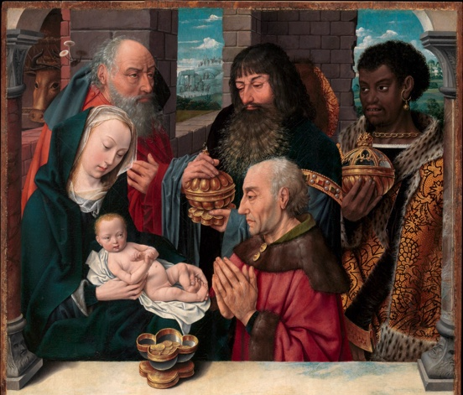
This psalm was the inspiration for the idea that the Magi were actually kings from foreign lands, coming to pay homage. This idea was captured in hymns and carols, and also became a favourite them in Christian art.
Here’s a typical example. We see three kings, who represent the three known continents. One is from Africa, the bearded man is from Asia, and the oldest man is from Europe. The story of the Magi had become the story of the world’s kings coming to pay homage and even more, to capitulate to the Christ child.

We associate Christmas with warm fuzzy feelings, so it hard for us to see how transforming Magi into kings could be a problem. But the idea that the world’s kingdoms would kneel to Christianity became pernicious and dangerous. Over time, as Christianity spread through Europe and then the world, Christian rulers came to believe that Christianity was the only legitimate faith. All others were mistaken at best, evil at worst. The idea, that all kings and nations should kneel before Christianity and admit its superiority became the basis of the forced conversions of millions of people worldwide over the last 1200 years. It inspired the Crusades against the Muslims, the pogroms against the Jews, and the forced conversions of African peoples who were enslaved in the Americas.

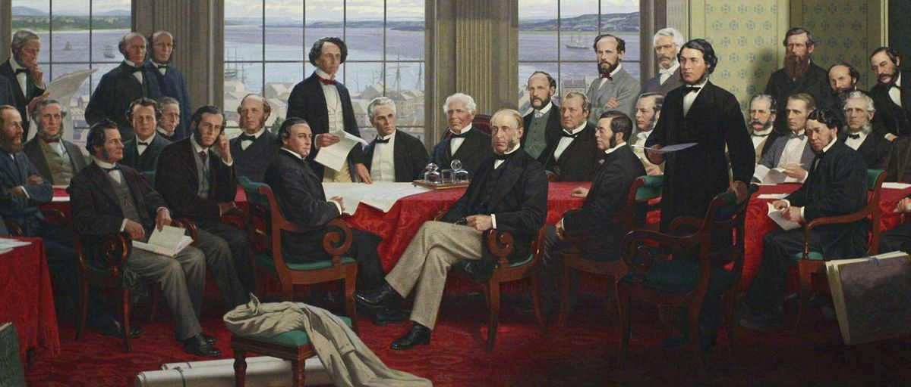

What to Call Canada? Canada would seem to be free of this dark history. We never conquered any other country, nor forced them to convert. But psalm 72 has a curious connection with Canada. When the fathers of confederation came together to form Canada in 1866, they had a problem. What should this new nation be called? John A. Macdonald and the other premiers wanted to call our country “The Kingdom of Canada”. But the name was rejected, because the British feared that it would offend the Americans, who had just finished their civil war. So, an alternate name was needed. The premier of New Brunswick proposed that Canada be called the Dominion of Canada, quoting this line from Psalm 72 : He shall have dominion also from sea to sea, / And from the River to the ends of the earth. That stuck, so our country’s title was derived from Psalm 72.

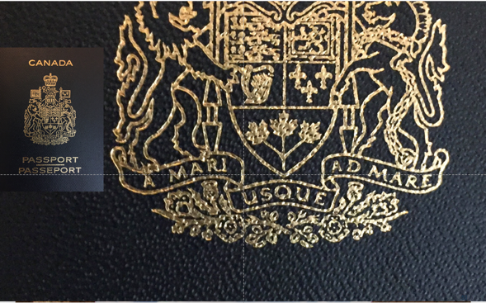
The influence of psalm 72 on Canada doesn’t end there, however. If you go to Ottawa, and visit the parliament buildings, you need to go through the peace tower, which was built in 1920. As you walk up, there is a huge window above you with this inscription over it “ He shall have dominion also from sea to sea”, straight out of psalm 72. It can also be found in Latin next to the doors as you enter – “A mari usque as Mare” – from sea to sea. And if that all seems obscure and has nothing to do with you, then take a look at your passport when you go home. On it you will find the Canadian crest, which also has that same Latin inscription from the Psalm, “ from sea to sea.” Every time you have offered your passport to a customs agent, you have been presenting a fragment from Psalm 72.
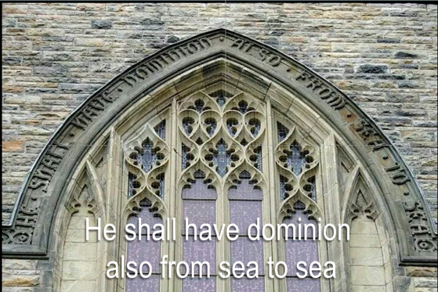
We are the dominion of Canada because the fathers of Confederation sincerely believed that Canada should be a nation where Christ would have dominion from sea to sea. That’s who “He” is on the inscription on the Parliament buildings. Canada may not have forcibly converted any other countries, but we did forcibly convert our indigenous people. We outlawed the practice of their religions, and we tried to replace their faiths with Christianity through the residential school program. That was our way of ensuring that Christ would have dominion from sea to sea.

Of course, a lot has changed since 1867. Canada no longer thinks of itself as a Christian nation, but as a secular state which welcomes people of all faiths. We expect religious belief to be a matter of private conscience. It would appear that the age of religious imperialism is over.

It may feel that way here, but if we take a look at the world, a very different picture emerges. The idea that Christianity is the only true faith, and that other faiths should capitulate or be considered enemies is increasingly popular. In Europe, so-called Christian nationalists have taken over the governments of Poland and Hungary. In Poland, the Catholic establishment has supported a government which was elected recently by demonizing LGBTQ people, and has refused to take in its share of Syrian refugees. In Hungary, the government denounces Muslims as a threat to Christian civilization. It has also made being homeless a criminal offence. In Italy last year, the Christian minister of the interior called for the placement of crucifixes in all public spaces, including the ports where refugee boats are turned away. In Brazil, the President who is burning the Amazon and attacking human rights was swept into office by Pentecostal Christians. And of course, to the south, the majority of Catholics and Evangelical Christians voted for Donald Trump, and seemed poised to do it again in 2020.

We may like to tell ourselves that in the 21st century nation states are secular, but the headlines tell us otherwise. These Christian nationalist governments are weaponizing Christianity. They have struck a nerve among Christians who feel that there is something emotionally empty about the promise of free trade, material wealth and political correctness. The morality they inherited is being called into question by same sex marriage, abortion and identity politics. The new morality offered by progressives is one with no emotional connection to the Earth, cosmos, or God. In the drive to not offend other faiths, progressive values are usually proclaimed as rules with no roots in any faith; these values promote equality, but provide no sense of hope, no connection to an afterlife or even the beauty of nature. To many people, all over the world, this simply rings hollow. It is easier to fall back on old ideas of a triumphant Christian nation, when America was great, when the right race was in charge, a time when people who didn’t believe in Christianity were converted or kept out. That attitude is winning elections all over the world.

But there is a lie buried within the idea of Christian nationalism. As we heard in psalm 72, faith in God has never been about respecting borders. Compassion and love know no borders. In the psalm, we hear that when kings come to God’s chosen one, that “He will deliver the needy when he cries,/ The poor also, and him who has no helper./ ¹³ He will spare the poor and needy,/ And will save the souls of the needy./ ¹⁴ He will redeem their life from oppression and violence.” The kings who come to God’s chosen one do not come after having been defeated in battle. Instead, they come to join a movement where compassion, love and justice for the weakest of society is the new value. This psalm, like all of the New testament, does not celebrate the power of nations or their reason to exist. Rather, it asks for humanity to be united in a vision of cosmic care for the weakest in our midst. For when we do that, we are close to God, and can live in harmony with the universe as a whole.

Christian nationalism, by contrast, is a contradiction in terms. Christian compassion cannot be limited by boundaries. It cannot be limited to people who have the right ethnic or religious identity; it does not apply only to those of a certain race or sexual orientation. Nationalism by definition marks some people as in, others as out. That is completely at odds with Christian values. In Christ, there is neither Greek nor Jew, Paul wrote ( Gal.3:28). Christianity by definition cannot be the basis of a nationalist movement without losing its soul and meaning. Love knows no borders – nations insist on them.

The challenge for we progressive Christians in this new year is whether we can be more honest about the spiritual inspiration of our compassion and love for others. Pretending that these values are secular universal truths is not working. People are voting for faith-based values, and so far, it is the far right which has reaped the rewards. We need to stake out a different claim. That we can admit our faith background as our inspiration, and then work with people of different faiths who value compassion, love, and help for the oppressed. We do not need to insist that there be just one faith from sea to sea. Rather, we need to welcome all those who share our concern for the oppressed, whether they are Muslim, Hindu, Jewish, or agnostic or atheist. We are already seeing this diversity at Soul Table, where people of all kinds of faith traditions have been gathering, attracted by our concern for the world and its peoples.

That is the work we are called to do as Christians – to help those who are excluded, and in so doing, as our hands reach out, our hearts widen, and our eyes open. If there is a universal truth it is that love and compassion for those in need is its own reward. When we help others, we restore our own connection to the power that rules the universe. It is a power that was recognized by a few wise people 2000 years ago, as they came to visit a child who would preach compassion. That meeting is called the Epiphany – the revelation of the divine truth. One day the truth of compassion and love will be recognized by all kings, all leaders, all peoples – and there will be no need for walls or passports. Compassion will be common sense, and love will reign from sea to sea. Amen.

"Why Did the Magi Bring Gold, Frankincense and Myrrh?", Biblical Archaeology, Nov 26, 2019, online.
The second century theologian Tertullian was the first to call the Magi kings, due to Pslam 72. Alison Barnes, “English Legends of the Three Kings,” History Today, Dec 2007
“Dominion of Canada” The Canadian Encyclopdia. Nov 7 2019.
All of the above: "The Guardian view on the rise of Christian-nativist populists: a troubling sign of things to come," The Guardian, Dec 24, 2019.
Dom Phillips, "'He's not perfect': why do so many Brazilians support rightwinger Jair Bolsonaro?", The Guardian, 14 Sep 2018
"The Guardian view on the rise of Christian-nativist populists: a troubling sign of things to come," The Guardian, Dec 24, 2019.
Daniel Steinmetz-Jenkinsand Anton Jäger, “The populist right is forging an unholy alliance with religion”, The Guardian, June 11 2019.
Luke Bretherton and Daniel Steinmetz-Jenkins “What progressives need to defeat Trump: populism and religion,” The Guardian, 24 November 2018
This was, perhaps not coincidentally, also the big lie of the Nazis’ National Socialism. Socialism was always an international movement.

