Christmas Day

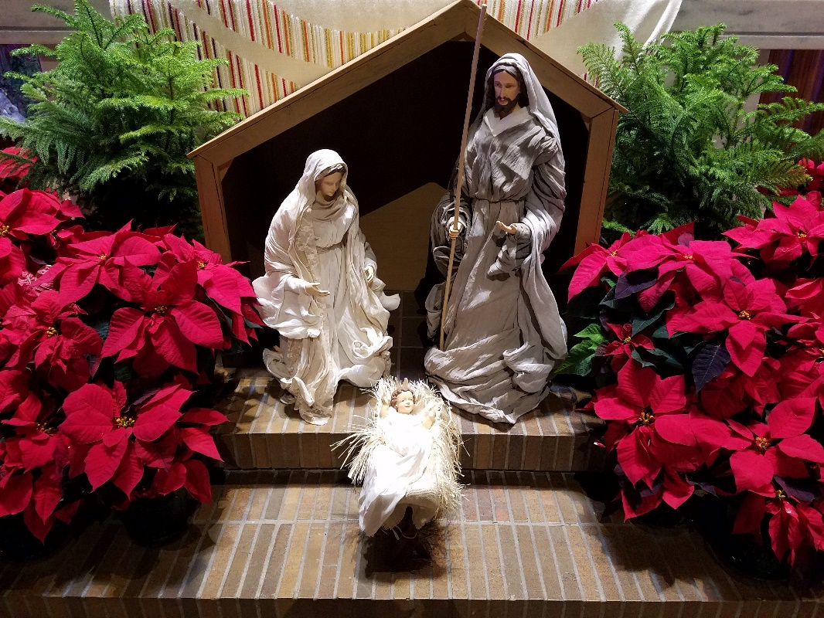

Friday, December 25th, 2020
a worship service for home and family

This worship service is meant to be done at home on Christmas, perhaps before or after opening presents or sharing a delicious brunch. You can work through these words of worship alone, but they’re better when done with family and friends. Songs are printed at the end for you to sing together, or pick one of your own Christmas favorites to sing. You might even play the music off a recording or from the internet to sing along with or just to listen to. In this worship you’ll find ways of sharing and celebrating life with those around you by sharing, reading, talking, praying, and blessing one another. God bless you this Christmas. -Pastor Rory Philstrom
Gather
I behold a new and wondrous mystery. My ears resound to the shepherds’ song, piping no soft melody, but chanting full forth a heavenly hymn. The angels sing: the archangels, the cherubim, the seraphim. The one who is above now dwells here below for our redemption. Since therefore all rejoice, I too desire to rejoice. I take my part, not plucking the harp, but holding in my arms the cradle of Christ. For this is all my hope, my life, my salvation, my pipe, my harp. I too sing with the angels, “Glory to God in the highest,” and with the shepherds, “Peace to God’s people on Earth.”
—Saint John Chrysostom
Sing
Sing together one of the songs printed in the back.
Share
From John 1:1-14
¹In the beginning was the Word, and the Word was with God, and the Word was God. ²The Word was in the beginning with God. ³All things came into being through the Word, without whom not one thing came into being. What has come into being ⁴in the Word was life, and the life was the light of all people. ⁵The light shines in the darkness, and the darkness did not overcome it.
⁶There was a man sent from God, whose name was John. ⁷He came as a witness to testify to the light, so that all might believe through him. ⁸He himself was not the light, but he came to testify to the light. ⁹The true light, which enlightens everyone, was coming into the world.
¹⁰The light was in the world, and the world came into being through him; yet the world did not know him. ¹¹He came to what was his own, and his own people did not accept him. ¹²But to all who received him, who believed in his name, he gave power to become children of God, ¹³who were born, not of blood or of the will of the flesh or of the will of a man, but of God.
¹⁴And the Word became flesh and lived among us, and we have seen his glory, the glory as of a father’s only son, full of grace and truth.
Take some time now to let each person share their “lows”. Where in your life has there been “darkness” in the last year? When were there times when you felt like the world did not know you, or did not accept you?
Psalm 98
¹Sing a new song to the LORD, who has done | marvelous things,
whose right hand and holy arm have | won the victory.
²O Lord, you have made | known your victory,
you have revealed your righteousness in the sight | of the nations.
³You remember your steadfast love and faithfulness to the | house of Israel;
all the ends of the earth have seen the victory | of our God.
⁴Shout with joy to the LORD, | all you lands;
lift up your voice, re- | joice, and sing.
⁵Sing to the LORD | with the harp,
with the harp and the | voice of song.
⁶With trumpets and the sound | of the horn
shout with joy before the | king, the LORD.
⁷Let the sea roar, and | all that fills it,
the world and those who | dwell therein.
⁸Let the rivers | clap their hands,
and let the hills ring out with joy before the LORD, who comes to | judge the earth.
⁹The LORD will judge the | world with righteousness
and the peo- | ples with equity.
Take some time now to let each person share their “highs”. Where there any times this last year where things were going so well that it seemed like Creation itself was singing and ringing out with joy?

Read
From Hebrews 1
¹Long ago God spoke to our ancestors in many and various ways by the prophets, ²but in these last days God has spoken to us by a Son, whom God appointed heir of all things, through whom God also created the worlds. ³He is the reflection of God’s glory and the exact imprint of God’s very being, and he sustains all things by his powerful word. When he had made purification for sins, he sat down at the right hand of the Majesty on high, ⁴having become as much superior to angels as the name he has inherited is more excellent than theirs.
⁵For to which of the angels did God ever say,
“You are my Son; today I have begotten you”?
Or again,
“I will be his Father,
and he will be my Son”?
⁶And again, when the Lord brings the firstborn into the world, God says,
“Let all God’s angels worship him.”
⁷Of the angels God says,
“They make their angels winds,
and their servants flames of fire.”
⁸But of the Son, God says,
“Your throne, O God, is forever and ever,
and the righteous scepter is the scepter of your kingdom.
⁹You have loved righteousness and hated wickedness;
therefore God, your God, has anointed you
with the oil of gladness beyond your companions.”
¹⁰And,
“In the beginning, Lord, you founded the earth,
and the heavens are the work of your hands;
¹¹they will perish, but you remain;
they will all wear out like clothing;
¹²like a cloak you will roll them up,
and like clothing they will be changed.
But you are the same,
and your years will never end.”
Talk
Take a few moments to talk about how the Bible readings might relate to your highs and lows.
What is God trying to say to your life?
What do the Bible verses mean to you today?
Sing
Sing together one of the songs printed in the back.
Pray
Pray for one another’s highs and lows.
One person prays for all or go around a circle and each pray for the person on their right.
You could begin your prayer with these words:
Holy and creative God, as we celebrate Christmas, we join the joyful praise of the cosmos, and we pray for our needs and all in need.…

You could end your prayer with these words:
O God, Majesty on high, Word of salvation, Power of glory, on this holy day we ask you to receive our prayers and to visit the world with your love, granting new life to the earth and its peoples. through Jesus Christ, our Savior and Lord.
Amen.

Bless
Bless one another with a word and touch of blessing.
You may bless each other with words like these:
The light and love and word of Jesus Christ bless you now and forever.

A kiss is a blessing…a hug is a blessing…a hand squeeze is a blessing…a smile is a blessing
…these all have power.
Sing
Sing together one of the songs printed in the back.
Send
Say or shout these words together:
JOY TO THE WORLD! THE LORD IS COME!
MERRY CHRISTMAS!

