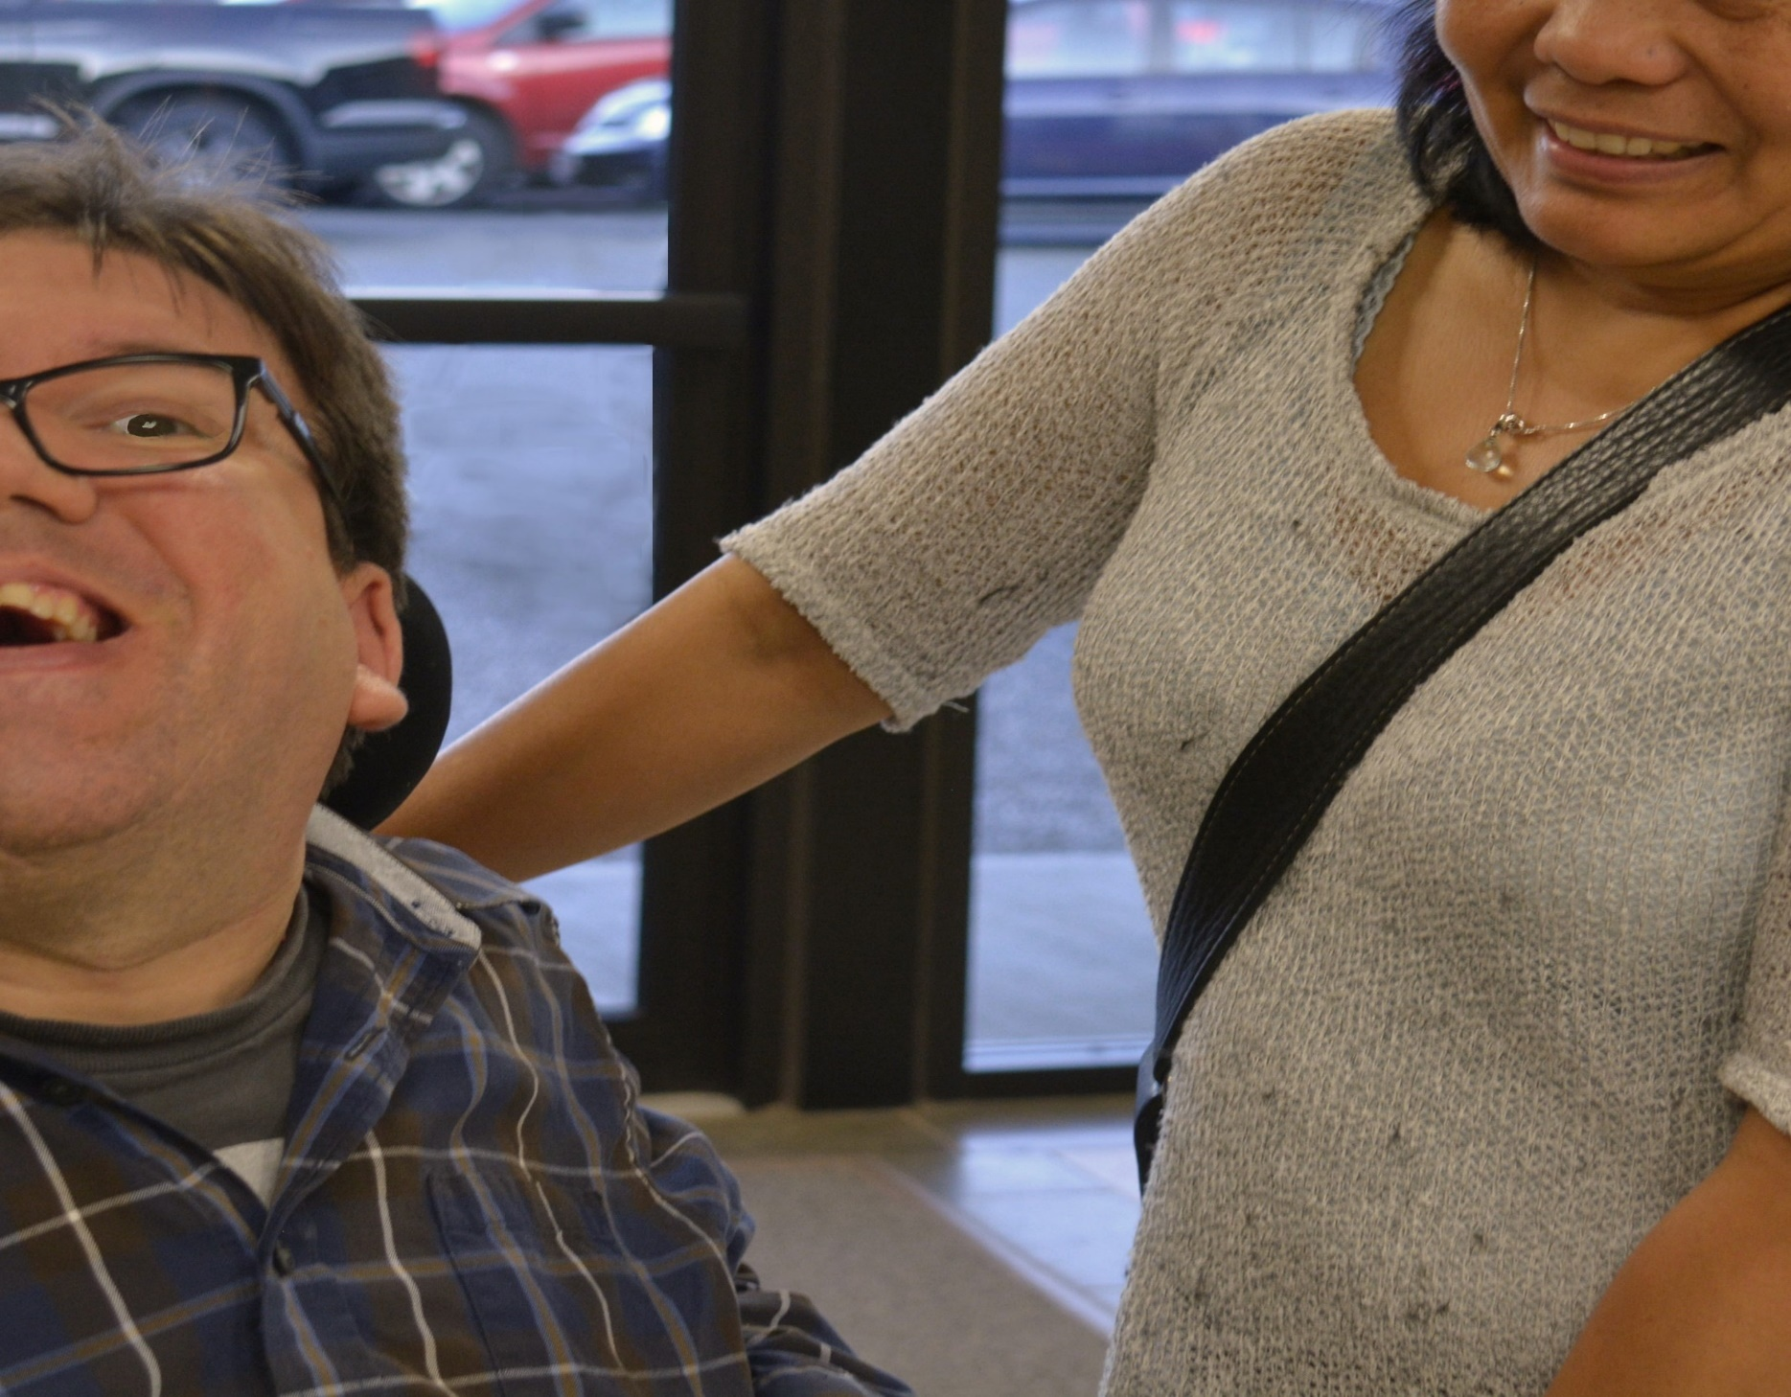
Make a Difference

Become a Home Share Provider

Don’t miss out on an opportunity with meaning
- Supporting and empowering people who experience intellectual disabilities
- Creating inclusive communities where everyone is fully accepted for who they are
- Experiencing relationships that will change you


Currently looking for a loving Christian Home from Surrey to Abbotsford to provide care to a middle-aged male. This individual is blind and does have some medical needs. He enjoys going to church, being on his computer, singing, bowling and being with people. A home with no large dogs or small children is required. He has a loving and friendly disposition and likes to be a ‘super resident’ where he is currently living.

Apply online at www.bethesdabc.com/careers.html –
Please reference #HS 0011 -

Supporting and empowering people with disabilities and their families..

Working toward a future where all people live together in interdependent communities and differences in ability are embraced.

