Faith Evangelical Lutheran Church, Washington, IL
Third Sunday of Advent
December 13, 2020
Prelude
Welcome

Lighting Advent Candles
Blessed are you, O Lord our God, ruler of the universe.
Your prophets spoke of a day when the desert would blossom and waters would break forth in the wilderness. Bless us as we light the candles on this wreath.
Strengthen our hearts as we prepare for the coming of the Lord.
May he give water to all who thirst, for he is our light and our salvation.
Blessed be God forever. Amen

Advent Song: “Awake, Awake, and Greet the New Morn” Red book # 242

1 Awake! Awake, and greet the new morn,
for angels herald its dawning.
Sing out your joy, for soon he is born,
behold! the Child of our longing.
Come as a baby weak and poor,
to bring all hearts together,
he opens wide the heav'nly door
and lives now inside us forever.

2 To us, to all in sorrow and fear,
Emmanuel comes a-singing,
his humble song is quiet and near,
yet fills the earth with its ringing;
music to heal the broken soul
and hymns of lovingkindness,
the thunder of his anthems roll
to shatter all hatred and blindness.

3 In darkest night his coming shall be,
when all the world is despairing,
as morning light so quiet and free,
so warm and gentle and caring.
Then shall the mute break forth in song,
the lame shall leap in wonder,
the weak be raised above the strong,
and weapons be broken asunder.
Text: Marty Haugen, b. 1950
Music: REJOICE, REJOICE Marty Haugen
Text and Music © 1983 GIA Publications, Inc., 7404 S. Mason Ave., Chicago, IL 60638. www.giamusic.com. 800.442.3358.
All rights reserved. Used by permission. Reprinted under OneLicense.net #A-711151

Confession and Forgiveness
Blessed be God, the Father, ☩ Son, and Holy Spirit,
whose forgiveness is sure
and whose steadfast love endures forever.
Amen.
You may dip your finger in water and make the sign of the cross on your forehead as a reminder of your baptism.
Together let us honestly and humbly confess
that we have not lived as God desires.
Please keep silence for reflection
Loving and forgiving God,
we confess that we are held captive by sin.
In spite of our best efforts, we have gone astray.
We have not welcomed the stranger;
we have not loved our neighbor;
we have not been Christ to one another.
Restore us, O God.
Wake us up and turn us from our sin.
Renew us each day in the light of Christ. Amen.
People of God, hear this glad news:
by God’s endless grace in Jesus
your sins are forgiven, and you are free—
free from all that holds you back
and free to live in the peaceable realm of God.
May you be strengthened in God’s love,
☩ comforted by Christ’s peace,
and accompanied with the power of the Holy Spirit.
Amen.

Peace:
P As forgiven people, we have peace with God, and peace with one another.
The peace of the Lord be with you always.
C And also with you.
P Let us share that peace with one another. Please take a moment to share God’s peace with those near to you, and say a prayer of peace for those at a distance.
P The grace of our Lord Jesus Christ, the love of God,
and the communion of the Holy Spirit be with you all.
C And also with you.
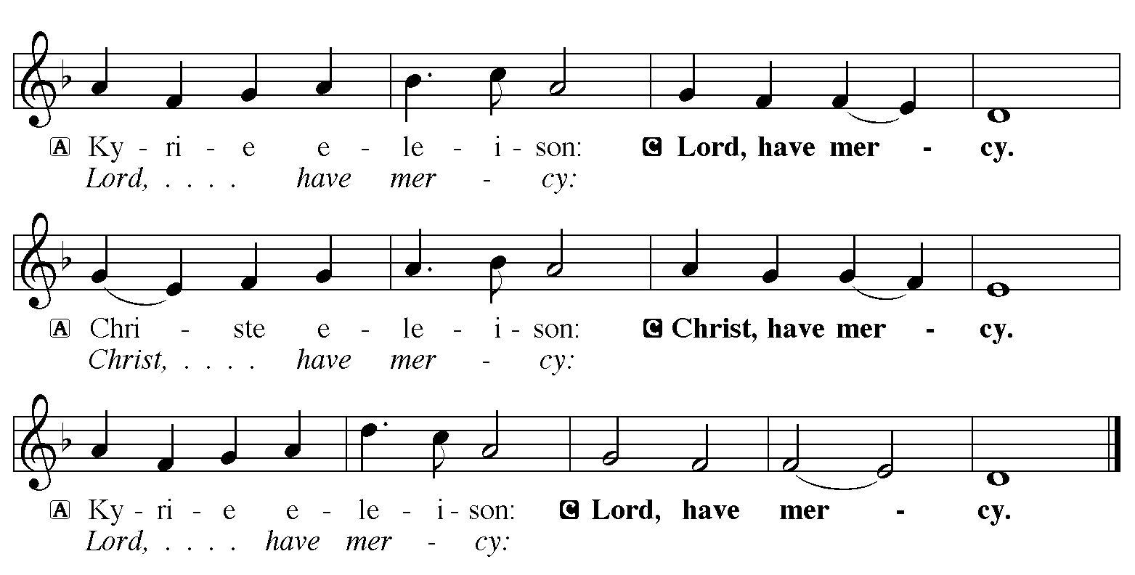

Hymn of Praise: “O Come, O Come, Emmanuel” Vs. 1, 4, 5, 6 Red Book # 257

1 O come, O come, Emmanuel, and ransom captive Israel,
that mourns in lonely exile here until the Son of God appear.

Refrain
Rejoice! Rejoice! Emmanuel
shall come to you, O Israel.

4 O come, O Branch of Jesse, free your own from Satan's tyranny;
from depths of hell your people save, and give them vict'ry o'er the grave. Refrain

5 O come, O Key of David, come, and open wide our heav'nly home;
make safe the way that leads on high, and close the path to misery. Refrain

6 O come, O Dayspring, come and cheer; O Sun of justice, now draw near.
Disperse the gloomy clouds of night, and death's dark shadow put to flight. Refrain

Text: Psalteriolum Cantionum Catholicarum, Köln, 1710; tr. Composite
Music: VENI EMMANUEL French processional 15th cent.
Text sts. 2, 6, 7 © 1997 Augsburg Fortress.
All rights reserved. Used by permission. Reprinted under OneLicense.net #A-711151
P The Lord be with you
C And also with you
Let us pray together the Prayer of the Day
Stir up the wills of your faithful people, Lord God, and open our ears to the words of your prophets, that, anointed by your Spirit, we may testify to your light; through Jesus Christ, our Savior and Lord, who lives and reigns with you and the Holy Spirit, one God, now and forever. Amen.

Children’s Message

First Reading: Isaiah 61:1-4, 8-11
¹The spirit of the Lord God is upon me,
because the Lord has anointed me;
he has sent me to bring good news to the oppressed,
to bind up the brokenhearted,
to proclaim liberty to the captives,
and release to the prisoners;
²to proclaim the year of the Lord’s favor,
and the day of vengeance of our God;
to comfort all who mourn;
³to provide for those who mourn in Zion—
to give them a garland instead of ashes,
the oil of gladness instead of mourning,
the mantle of praise instead of a faint spirit.
They will be called oaks of righteousness,
the planting of the Lord, to display his glory.
⁴They shall build up the ancient ruins,
they shall raise up the former devastations;
they shall repair the ruined cities,
the devastations of many generations.
⁸For I the Lord love justice,
I hate robbery and wrongdoing;
I will faithfully give them their recompense,
and I will make an everlasting covenant with them.
⁹Their descendants shall be known among the nations,
and their offspring among the peoples;
all who see them shall acknowledge
that they are a people whom the Lord has blessed.
¹⁰I will greatly rejoice in the Lord,
my whole being shall exult in my God;
for he has clothed me with the garments of salvation,
he has covered me with the robe of righteousness,
as a bridegroom decks himself with a garland,
and as a bride adorns herself with her jewels.
¹¹For as the earth brings forth its shoots,
and as a garden causes what is sown in it to spring up,
so the Lord God will cause righteousness and praise
to spring up before all the nations.
R The Word of the Lord
C Thanks be to God
Second Reading: 1 Thessalonians 5:16-24
¹⁶Rejoice always, ¹⁷pray without ceasing, ¹⁸give thanks in all circumstances; for this is the will of God in Christ Jesus for you. ¹⁹Do not quench the Spirit. ²⁰Do not despise the words of prophets, ²¹but test everything; hold fast to what is good; ²²abstain from every form of evil.
²³May the God of peace himself sanctify you entirely; and may your spirit and soul and body be kept sound and blameless at the coming of our Lord Jesus Christ. ²⁴The one who calls you is faithful, and he will do this.
R The Word of the Lord
C Thanks be to God
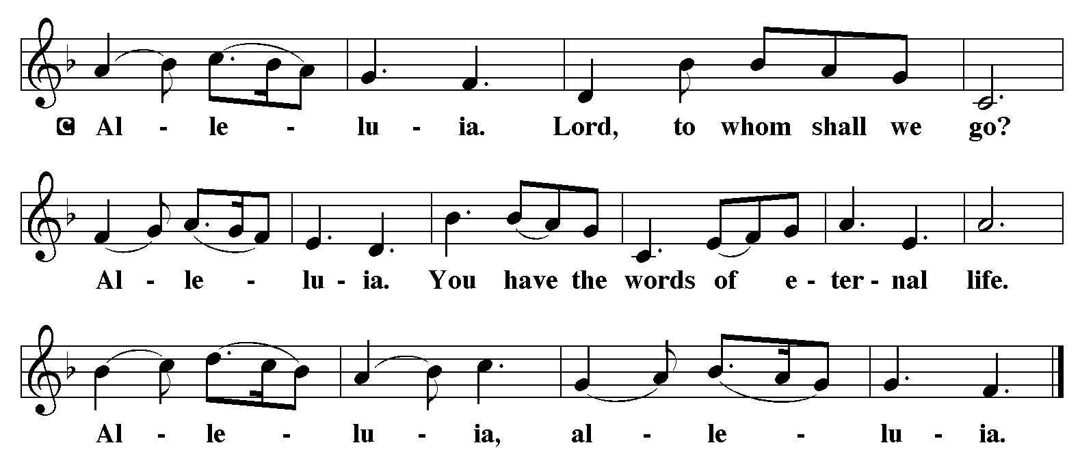

Holy Gospel: John 1:6-8, 19-28
C Glory to you, O Lord
⁶There was a man sent from God, whose name was John. ⁷He came as a witness to testify to the light, so that all might believe through him. ⁸He himself was not the light, but he came to testify to the light.
¹⁹This is the testimony given by John when the Jews sent priests and Levites from Jerusalem to ask him, “Who are you?” ²⁰He confessed and did not deny it, but confessed, “I am not the Messiah.” ²¹And they asked him, “What then? Are you Elijah?” He said, “I am not.” “Are you the prophet?” He answered, “No.” ²²Then they said to him, “Who are you? Let us have an answer for those who sent us. What do you say about yourself?” ²³He said,
“I am the voice of one crying out in the wilderness,
‘Make straight the way of the Lord,’ ”
as the prophet Isaiah said.
²⁴Now they had been sent from the Pharisees. ²⁵They asked him, “Why then are you baptizing if you are neither the Messiah, nor Elijah, nor the prophet?” ²⁶John answered them, “I baptize with water. Among you stands one whom you do not know, ²⁷the one who is coming after me; I am not worthy to untie the thong of his sandal.” ²⁸This took place in Bethany across the Jordan where John was baptizing.
The Gospel of the Lord
C Praise to you, O Christ
Sermon by Pastor John Rothfusz

Hymn: “Savior of the Nations Come” Red book # 263
All rights reserved. Used by permission. Reprinted under OneLicense.net #A-711151
Installation of Church Council Members for 2021

Apostles’ Creed
C: I believe in God, the Father almighty,
creator of heaven and earth.
I believe in Jesus Christ, God's only Son, our Lord,
who was conceived by the Holy Spirit,
born of the virgin Mary,
suffered under Pontius Pilate,
was crucified, died, and was buried;
he descended to the dead.
On the third day he rose again;
he ascended into heaven,
he is seated at the right hand of the Father,
and he will come to judge the living and the dead.
I believe in the Holy Spirit,
the holy catholic church, the communion of saints,
the forgiveness of sins, the resurrection of the body,
and the life everlasting. Amen.

Offering: Jesus is coming soon, to bring healing and hope to our world. We give thanks and praise as we lift up our tithes and offerings to the Lord. Please take a moment now to make an electronic offering to the church on the website, with the Tithe.ly app or write a check and send it in.

Offering Hymn: “Love Has Come” Red Book # 292
All rights reserved. Used by permission. Reprinted under OneLicense.net #A-711151

Prayers: After each portion of the prayers finishes with “Lord in your mercy,” please respond, “Hear our prayer.”
Lord’s Prayer
Our Father, who art in heaven, hallowed be thy name,
thy kingdom come, thy will be done, on earth as it is in heaven.
Give us this day our daily bread; and forgive us our trespasses,
as we forgive those who trespass against us;
and lead us not into temptation, but deliver us from evil.
For thine is the kingdom, and the power, and the glory,
forever and ever. Amen
Announcements
Benediction: The Lord bless you and keep you. The Lord make his face to shine upon you and be gracious to you. The Lord look on you with favor and give you peace. In the name of the Father, and of the Son, and of the Holy Spirit. Amen.

Hymn: “Lo, How a Rose E’er Blooming” Red book # 272
Public Domain

*Dismissal
P Go in peace, serve the Lord.
C Thanks be to God!
Postlude

