Vigil of the Resurrection
Every Saturday Night

Hymns taken from Common Praise, the hymnbook of the Anglican Church of Canada, & Voices United, the hymnbook of the United Church of Canada unless otherwise noted
Service adapted from the Book of Alternative Services of the Anglican Church of Canada

Jesus Christ is the light of the world.
A light no darkness can extinguish.

VU 19 – Kindle a flame

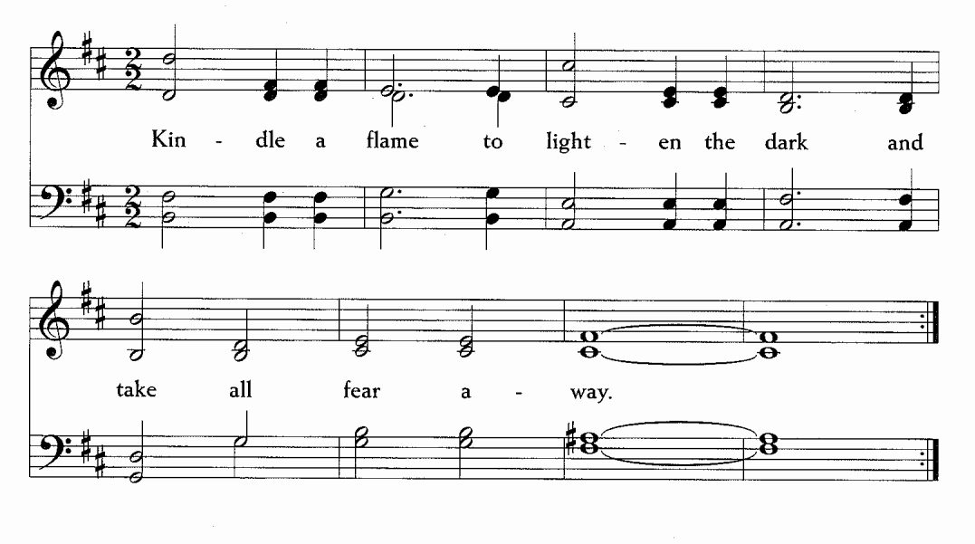

We praise and thank you, O God our Creator. Through your Beloved, Jesus Christ our Guide, you have enlightened us: dark death has been destroyed and radiant life is everywhere restored. What was promised is fulfilled: we have been joined to God, through renewed life in the Spirit of the Risen One. Glory and praise to you, our Creator, through Jesus your Beloved, who lives and with you and the Spirit, in the realm of light eternal, forever and ever. Amen.

VU 10 – Prepare the way of the Lord
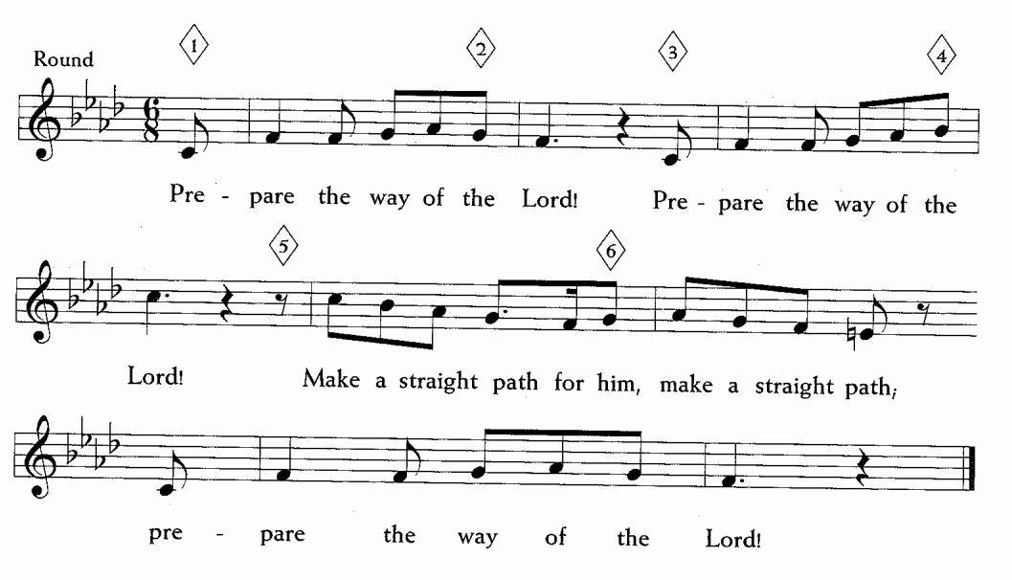

5 minutes of silence & stillness

CP 367 – Hosanna

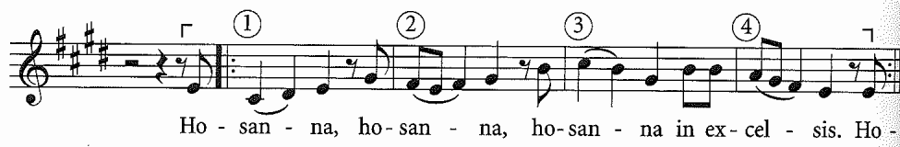

VU 863 – Psalm 141
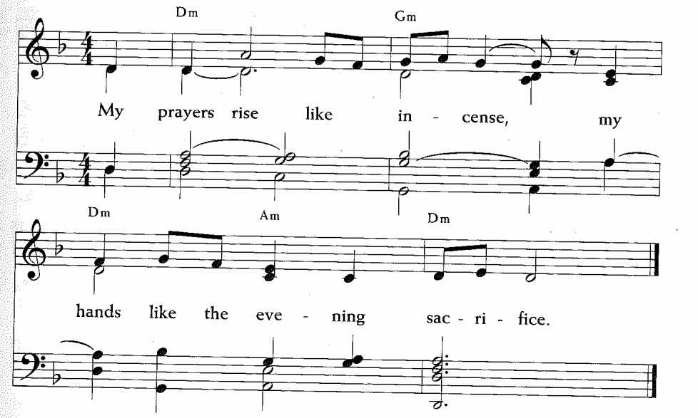

I call to you, O God; come to me quickly;
hear my voice when I cry to you.
Let my prayer rise before you as incense,
the lifting up of my hands as an evening sacrifice. R

Keep guard over my mouth, O God; watch the door of my lips; keep my heart from slipping into evil.
Let me not be busy with evildoers;
let me not be taken in by their sensuous delights. R

Should the righteous rebuke me, let me accept it as grace;
but keep the oil of injustice from ever touching my head.
I continually pray against wicked deeds; when we come to judgement, we will know the truth of your word. R

But my eyes are ever turned toward you, for you are my God;
in you I take refuge; do not deprive me of life.
Keep me from the snare set for me by evildoers;
let them be ensnared, but God, grant me release. R

Prayers with VU 411 – O God We Call

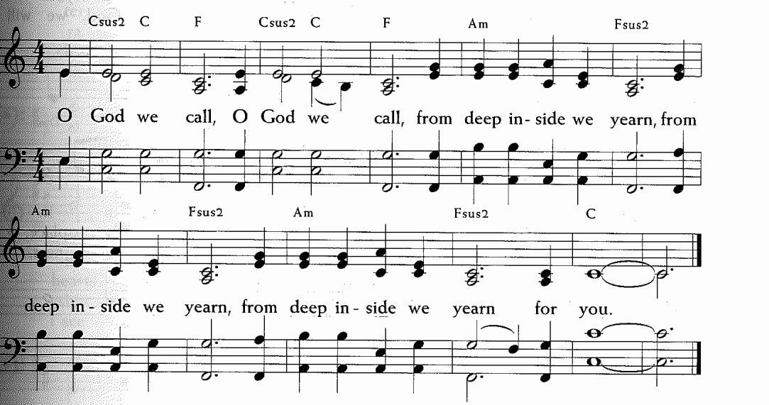

Beloved Christ, you embody all the colors of the world and serve as a bridge between different realms: Heaven and Earth, east and west, settler and indigenous. Inspire us to remember the values expressed by the colours of your rainbow. R

Red is for life, the root of spirit.
Living and Loving Christ, you are our Root. Free us from shame and grant us the grace of healthy pride so we can follow you, our inner light. We give thanks that God created us just the way we are.

Orange is for sexuality, the fire of spirit.
Passionate Christ, you are our Fire, the Word made flesh. Free us from exploitation and grant us the grace of mutual relationships. Kindle a fire of passion in us. R

Yellow is for self-esteem, the core of spirit.
O Christ, you are our Core. Free us from closets of secrecy and give us the guts and the grace to be free. Build our confidence with your steadfast love.

Green is for love, the heart of spirit.
Transgressive Christ, you are our Heart, breaking rules out of love. In a world obsessed with purity, you touch the sick and eat with outcasts. Free us from conformity and grant us the grace of uniqueness. Fill our hearts with untamed compassion for all beings.

Blue is for self-expression the voice of spirit.
Liberator Christ, you are our Voice, speaking out against all forms of oppression. Free us from apathy and grant us the grace of activism. Motivate us to call for justice. R

Violet is for vision, the wisdom of spirit.
Interconnected Christ, you are our Wisdom, creating and sustaining the universe. Free us from isolation and grant us the grace of interdependence. Connect us with others and with the whole creation.

All-encompassing Christ, as the colours come together to make one light, free us from rigid categories, and grant us the grace of interwoven identities. Lead us beyond black-and-white thinking to experience the whole spectrum of life. R
Prayers adapted from: https://www.huffpost.com/entry/rainbow-christ-prayer-hon_b_1616193

CP 308 – Jubilate Deo

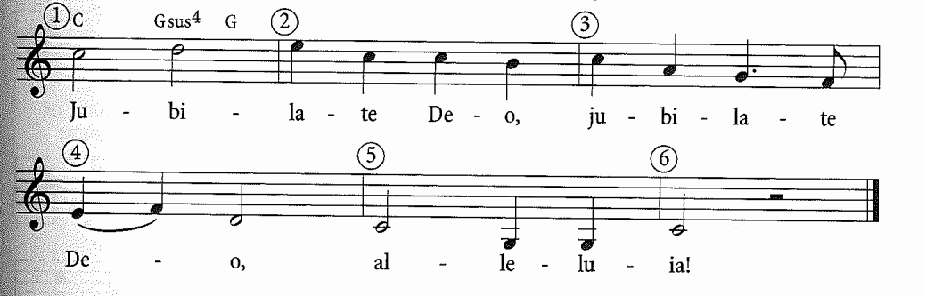

5 minutes of silence & stillness
Resurrection Gospel with Listen to the Word That God Has Spoken

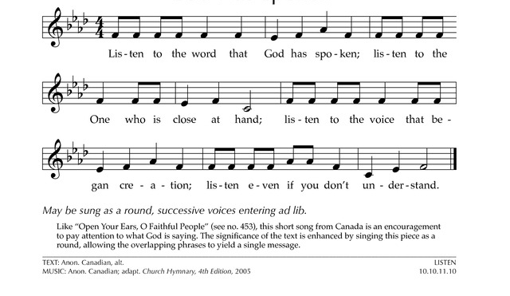

When the Sabbath was over, Mary Magdalene, Mary the mother of James, and Salome bought spices so that they could go and anoint Jesus’ dead body. Very early on the first day of the week, just after sunrise, they came to the tomb. They were saying to each other, “Who’s going to roll the stone away from the entrance for us?” When they looked up, they saw that the stone had been rolled away. (And it was a very large stone!) Going into the tomb, they saw a young man in a white robe seated on the right side; and they were startled. But he said to them, “Don’t be alarmed! You are looking for Jesus of Nazareth, who was crucified. He has been raised. He isn’t here. Look, here’s the place where they laid him. Go, tell his disciples, especially Peter, that he is going ahead of you into Galilee. You will see him there, just as he told you.”

Listen to the Word That God Has Spoken

We thank you, Healing God, for the gift of water. Over water the Holy Spirit moved in the beginning of creation. Through water you led the children of Israel out of their bondage in Egypt into the land of promise. In water your Beloved Jesus received the baptism of John and was anointed by the Holy Spirit as the Messiah, the Christ, to lead us, through his death and resurrection, from the bondage of sin into everlasting life.
We thank you, Creator, for the water of baptism.
In it we are buried with Christ in his death.
By it we share in his resurrection.
Through it we are reborn by the Holy Spirit.
Therefore, in joyful obedience to your Son,
we celebrate our fellowship in him in faith.
We pray that all who have passed through the water of baptism may continue forever in the risen life of Jesus Christ our Saviour.
To Christ, to you, and to the Holy Spirit, be all honour and glory, now and forever. Amen.

CP 530 – By Night We Hasten

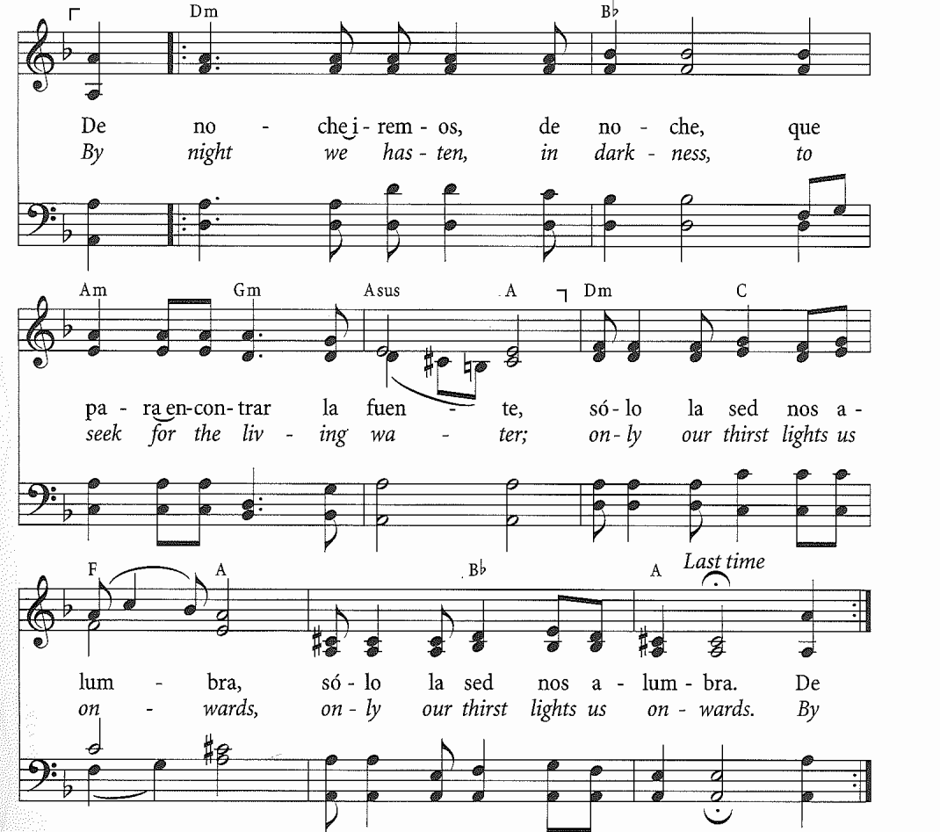

Our God offers us joy, wonder, and influence.
God’s compassion is true and fair.
Praise our God, all you who wait and hope,
all you who stand in awe, great and small.
Let us rejoice in the Spirit, follow Christ, and give God praise.
The time has come for the wedding feast of the Lamb!

O God who brought your people out of slavery with a mighty hand, strengthen us to take our stand with you beside the oppressed of the world, that in the victory of Christ every fetter of body, mind, and spirit may be broken, and the whole human family, restored to your image, may sing your praise in joy, freedom, and peace; through the same Jesus Christ our Lord. Amen.

May God the Creator continually show us Loving-Kindness. Amen
May God the Beloved grant us the joy of Resurrection. Amen
May God the Spirit renew our hearts in Love. Amen
May our loving God – Creator, Beloved, and Holy Spirit – continue to bless us. Amen.

CP 553 – Ubi Caritas

