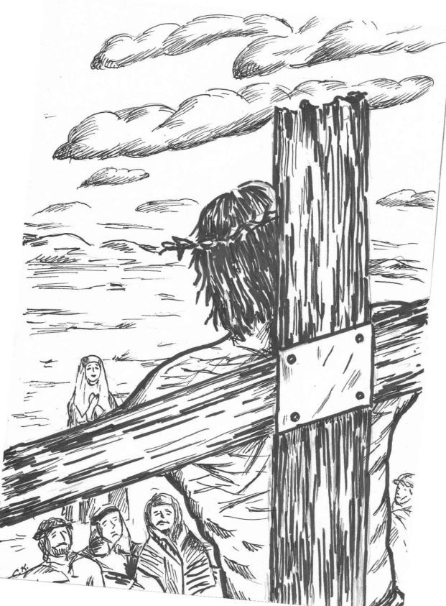
A Tenebrae Service Of Shadows
Good Friday
April 19th, 2019

Welcome and Introduction to the Service

Opening Words: from Isaiah 53
He was despised and rejected, a man of sorrows and acquainted with grief; and as one from whom we hide our faces, he was despised, and we esteemed him not.
Surely he has borne our griefs and carried our sorrows. He was wounded for our transgressions, he was bruised for our iniquities; upon him was the punishment that made us whole, and with his scars we are healed. All we, like sheep, have gone astray; we have turned, everyone, to
their own way, and the Lord has laid on him the iniquity
of us all.

Prayer

♪ Hymn: ‘The Old Rugged Cross'

-2-

Scripture: Luke 22:47 - 23:33 (adapted)
After Jesus rose from prayer, suddenly a crowd came, and the one called Judas, one of the twelve, was leading them. He approached Jesus to kiss him; but Jesus said to him,
J: ‘Judas, do you betray the Son of Man with a kiss?’
Then Jesus said to the chief priests, the officers of the temple police, and the elders who had come for him,
J: ‘Have you come out with swords and clubs as if I were a bandit? When I was with you day after day in the temple,
you did not lay hands on me. But this is your hour, and
the power of darkness!’
Then they seized him and led him away, bringing him into the high priest’s house. But Peter was following at a distance. When they had kindled a fire in the middle of the courtyard and sat down together, Peter sat among them. Then a servant-girl, seeing him in the firelight, stared at him and said, ‘This man also was with him.’ But he denied it, saying,
P: ‘Woman, I do not know him.’
A little later someone else, on seeing him, said, ‘You also are one of them.’ But Peter said,
P: ‘Man, I am not!’
Then about an hour later yet another kept insisting, ‘Surely this man also was with him; for he is a Galilean.’ But Peter said,
P: ‘I do not know what you are talking about!’
At that moment, while he was still speaking, the cock crowed. The Lord turned and looked at Peter. Then Peter remembered the word of the Lord, how he had said to him, ‘Before the cock crows today, you will deny me three times.’ And he went out and wept bitterly. Then the assembly rose as a body and brought Jesus before Pilate. They began to accuse him, saying, ‘We found this man perverting our nation, forbidding us to pay taxes to the emperor, and saying that he himself is the Messiah, a king.’ Then Pilate asked him, ‘Are you the king of the Jews?’ And Jesus answered,
J: ‘You say so.’

-3-

Then Pilate said to the chief priests and the crowds, ‘I find no basis for an accusation against this man.’ But they kept shouting,
Congregation: ‘Crucify him, crucify him!’
They kept urgently demanding with loud shouts that he should be crucified; and finally, their voices prevailed. So Pilate gave his verdict that their demand should be granted, and he handed Jesus over to be crucified.

♪ Were you there when they crucified my Lord?
VU 144 Were you there when they crucified my Lord?
Oh …… Sometimes it causes me
to tremble, tremble, tremble.
Were you there when they crucified my Lord?
Seven Last Words From The Cross

1. The First Word: Luke 23: 32-34 Joel Maranion
Two others also, who were criminals, were led away to be put to death with him. When they came to the place that is called The Skull, they crucified Jesus there with the criminals, one on his right and one on his left. Jesus said, "Father, forgive them, for they know not what they do." ​

Extinguishing The Candle
L Lord Jesus - you gave your life for us.
P You suffered and died that we might be made whole.
(silence)

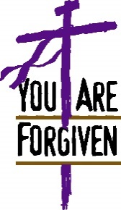

-4-

2. The Second Word: Luke 23: 39-43 Josephine Jaramilla
One of the criminals hanging there threw insults at him:
"Aren't you the Messiah? Save yourself and us!" The other one, however, rebuked him, saying: "Don't you fear God? Here we are
all under the same sentence. Ours, however, is only right, for we are getting what we deserve for what we did; but he has done no wrong." And he said to Jesus, "Remember me, Jesus, when you come as King!" Jesus said to him, "I tell you this: Today you will be in Paradise with me."

Extinguishing The Candle
L Lord Jesus - you gave your life for us.
P You suffered and died that we might be made whole.
(silence)

3. The Third Word John 19:25-27 Kaira Dela Cruz
Standing close to Jesus' cross were his mother, his mother's
sister, Mary the wife of Clopas, and Mary Magdalene. He saw his mother and the disciple he loved standing there; Jesus said to his mother, "Woman, here is your son." Then he said to the disciple, "Here is your mother." And from that time the disciple took her to live in his home.

Extinguishing The Candle
L Lord Jesus - you gave your life for us.
P You suffered and died that we might be made whole.
(silence)

♪ Gift of Music: ‘At The Cross’ Hazel Bay-Asen
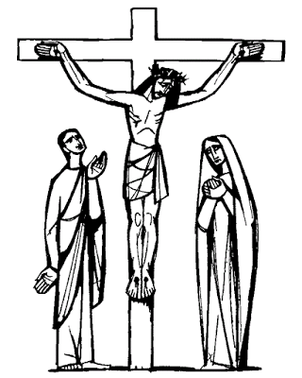
-5-

The Fourth Word: Mark 15:33-34 Imelda Bareng
And when the sixth hour had come, there was darkness over the whole land until the ninth hour. And at the ninth hour Jesus cried with a loud voice, "My God, my God, why have You forsaken me?"

Extinguishing The Candle
L Lord Jesus - you gave your life for us.
P You suffered and died that we might be made whole.
(silence)

The Fifth Word John 19:28 Randy Bentayen
After this Jesus, knowing that all was now finished, said (to fulfil the scripture), "I thirst." A jar of sour wine was standing
there. So they put a sponge full of the wine on a branch of hyssop
and held it to his mouth.

Extinguishing The Candle
L Lord Jesus - you gave your life for us.
P You suffered and died that we might be made whole.
(silence)

♪ Hymn: ‘Above All’ (Randy B & Larry A. on guitar)

The Sixth Word: John 19:29-30 Roy Dumagpi
When Jesus had received the wine, he said, “It is finished.” Then he bowed his head and gave up his spirit.

Extinguishing The Candle
L Lord Jesus - you gave your life for us.
P You suffered and died that we might be made whole.
(silence)

The Seventh Word: Luke 23:46 Nia Bentayen
Then Jesus, crying with a loud voice, said, ‘Father, into Your hands I commend my spirit.’ And having said this, he breathed his last.

Extinguishing The Candle
L Lord Jesus - you gave your life for us.
P You suffered and died that we might be made whole.
(silence)

Prayer for Good Friday

♪ Hymn: ‘When I Survey The Wondrous Cross’ VU 149

Blessing
Lakeview Multicultural United Church
Welcome to Lakeview Multicultural United Church on this Good Friday as we stand together at the foot of the Cross. May you find here a strengthening word, caring friends, and the embracing spirit of Christ.
Interim Minister: Rev. Valerie Taylor
email: valtaylor1981@gmail.com
church phone: 604-874-0634
emergencies: 604-434-6388
website: www.lakeviewunited.ca
Musicians: Mark Dumagpi
Randy Bentayen & Larry Angulo
Projectionist: Roy Dumagpi

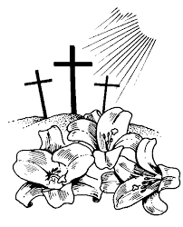
Celebrate Easter!
7:30 am Easter Sunrise Ecumenical Service
at Trout Lake (south side near washrooms)
9 – 10 am Easter Breakfast at the church
10:30 am Easter Service with cantata
11:30 am Refreshments (bring sweets)
Easter Egg Hunt for the children
Easter Photo Booth (by donation)

for more information please visit our website www.lakeviewunited.ca

