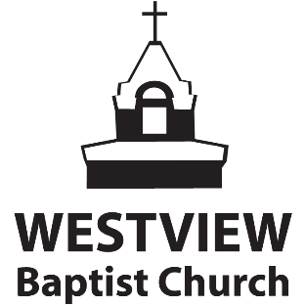
Sunday November 29 Online Worship Service

Welcome to our worship service this Sunday morning. Today we bring our worship to God from wherever we are and celebrate the first Sunday of Advent. We invite you to follow this outline as we bring our praise and adoration to God, and hear Dayle bring us God’s Word from the book of Amos.
-------------------------------------------------------------------------------------------------------------------------------------------------
GIVING:
We thank you for your generosity and your faithfulness in giving. We know that during this time there are many financial needs as a church family; we also know that giving is an integral part of worship and something we want to encourage you all to stay active in doing. We have made it simple to be able to still give through Push Pay (our electronic giving platform.) You can give on our website, or through the PushPay app, or by using e-transfer. You may also mail a cheque to the church.
Let’s pray:
“Father, we know that You are the one certain thing in our uncertain world right now, and we recognize in this time you still call us to a life of worship, to a life of trust and obedience. We pray that during this time our worship will continue through giving, knowing that the work of ministry is not done. Use the generosity of your people to fuel the advance of the gospel so that more will come to know Jesus as Lord & Saviour.
CLICK HERE TO GIVE

OUR SUNDAY WORSHIP SERVICE
We encourage you to begin your worship time today by clicking on the video below. The Worship team will begin our celebration, and we hope these songs will draw you into His presence as you sing them, and help prepare you to hear from God’s word.
Tyler will bring us some important announcements for this season, and we will have the first reading and carol for Advent. Then we will have a special Christmas song featuring Jen and our worship team. Then Dayle will conclude his sermon series from the book of Amos.. We pray that God will bless you today.
Click here to watch the worship team, the announcements from Tyler, our Advent segment, and our continuing teaching on Amos, from Dayle.
------------------------------------------------------------------------------------------------------------------------------------------------
YOUTH MINISTRY SECTION - Click Here
-------------------------------------------------------------------------------------------------------------------------------------------------
CHILDREN’S MINISTRY SECTION - Click Here
-------------------------------------------------------------------------------------------------------------------------------------------------

