Joining the Youth Discord & Minecraft Server

Table of Contents:
- Introduction & Rules
- Part 1 – Discord
  - Downloading
  - Pacific Youth Server
- Part 2 – Minecraft
  - Downloading & Setup
  - Getting on the server

Introduction & Rules:
Well hello there. It seems as though you would like to join our ranks, I say a welcome to you! It is a privilege to embark on this journey together, and merry times are to be had. However, along with this privilege there comes responsibilities, both to yourselves and the other whom are enjoying themselves. As such, please take note of the following guidelines:
- No griefing, so no stealing items, destroying others builds, or killing without permission
- No inappropriate actions. Whether this is said in the chat, discord, or built, don't do it.
- No cheating. If you somehow have creative or commands, tell me and don't use it. X-ray and other unfair advantage texture packs also count. Optifine is acceptable as long as no unfair advantage is used.
- Have fun!!!

Part 1 – Discord:
We will start with Discord, as getting everyone on a common communication channel will make troubleshooting issues much easier. Discord is available for PC/MAC and Mobile Devices, so use what would work better for you.

Step 1:
Visit the link https://discordapp.com/download or type “discordapp.com/download” in your search bar and click the appropriate download button. The download will begin automatically.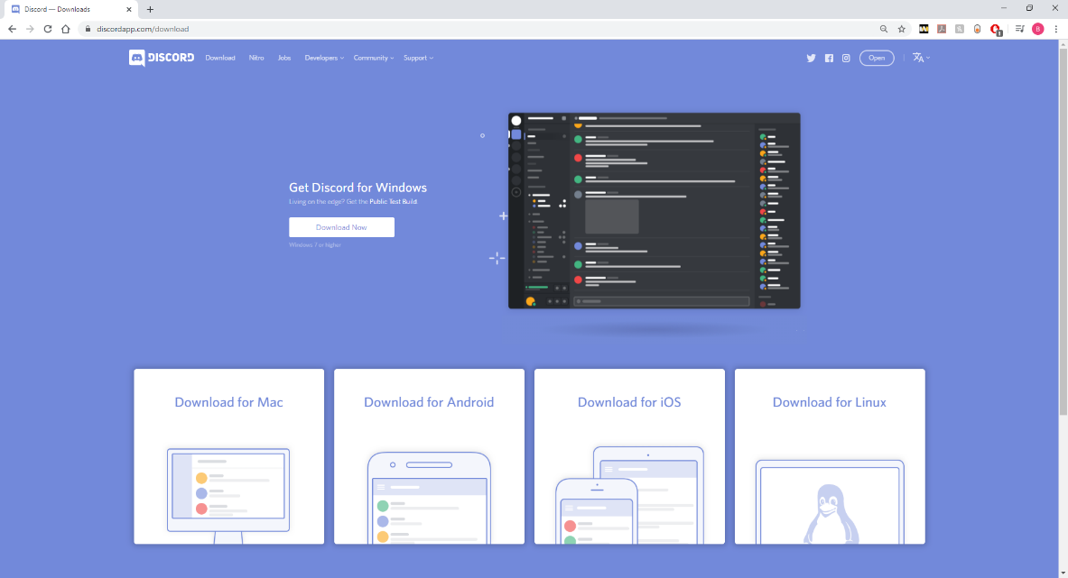
Step 2:
Once the download is finished, open it and discord will set itself up. Next either log in, or create an account if this is your first time using Discord.
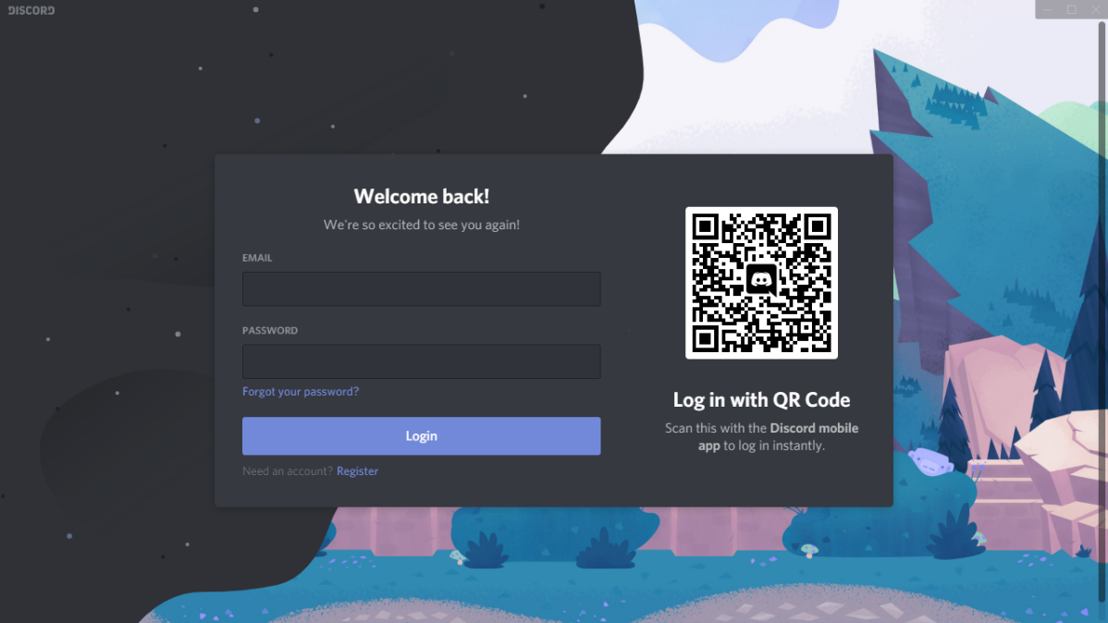
Step 3:
After you have logged in visit the following link: https://discord.gg/ZBgNmH9. If you already have Minecraft, send your username in the chatroom, and you will be approved for the server by our admin. After you have been whitelisted on the server you will be added to the General Voice Channel on Discord. If you do not have Minecraft just follow along with Part 2 of this form.

Part 2 – Minecraft:
Time to get the goods.

Step 1:
Travel to https://www.minecraft.net/en-us/ and click on “Get Minecraft”. Select COMPUTER and then PC or MAC for your respective platform.
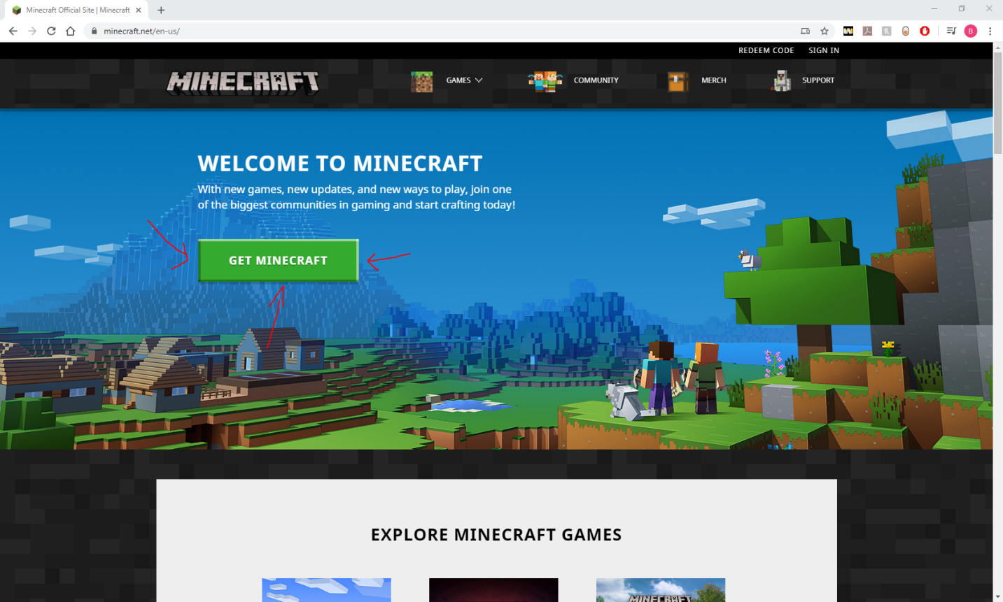

Step 2:
Select “Minecraft: Java Edition”. Click “Buy Minecraft and go through the registration and purchasing steps.
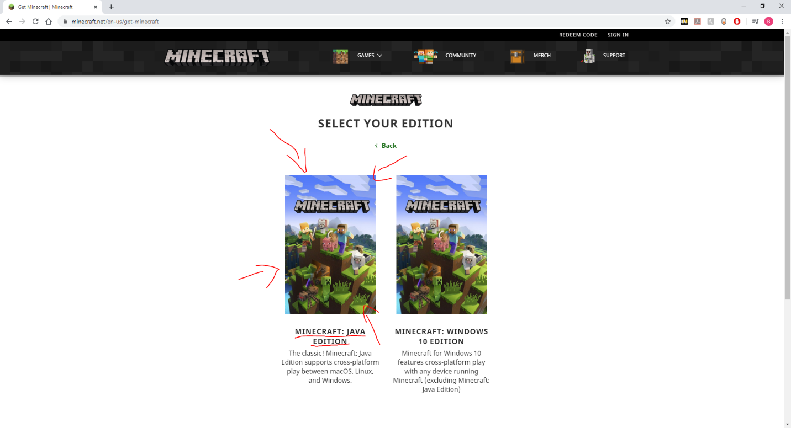
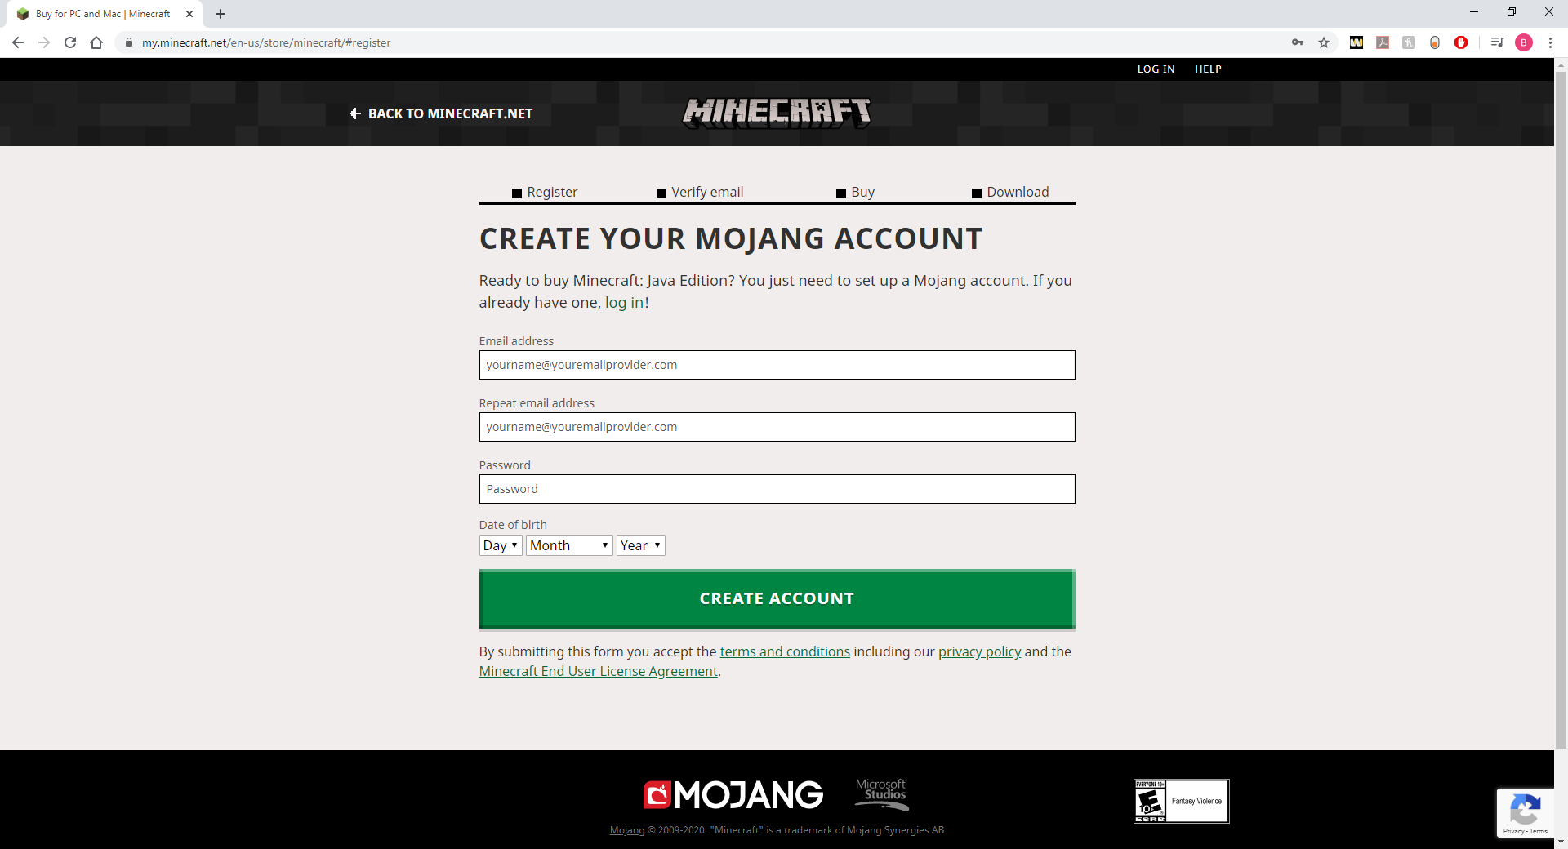

Step 3:
Once the download is done and you have signed into your account through the launcher you need the correct version of Minecraft to be compatible with the server. Follow the steps and pictures below:
- Go to “Installations” tab and click on “New”
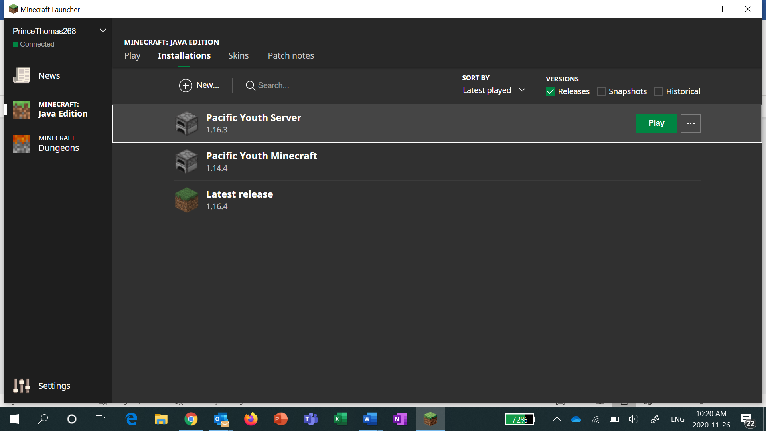
- Click on the dropdown for “Version” and scroll down to find and select “Release 1.16.3”. Create then press play
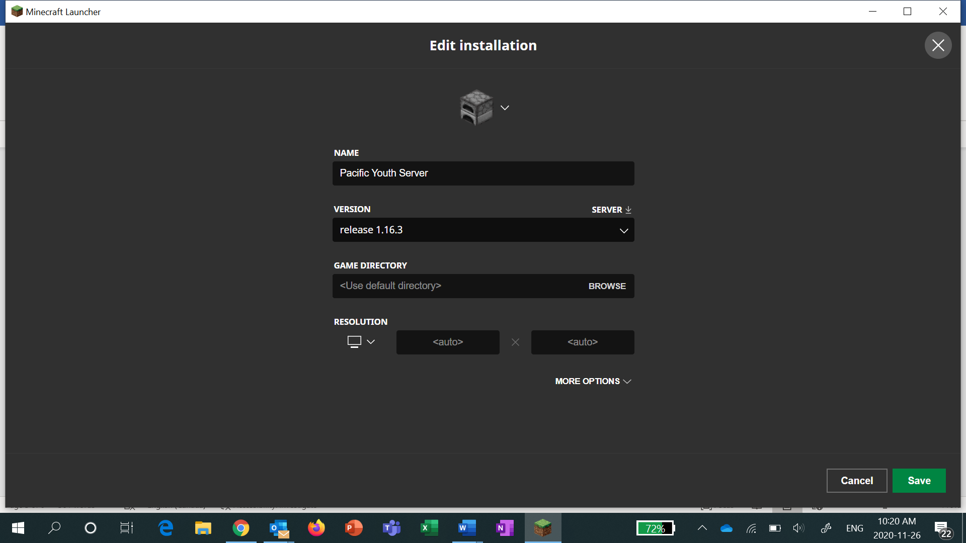
To join the Server go to “Multiplayer” -> “Direct Connect.” Then enter: “51.178.133.181:25573” and then “Done”. Afterwards click on the join server.
*NOTE* You won’t be able to access the server unless you are whitelisted, so please make sure you have gone through the discord instructions above so our admin can allow you to join.
